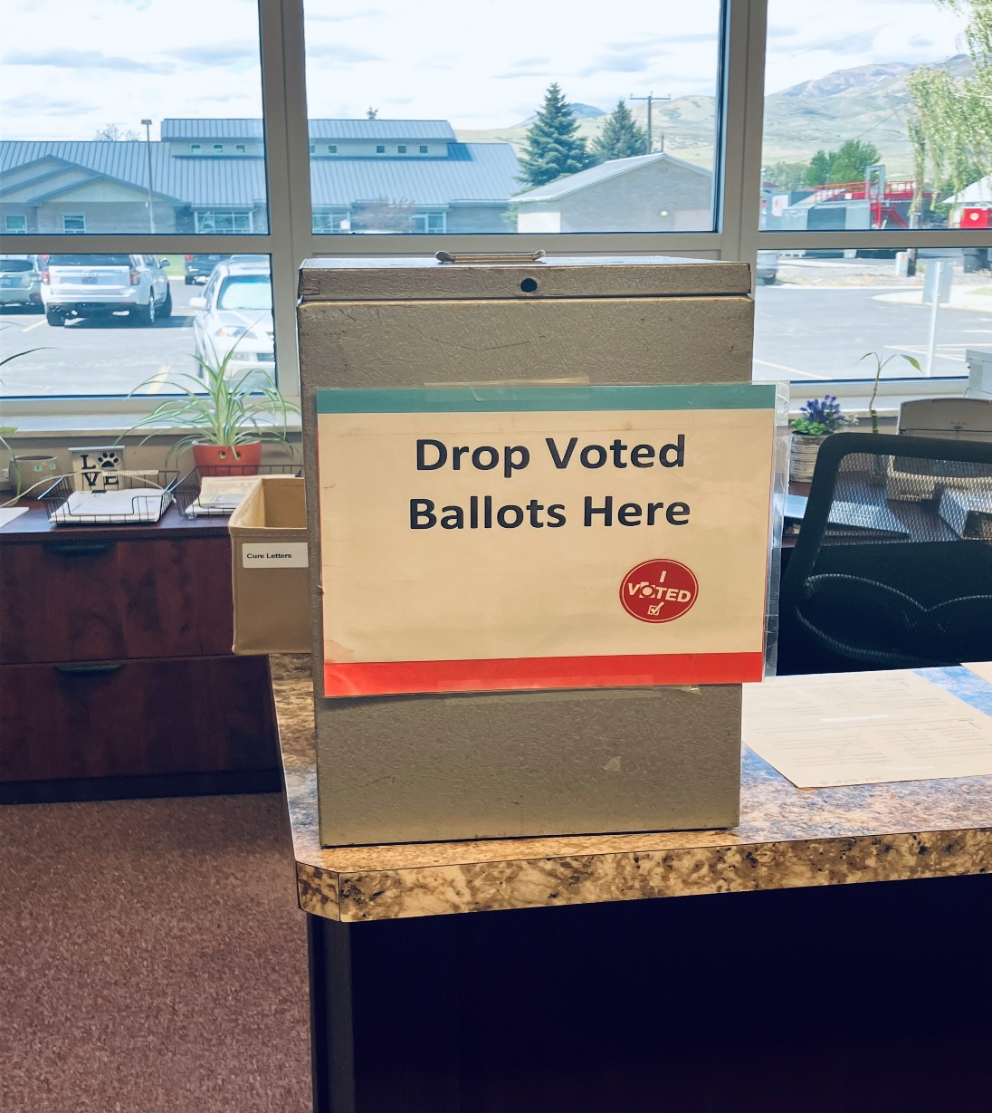
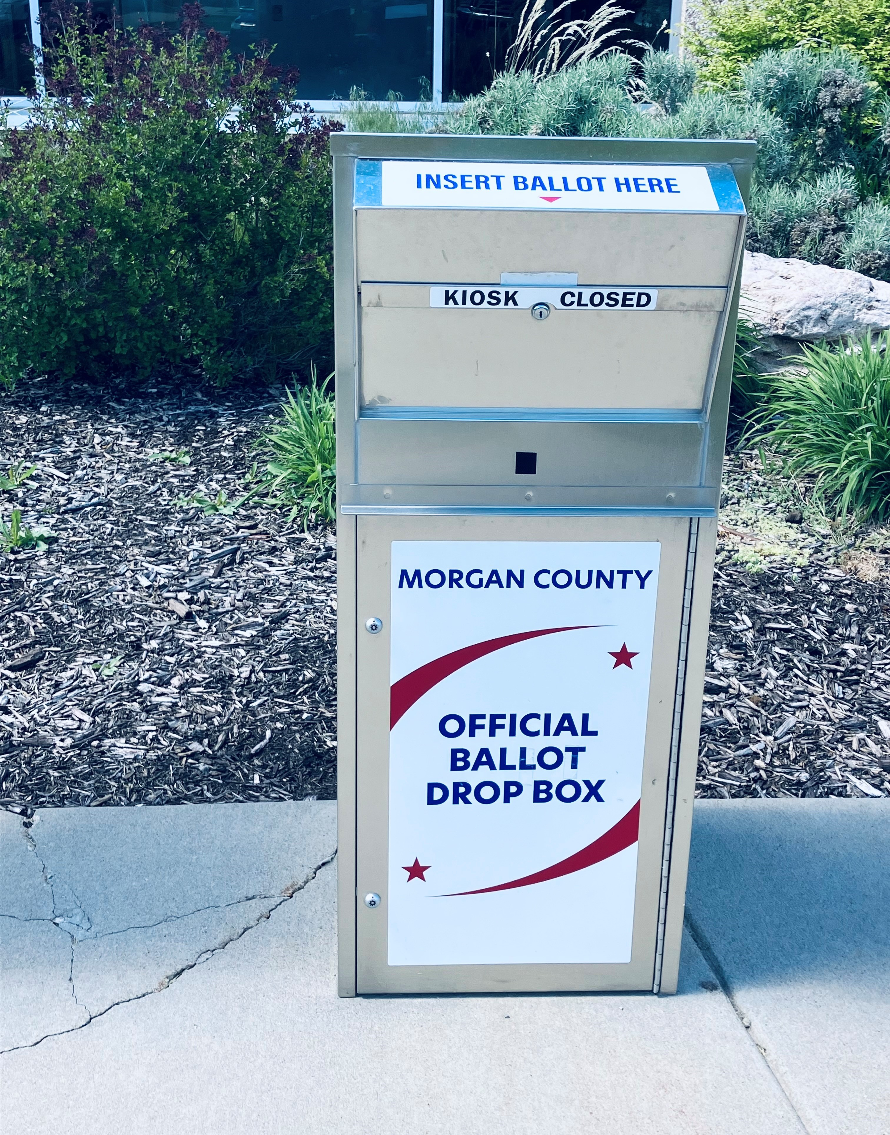
Drop box location for you voted ballot: Morgan County Building 48 West Young Street, Morgan Utah
Monday- Friday 8:00am to 5:00pm
Election Day 7:00 am to 8:00pm
Mail Voted Ballot with USPS

