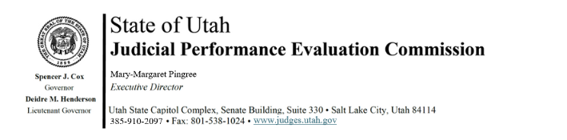

Judicial Performance Evaluation Commission
AGENDA
Tuesday, May 21, 2024
8:30 am-12:00
Hybrid Meeting *

Members: Mallory Bateman, Christine Durham, Sherrie Hayashi, Blair Hodson, Rick Hoffman, James C. Jenkins, Curtis M. Jensen, David J. Jordan, Sonya Martinez-Ortiz, Gil A. Miller, Bridget Romano, Tom Ross, Shannon Sebahar

Staff: Madison Klein, Chris Russell, Mary-Margaret Pingree, Chris Pieper

8:30 a.m. Welcome Gil Miller
Approval of Minutes – April 23, 2024

8:35 a.m. Public Comment Gil Miller

8:40 a.m. Announcements/Updates Mary-Margaret Pingree

8:45 a.m. Voter Outreach Budget Mary-Margaret Pingree

9:00 a.m. 2024 Retention Evaluations Gil Miller

10:30 a.m. Commissioner Picture & Break

10:45 a.m. 2024 Retention Evaluations - Voting Gil Miller
Open Session

11:00 a.m. 2024 Retention Evaluations Gil Miller
Closed Session

11:30 a.m. Thank You Mary-Margaret Pingree

12:00 a.m. Adjourn

Next Meeting: Tuesday, June 11, 2024
9:00 a.m. – 12:00 noon
Senate Building, CCJJ Conference Room

*Anchor Location: Senate Building, Suite 330, CCJJ Large Conference Room

