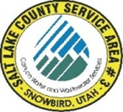
NOTICE OF
REGULAR MEETING
of the Board of Trustees of
SALT LAKE COUNTY SERVICE AREA #3 – SNOWBIRD
to be held on Monday May 20th, 2024, at 12:00 P.M.
You may join the meeting electronically from the link below.
https://meet.goto.com/121486501
You can also dial in using your phone.
United States: 121-486-501
Access Code: +1 (872) 240-3311
Dave Richards
Tom Prosek
Chris Bremer

MEETING AGENDA

- Richards Approval April 15th 2024 meeting minutes.

- Carpenter Systems Operations and Development.

- Carpenter Treasurers Report ending April 30th, 2024

- Richards Approval of April 13th through May 17th, 2024.

Post Date: __________________
Attest: ______________________
Bryauna A. Alderin/ Clerk

