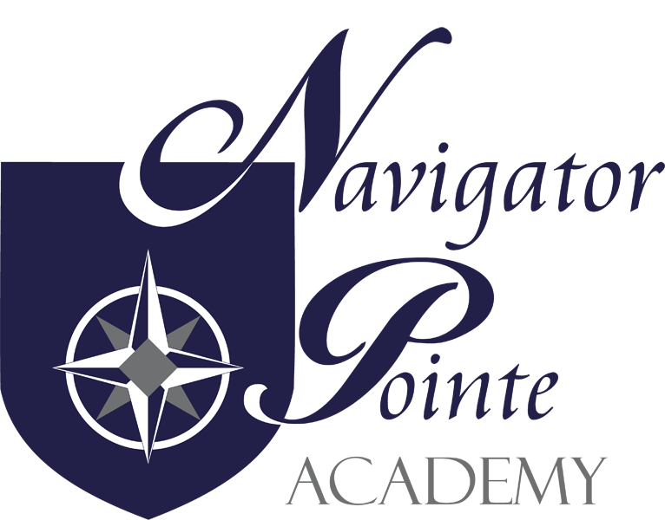

Governing Board Meeting

6844 South Navigator Drive
West Jordan, Utah

Thursday, April 18, 2024
6:00 p.m. – 7:00 p.m.

I. Call to Order/Welcome at 6:13 p.m.
II. Public Comment - None
III. Governance
- Board Training/Policy Review
  - Fernando Cruz presented the Seven Absolutely Universal, Non-Negotiable, Unchanging Principles of Good Charter School Governance by Brian Carpenter. Jake will present board training in May.
- Monthly Board Meeting Minutes Approval (Board action may be required)
  - Jake made a motion to approve the March 21, 2024 Board Meeting Minutes. Fernando seconded the motion. Roll Call: Jake – yes; Kristi – yes; Fernando yes. Motion passed.
- “Closed Session, as necessary, to discuss allowed items” (Board action may be required)
  - Not Needed this time

IV. Director’s Report
- Volunteer – 1070.75 hours have been volunteered. Spirit Week helped with hours. We have several parents who have gotten their background check so they can volunteer in the school and on field trips.
- Student Achievement – in process of taking the RISE test. The school gets immediate feedback on the test results but they are often adjusted by the state. They have started the K-3 Acadience testing in Reading and Math. Don’t have the results from those tests yet.
- Character Development – during Spirit Week they set up pen pals, continued the Junior High buddy, had fun activities for each grade level. Ended the week with the Saxon Math/Food Drive where they were able to collect 2308 pounds of food to donate to the Utah Food Bank. They did collect a lot of Ramen Noodles.
- Core Knowledge Night was well attended.
- Enrollment – 400 current enrollment. Waiting lists at every grade level as well as available spots. Kindergarten is getting harder to fill with traditional schools offering all day Kindergarten. Want to have about 440 students enrolled. Need to make additional room for Special Ed because number of students receiving special education services has greatly increased.
V. Financial Report
A. Need to work on getting a RFP for Auditor. Will add the Auditor decision on May’s
board meeting agenda.
B. 103 days cash on hand. Interest rates are up so we are making more interest income.
We just purchased two new copiers. On target for a $70K surplus at the end of the
fiscal year.
C. Jake made a motion to accept the March 2024 financials. Fernando seconded the
motion. Roll Call: Jake – yes; Fernando – yes; Kristi – yes..

VI. Next Meeting Schedule – May 16th at 6:00 p.m.
VII. Adjourn at 7:14 p.m.

