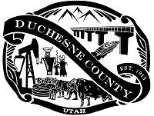
DUCHESNE COUNTY
Chelise Jessen
Clerk-Auditor
PO Box 270 Duchesne, Utah 84021

NOTICE
2024 Primary Election Logic & Accuracy Test
In accordance with Utah Code 20A-4-104, the Duchesne County Clerk's Office will conduct a public Logic & Accuracy Test of automatic tabulating equipment prior to June 25, 2024 Primary Election. The test will be held on June 3, 2024, at 1:00 PM in the ballot processing center, which is located at the Duchesne County Administration Building, 734 North Center Street, Duchesne, Utah 84021

NOTICE
2024 Post-Election Audit
In accordance with Utah Code 20A-4-104 and 20A-1-108, the Duchesne County Clerk's Office will conduct a post-election audit of the 2024 Primary Election on Wednesday, July 3, at 10:00 AM. The audit will be conducted in the ballot processing center, which is located at the Duchesne County Administration Building, 734 North Center Street, Duchesne, Utah 84021

