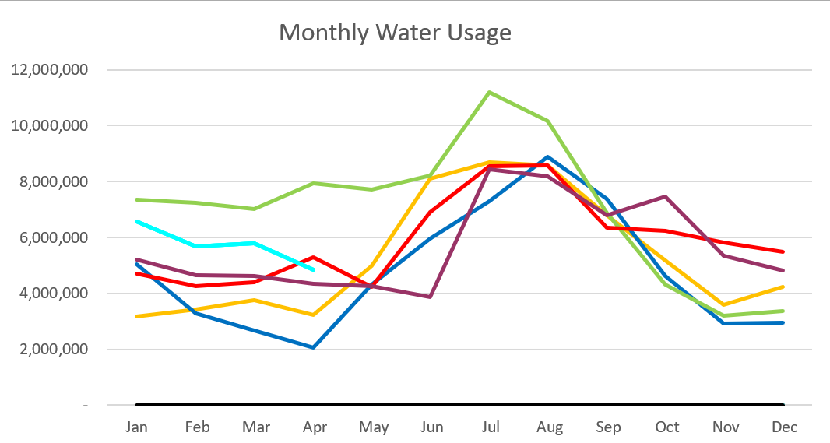

2024 – Light Blue 2023 – Purple
2022 – Red 2021 – Yellow
2020 – Blue 2019 – Green
April 2024

Usage is down and so is unaccounted water with it. Some of the unaccounted water could be water going to fill the tanks and was not used in the system yet. All our spring source meters are before the tanks.
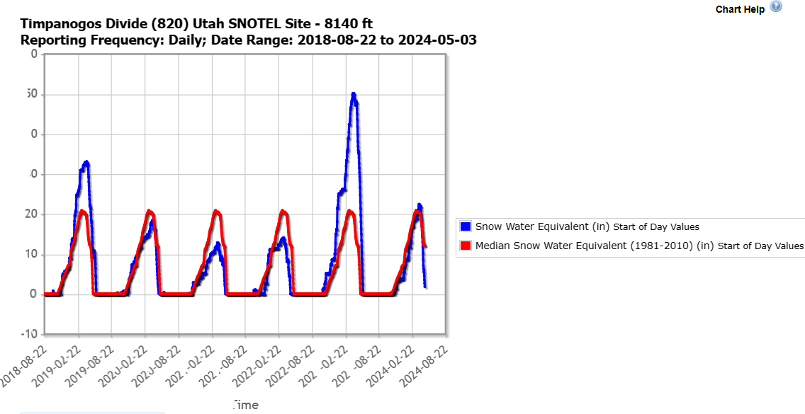

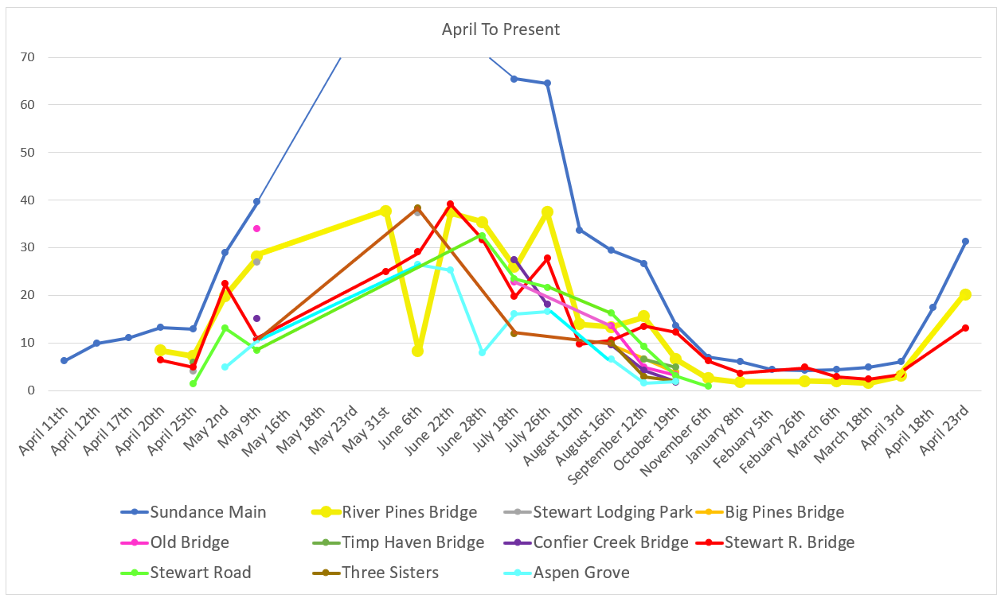
C
F
S

Water Department Information for April
- Our overall water consumption is higher compared to this time last year but lower than 2022.
- Aspen Grove wet-well levels are averaging 7.7 feet for April 2024 which is higher from last month. The springs are starting to pick up and currently Aspen Grove wet well is holding around 8.7 now. This time last year for April 2023, our average was 5.98 feet. The average is higher this year compared to last.
- Stewart Spring is averaging 55 gpm for April 2024, which is similar to last month. This time last year it was averaging 0 gpm for April 2023.
- Stewart spring overflow is running just above 31 gpm for the month of April with is up a 10 gpm from last month. Making the Stewart Spring producing an average of 86gpm for April.
- We installed a meter can and meter for the runoff water coming from stewart tank. The water is flowing around 80 gpm.
- Unaccounted water
  - Upper Pressure Zone
    - This might be from the timing of the reads – counting what we used to fill up the tank but has not been used by the upper pressure zone.
  - Lower Pressure Zone
    - Could be meters, could be a leak. Working on meters first.
  - Stewart Zone
    - Same as the Lower pressure zone. Could be meters or leak. Working hard on replacing meters.
- We have replaced 112 meters so far and have 142 meters left to replace as of May 3, 2024. And 41 meters are on cellular endpoints.
- We have received 48 1-inch meters and 48 ¾ inch meters. With 48 cellular endpoints.
- Infiltration Sampling is complete.
- Working on designs for 3 water projects. Stewart spring horizontal drilling, Infiltration gallery, and Aspen Grove expansion.
- The plan is to go out to bid in the coming weeks
- We are also working with the Forest Service to see if redevelopment of the spring is an option.
- The application for the lead and copper rule is complete and waiting to hear back on the grant.
Wastewater Department Information for April
- We have three labs for April. BOD was out of limits on the 2nd and 18th of April. TSS and FOG were within limits.
- The Plant upgrade is moving forward. We are currently waiting on the state for a construction permit. When we receive the permit, we will be able to go out to bid.
- Working with Sundance to get the drain field radio back up and running. The radio box is installed, and we are receiving signals. We need to check each sensor.
- Waiting on a rebuild cost for the screw press. This is part of the plant upgrade.
- We are now running on one MBR.
- We did a lift station, MBR and EQ cleaning.
- We completed a Wastewater Jar test, waiting for the results and availability of products.

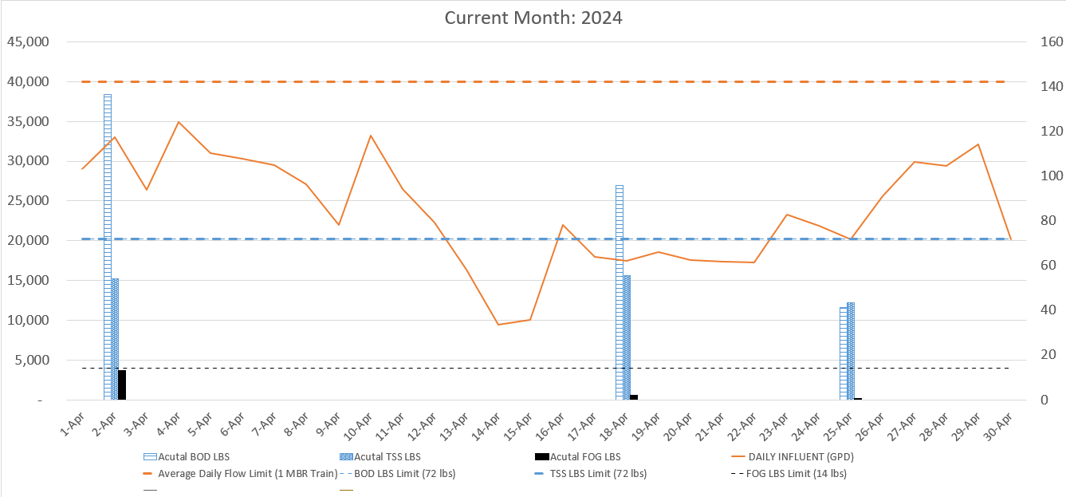

AVERAGE DAILY FLOW (GPD) | 23,726
HIGHEST DAILY FLOW (GPD) | 34,898

