Sex Offense Registry
An overview of the Registry System throughout the United States

Michele Leslie, Psy.D. Director, Sex Oﬀense Management Board (SOMB)
05/01/2024

Overview
- History of the Sex Oﬀense Registry
- Sex Oﬀense Registration in the United States
- Current Sex Oﬀense Registry in Utah
- Proposal for Utah Sex Oﬀense Registry
- Recidivism
  - Next meeting

History of Sex Offense Registration

Brief History of Sex Offense Registration

1947
  - The ﬁrst U.S. sex oﬀender registry was established in California

1996
  - Every state operated some kind of registry
  - Most only visible to law enforcement agencies

1994
  - (up until…) Laws governing sex oﬀense registries existed on a state level
  - (until…) Jacob Wetterling Crimes Against Children and Sexually Violent Oﬀender Registration Act
    - Wetterling Act
      - Minnesota, 1989
    - Requires states to create registries and enforce “more rigorous registration requirements for sex oﬀenders.”
    - The ﬁrst FEDERAL LAW requiring each state to maintain a registry and to standardize registry programs

Brief History of Sex Offense Registration (cont.)
- Wetterling Act (cont.)
  - Requirements:
    - Register for 10 years
    - Verify address(es) to law enforcement annually
    - Sexually Violent Predators (SVPs)
      - Register for life
      - Verify address(es) every 90 days
    - No mandate for notiﬁcation of registrants
- 1996
  - Megan’s Law
    - New Jersey, 1994
    - Required states to notify the public about registrants
    - “Morphed” into public registry websites
      - Registries are a “type” of notiﬁcation
- 2006
  - Adam Walsh Child Protection and Safety Act (AWA)
    - Florida, 1981
    - Includes Sex Oﬀender Registration And Notiﬁcation Act (SORN/SORNA)
    - “Set federal minimum standards for jurisdictions’ sex oﬀender registries”
      - i.e. WHO must register and for HOW LONG

SORN/SORNA - a little side track adventure from the timeline

SORNA requirements:
  - Registration stems from the crime of conviction
    - Can be met by implementing oﬀense-based tier systems

SORNA sets minimum requirements
  - States may choose to impose more restrictive limitations

CAN exempt juveniles and “certain Tier I individuals” from public registry websites
  - **may be out of compliance with SORNA**
    - Of additional note - utilizing risk assessment in decision making may also result in SORNA noncompliance



SOR A's Goals

SORNA has several goals, which aire:²²
- Extending Nthe jurisdictions in which regiistrat1ion is required beyo,nd the 50 states, the District of
Collumbia, and the principal U-5. territories, to include also federally recognized [American] Indian tribes."
- Incorporating Na more comprehensive group of sex: offenders and sex offenses for wl7ich registration is required.''
- Requiring RSOs "to re,gister aind keep their registration c:urr,ent in each jurisdiction in whicih they reside, work, or go, to school."
- Requiring sex offenders to provide more extensive registration information."
- Requiiring "sex offendlers to make periodic in-person appearanc,e:sto v,erify and update their registration
informa:tion."
- Expanding "the amount of information availabl;e to the public regarding registered sex offenders.N
- Ma ing "d10nges in the required minimum dJJratio.n of re.gistration for sex off.enders."


SORNA's Offense-Bas d Tiers Defin d

Tier I offernses involve:
  - Sex offenses, including sexual acts or sexual contact with another, that am not Tier II or li,er Ill offenses (e.g., possession or recerpt of child se)(ml abuse material [child pornography]).

Tier II offenses involve:
  - Use of minors in prostitution (including solicitations).
  - Entking a minor to engage in criminal sexual activity.
  - Non-forcible sexual acts with a minor 13 to 15 years old_
  - Sexual1 contact with a minor 13 or older.
  - Use of a minor in a sexual performance.
  - Productim1or distribution of chi.Id sexual abuse material (child pornography)_
  - Any sex offense that is not a first sex offense and that rs punishable by more than one year in jail.

Tfer ill off.ense5 involve:
  - Nonparental kidnapping of a minor_
  - S xual acts wrth another by force or threat_
  - Non-forcible sexual acts with a minor under 13.
  - Sexuat contact with a minor under 13.
  - Any se:-: offense punishabl'e by more than one year in jail where the offender has at least one prior Tier ll off,eMe,26

SORN/SORNA - a little side track adventure from the timeline (cont.)

Registration requirements
  - Duration
    - How long an individual is required to register for
      - Including reduction/termination
  - Frequency
    - How often an individual must update/verify their information
  - Public Notiﬁcation
    - Including the registry
- There are other requirements identiﬁed by SORNA in regards to registration, however these are the most inﬂuential in regards to the use of risk assessment measures

Back on Track - Brief History of Sex Offense Registration (cont.)

Present Day
  - All ﬁfty states and the District of Columbia have public sex oﬀense registries
  - Some states have additional forms of notiﬁcation

Registration and Notiﬁcation in the United States

Report Source

Sex Oﬀender Sentencing, Monitoring, Apprehending, Registering, and Tracking
  - SMART Oﬃce
  - Under the U.S. Department of Justice’s Oﬃce of Justice Programs
  - The “support system” of registration and notiﬁcation in states
    - Also does the tracking of developments within this population and administers grant programs to support progression with this population

2018
  - SMART contracted with the Federal Research Division (FRD)
    - Examining registration and notiﬁcation practices within the United States in relation to risk assessment
    - Research up until August 2021

Research Overview

Two Phase Approach
  - Phase 1
    - “Broad but shallow” review of every state (and District of Columbia) and their registration/notiﬁcation practices
      - 51 state jurisdictions
  - Phase 2
    - Of those identiﬁed as using risk assessment measures in some capacity, a more in-depth review of the practices were completed
    - Including 5 case studies
- Examined law “as it would apply to a standard [registrant] who is convicted of an in-state oﬀense as an adult, who lives at a ﬁxed address, and who has not been convicted of failure to register.”

Phase 1 Findings

15 (out of 51)
  - “Risk assessments are consistently considered when determining oﬀenders’ registration and/or notiﬁcation requirements
    - Arizona; Arkansas; California*; Georgia; Massachusetts; Minnesota; Montana; New Jersey; New York; North Dakota; Oregon; Rhode Island; Texas; Vermont; Washington
      - Main focus

2 (out of 51)
  - Risk assessments aﬀect registration and notiﬁcation for a “smaller group of select oﬀenders”
    - Iowa; New Hampshire
- A total of 17 states utilize risk assessment in SOME FORM for registration and/or notiﬁcation
- 22 states determine registration requirements using oﬀense-based tiers which “meet or exceed SORNA’s minimum requirements.”

Phase 2 Findings
- Completed a deep-dive on 5 of the 15 states
- Completed short proﬁles on on 10 of the 15 states
- Completed brief policy descriptions of the 2 “additional” states

Risk Assessment Methodologies and Instruments

14 of the 15 states
  - Utilize at least one risk assessment instrument

1 state uses “structured professional judgment risk assessment”
  - Massachusetts

Who completes to assessment?
- States’ Department of Corrections
- Local prosecutors
- Management boards
  - 5 states
    - Single agency responsible for scoring AND classifying oﬀenders
    - Arkansas; Georgia; New Jersey; Oregon; Rhode Island
  - 10 states
    - Scoring and classiﬁcation of individuals is handled separately
    - Arizona; California; Massachusetts; Minnesota; Montana; New York; North Dakota; Texas; Vermont; Washington

Sex Offense Risk Assessment

“Risk Assessment”
  - Wide range
  - Used to “assess recidivism of convicted oﬀenders”
    - Not speciﬁc to sexual oﬀenders

“Sex Oﬀense - Speciﬁc Risk Assessment”
  - Speciﬁc tools designed to assess recidivism of sexual oﬀenders
  - Can include:
    - Variety of approaches
      - May or may utilize actuarial risk assessment tools
        - “Guiding document composed of empirically or theoretically based risk and/or protective factors used to aid an evaluator in the assessment of recidivism risk.”
        - **will be proposing the use of risk assessment tools**
    - Conducted at diﬀerent times throughout involvement in the criminal justice system
    - Using to inform decision making
      - Treatment decisions, sentencing, registration, supervision, etc.

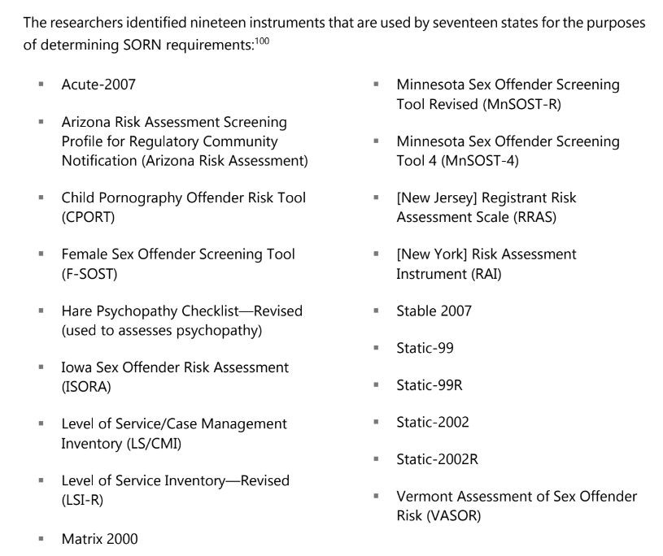

Static-99R The most used risk
assessment instrument for determining state-level SORN
requirements in the U.S.
(7 states)
California; Georgia; Iowa; North Dakota; Oregon; Rhode Island; Washington

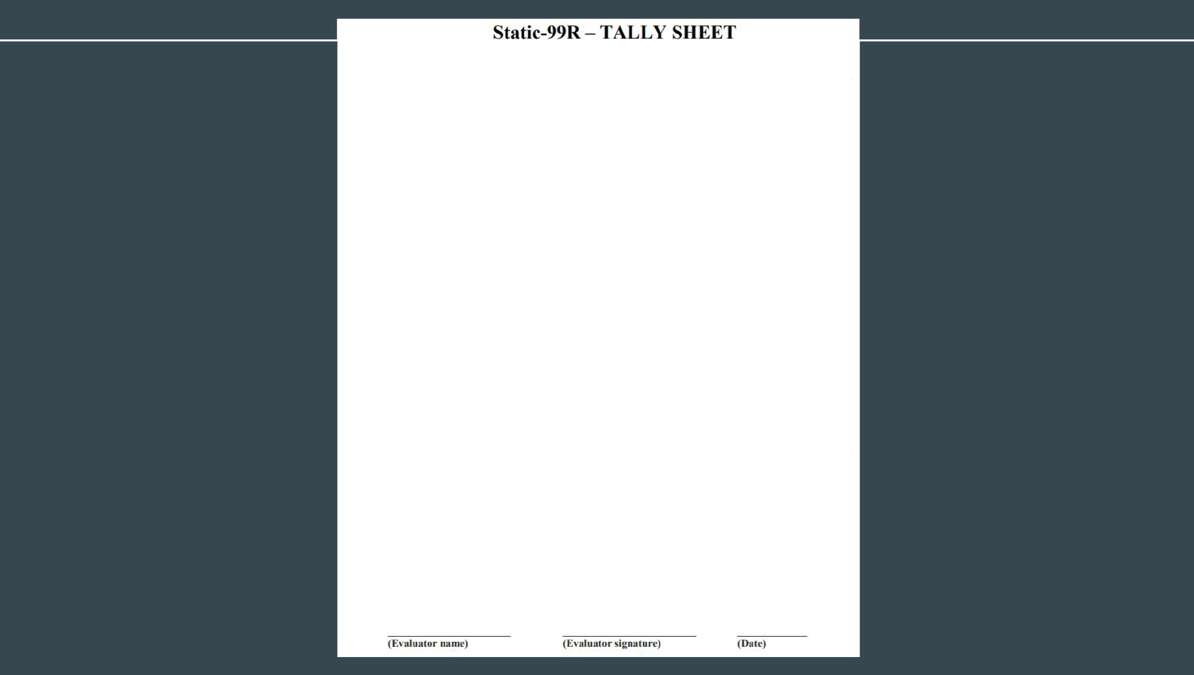
Assessment date: Date of release from index sex offence:

Item# | Risk £,'actor | Codes |  | Score
I | Age al release from index sex offence | Aged 18 to 34.9  Aged 35 to 39.9  Aged 40 to 59.9 Aged 60 or older |  | I  0  -1  -3
2 | Ever lived with a lover | Ever lived with lover for at leas! two years?  Yes  No |  | 0  I
3 | Index non-sexual violence - Any convictions | No  Yes |  | 0  I
4 | Prior non sexual violeoce - Any convictions | No  Yes |  | 0  I
5 | Prior sex offences | 0  1,2  3-5  6+ | Convicrions  0  I 2,3  4+ | 0  I  2  3
G | Four or more prior sentencing dates (excluding index) | - or less:  - or more |  | 0  I
7 | Any convictions for non-contact sex offences | No  Yes |  | 0  I
8 | Any W1related victims | No  Yes |  | 0  I
9 | Any stranger victims | No  Yes |  | 0  I
10 | Any male victims | No  Yes |  | 0  I
 | Total Score | Add up scores from individuill risk factors

Nominal Risk Levels (2016 version) | Total | Ri,k Level
Nominal Risk Levels (2016 version) | -3, -2, | 1 - Very Low Risk
Nominal Risk Levels (2016 version) | -1, 0, | II - Below Avcra!!c Ri,k
Nominal Risk Levels (2016 version) | I, 2,3 | Ill - A,,crage Risk
Nominal Risk Levels (2016 version) | 4, 5 | !Va -Above Average Risk
Nominal Risk Levels (2016 version) | 6 and hh!her | IVb -Well AboveAvcra!!e Risk

There/ was1 w(lS not/ sufftc.ieul i11for111(1/ion mrai/(lb/e to complete the Stutic-99H score followh,g t/Je emling mrimuil (2016 version). I believe that t/Jis .reore / fairly represents, dues not fairly represent/ t/Je risk presented bJ1 .Ur. .,.\'...\X,\1,-,, this time. Comments/Explrmatio11.-

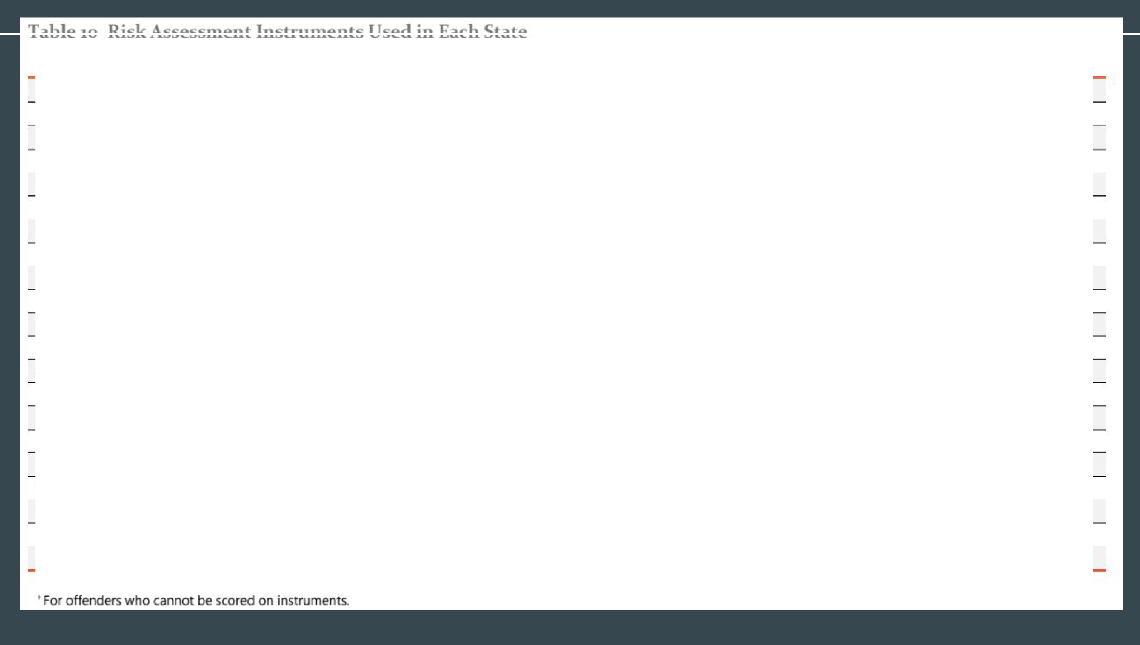
.
Risk As.sessment l1utrument Used | AZ | AR | CA | GA | IA | MA | MN | MT | NH | NJ | NV ND |  | OR RI |  | TX | VT WA
Acute-2007 |  |  | X
Arizona Risk Assessment X
CPORT |  |  |  | X
F-SOST |  |  |  |  |  |  | X
Hare Psychopathy Checklist |  |  |  |  |  |  |  |  |  |  |  |  |  |  | X
!SORA |  |  |  |  | X
LS/CMI |  |  | X |  |  |  | X |  |  |  |  |  | X
LSI-R |  |  |  |  |  |  | X |  |  |  |  |  |  |  | X
Matrix 2000  MnSOST·R |  |  |  |  |  |  |  |  |  |  |  | X |  |  | X
MnSOST-4 |  |  |  |  |  |  | X
RRAS |  |  |  |  |  |  |  |  |  | X
RAJ |  |  |  |  |  |  |  |  |  |  | X
Stable 2007 |  |  | X |  | X |  |  |  |  |  |  |  |  | X
Statiic-99 | X
Static-99R |  |  | X | X | X |  |  |  |  |  |  | X | X | X |  | X
Static-2002 |  |  |  |  |  |  |  |  |  |  |  |  |  |  | X
Static-;wo2R |  |  |  | X |  |  |  |  |  |  |  |  |  | X
VASOR | X
Structured Clinical Judgment |  |  |  |  |  | X' |  |  |  |  |  |  |  | x+
Unknown |  |  |  |  |  |  |  | X | X |  |  |  |  |  |  | X
For all offenders.

•

Risk - Level Tiers

Most states use a three-level or four-level tier classiﬁcation system for registration
  - Lowest level = lowest risk
  - Highest level = highest risk

An oﬀender’s risk level impacts requirements in diﬀerent ways, depending on what state:
  - Aﬀect registration requirements
  - Aﬀect notiﬁcation requirements
  - Aﬀect BOTH registration and notiﬁcation requirements

Classifying agencies in some states:
  - Can “override” the classiﬁcation determined by the risk assessment
  - Can utilize multiple factors in determining registration/notiﬁcation
    - Not just the risk assessment

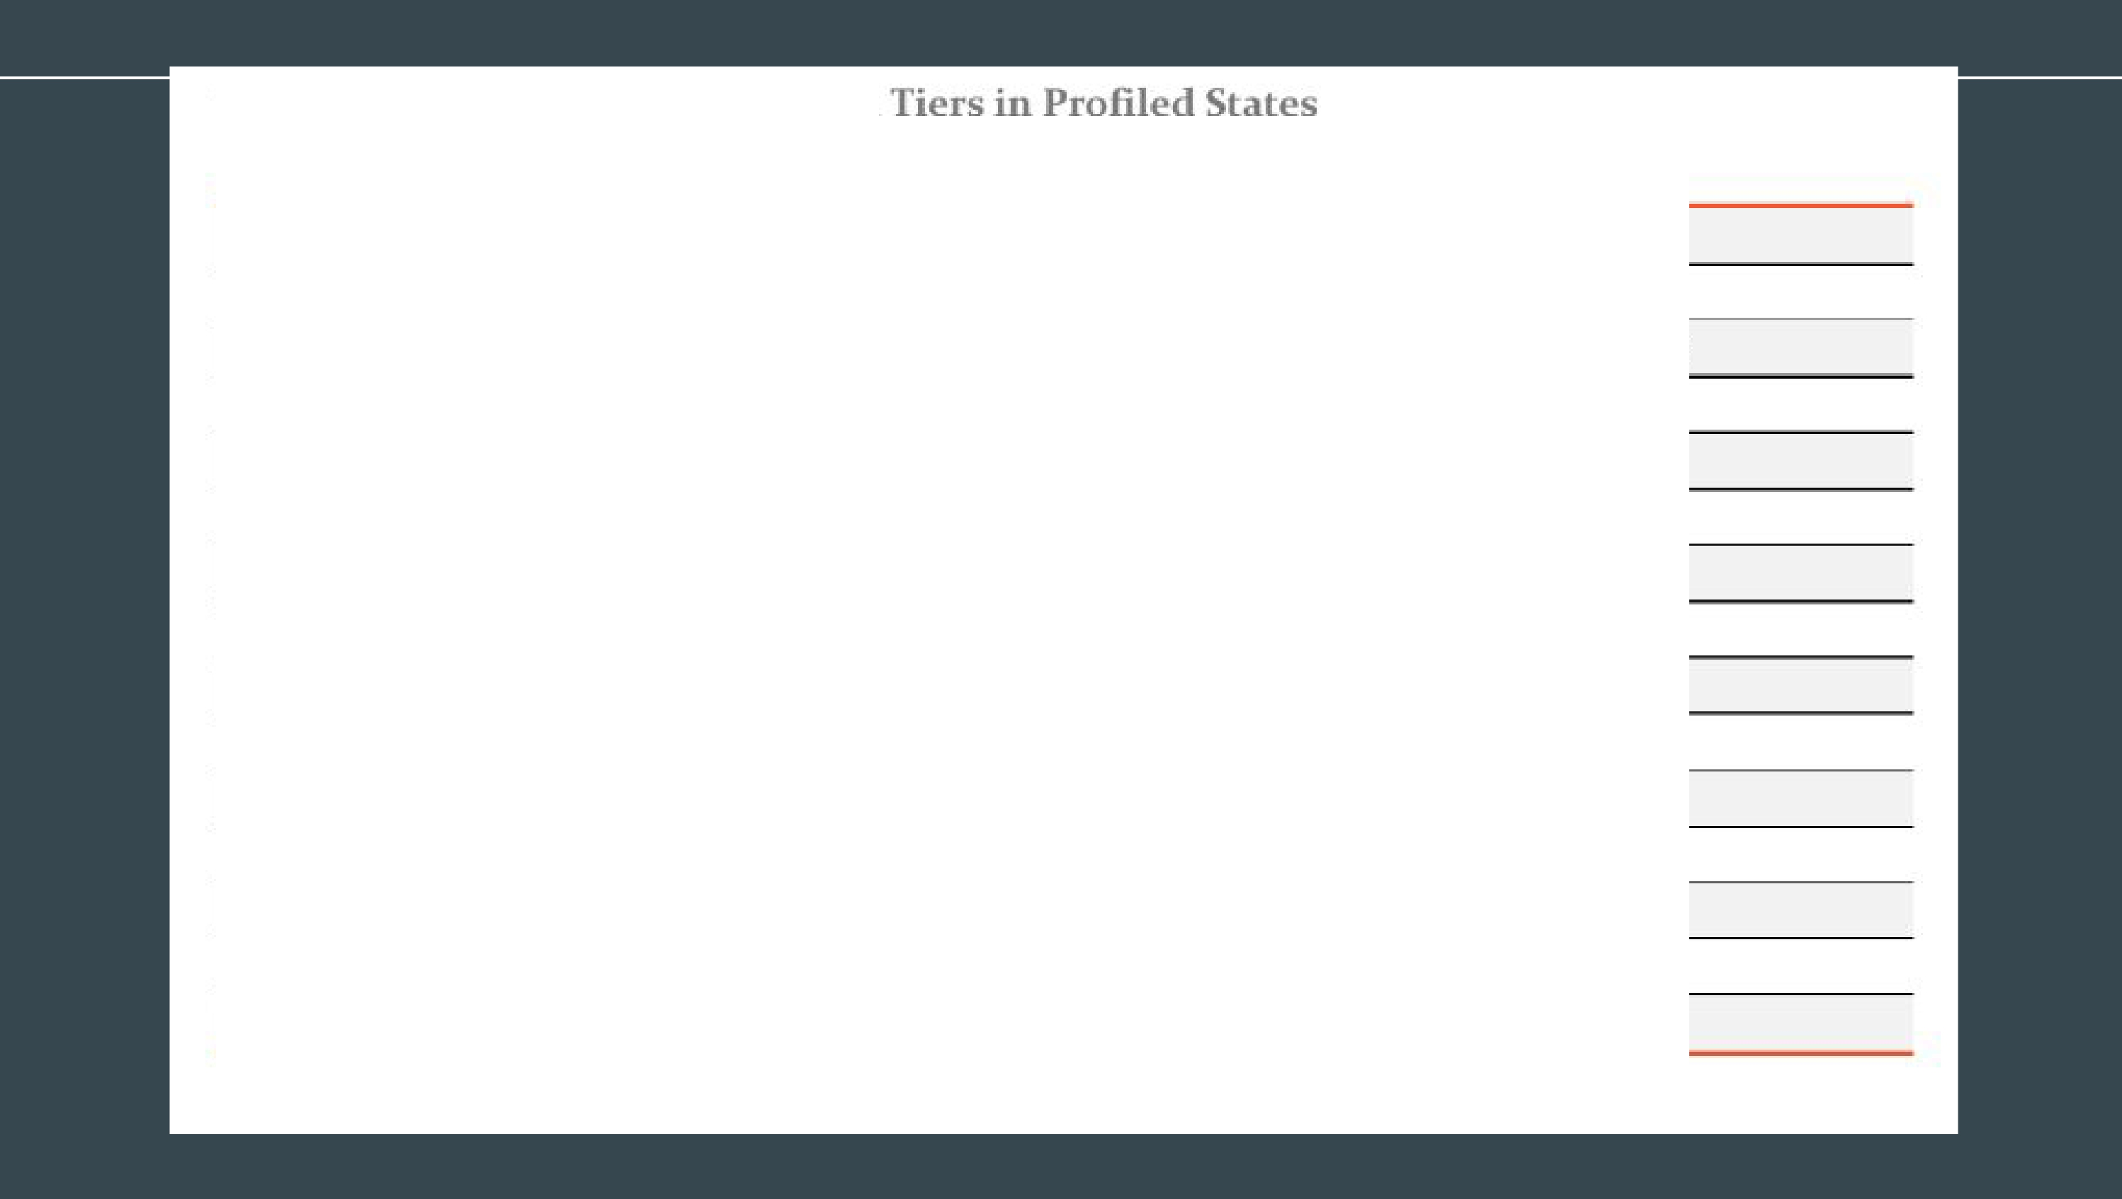
Table 3. Ri.skAs essment-Informed
State Risk. Assessment-Informed Tiers
Ari:z:ona level 1, Level 2, Level 3
An'kains.:;is Levell 1, Leve'I 2, Level 3, Level 4 (Sexually Dangerous Persons)
California Tier One, T1er Two, Tier Three-Risk Assessment Lever, Tier Three Georgia Level 1, Level 2, Sexually Dangerous Predator Massachusetts Level 1, LeveI 2, Level 3
Minnesota level 1, Level 2, Level3
Montana level 1, Level 2, Level 3
New Jersey level 1, LeveI2, Level3
New Ymk level 1, Level 2, Level 3
North Dakota Low Risk, Moderate !Risk, High Risk Oreg1on Level L Level 11, Level Ill
Rhode Is.Iand Level I, Level D, Level DI
Texas Levell One, Level Two, Level Three
Vermont Htgh Risk, {all other offenders)
Wa5hington Level I. Level D, level In
- Only offenders in Ti,er Three-Risk Assessment Level are·placed into this tier based on risk assessment.

Table 4. Risk Assessment Instrument Scoring Agencies in Profiled States
State Agency Re5ponsible for Scoring Risk A5sessment Instruments
Arizona Department of Corrections, Rehabilitation & Reentry
DOC Sex Offender Community Notific.ition Assessment Progr;,m Department of Corre;:tions ,rnd Rehabi11itation
AND

California
Probati.o.n Otticers
AND
Treatment Providers

Georgi;, Dep.irtment of Beh.ivioral Health and Developmental Disabilirties, Sexual Offender Registration Review Board
Massachusetts N/A
Minne.sota DOC Risk A.ssessment/Community Notification Unit Monta,n;, Department of Corrections
New Jersey Local Prosecutors (no centr.il agency)
New York Board of Examiners of Sex Offenders North Dakota Department of Corre;:tions an.d Rehabillitation
Oregon Board of Parole and Post-Prison Supervision Rhode Island Sex Offender Board of Review
Department of Criminal Justice

TeKaS
AND
Deregistration Specialists Licensed by He.ilth ;,,nd Human Services Commission's Council on,Sex Offender Treatment

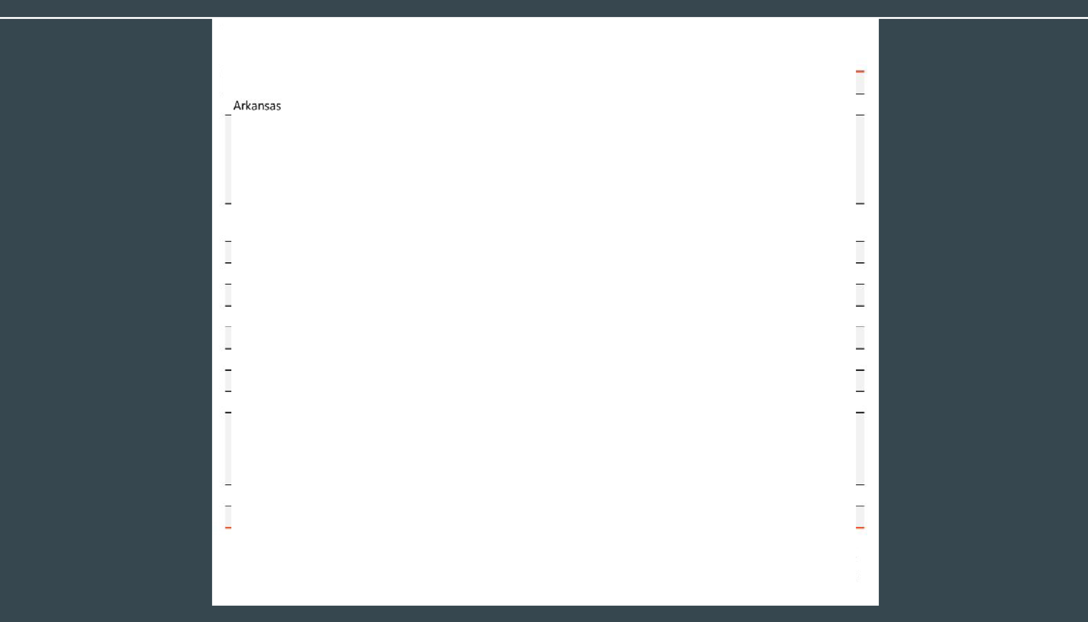
Vermont DOC
W;,shington DOC L;,w Enforc,ement Notification Program'
'Within the state of Washington, while the End of Sentence Review Committee makes the risk.-level recommendation, the risk assessment instrument is scored by a specialist in the Law Enforcement No.tification Program (End o,f Sentence Review Committee and Law Enforcement Notification Program), 2078 Annu:JI Report, Marth 2019, 9, https://www_doc.wa.gov/doc s/publications/reports/300-SROOl .pdf.

Table 5. Risk-LeveJ Tier-Classifying Agencies in Profiled States
State Agency Responsible for Assigning Offenders to a Ti,er/Leve Cla&-'Sificati•o•n
Arizona Local Law Enforcement (no •central agency)
Arkainsas Sarne as Scoring Agency
California, State Depart,ment of Justice
I Georgia Sarne as Scoring Agency
Massachus,eUs. Sex Offender Regis.try Board Minnesota DOC End of Confinement Review Committees Montana, Court
INew Jersey Sarne as Scm'\ing Agency
New VOrk Court
North Dakota Office of the .Attorney GeneraI
!Orggon Sarne as Srnriing Agency

I RhodieIsland

Texas
Sarne as Soor ng.Agency
State Department of Criminal Justice
OR
Court


Vermont DOC Sex Offender Review Committee
Washington Local Law Enforoement (with input from DOC End of Sentence Review Committee)

Table 9. Determining Factors or Duration of Registration and F qu ncy of Reporting in Profiled Sta es

State
D1ete,rmining Factors for
Duration of 1Registnti,o,n1 Determining Factors for F11eq11Jency of Reporting

Arizona Type of Offense, Relief from Registradon,
SVP' Designation
Type of Offense, Number of Offenses,

Single Frequency for All Non-lransient Offenders

Arkansas

,California

iGeorgia

M ass.achusett:s
SVP Designation, Compliance, Relief from Registratlon, Risk Assessment
Type of Offense, Number of Offenses, SVP Designation, Relief firom Registrati,on, Risk Assessment
Singh?Duration for All Offenders (option for some to petition for relief based o,nnisl< assessment)
Type of Offense, Number of Offenses, SVP Designation, Relief from Registra/il:ion, Sex ,Offender Registiry Board Determination
Singile Frequency for AIll Non-SVIP Offenders

Sin91le Frequency for All Non-SVP Offenders

Riisk Assessment

Siinglle Frequency for AIII Non-SVP 0ffende:rs.


Min11e·sota Type of Offense, Number of Offenses,
SVP Designation
Risk Assessment, $VP Designation

State
Determining Factors for
Duration of Registration Determining Factors for Frequency of Reporting

Montana
Single Duration for All Offenders (option for some to petition for relief based on risk assessment)

Risk Assessment

New Jlersey Single Duration for All Offenders (option for some to petition for relief)
Type of Offense, Number of Offenses,
Type of Offense (not SORNA-compliant)

New York
SVP Designation. Relief from Registration.
Risk Assessment
Risk Assessment, SVP Designation

North Dakota Type of Offense, Number of Offenses,
SVP Designation, Risk Assessment, Victim
Single Duration for All Offenders
Type of Offense, Number of Offenses, SVP Designation, Risk Assessment, Victim

Oregon

Rhode Island
(option for some to petition for relief based on risk assessment)
Number of Offenses, SVP Design.ition, Riisk Assessment, Victim, Use of Violence/Force
Single Frequency for All Non-SVP Offenders

Number of Offenses. SVP Designation, Risk Assessment Victim, Use of Violence/Force

Texas Type of Offense, Number of Offenses, Relief from Regist,ation, Risk Assessment
Type •Of Offense, Number of Offenses,
Number of Offenses

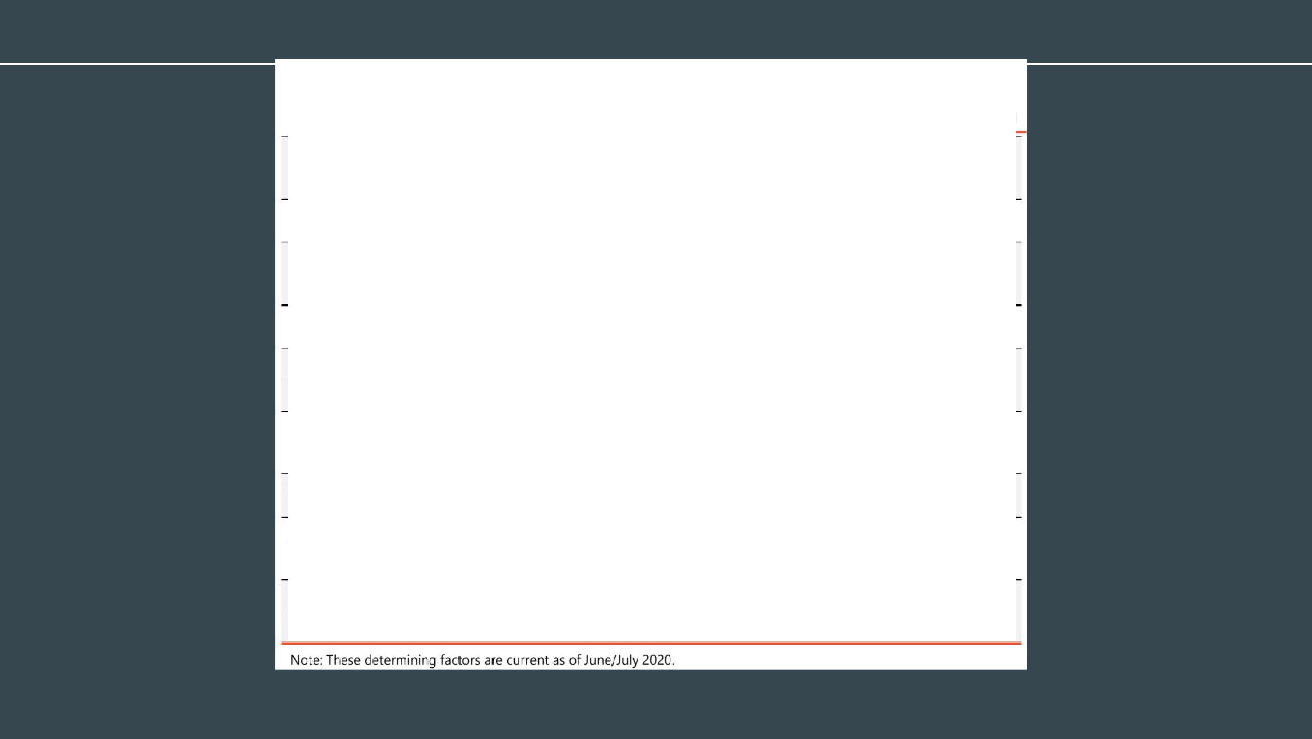
Vermont

Washington
SVP Designation, Compliance, Risk Assessment
Type of Offense. Number of Offenses. SVP Designation, Relief from Registration, Risk Assessment
Risk Assessment, SVP Designation, Compliance

Risk Assessment, SVP Designation

How Risk Assessment Affects Relief from Registration

SOME (not all) states allow for petition of removal from the registry
- Risk assessment may be critical for removal:
  - Only individuals in lower tiers may ﬁle a petition for removal, based upon reduction in risk score

8 states
  - Risk assessment plays a role in petitions
    - Arkansas; California; Georgia; Montana; New York; Oregon; Texas; Washington

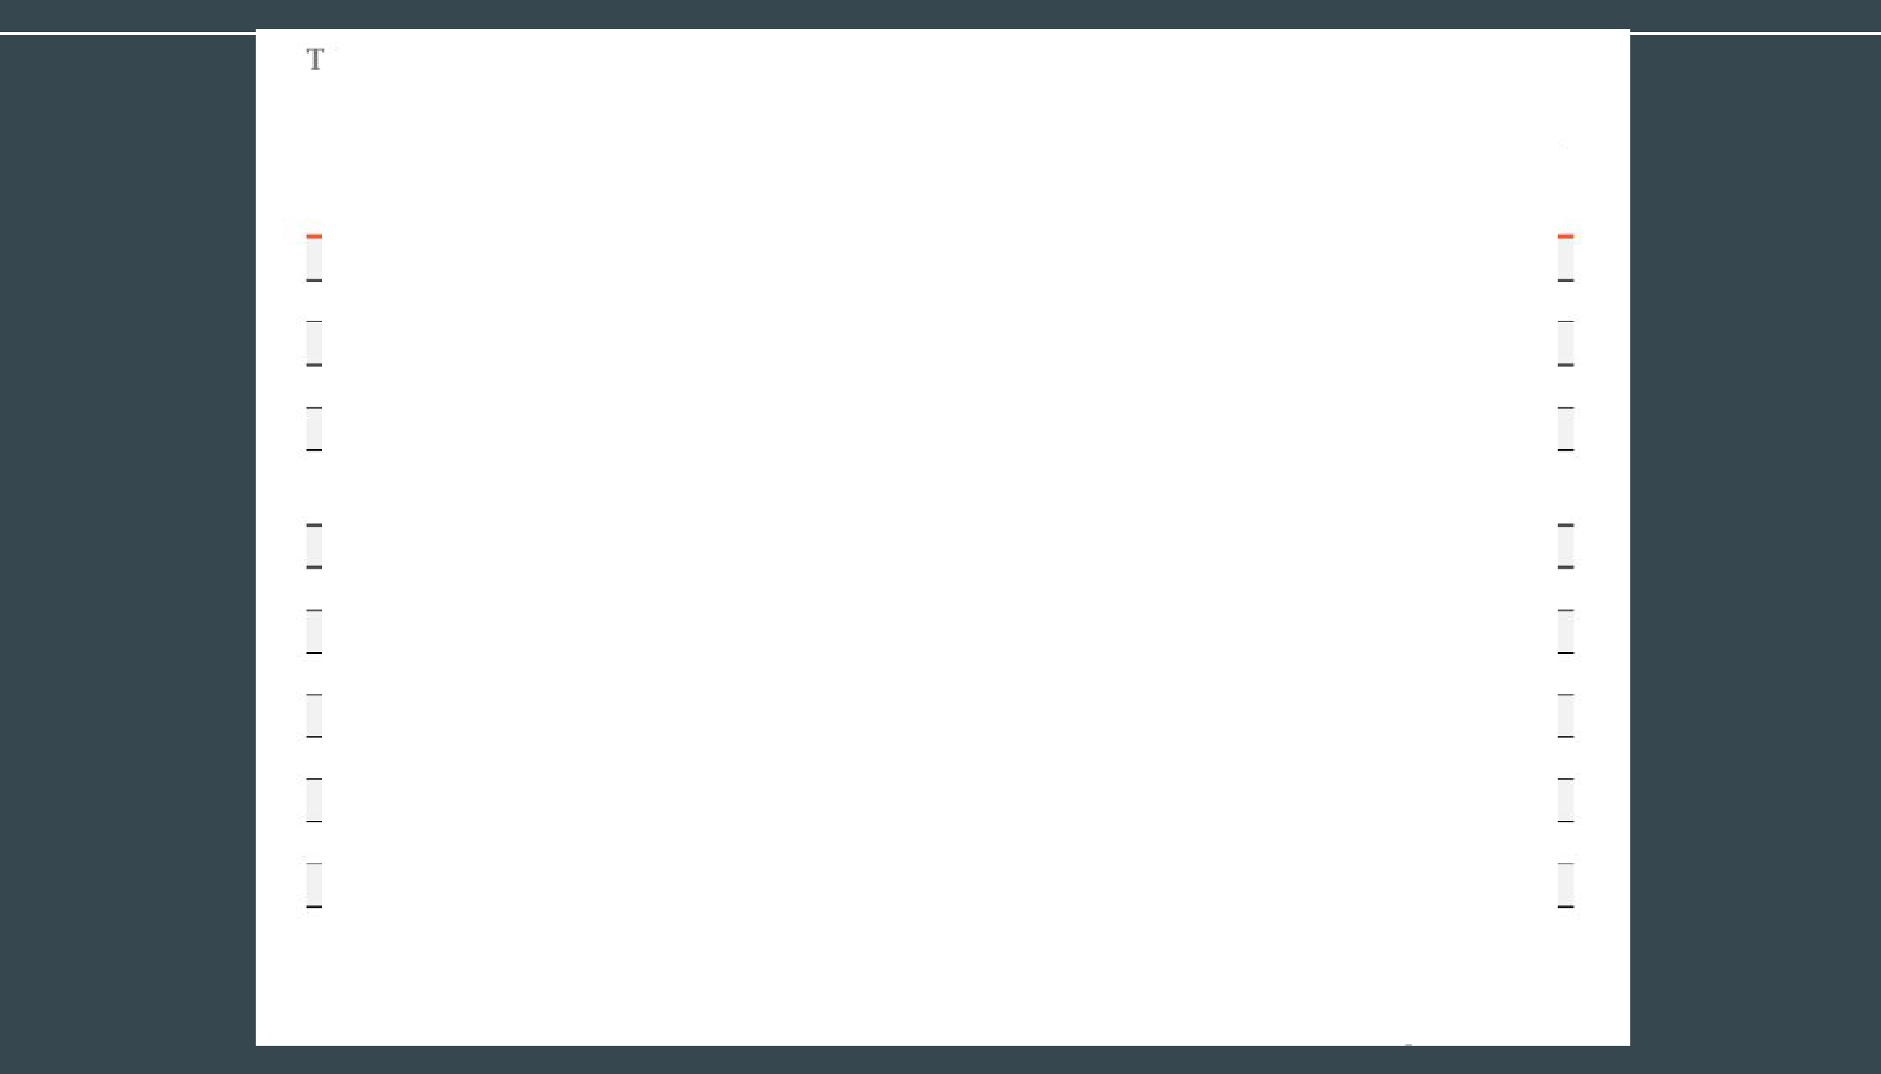
able 8. Summary of Research Findings

State | Has State Substantially Implemented  SORINA? | Does State Use Tiers That Meet SORNA's Min.  Requirements? | Does State Use Risk  Assessments? | .Are Risk Assessments Used for Registration or Notification Purposes  (for Adults)?
Alaib.ima | y | y | y | Neither
Alaska | N | N | Unclear | N/A
Arizona | N | N | '{ | NoHfication
Arkansas | N | N | y | Both
California | N | N | y | Both
Col!orado | y | y | '{ | NotfficatJon (only for SVPs)
Connecticut | N | N | Unclear | N/A
Delaware | y | y | y | Neither
District of Columbia | N | N | Unclear | N/A
Florida, | y | y | y | Neither
Georgia | N | N | y | P-egistration
Hawaii | N | y | Unclear | N/A
Idaho | N | N | y | Unclear
Illinois | N | N | y | Neither
Indiana | N | N | Unclear | N/A
 |  |  |  | Registration-Duration
Iowa N y y (only for offenders petitioning for relief
from registration)


Table 8. Summary of Research Findings

State | Has: State Substantially Implemented  SORJNA? |  | Does State Use Tiers That Meet SORNA's Min.  Requirements? | Does State Use ;Risk  Assessments? |  | Are Risk .Assessrne.nts Used fo.r Registration or Notmcation Purposes  (for Adults)?
Kansas | y |  | y | Um:lea1r |  | N/A
Kentucky | N |  | N | y |  | Neither
louis:iana | y |  | y | Undeall' |  | N/A
Mame | N |  | N | y |  | Neither
Maryland y |  |  | y | y | Nerther
Massach usett:s N |  |  | N | y | Both
Michigan |  | y | y | Unclear |  | N/A
Mi1nnesota |  | N | N | y |  | Both
Mississippi |  | y | y | Unclear |  | N/A
Missouri |  | y | y | Unclear |  | N/A
Montana |  | N | N | y |  | Both
Nebraska |  | N | y | y |  | Nefther
Nevada |  | y | y | Undeall' |  | N/A

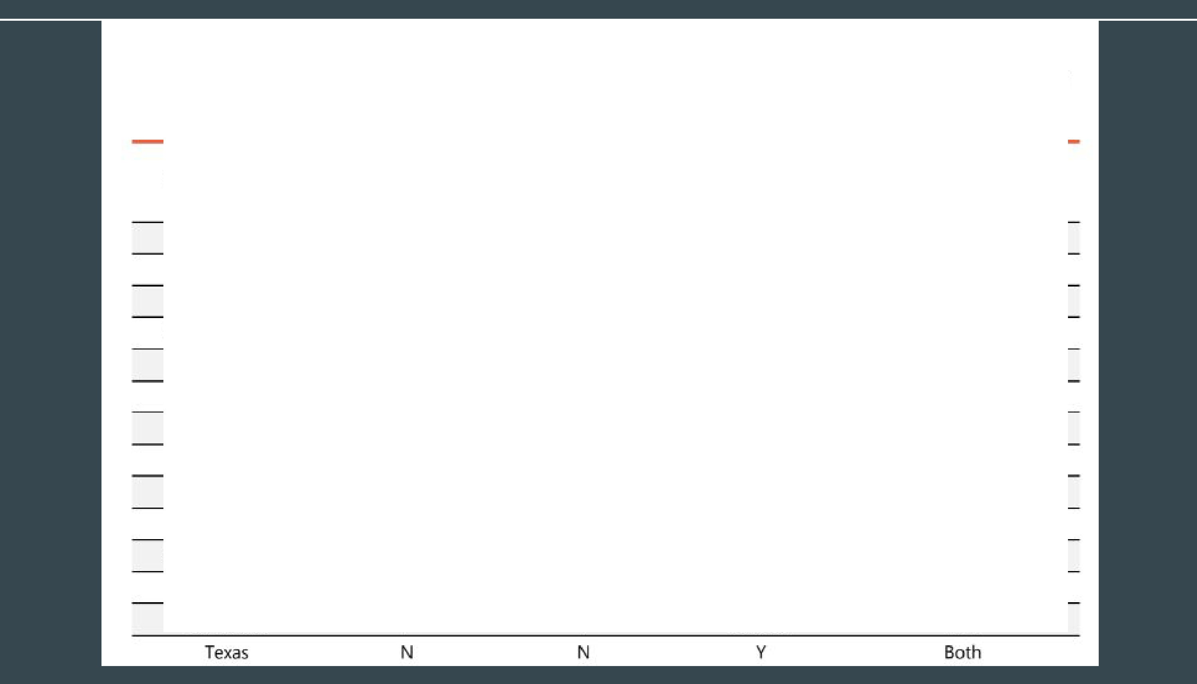
Has Sta1te Does State Use Are Risk Assessments Substantially Tien That Meet DoesSta\e Used for Registration or Implemented SORNA's IMin. Use Risk Notification Purposes
State SORJNA? Require111ents? Assessments? (lo II" Adults.)?
Notification (only for N1ew Hampshire N y y o,ffertders petitioning to,
modify requirements)
New Jersey N N y Notification
New Mexico N N Unclear N/A
New York N N y Both
North Cuoljna N N y Neither
North Dakota N N y Both
Olhfo y y Unclear N/A
Oklahoma y y y Unclear
Oregon N N y Both
Pennsylvania N N y Nefther
Rhode Island N N y Both
Souit:h Carolina V y Undear N/A
South Dakota y y Unclear N/A
Teru,essee y y Unclear N/A

Table 8. Summary of Research Findings

Slate
Has State Substantially Implemented SORJNA?
Does State Use Tiers That Meet SORNA's Min.
Requirements?

Does Stat,e Use ;Ris.k Assessments?
Are Risk Assessm.enb Used fo.r Registration or Notification Purposes (for Adults)?
Unclear
(possible registratiori­

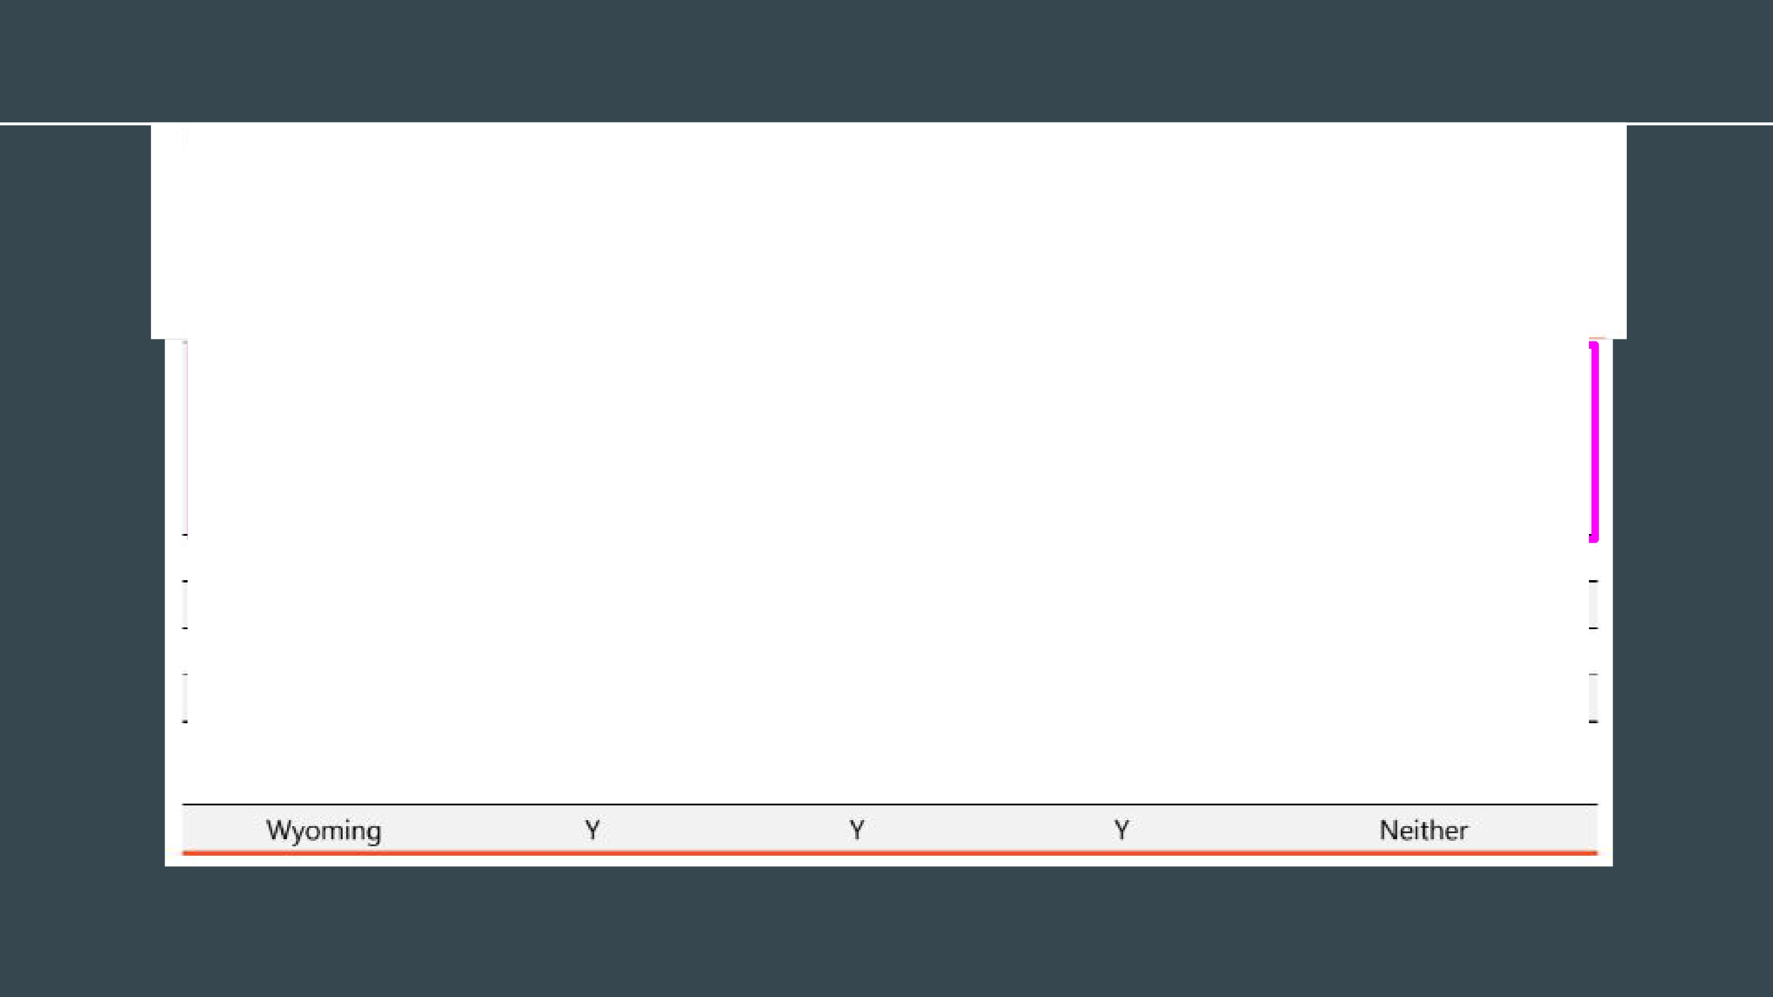
Utah N Unclear

Vermont N rN y
Virginia y y y
Washington N rN y
West Virginia N rN Unde,;:1r

Wisconsin N rN Unclear
duration: only for offenders petitioning for relief -from reg.istration}
Both Ne,rther Both N/A
Unclear
(possible notllficatiofl)

Utah:
Sex, Kidnap, and Child Abuse Offender Registry

Current Utah Model

Severity (approx.) | Offenses  (See full list in Appendix) | Required Duration | Petition | Residence Restrictions | Other Restrictions | Updates* | Public
1st & 2nd degree felonies | -Any re-offense of a registerable crime  -Human trafficking of adult or child for sexual exploitation  -Felony enticing of a minor  -Aggravated kidnapping (nonparental)  -Forcible sodomy  -Sex abuse of a child  -Sexual exploitation of a minor (aggr. and non-aggr.)  -Aggravated sexual extortion  -Aggravated exploitation of prostitution  -Attempting, soliciting, conspiring to:  Rape, object rape, sodomy of child, aggravated sexual abuse or assault | Life | 20 years in community | 1000 ft from victim  (Exceptions apply) | For offenses against a minor (<18):  -Daycares or preschools  -Public or HOA/apartment complex swimming pools  -Public or private primary or secondary schools  -Public or HOA/apartment complex playgrounds  -No coaching of minors | 6 months  $100/yr  (additional  $25 in some jurisdictions) | Yes  (exceptions apply)
3rd degree felonies | -Attempting, soliciting, or conspiring to any life offense above (except where in bold above)  -Other offenses not noted in above or below categories | 10 Years  (12-13 years in community) | 10 years in community
Class A misdemea nors | -Enticing a minor (Class A misdemeanor)  -Kidnapping  -Unlawful detention  -Sex act with a minor if <10 years older than victim  -Sex act abuse of a minor if <10 years older than victim  -Sex conduct with 16-17 year old if <15 years older than victim  -Voyeurism (Class A misdemeanor) | 10 Years  (11-12 years in community) | 5 years after termination of sentence  (6-7 years in community) |  | For offenses against a child (<14):  -”Presence of a Child” restrictions  (Exceptions apply)
This may look organized, but the Utah Law Code doesn’t read nearly this easy or effectively. UT Sex Offense Registry - Opportuni3t3ies
Matthew Pierce

Additional Information

The Department of Public Safety
  - Oversees the registry
    - As of July 1, 2024

Main Assessments used with individuals convicted of a sexual oﬀense
  - UDC
    - Static-99R and Stable 2007
  - AP&P
    - Vasor-2 and SOTIPS
  - CPORT
    - CSEM Oﬀenders

California

Assessment and Tiers

Passed in 2017, implemented in 2021
  - Movement from lifetime registration for all oﬀenders to a three tiered* system

3 Tiers
  - Tier 3 risk assessment/ Tier 3 Lifetime
    - Intended for repeat oﬀenders and/or SVP
      - The tier captures more than the intent
      - Must register for life
    - Turned into half of the above oﬀenders and half “risk assessment level”
      - 6 or higher on the Static-99R
      - Can petition for removal after 20 years
  - Tier 2
    - “Lower level risk” than tier 3
    - Can petition for removal after 10 years
  - Tier 1
    - “Lowest level risk”
    - Can petition for removal after 5 years

Utilization of risk assessment measures
  - Used to assist in determination of tiers
  - Aside from the “risk assessment level,” measures are used in conjunction with other factors
    - i.e. conviction

Use of Static-99R

California Department of Corrections and Rehabilitation (CDCR)
  - Scores each individual on the Static-99R prior to release from incarceration

Static-99R
  - ONLY assessment used related to registry
    - Other assessments used to determine treatment, etc.
  - First scored prior to sentencing
  - If the individual goes into custody
    - Within 4-10 months of (release from) custody
      - Same with hospitalization

Unable to use Static-99R
  - Females
    - Crime of conviction
  - CSEM oﬀenders
    - Automatically Tier 2

Time oﬀense-free in the community
  - Important in California
  - Related to the three tiers

Additional Information

Does not follow SORNA
  - After the Adam Walsh Act, California reviewed the requirements (2006/2007), and decided not to align with the requirements
  - Important to note:
    - the state of California is required to fund the registry/management

Presently
  - Attempting to update the tiered system to be more in line with risk assessment
    - Ex: CSEM oﬀenders

Risk Assessment Agencies
  - California Sex Oﬀense Management Board (CASOMB)
    - Addresses California’s policies and practices related to the assessment, treatment, and management of sexual oﬀenders
  - State Authorized Risk Assessment Tools for Sex Oﬀenders (SARATSO) Review Committee
    - Speciﬁc focus on risk assessment instruments used within the state of California
  - California Department of Justice Sex Oﬀender Registry (CSOR)
    - Responsible for classifying individuals onto tiers

Colorado

Why talk about Colorado?

Have a good relationship with them
- Good comparison
  - Have an “alternative use” for risk assessments
  - Need to think about all aspects when deciding what is best for Utah

Have a tiered system
  - SORNA compliant
  - Use of conviction for tier placement

Where does risk assessment come in?
  - Aggravator for registry and notiﬁcation requirements
    - Sexual Violent Predator (SVP) requirement from Megan’s Law

Developed a risk assessment instrument speciﬁc to Colorado oﬀenders
  - Use to determine SVP
  - Aggravates registry requirements to quarterly for life and requires active community notiﬁcation

Colorado SOMB has proposed changing model to a three tier system based on risk for community notiﬁcation purposes
Developing A Risk and Oﬀense-Based Blended Sex Oﬀender Registration and Notiﬁcation System
CHRIS LOBANOV-ROSTOVSKY, LCSW
August 12, 2022

Utah Registry Proposal

Overview

Movement from conviction based registry (current) to
Blended Registry

Use risk assessment to determine registration AND notiﬁcation requirements
  - Registration
    - Conviction and assessment score
      - Does it match?
      - If one is higher/lower than the other, what takes precedence?
  - Notiﬁcation
    - Depending on what tier (based on risk assessment and conviction) will determine what type of notiﬁcation is required
- Use risk assessment measures to AID in tier level designation

Proposal: Risk Assessment

Utilize risk assessment measure(s) to determine:
  - Tier level
  - Reduction in tier level
  - Removal from the registry
  - Notiﬁcation?

Measures
  - Static - 99R
    - *most utilized*
    - Currently used in UDC

“Other Oﬀenders:”
  - CPORT
    - CSEM conviction only
  - Crime of conviction
    - Females

Proposal: Registry Format

Tiers
  - 3 tier system
    - Tier 1
      - “Lowest risk for reoﬀense”
    - Tier 2
      - “Moderate risk for reoﬀense”
    - Tier 3
      - “Well above average risk for reoﬀense”

Proposal: Notiﬁcation

Tier 1
  - Law Enforcement only
    - Similar to states such as Massachusetts and Minnesota

Tier 2 and 3
  - Public

Proposed Utah Model (Short-Term)

Tier | Offenses  (See full list in Appendix) | Risk Assessment | Duration | Petition | Public  (exceptio ns apply)
III | -Any re-offense of a Tier II crime  -Any re-offense of a Tier I crime >2-4 times  -Human trafficking of adult or child for sexual exploitation  -Aggravated kidnapping (nonparental)  -Forcible sodomy  -Sex abuse of a child  -Aggravated sexual exploitation of a minor (rename?)  -Production of CSEM  -Aggravated sexual extortion  -Aggravated exploitation of prostitution  -Attempting, soliciting, conspiring to:  Rape, object rape, sodomy of child, aggravated sexual abuse or assault | “Above Average Risk” (4-5) “Well Above Average Risk” (6+) | Life | 20 years in community | Yes
II | -Attempting, soliciting, or conspiring to any Tier III offense (except where in bold)  -Any re-offense of a Tier I crime  -Felony enticing of a minor  -Other offenses not noted in above or below categories | “Average Risk” (1-3) | 10 Years | 10 years in community | Yes
I | -Possession and distribution of CSEM  -Attempting, soliciting, or conspiring to of any tier II offense  -Enticing a minor (Class A misdemeanor)  -Kidnapping  -Unlawful detention  -Sex act with a minor if <10 years older than victim  -Sex act abuse of a minor if <10 years older than victim  -Sex conduct with 16-17-year-old if <15 years older than victim  -Voyeurism (Class A misdemeanor) | “Very Low Risk” (-3, -2)  “Below Average Risk” (-1, 0) | 10 Years | 5 years in community | No

46

Considerations

Reassessment/Tier Lowering/request for removal
  - How often would a reassessment take place?
  - Would a tier lowering take place as a result of reduction in risk and/or other requirements met
    - Treatment, following rules, etc.
  - How long after being on the registry can a request for removal take place?
    - Tier 1, 2, and 3
  - Would we have a “lifetime” requirement with no chance for removal?

Registry
  - What information is needed on the registry?

Additional Questions/Considerations

Will there be a right/process to appeal/challenge a determined risk level/tier?
- This may make more work for more people
  - WHO will complete the assessments?
  - WHO will oversee?

What if the assessment is wrong?
- Timeframe of classiﬁcation?
  - i.e. when will assessments take place and how often can a reassessment take place?

References
Flattery, M., Zaman, R., & Helene, Z. (2022). Sex oﬀender risk assessment: state-level policies for determining registration and notiﬁcation requirements. Oﬃce of Justice Programs.
Lobanov-Rostovsky, C. (2022). Developing a risk and oﬀense-based blended sex oﬀender registration and notiﬁcation system [Powerpoint Slides]. Idaho Sex Oﬀender Management Board Presentation.
Pierce, M. (2023). UT sex oﬀense registry - opportunities [Powerpoint Slides]. Sex Oﬀense Management Board Presentation.

