MINUTES OF THE MARCH 22, 2024, at 11:30AM
ADMINISTRATIVE BOARD MEETING

OF THE UTAH LOCAL GOVERNMENTS TRUST

Board Members Present:

- Bradley M. Powell
- Mayor Stephanie L. Miller
- Pamela A. Roberts
- Christopher F. Robinson
- Alison H. McCoy

Board Members Present via Zoom:

- Caroline R. Rodriguez
- David N. Zook

Staff Members Present:
Steven A. Hansen
Ryan Hatch
Jeff Rowley

Guests Present:
Mayor Kress Staheli, Washington City
Kyle Greene, Partner, Squire and Company, P.C.

General Counsel Excused:
A. Craig Hale, Attorney at Law, Hale & Wood, LLP

ORDER
Board Chair, Christopher Robinson called the meeting to order at 11:32am on Friday, March 22, 2024.

- MINUTES APPROVAL
A motion to approve the minutes of the Administrative Board of the Utah Local Governments Trust meeting on December 15, 2023, was made by Bradley Powell and seconded by Pamela Roberts. Motion passed unanimously.

- TEAM TRUST SPOTLIGHT
Steven Hansen introduced Jeff Rowley, Claims Manager, to the Board of Directors. Jeff Rowley introduced himself to the Board, talked about his experience, and detailed his responsibilities.

- RECOMMENDATION TO APPOINT KRESS STAHELI, MAYOR, WASHINGTON CITY, TO TRUST BOARD OF DIRECTORS
A motion was made by Pamela Roberts and seconded by Alison McCoy to appoint Mayor Kress Staheli, Washington City, to the Administrative Board of Directors of Utah Local Governments Trust. Motion passed unanimously.

- AUDITOR’S REPORT
Kyle Greene, Partner, Squire and Company, P.C. reported to the Board.

The auditor’s opinion was that the financial statements present fairly, in all material respects, the financial position of the Trust as of December 31, 2023, in accordance with accounting principles generally accepted in the United States of America.

The auditors did not identify any deficiencies in internal control that they consider to be material weaknesses.

The results of the auditor’s tests disclosed no instances of noncompliance or other matters that are required to be reported under Government Auditing Standards.

In the auditor’s opinion, Utah Local Governments Trust complied, in all material respects, with the state compliance requirements for the year ended December 31, 2023.

The auditors noted that management has fulfilled its responsibilities for the financial statements and complied with applicable requirements.

A motion to approve the auditor’s report for calendar year ending December 31, 2023, was made by Bradley Powell and seconded by Pamela Roberts. Motion passed unanimously.

- FRAUD RISK ASSESSMENT
A motion to acknowledge that the Board has received, reviewed, and approved the Fraud Risk Assessment and authorized Steven Hansen to sign and submit the Fraud Risk Assessment to the Utah State Auditor was made by Pamela Roberts and seconded by Alison McCoy. Motion passed unanimously.

- CLOSED SESSION: DISCUSSION OF THE CHARACTER, PROFESSIONAL COMPETENCE, OR PHYSICAL OR MENTAL HEALTH OF AN INDIVIDUAL AS PROVIDED BY UTAH CODE ANNOTATED §52-4-205
No closed session required.

- ANNUAL MEETING AGENDA
Steven Hansen reviewed the annual meeting agenda.

- BOARD POSITIONS EXPIRING
Alison H. McCoy, Tooele County Auditor, appointed term will expire on May 15, 2024

- RECOMMENDATION TO RE-APPOINT ALISON MCCOY, TOOELE COUNTY AUDITOR, TO TRUST BOARD OF DIRECTORS
A motion was made by Bradley Powell and seconded by Pamela Roberts to re-appoint Alison H. McCoy, Tooele County Auditor, to the Administrative Board of Directors of Utah Local Governments Trust effective May 15, 2024. Motion passed unanimously.

- BOARD ELECTION AT ANNUAL MEETING
A motion was made to appoint Pamela Roberts as the chair and Alison McCoy as the vice chair of the Election Committee by Bradley Powell and seconded by Mayor Stephanie Miller. Motion passed unanimously.

- PROFITABILITY
Steven Hansen reviewed the profitability analysis prepared by Taylor Walker Consulting Actuaries. A review of the performance by year, by line of coverage.

- CONSENT AGENDA FOR INVESTMENTS, DISBURSEMENTS and FINANCIALS
A motion to accept the Investments, Disbursements and Financials was made by Bradley Powell and seconded by David Zook. Motion passed unanimously.

- AGRiP DEBRIEF
Board members, Bradley Powell, Christopher Robinson, Alison McCoy, and David Zook reported on lessons learned and best practices from their recent attendance at the AGRiP Conference.

- PUBLIC COMMENT SESSION
No members of the public are present in person, or online via Zoom.

- OTHER BUSINESS
No other business.

Motion to adjourn was made by Alison McCoy and seconded by Pamela Roberts. Motion passed unanimously.

2024 TENTATIVE DATES AND TIMES
- Wednesday, May 8-10 – NLC-RISC Trustees Conference, Salt Lake City, UT
- Thursday, May 16, 2024 – Annual Meeting, 10:00am
- Thursday, May 16, 2024 – Board Meeting, 12:30pm
- Friday, August 16, 2024 – Board Meeting, 11:30am
- Friday, September 13, 2024 – Board/Staff Family, Heiner Canyon Ranch, 3:00pm
- Friday, October 18, 2024 – Board Meeting, 11:30am
- Friday, December 20, 2024 – Board Meeting, 2:00pm, Dinner 5:00pm

Sincerely,
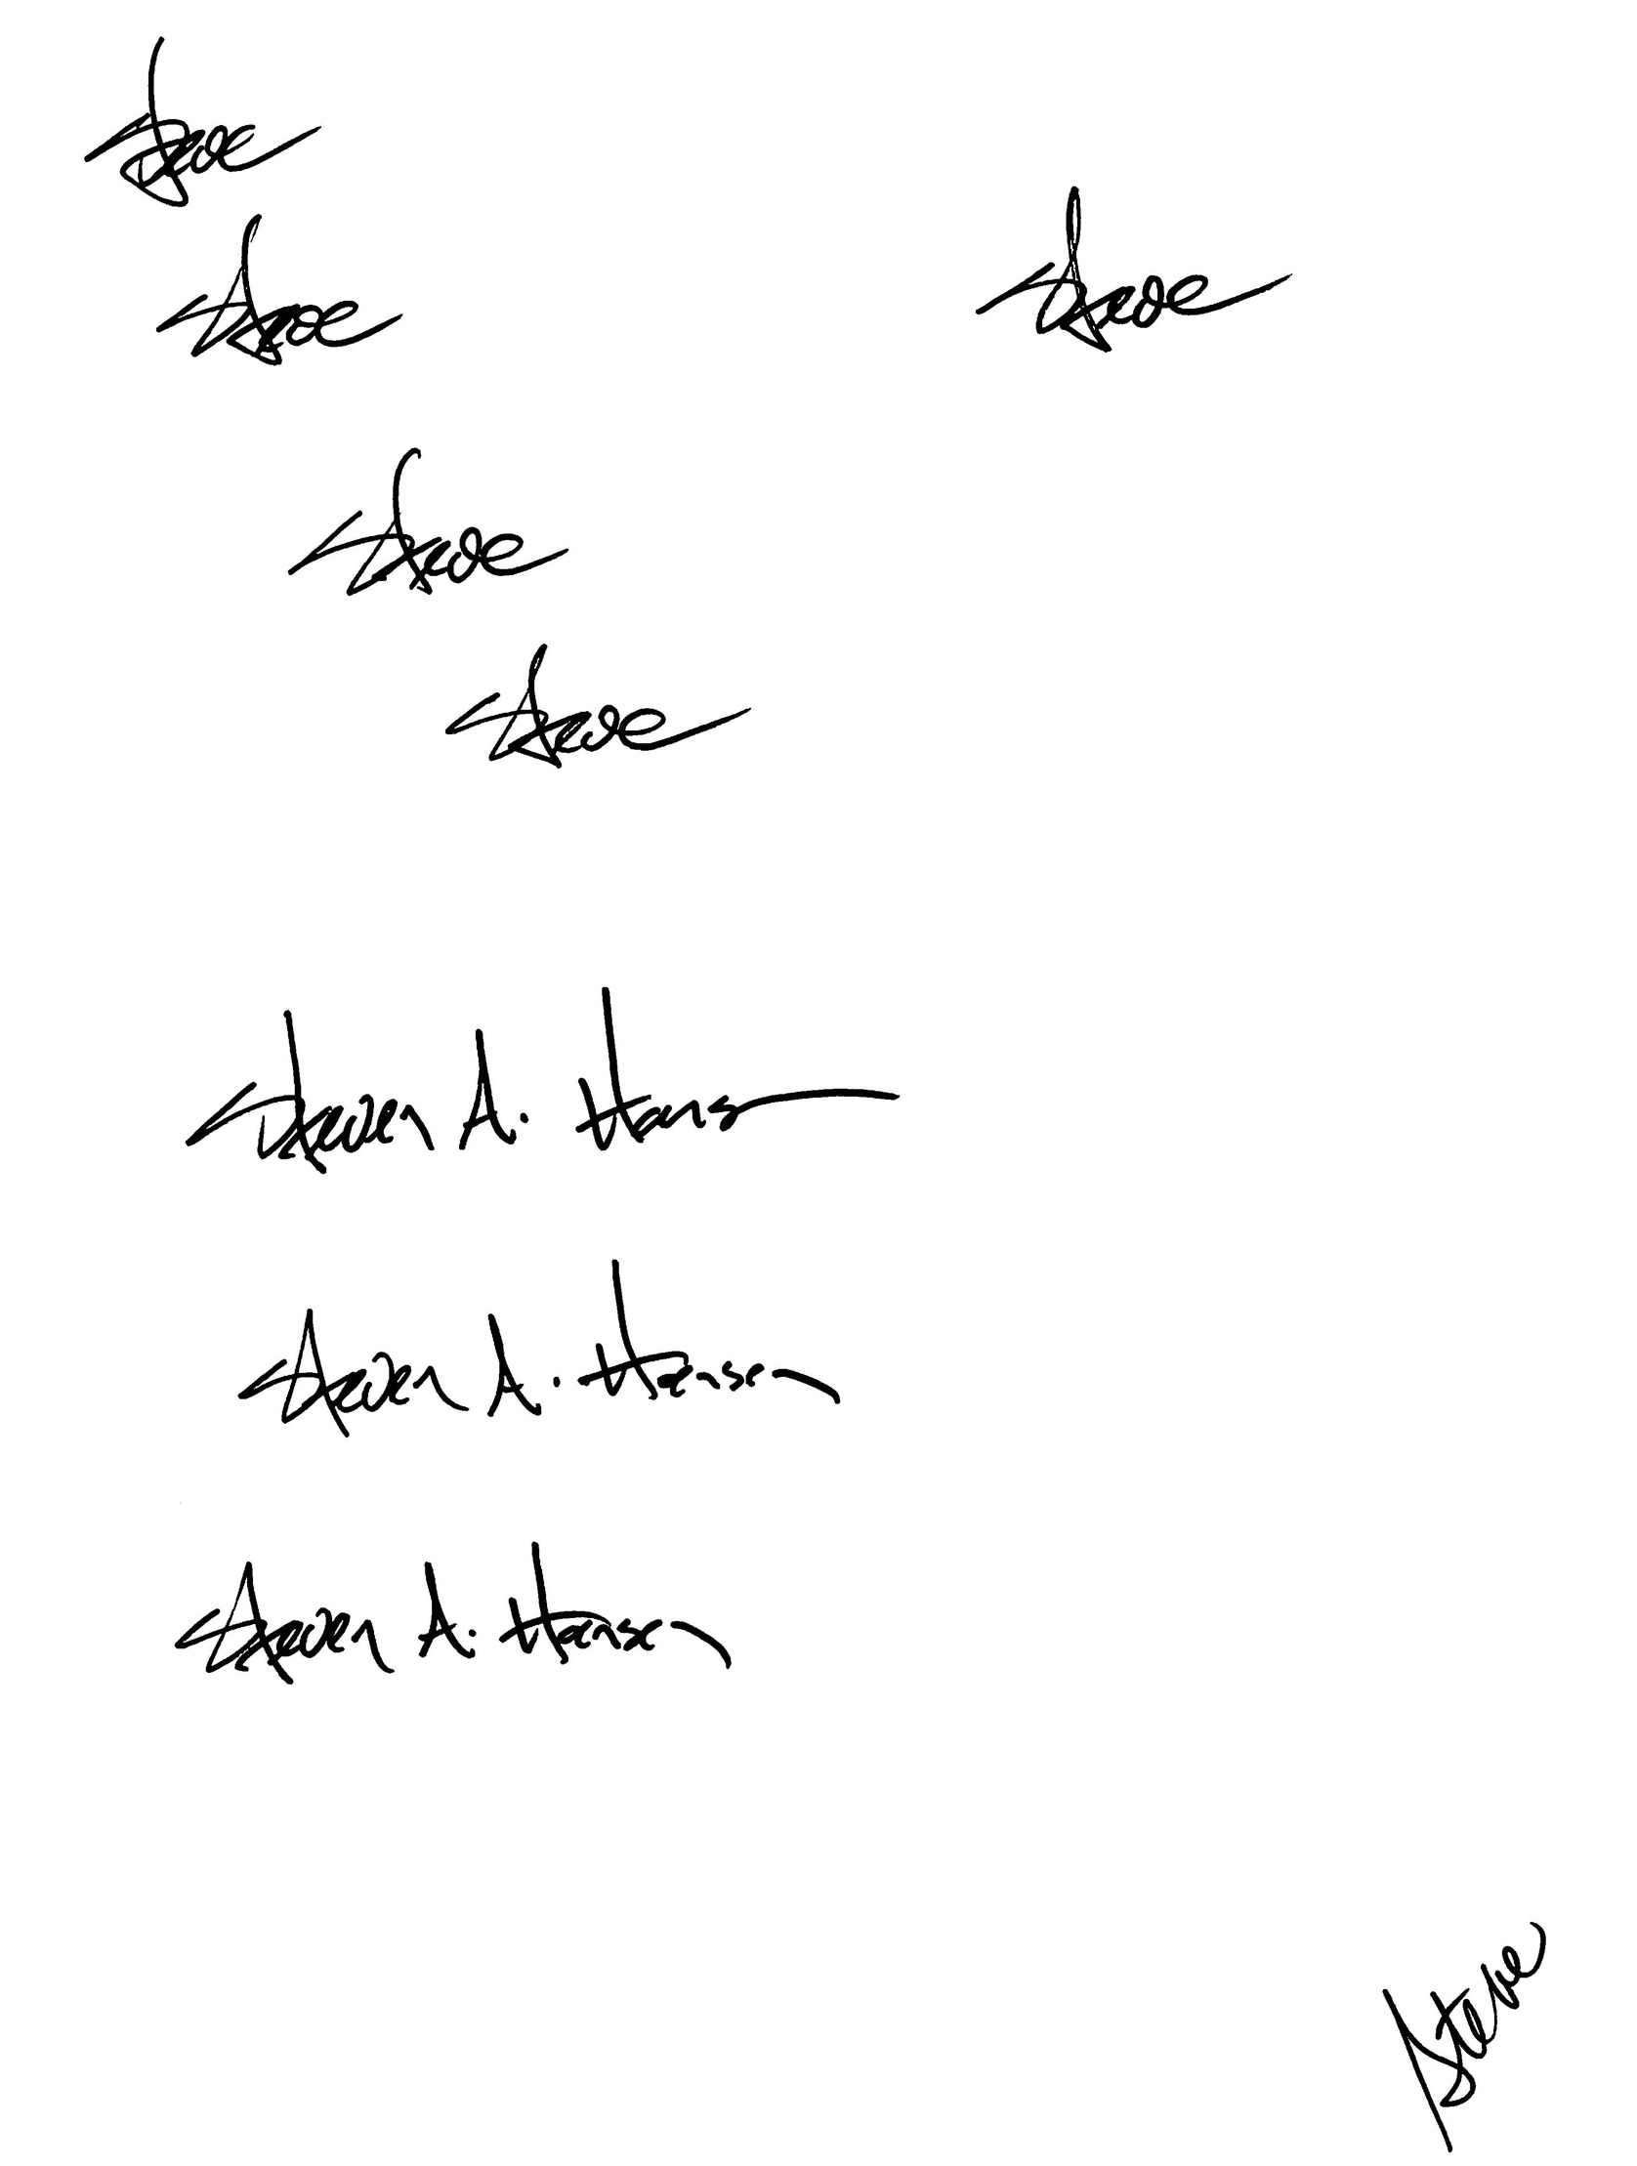
Steven A. Hansen CEO

