Present: Zachary Posner (Information Technology), Chris Stavros (Assessor), Chris Harding-online (Auditor), Joey McNamee (Community Services), Lisa Ashman-online (District Attorney), Beth Graham-online (Human Services), Hoa Nguyen-online (Council), Megan Hillyard–online (Administrative Services), Talia Butler-online (Public Works), Rashelle Hobbs-online (Recorder), Phil Conder (Treasurer), Michelle Hicks (Mayor Administration), Rosa Rivera-online (Sheriff), Reid Demman-online (Surveyor)
Representation Absent: Clerk
Staff Present: Tony Jolley-online, Mark Evans-online, Rina Shipley-online, Cindy Beck, Ben Thompson-online, Andrew Dudley-online, Corey Hess-online, Dean Bullock-online, Lee Wilstead-online, Mark Miller-online, Mike Bailey-online, Kira moody, Valina Eckley-online, Hillary Boccagno-online, Trevor Hebditch, Cherie Root

TOPIC | POINTS OF INTEREST
Welcome & Remote Meeting Instructions | Chris Stavros opened the meeting.  Trevor Hebditch shared the following slide:  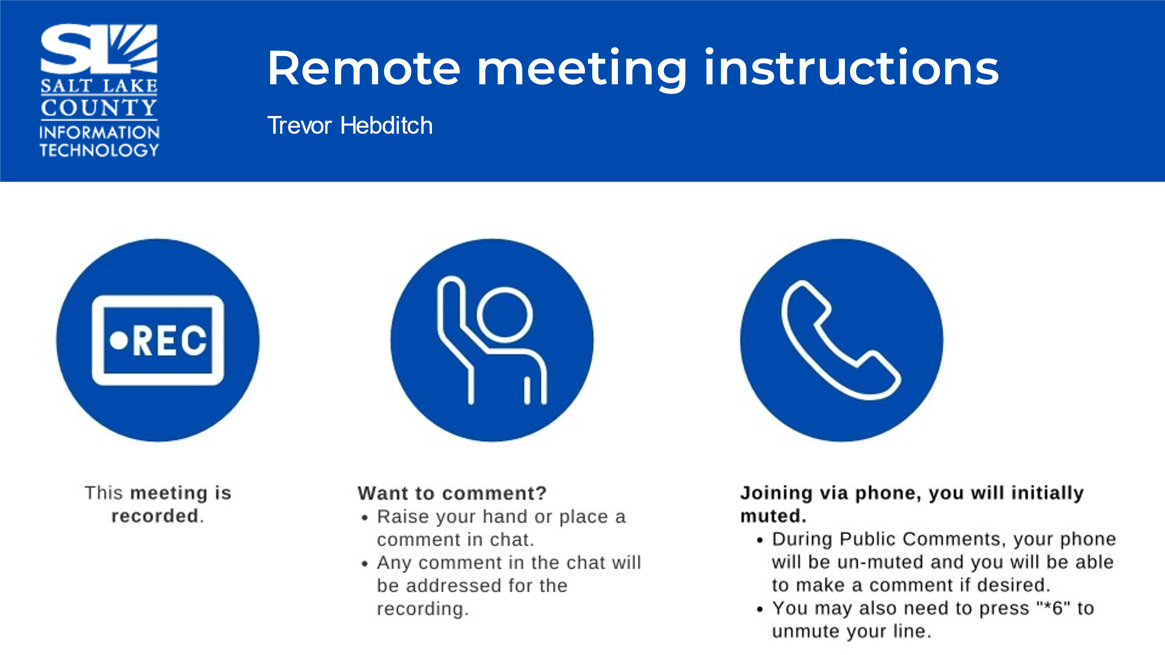
Public Comments  (Chris Stavros) | None.
2024 TAB Leadership Nominations  (Chris Stavros) | Phil Conder made the nomination for Chris Stavros to be Chair and Reid Demman the Vice-Chair.  Motion to accept the nomination by Phil Conder, Joey McNamee seconds the motion. No discussion.  Motion passed unanimously.
Approval of minutes from December 14, 2023 meeting | Motion to accept the minutes by Phil Conder, Michelle Hicks, seconds the motion. No discussion.  Motion passed unanimously.
2025 Budget Request Dates (Cherie Root)  *JULY 1st, 2024 is the deadline for Information Technology Requests. | 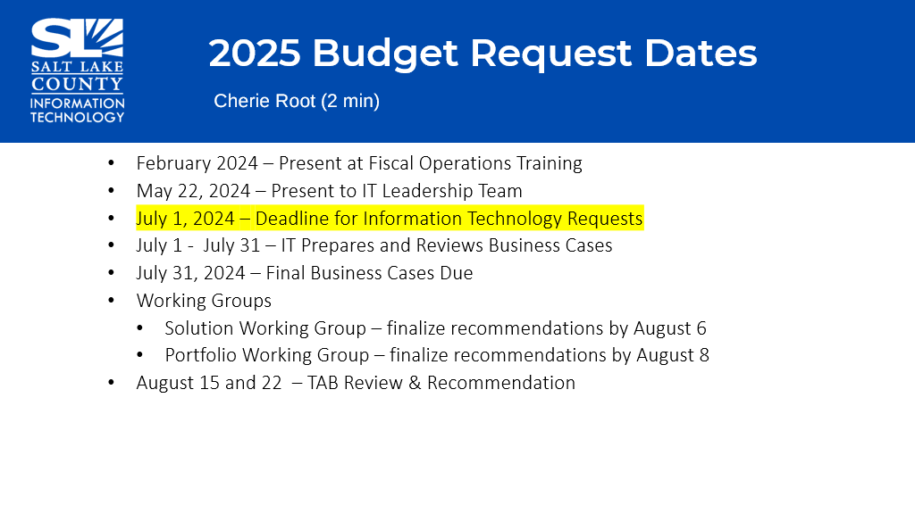  Please be mindful of these dates for this year.
Follow-up Items (Cherie Root) | 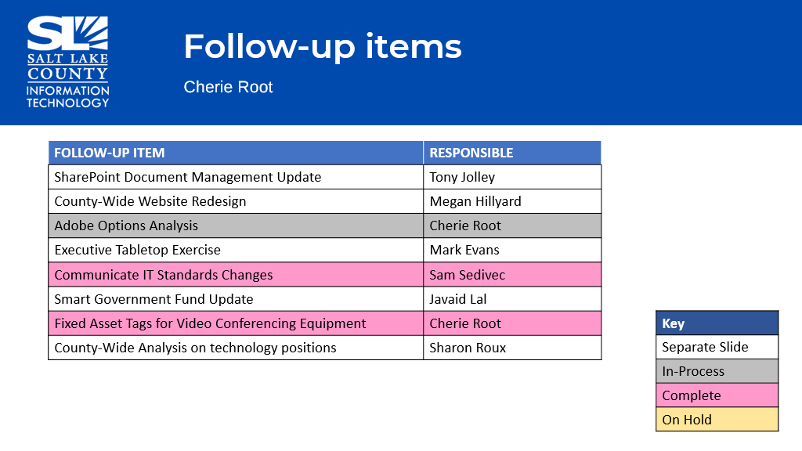
SharePoint Update  (Tony Jolley) | 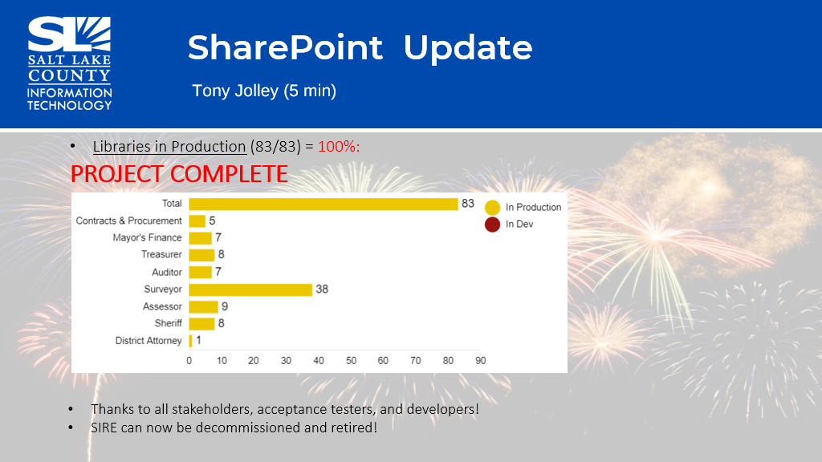  - Phase One is complete. Appeal Process is complete.  - Some agencies are benefitting from Phase Two development. Part of Phase Two development for the Assessor is Prognose Integration and additional inmprovements.  - Thanks to all the stakholders, testers, and developers as SIRE can be decommissioned/retired.
Website Redesign Update  (Megan Hillyard / Zachary Posner) | - In the final stages and running low on contract dollars. A vast majority of the county is completed and moved over to the new website.  - For the remaining few agencies please do what you can to get what is needed wrapped up before we run out of contract dollars.
Tech Positions County-Wide (Sharon Roux) | 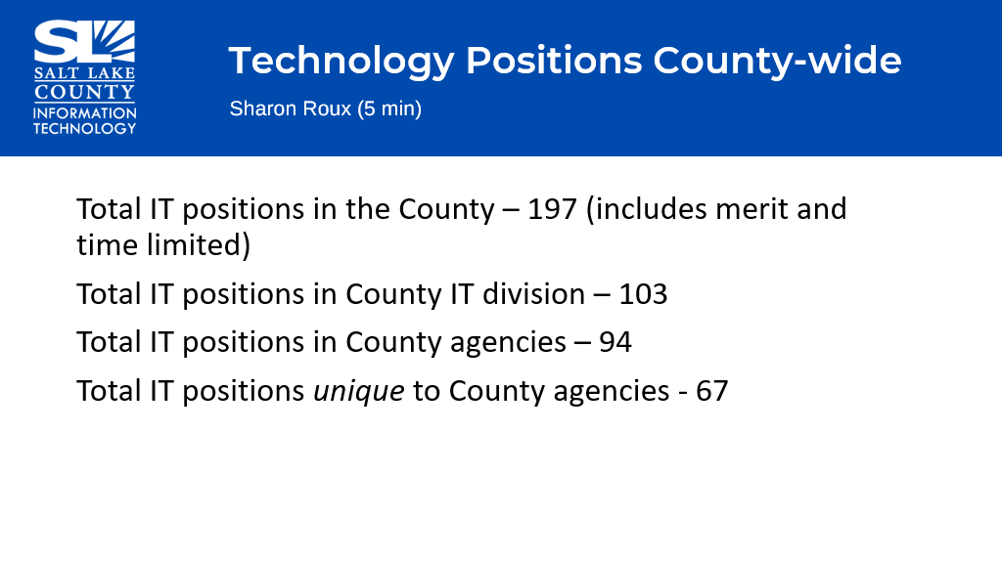  - Is the report in its current format serving the needs of TAB? Should a different format or detail be needed, the report can be adjusted.  - The report is to provide TAB “technology positions” county-wide to show where resources are being used and how they are being used.
Working Group Milestones (Tony Jolley) | 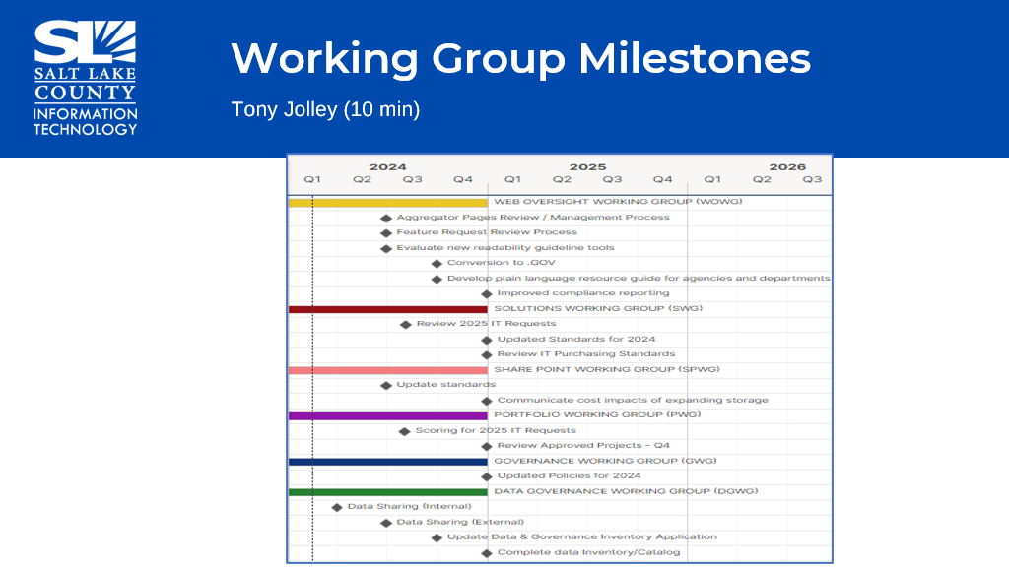
Governance Working Group (GWG) (Tony Jolley)  Purpose, Milestones for 2024, & Current Members | 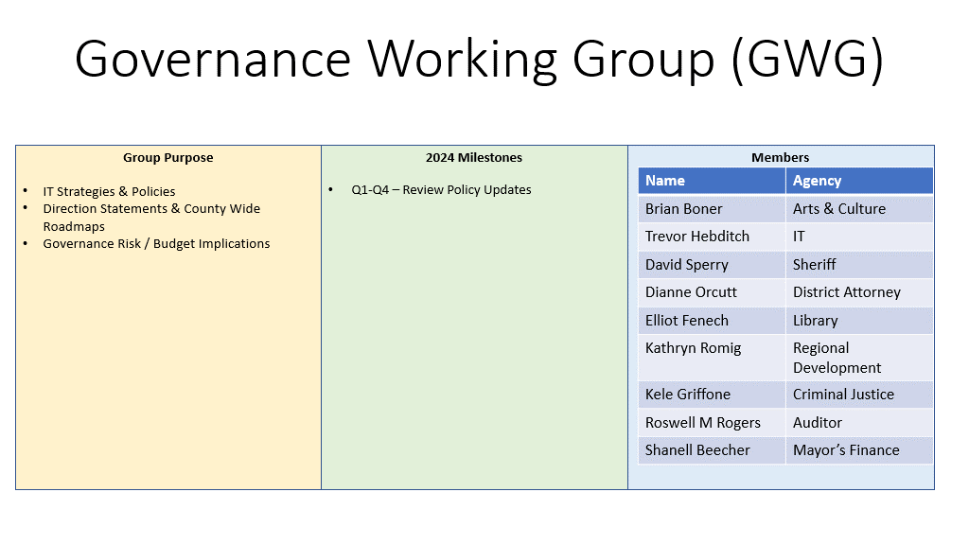
Solutions Working Group Update (SWG) (Tony Jolley)  Purpose, Milestones for 2024, & Current Members | 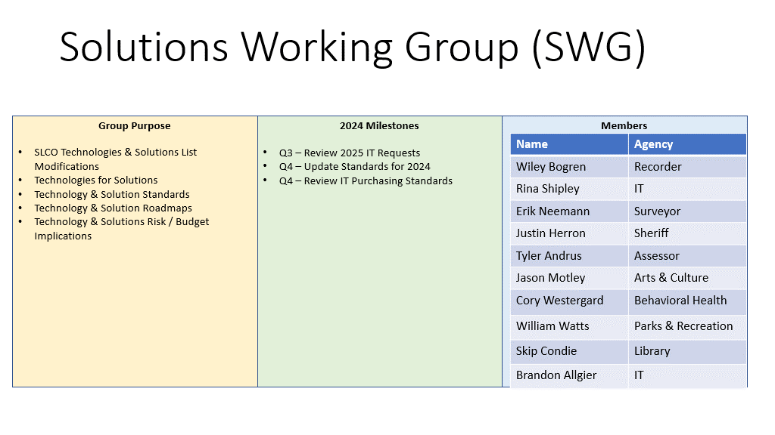
Portfolio Working Group Update (PWG) (Tony Jolley)  Purpose, Milestones for 2024, & Current Members | 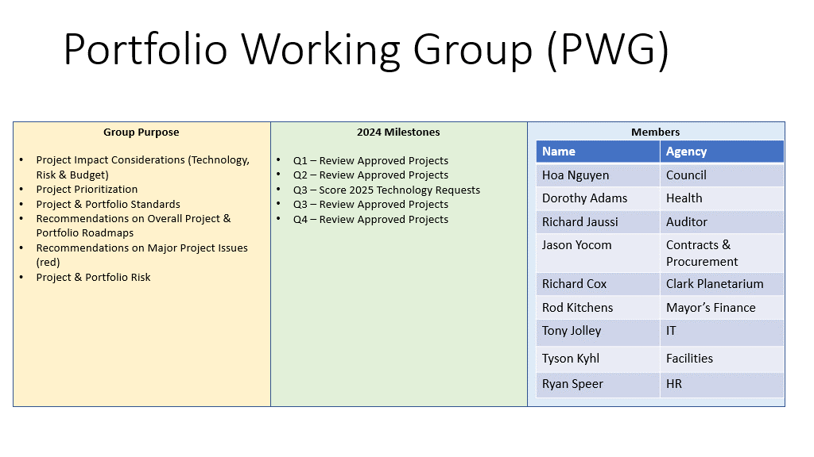
Data Governance Working Group (DGWG)  (Tony Jolley)  Purpose, Milestones for 2024, & Current Members | 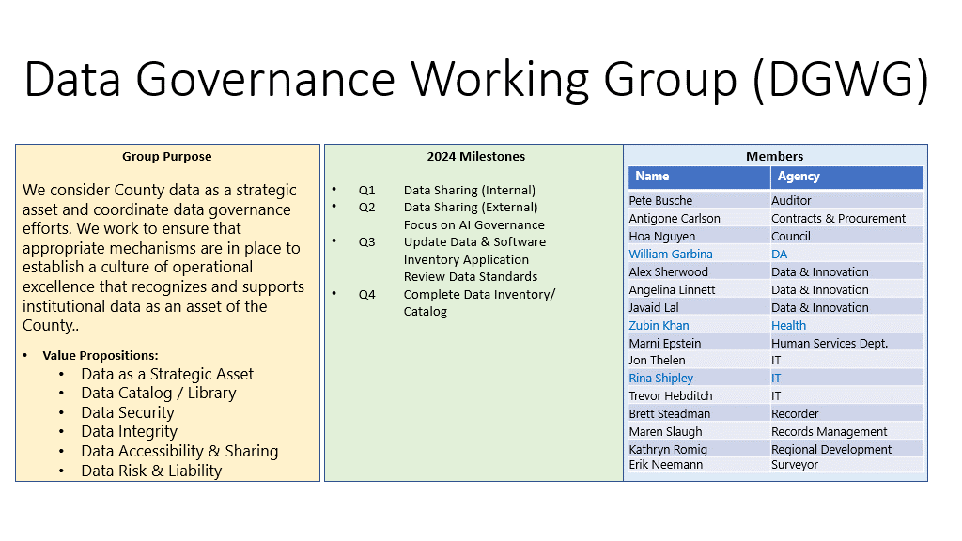
SharePoint Working Group (SPWG)  (Tony Jolley)  Purpose, Milestones for 2024, & Current Members | 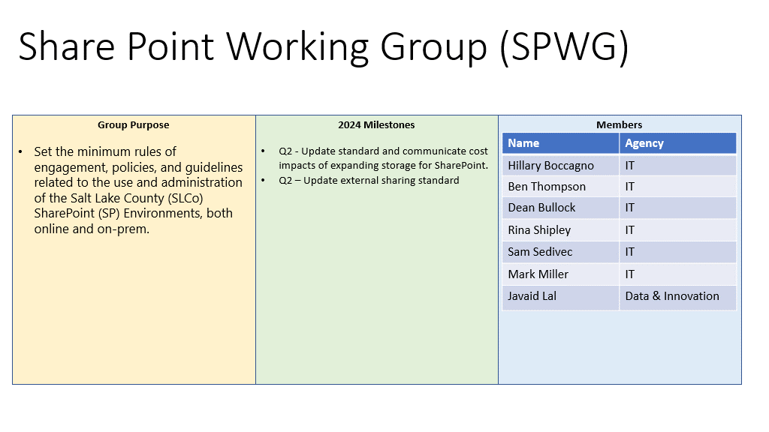
Web Oversight Working Group (WOWG)  (Tony Jolley)  Purpose, Milestones for 2024, & Current Members | 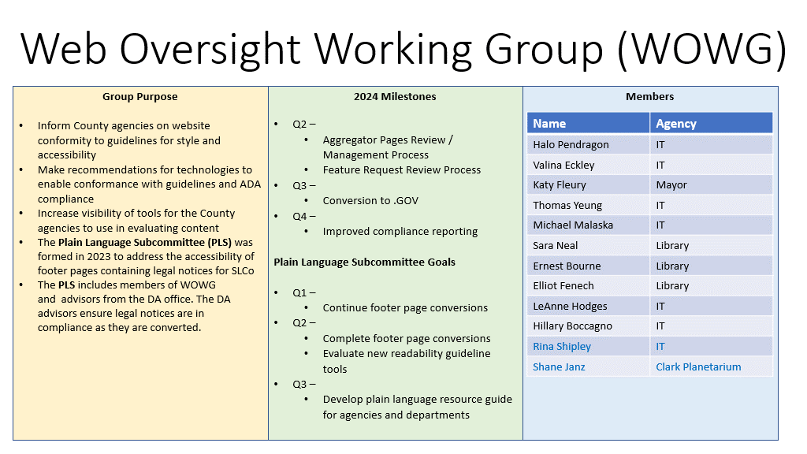
Solutions Working Group (Rina Shipley/Mark Evans) | 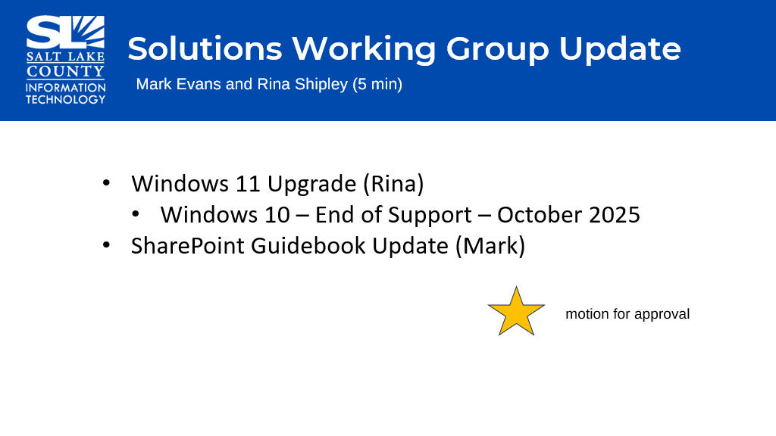  - Windows 10 operating system is going off support in October 2025. Microsoft will no longer be providing security patches. Some existing machines are NOT capable of running Windows 11. Lists of these machines that are not able to be upgraded will be sent out to the agencies.  - Created a Standard on the SharePoint governance. The standard basically states “we all agree to follow the guidance that is in the SharePoint guidebook.” Reviewed some new additions to the guidebook. The new additions are trying to create some best practice guidelines as it relates to our data when data is shared to external parties.
Approval of SharePoint Guidebook Update | Motion to accept the SharePoint Guidebook Update by Michelle Hicks, Phil Conder seconds the motion. No discussion.  Motion passes unanimously.
Data Governance Working Group (Javaid Lal) | 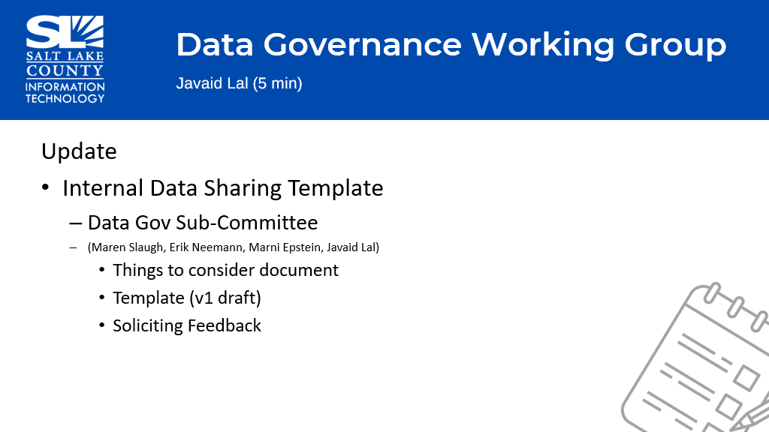
Smart Government Fund Update (Javaid Lal)  Four Projects Currently funded from Smart Government Fund. | 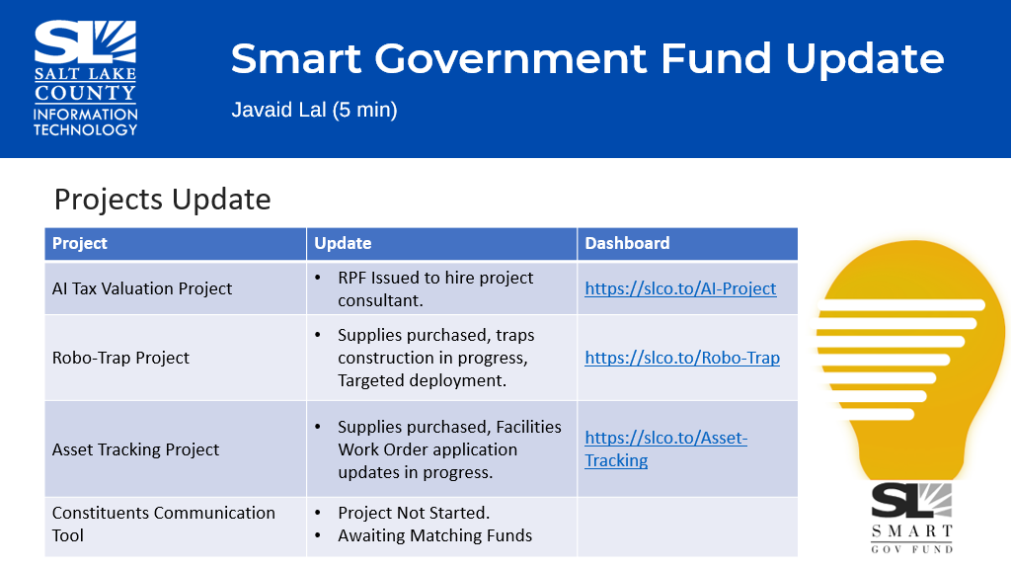
Smart Government Fund Update (Javaid Lal)  Ten new ideas have been submitted.  New Committee for Smart Gov Fund | 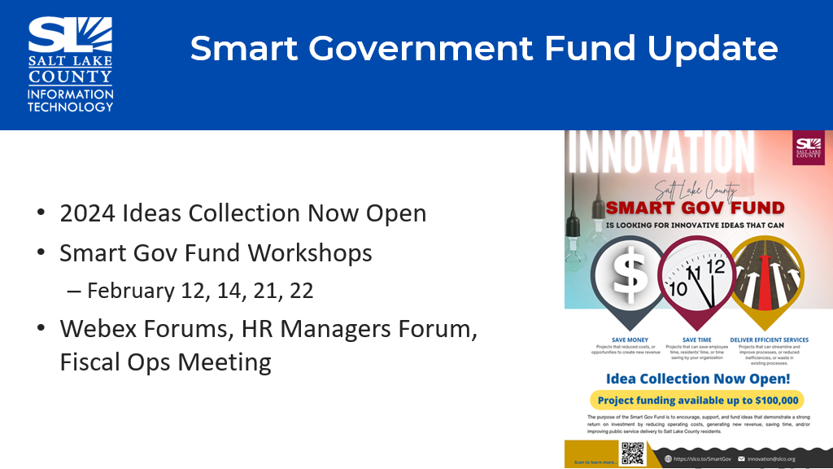  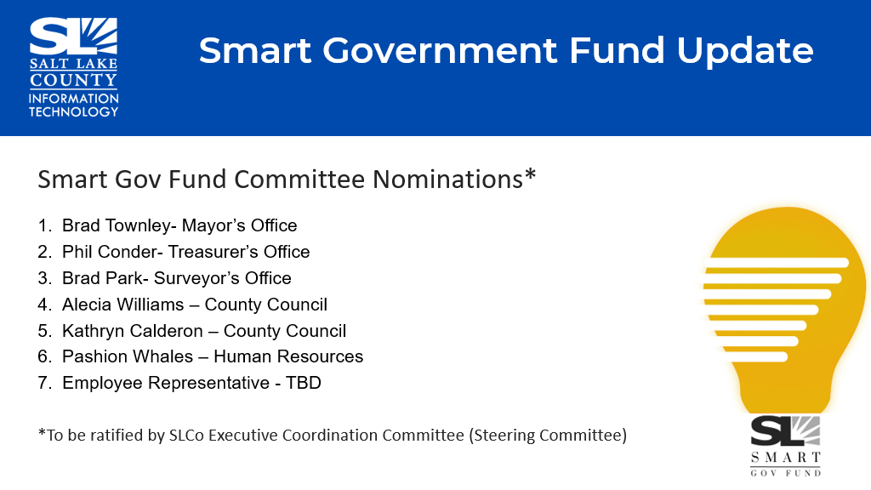
ePortal Enrollment  (Rina Shipley) | Making progress on the migration to ePortal. This provides single sign on and multi-factor authentication (MFA) to web applications that we use. Please be patient with the changes of moving to ePortal and the mandated email change from .org to .gov.
IT Security Update (Closed Session) | Motion to enter a closed session to discuss deployment of security personnel, devices, or systems by Michelle Hicks, Phil Conder, second.  Aye: Administrative Services, Assessor, Auditor, Community Services, District Attorney, Human Services, Mayor Administration, Public Works, Recorder, Sheriff, Treasurer  Nay: None  Roll Call: Absent Clerk, Surveyor  Motion Passed unanimously.  Motion to exit the closed session by Phil Conder, Michelle Hicks, seconds.  Motion Passed unanimously.
HIPPAA & Data Sharing (Beth Graham) HIPPAA & Data Sharing (Cont.)  (Beth Graham) | - Emphasized the need for and importance of a strong data policy.  - A formal sub committee was formed about a month ago. The committee (systemic coordination data work group) has representation from Human Services, Health Department, Behavioral Health, and a few others.  - The representation is also found in the TAB working group (Data Governance working group).  - Working in 3 simultaneous areas: develop a shared County philosophy around data sharing, agreements, and standards; figuring what technology will allow for effective and efficient data sharing; and the final area is HIPAA review and compliance assurance to allow for that data sharing.
IT Shared Service Model (Jill Miller) | - The safety of Salt Lake County as it relates to technology and specifically Cyber-attacks and other security issues, Mayor Wilson is asking for the CIO (Zachary Posner) to have a complete understanding of our systems and practices we have in place.  - Some agencies have systems and infrastructure that the IT Division doesn’t necessarily have “day to day” access or interaction with, but the mayor’s desire is for the CIO to have situational awareness to make sure we are looking at things holistically.  - Starting with the Mayor’s portfolio, we have begun to work with agencies who use specific technology and different systems to better understand them and to possibly look for opportunities to coordinate and maybe integrate.  - How we communicate as a County can get more complex as we grow. Different agencies use different systems to best serve their needs. We want to create dialogue and understanding (guidelines) so that we don’t have unintended consequences (ex. Setting up systems that create barriers.).
Other Business | - Potentially building an AI policy subcommittee made up of elected specifically, TAB members, decision makers, etc. We need to make sure the “user” is still the responsible party. There is great work being done around this topic as AI becomes more known and used. Humans still need to supervise what AI produces.  - The idea of creating an AI subcommittee was well received and to move the discussion forward of next steps (proposal).
Communication Items (Chair & CIO)  TAB Chair and Co-Chair for 2024: Chris Stavros & Reid Demman (respectively) | 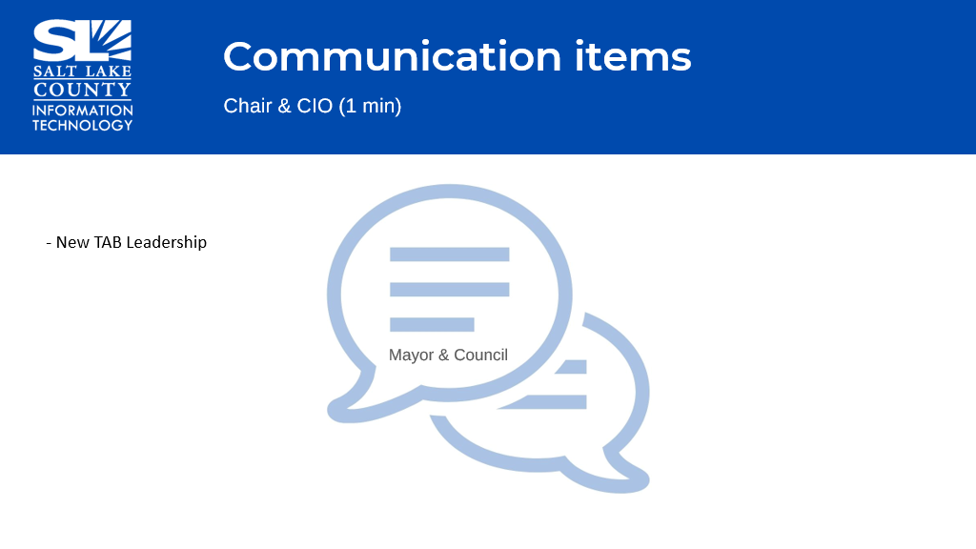
Upcoming Meeting Schedule  (Cindy Beck)  . | 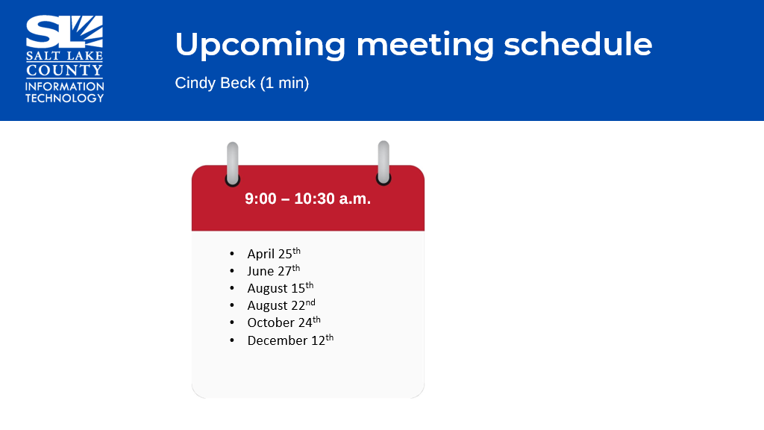  - It is noted both August Meetings will be combined with GIS Steering and TAB.  - With recent Webex updates, I may need to cancel and resend some of the upcoming meetings for 2024.
Review Action Items (Cindy Beck) | - All TAB members to send feedback on the Technology Positions Report to Sharon Roux.  - The CIO will draft a proposal to form an AI subcommittee.  - The CIO will provide updates regarding IT Shared Services analysis.
Next TAB Meeting April 25th, 2024 | 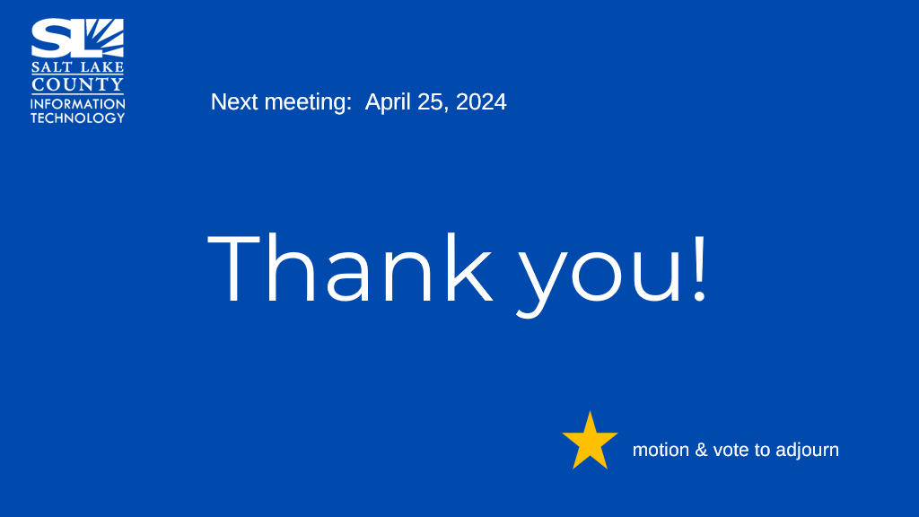
End of Session | Motion to adjourn the meeting by Rashelle Hobbs, Joey McNamee seconds. Meeting adjourned. So moved.
Next Meeting | - April 25, 9:00 – 10:30 AM
Submitted by Cindy Beck

