MINUTES
Weber School Foundation Board Meeting
3/21/2024 12:00 PM | Meeting held at Weber School District Office and called to order by Jen Dunyon

Attendance
Present: Craig Adams, Jenna Andrascik, Lindee Bess, Dave Broadbent, Jan Burrell, Gina Butters, Flora Cassity, Michelle Darrington, Scott Dixon, Jeremy Dunn, Jen Dunyon, Kori Ann Edwards, Jamie Ellison, Bryan Hurst, Matt Jensen, Ashley Loftus, Phillip Mickey, Clyde Moore, Emily Oyler, Kathy Saunders, Josh Skidmore, Jake Talbot, Jennie Taylor & Angie Towns
Excused: Mark Adams, Dave Andersen, Matt Bell, Bryan Benard, Barry Beus, Tyler Buxton, Craig Dearden, Tony Divino, Kimberli Green, Brandi Hammon, Branden Hansen, Brett Karras, Steve Kier, Ryan Olsen & Kerry Wahlen.
Guest: Alex Taylor, Weber High School Actor’s Rep Student Group

Welcome
President Jen Dunyon welcomed everyone to the meeting and shared the exciting news that Scott and Julie Dixon were inducted into the Bonneville High School Hall of Fame and Christmas Tree Jubilee Chair Kim Skidmore received the Volunteer Service Award from the Weber School District Board of Education. Congratulations!

Approval of Minutes
Kathy Saunders made a motion to approve the minutes from the February 15, 2024 meeting with a second from Kori Ann Edwards. The minutes were unanimously approved.

Share our Story
Jan Burrell read a thank you letter from Chelsea Drew Anderson, a student at Two Rivers High School regarding the help that she has been receiving at the Teen Center and what it has meant to her.

Committee Reports
Special Needs—Flora Cassity reported since our last meeting we have received 17 Ipad requests with touch chat apps and cases. 12 requests were from Ogden School District, 5 requests were from Weber School District. These requests total $11,898.00. Jeremy Dunn made the motion to approve these projects with a second from Dave Broadbent. The board unanimously approved.
Finance-Craig Adams reported that the Finance Committee met for the Investment Advisor presentations. They met with Wells Fargo, Soltis Investment Advisors and Moreton Asset Management. All three companies gave great presentations. The committee would like to recommend Soltis Investment Advisors for approval from the board. We will be moving our money from Peterson Wealth and reallocating funds. The committee feels great about moving forward with these new advisors and would like to thank the Finance Committee for their involvement with this process. Jeremy Dunn made the motion to approve this recommendation with a second from Phil Mickey. The board unanimously approved.
Projects-Kathy Saunders reported since our last meeting we have received the following for review and approval: 1 School Grant, 10 Class Grants and 14 SPED Class Grants. From the 10 Class Grants, 8 have been funded through DonorsChoose, 2 are non DonorsChoose for approval. From the 14 SPED Class Grants, 9 SPED have been funded through DonorsChoose and 5 are non DonorsChoose for approval. Flora Cassity made the motion to approve these projects with a second from Kori Ann Edwards. The Board unanimously approved. The grant portals will be closing on April 30, 2024.
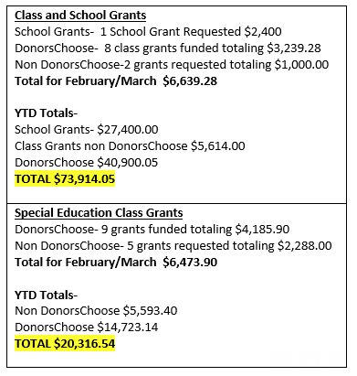
Teen Center-Jennie Taylor informed the board that construction began in February at the Bonneville High Teen Center. We are hoping for the ribbon cutting in June! The construction on the Roy High Teen Center will begin soon.
Construction on the Weber High and Fremont High Teen Centers will begin after this school year is out. The newsletter will be coming out the end of this month. Thank you to Lindee Bess’ staff for helping us with this! Steve Kier is working with Dave Andersen to put together a good budget for each Teen Center. Steve will report on this next month.

Director’s Report
Golf Update-Emily reported that we are SOLD OUT with one extra team this year. The Golf Committee has decided to change the format to BEST BALL and are excited about this change. Michelle is working on student groups, volunteers and entertainment. Jamie is working on raffle items.
Jubilee Sponsorships-The Foundation Staff met with a community committee regarding Christmas Tree Jubilee sponsorship levels. This committee consisted of different business representatives, volunteers, committee members and Jubilee attendees. Costs keep going up and many organizations have raised their sponsorship levels as well.
New Sponsorship Opportunities for the 2024 Christmas Tree Jubilee are listed below:
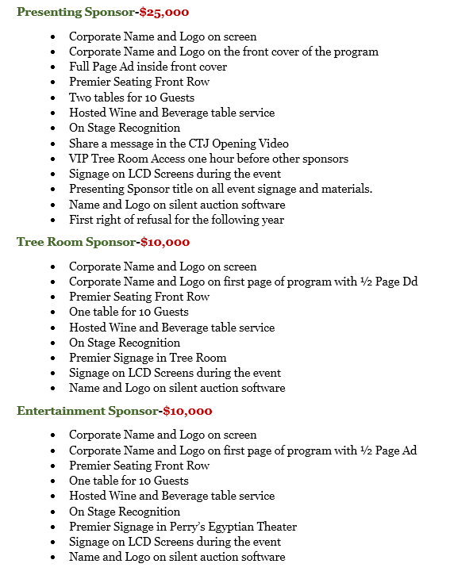
We have never offered a Presenting Sponsor before. Many other organizations offer this level at their events. Emily will meet with those being asked for this level personally. We would like to have this level filled quickly because they will be participating in the CTJ Opening Video.
Ratification-Teacher Hardship Funding-Emily informed the board that the last couple of years Hogan Construction has given a donation to the Foundation for teachers or employees going through hardships. Administrators nominate these individuals and we received 19 nominations this year. Hogan donated $7,000.00 this year and with a match of $2,500.00 from the Foundation each of these nominees will receive a $500.00 Visa Card. Jennie Taylor made the motion to approve this match with a second from Angie Towns. The board unanimously approved.
Weber High School Actor’s Rep-“Look in a Book”-Mark Daniels, Drama Teacher at Weber High School applied for a Class Grant through the Foundation for this Literacy Outreach Program. Students are bringing books to life! They were able to perform these skits at many elementary schools and the grant paid for the busses. They performed “Chrysanthemum” for the board. The board loves to provide support for these programs!
Other Business-
-Superintendent Butters informed that today is “Rock Your Socks Day” in Weber School District. This is to raise awareness for World Down Syndrome Day.
-Gina went over the Weber School District’s Core Values: Our Core 4 with the Foundation board members. We will email out a copy of this to board members.
-The name of the new Elementary School is Haven Bay Heron’s
-The Weber School District Board of Education has voted to discontinue Jr. High Football. Gina went over the process of this decision with the board.
-April Board Meeting: April 18, 2024
-President’s Award Banquet Invitation

Next Meeting
April 18, 2024
11:45 a.m.

