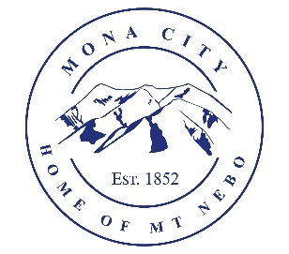
Mona City
435-623-4913
www.monacity.gov
20 West Center Street Mona, Utah

City Council Public Hearing Notice
Tuesday, May 14, 2024
7:00 pm (City Council Room, 20 W. Center St.)

PUBLIC NOTICE IS HEREBY GIVEN that the Mona City Council will hold a public hearing on Tuesday, May 14, 2024, at 7:00 p.m.in the Mona City Council Chambers located at 20 West Center Street, Mona City. The purpose of this hearing is for a presentation from EFG Consultation concerning increasing the water impact fee, and to accept public comment and consider an amendment to the Mona City Fee Schedule to increase the water impact fee on new construction from $1,543 to $3,222.

CERTIFICATE OF POSTING

This agenda is hereby properly advertised this 17th day of Aprill, 2024, through posting of copies of this agenda at the following places: the Mona City Office, at the United States Post Office Mona City Branch, on the Utah Public Notice Website at www.utah.gov/pmn/index.html.

_______________________________________
Alicia Hills, Mona City Recorder

Upon Request, in compliance with the Americans with Disabilities Act, reasonable accommodations for individuals with disabilities will be provided. For assistance, please call 435-623-4913.

