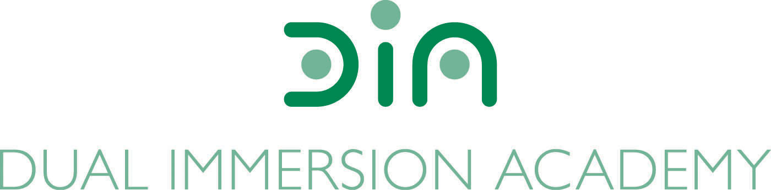

DIA Board of Directors Agenda
April 16, 2024
Dual Immersion Academy

Begin at 5:30 pm
In-person/Virtual
Roll Call

- Budget Report

- School Land Trust Plan Review

- Director’s Executive Report by Angela Fanjul

- DIA Staff – Secretary to the Board position to fill

- Facilities (update) by Mequette Sorensen

- Board Candidates/Membership by Teri Slaugh

  - Address any questions/concerns/discussion of our member candidates and entertain any motions to add any or all of them to the board.

- Closed Session under UT 52-4-205 (as needed)
Re-open the meeting for board vote (as needed)

- Approval of minutes: February 20, 2024

- Motion to close the meeting.

Conclude meeting by 7:00 pm

Next meeting:
Tuesday, May 21, 2024
At 5:30 pm

