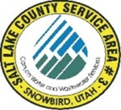
NOTICE OF
REGULAR MEETING
of the Board of Trustees of
SALT LAKE COUNTY SERVICE AREA #3 – SNOWBIRD
to be held on Monday April 15th, 2024, at 12:00 P.M.
You may join the meeting electronically from the link below.
https://meet.goto.com/621616189
You can also dial in using your phone.
United States: +1 (224) 501-3412
Access Code: 621-616-189
Dave Richards
Tom Prosek
Chris Bremer

MEETING AGENDA

- Richards Approval March 18th 2024 meeting minutes.

- Carpenter Systems Operations and Development.

- Carpenter Treasurers Report ending March 31st, 2024

- Richards Approval of March 16th through April 12th, 2024.

Post Date: __________________
Attest: ______________________
Bryauna A. Alderin/ Clerk

