Oremfest Committee
56 North State St, Orem, UT Council Conference Room
Thursday, April 11, 2024
6:00pm
This meeting is being held electronically to allow a board/commission member to participate.
Zoom Link: https://chat.google.com/dm/oKrKxkAAAAE/hNjuP3RytNQ/hNjuP3RytNQ?cls=10

Agenda
- Welcome Christie Ekins
- Approval of March 14, 2024, Meeting Recording/Minutes Christie Ekins
- Introduction to Safety Overview Karina Eckern
- Orem Fire Safety Heath Stevensen
- Parade Protocols Jason/Matt
- 6. Orem Police Safety Blake Fenn
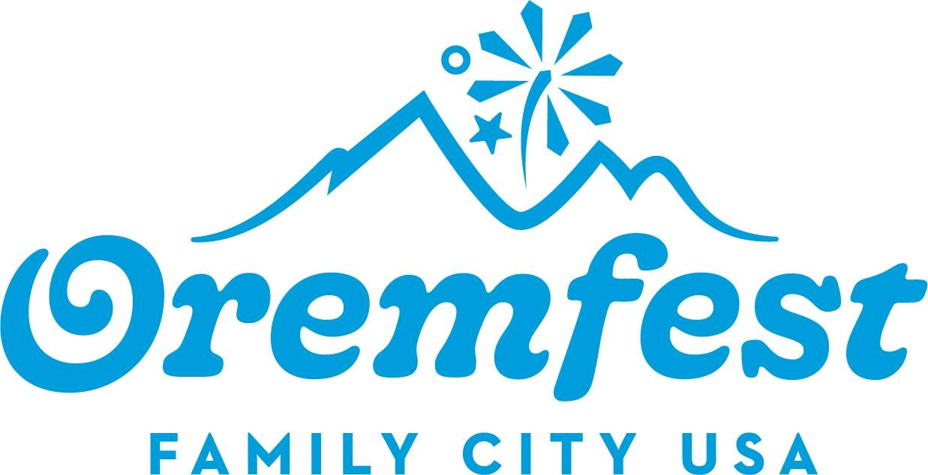
- Oremfest Sponsor Update Heather Cox
- Member Reports Christie Ekins
  - Report individually on each area for committee Members
  - Does anyone have anything new they would like to present?
- Next Meeting Karina Eckern
  - May 9, 2024
10. Adjournment Christie Ekins

THE PUBLIC IS INVITED TO PARTICIPATE IN ALL CITY MEETINGS.
If you need special accommodation to participate in the Advisory Commission meetings, please contact us on the City's website at orem.gov or call (801) 229-7000 at least three working days prior to the meeting. This agenda is available on the Utah Public Notice website at utah.gov/pmn.

