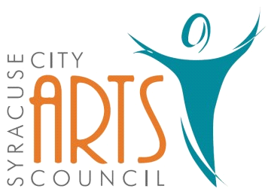
Syracuse City Arts Council Meeting Agenda
April 3, 2024 8pm
Meeting begins at 8pm
in the Syracuse City Municipal Building’s large conference room
located at 1979 West 1900 South.
1. Opening Business
- Call to Order
- Adoption of April 3, 2024 Agenda
- Review and Adoption of March 6, 2024 Minutes
- Approve Budget Expenditures since March 6, 2024

2. Public Comment-This is an opportunity to address the Council regarding concerns or ideas. Please limit comments to three minutes.

3. 2023-2024 SCAC Upcoming Season Events
Orchestra: May 20, 2024 – Kurt Bestor - a life composed
Jazz Band: June 6, 2024 North Ogden Summer Jazz Festival, June 22, 2024 Syracuse Heritage Days
Jr. Theatre: June 17-21, 2024 Broadway Bootcamp, (next season - Finding Nemo Jr.)
Theatre: Newsies July 18-22, 2024
Fundraisers: June 19, 2024 Bingo Night
Other:

4. Jr. Theatre - Summer Camp Update

5. Kurt Bestor Concert update

6. Newsies Auditions

7. 2025 summer musical vote

8. Publicity: Syracuse Connection information & other publicity as needed

9. Walk in items

WORK SESSION
10. Committee/Board Member Updates/Discussion

11. Future Agenda Items

12. Adjournment
~~~~~~~~~~~~~~~~~~~~
In compliance with the Americans Disabilities Act, persons needing auxiliary communicative aids and services for this meeting should contact the City Offices at 801-825-1477 at least 48 hours in advance of the meeting.

CERTIFICATE OF POSTING
On April 2, 2024 this agenda was provided to the Standard Examiner and submitted to Syracuse City for posting on the Syracuse City Hall Notice Board and for publishing on the Syracuse City website, at http://www.syracuseut.com, and on the State Public Notice website, at http://www.utah.gov/pmn/indix.html. A copy was also submitted to the website manager for publishing on the Syracuse City Arts Council website, at http://www.syracuseutaharts.org/about-us/council-minutes. Libby Fawcett, Syracuse City Arts Council Chair

