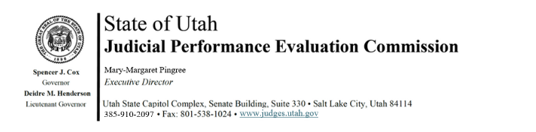

Judicial Performance Evaluation Commission
AGENDA
Tuesday, March 26, 2024
8:30 am-11 am
Hybrid Meeting *

Members: Mallory Bateman, Christine Durham, Sherrie Hayashi, Blair Hodson, Rick Hoffman, James C. Jenkins, Curtis M. Jensen, David J. Jordan, Sonya Martinez-Ortiz, Gil A. Miller, Bridget Romano, Tom Ross, Shannon Sebahar

Staff: Madison Klein, Chris Russell, Mary-Margaret Pingree, Jason Mata, Chris Pieper (Attorney General’s Office)

8:30 a.m. Welcome Gil Miller
Approval of Minutes – March 12, 2024

8:35 Announcements & Updates Mary-Margaret Pingree

8:50 Administrative Rule Updates Mary-Margaret Pingree

9:00 Pilot Project Updates Mary-Margaret Pingree

9:10 2024 Retention Evaluations Chris Russell
Closed Session Jamie Nelson

9:45 2024 Retention Evaluations - Voting Gil Miller
Open Session Madison Klein

11:00 am Adjourn

Next Meeting: Tuesday, April 9, 2024
8:30 a.m. – noon
3760 S. Highland Drive, 4th Floor

*Anchor Location: Senate Building, 350 State Street, Suite 330, CCJJ Conference Room

