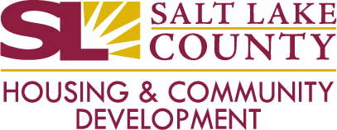
HOME Consortium Board Meeting
Wednesday, March 20, 2024, 11:00 AM – 3:30 PM
In-person luncheon meeting – Salt Lake County Government Center, South Building – Room IS-S3-070 (Honeycomb)
Virtual Meeting via Webex https://slco.webex.com/slco/j.php?MTID=mb10acbb1b792d80261ff2faf29b8120b
Join by Meeting Number – Meeting number: 2494 917 4384 Meeting password: nAumqhqN429
AGENDA
- Welcome and Introductions – Michael Akerlow
  - Approval of Meeting minutes 3/13/2024
- Guidelines for Applicant Presentations and Scoring Sheet Review – Michael Akerlow
- HOME Rehabilitation Applicant Presentations
  - Jordan River Trail LLC 11:10 AM
  - Housing Opportunities 11:25 AM
  - Assist 11:40 AM
  - First Step House (Rehab and TBRA) 11:55 AM
  - West Valley City 12:20 PM
  - Taylorsville City 12:35 PM
- HOME TBRA Applicant Presentation
  - The Road Home 12:50 PM
  - Housing Connect 1:05 PM
  - Utah Community Action 1:20 PM
- 10 Minute Break
- Funding Discussion and Final Recommendations
- Other Business
- Adjourn

