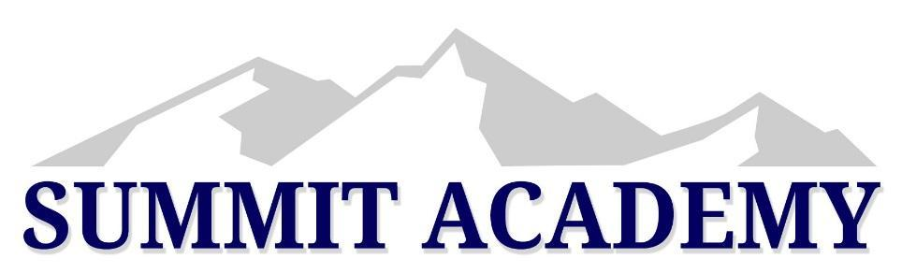
Summit Academy Board of Trustees
1225 E 13200 South
Draper, UT 84020
February 6, 2024
7:00 PM
Work Session
(APPROVED)

Welcome
The Work Session was called to order at 7:05 pm with Jon Eborn, Chelsea Welch, Robyn Derbidge, Bob Zentner, Joel Woodruff, Marcia Whitman, Elizabeth Lau, and Peter Baxter.
Board Survey
Every school has a Qualtrics account. Dr. Molly Hart is trying to get all of the information regarding how this can be used at each school. We will finish this discussion in February. Marcia is asking when we would like to get the survey to parents and staff out in February or March. Jon says that this discussion is better to have during a work session. The state has an agreement with Qualtrics so that their services are a lot cheaper than even Survey Monkey. Jon Eborn lets the board know that he would really like to engage Qualtrics for this year to add credibility to the survey this year so that Parents have more trust that the survey is anonymous. Robyn Derbidge let everyone know that the later in the year that you do a survey, the more parents you lose because they get so busy closer to Spring. Chelsea Welch reminds everyone that the survey is important and would like the consistency for the questions from year to year and that it is important. Joel thinks that the board could make simple adjustments to last year's survey and it could be done quickly. Peter Baxter reminds the board that the value of a survey is being able to measure growth and improvement. The board decides to use last year’s survey with a few changes. Jon Eborn is wondering about the question regarding the net promoter score and how that information is best presented. Joel Woodruff clarifies that there are two surveys, the employees and the parents. The director survey is something different. The current survey is in the drive for all board members to access.

Director Evaluation
Bob met with director Molly Hart and went over the rubric with her and how to move forward with her. Bob made some notes regarding this. Bob has the most experience being evaluated and evaluating others than anyone else on the board. Bob Zentner felt that the Director evaluation was very long and laborious and was hoping to tweak it somewhat. Bob and Molly went through the whole thing together. We found that there was a lot of redundancy and a lot of crossover with the business manager role. This evaluation is supposed to happen twice a year. She felt that twice a year was a lot. She felt better about speaking about it at a board meeting now and then, but that twice a year was too much. Bob felt good about the pleasant and long conversation with her and were both on the same page. Bob is sure that some of his notes may not make sense to everyone without his discussion of them. Jon Eborn had a couple of questions about it. A few years ago, there were some problems with the previous director and access to evaluations that were needed and the board was not able to access those. We need to go through this at the end of the year. We really couldn’t go through it with Molly at the beginning of the year because she was brand new. Jon is asking why Bob wants to take out feedback from employees out of the process. Bob said that he doesn’t have his original but that some of that information needs to come directly from the principals rather than through her. Bob feels like it would be more valuable to have the director bring her evaluation of principals directly to the board. It is important to remember those five areas on page 16 and put it on her evaluation as a whole. Bob feels like it would be better to do it in little pieces at a time throughout the year. Jon is remembering some experiences from the past and how to learn from that. Jon feels like documentation from the director is very valuable for the board. Chelsea Welch adds some context. The rubric was meant to be the way the board evaluates the director. It was understood that evaluations would be made and then after those were completed that they would be placed in a location accessible to the board. It was never meant to be an exhaustive list. If it is, then a lot of this should be communicated during board meetings. Bob mentions that check in’s monthly may be more effective than all at once at the end of the year. Jon realizes that there is a lot of subjectivity in this. Bob thinks that once the instrument is solid, to go through each item with her would be very important. It would also clear up some of the things that Chelsea was talking about. Jon says that the goal for the board would be to give Molly a heads up on this information and that if she has some concerns, we could be made aware of that. We do this in February because that is when contract renewals are done and new hiring begins. Jon says that this should be done in a work session. Molly Hart is fully aware that she is brand new and has no expectations. Joel would like an example of what a one looks like and what a five looks like. That would be very helpful. Jon says that it gets to be thoughtfully talked about in a work session. Jon reminds everyone that if there were any concern regarding the current director, that those things would be coming up in board meetings. Robyn likes the idea of breaking the evaluation up into sections. Some pieces would be valuable to do at the beginning of the year rather than at the end. Chelsea mentions that it is important to know that this evaluation was developed in the context to have more opportunities to check in with the director to avoid problems faced with directors in the past. That plan wasn’t able to take place in the past with the previous director for different reasons. We will go into this more thoroughly during a future work session. This is the current approved evaluation. We can make changes and edits for a changed evaluation for a future year if that is what the board wants to do. We would like to get a feel for the director in a timely manner before new contracts are signed. Bob mentions that Molly is new and that this instrument is new to her and she is a bit overwhelmed. It would be valuable to go through the evaluation with her. She feels confident in her work and feels confident in our feelings regarding her work so far. Bob feels like doing something at the next board meeting would be valuable. Chelsea Welch shares an idea about some things that they did in the past. Sometimes the board would choose different segments of the evaluation to focus on yet still complete the entire evaluation. Bob mentions that discovering what other schools used as evaluations was interesting. One school doesn’t even have an evaluation, and another school used its strategic plan. Bob thinks that we are on the right track of some sort of instrument for improvement, evaluation and growth. Jon will commit to send out the rubric spreadsheet prior to a new meeting to discuss this.

Training
Jon is having a hard time getting someone to come into a board meeting and wants to know if the board is okay to have them come to a work session because they are not available during the dates of board meetings that we have. Jon will try and get something scheduled with the Association. We need to get our training in. That is really important.

Board Paperwork & Commitment
At the next board meeting, Jon will be bringing paperwork regarding Code of Conduct, Conflict of Interest, and board bylaws to sign to make sure that everyone has an understanding of what needs to be signed and committed to. Please be aware of that. We serve two year terms and would like to stagger that.

Board Leadership Change
The bylaws require that leadership changes happen every two years. It is appropriate for the board to be thinking of members to move to new positions for the coming two years. It happened in the March board meeting last year. Let’s be thinking about that and where you would like to serve. There are a lot of things that you get to do as a board president. You will love it. We need to make some decisions regarding leadership positions. Robyn asks if they can nominate Jon to be President again if the board votes for that, and he states that no, the bylaws require that a change is made after two years of serving. He reminds everyone that it is healthy for a board to have leadership changes and wants everyone to be thinking about that.

A Motion to go into closed session for the purpose of discussion of the character, professional competence, or physical or mental health of an individual for Summit Academy Schools was given by Marcia Whitman.
A second was given by Robyn Derbidge
Vote - Yes- Jon Eborn, Chelsea Welch, Robyn Derbidge, Joel Woodruff, Bob Zentner, Marcia Whitman, Elizabeth Lau, and Peter Baxter.
Motion carries

Open session resumed at 8:35 p.m.
A Motion to extend and invitation to Tracy Ellis to join the Summit Academy Schools School Board pending results from a background check was given by Robyn Derbidge
A second was given by Chelsea Welch
Vote - Yes- Jon Eborn, Chelsea Welch, Robyn Derbidge, Joel Woodruff, Bob Zentner, Marcia Whitman, Elizabeth Lau, and Peter Baxter.
Motion carries

A Motion to adjourn was given by Robyn Derbidge
A second was given by Marcia Whitman
Vote - Yes- Jon Eborn, Chelsea Welch, Robyn Derbidge, Joel Woodruff, Bob Zentner, Marcia Whitman, Elizabeth Lau, and Peter Baxter.
Motion carries
Adjourned at 8:37 p.m.

