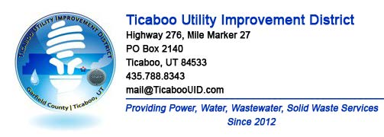
TICABOO UTILITY IMPROVEMENT DISTRICT
PUBLIC NOTICE Board of Trustees regularly scheduled meeting
DATE: Wednesday March 13th 2024
TIME: 12:00 PM
LOCATION: Electronic Meeting
Pursuant to House Bill 5002, 'Open and Public Meetings Act Amendments,' passed during the 2020 Fifth Special Session of the Utah Legislature and codified under Utah Code Ann. § 52-4-207(4), I, Alexa Wilson, hereby make the following written determination in my capacity as Chair of the Board of Trustees of the Ticaboo Utility Improvement District warranting the TUID Board to convene and conduct electronic meetings without a proper anchor location:
AGENDA
1. Call Meeting to Order – Alexa Wilson
a. Roll Call of Board Members – Alexa Wilson
2. Adoption of Agenda – Alexa Wilson
3. Approval of minutes- From February special meeting- Alexa Wilson
4. Review procedures for handling electronic participation by the public – Alexa Wilson
5. Public Comment -- TUID welcomes comments from the public. The Board sets aside 15 minutes at each Board meeting to hear from anyone wishing to speak. Each presenter is allowed one opportunity and has up to three (3) minutes for remarks. Any member of the public who desires to make a comment shall use the 'raise hand' feature during the Google Meet meeting. The public comment segment of the Board meeting is not the time for a question-and-answer discussion. TUID staff are available for dialogue outside of Board meetings.
6. 2024 Hinton Burdick engagement letter for 2023 audit. Review letter and board vote on approving HB for 2023 audit including fee to be charged of $12,400.00
7. Vote on Solid waste resolution R-2024-02
8. Board Reports- Updates on rate and revenue discussions- Alexa Wilson. Updates- Amy Golden, Mike Morlang. Water rights update and update on fuel surcharge.
9. General Manager and Management Team report. John Motley - Ray Golden.
a. John Motley 2023 Year end report and 2023 qtr. 4 financials and 2023 summary financials report and presentation.
10. Confirm the next meeting date for April 2024.
11. Adjournment

