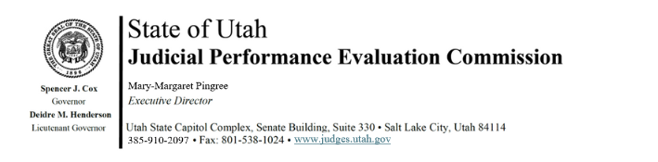

Judicial Performance Evaluation Commission
AGENDA
Tuesday, March 12, 2024
8:30 am-12 noon
Hybrid Meeting *

Members: Mallory Bateman, Christine Durham, Sherrie Hayashi, Blair Hodson, Rick Hoffman, James C. Jenkins, Curtis M. Jensen, David J. Jordan, Sonya Martinez-Ortiz, Gil A. Miller, Bridget Romano, Tom Ross, Shannon Sebahar

Staff: Madison Klein, Chris Russell, Mary-Margaret Pingree, Jason Mata, Chris Pieper (Attorney General’s Office)

8:30 a.m. Welcome Gil Miller
Approval of Minutes – February 20, 2024

8:35 Announcements Mary-Margaret Pingree

8:40 Administrative Rule Updates Mary-Margaret Pingree

8:50 2024 Retention Evaluations Chris Russell
Closed Session Jamie Nelson
Jason Mata
10:30 Break

10:45 2024 Retention Evaluations Madison Klein
Closed Session Mary-Margaret Pingree

10:45 2024 Retention Evaluations - Voting Gil Miller
Open Session

12 noon Adjourn

Next Meeting: Tuesday, March 26, 2024
8:30 a.m. – noon
3760 S. Highland Drive, 4th Floor

*Anchor Location: 3760 S. Highland Drive, Salt Lake City, UT 84106

