

Lake Point General Plan
V.5 DRAFT, 2024

Note: Thank you for your participation in the development of this plan! Any future comments can be made at the City Council public hearing on 02.28.2024

Lake Point’s Vision
Lake Point envisions a city where Liberty and Freedom are the guiding principles that inspire us to continue the country lifestyle that is conducive to raising families. We value preserving our rural lifestyle and heritage, as well as our community's core values. We welcome new residents and ask for their help in sharing our commitment to maintain a peaceful and self-sufficient way of life.
We believe that the natural beauty, gorgeous sunsets, and resources of Lake Point provide ample opportunities for individuals and families to live fulfilling lives, free from the stresses and pressures of urban living. Our commitment to limited government, property rights, and free enterprise allows us to cultivate a community that values individual responsibility and initiative. We recognize that the more transparent our government is, and the more that we provide opportunities for the community to be involved, the better our city will become.
We envision a Lake Point where our children can thrive, our families can grow, and our community can prosper. Our commitment to preserving our rural way of life and promoting freedom and liberty for all is what sets us apart and makes Lake Point a truly special place to call home.

Lake Point’s Core Values
In 1854 (MDCCCLIV) E.T. City was founded. It is known today as Lake Point and these founding principles of its roots still guide its destiny:
M | Magnanimity – Family has always been a strength for Lake Point. Whether longtime residents or recently moved in, Lake Point has always had a beautiful ability to become an extended family for its residents where they feel at home.
D | Decency – As Lake Point continues to grow, we realize that our strength comes from the many individuals who make up our community. Being decent to one another is more than just manners, it includes being honest, civil, and respectful of ourselves, other people and their property, and working together as allies to protect our desired quality of life.
C | Capitalism – The highest level of prosperity that may occur within Lake Point, is when a free-market economy and a minimum of government regulations is implemented. Throughout the years, this has brought many businesses to our town and we have watched them thrive in this environment. We see these businesses give back in many ways and are grateful for them.
C | Courage – Lake Point residents stand up and stand together. We thoughtfully take action to preserve our way of life, addressing all challenges and threats, both internal and external, to ensure the continued prosperity and well-being of our city.
C | Character – Lake Point citizens maintain terrific (T.R.R.F.C.C.) Character: Trustworthiness, Respect, Responsibility, Fairness, Caring, and Citizenship. *
L | Liberty – Lake Point loves living in a community free from oppressive restrictions imposed by any authority on one’s way of life and behavior. We realize how careful we must be in exercising our freedom in such a way as to not infringe upon the liberty of ourselves or others.
I | Inalienable Rights – Lake Point residents are endowed by their Creator with unalienable Rights, such as Life, Liberty and the pursuit of Happiness. The city of Lake Point is charged to guard and protect these rights for all those who enter its boundaries. We embrace the spirit of The Declaration of Independence, and we commit to upholding and cherishing these fundamental rights for the well-being and prosperity of our community.
V | Vigilance and Volunteerism – Lake Point must be ever vigilant in keeping its newfound freedom. To help achieve this, city residents recognize the importance of their role as they Volunteer to serve our community. Citizens have the responsibility to be involved, speak up, and provide feedback to better our community. Abundant volunteer service is critical in creating our community. That service will provide a vibrant, friendly, rural community for all of us to enjoy right now and for many more years to come.
*https://tinyurl.com/trrfcc
TABLE OF CONTENTS

EXECUTIVE SUMMARY 8
1 - COMMUNITY CONTEXT + VISION 9
1.02 Historical Settlement 9
1.04 Prior General Plan 10
1.06 Current and Expected Development 10
Exhibit 1.06.1 Overview Map of Lake Point 11
1.08 Population Estimate (2023) + Outlook 12
Exhibit 1.08.2 Socioeconomic Indicators (US Census) 13
1.10 Land Ownership and Capacity 14
Exhibit 1.10.01 Public Land Map 15
Exhibit 1.10.02 Development Suitability Map 16
1.12 Potential for Development 17
1.14 Anticipated Changes + Future Scenario 17
1.16 Community Input Summary 18
1.18 Vision Statement 18
2 - LAND USE 20
2.02 Current Conditions 21
Exhibit 2.02.1 Current Zoning Map 22
2.04 Desired Future - Land Use 23
2.06 Anticipated Changes 23
Exhibit 2.06.1 Development Potential Illustration 24
2.08 Areas with Development Potential 24
2.10 Agricultural Protection Areas 25
Exhibit 2.10.1 Illustration of Agricultural Protection Areas 25
2.12 Site Planning Considerations 25
2.14 Future Land Use Designations 26
Exhibit 2.14.1 Conservation (CRPO) Land Use Type 27
Exhibit 2.14.2 Residential (1 dwelling unit/acre) (RR-1) Land Use Type 28
Exhibit 2.14.3 Commercial - Neighborhood (CN) Land Use Type 29
Exhibit 2.14.4 Commercial - Highway (CH) Land Use Type 31
Exhibit 2.14.5 Commercial - General (CG) Land Use Type 33
Exhibit 2.14.6 Industrial (IND) Land Use Type 35
Exhibit 2.14.7 Multiple-Use Development (MU-40) Land Use Type 37
2.16 Future Land Use Map 38
Exhibit 2.16.1 Future Land Use Map 39
Exhibit 2.16.2 Parcel Map 40
2.18 Goals + Objectives: Land Use 40
2.20 Implementation Action Steps: Land Use 41
3 - COMMUNITY DESIGN 42
3.02 Existing Conditions: Community Design 43
3.04 Desired Future: Community Design 43
3.06 Anticipated Changes 43
3.08 Beautification + Nuisances 43
3.10 Dark Sky Preservation 44
3.12 Goals + Objectives: Community Design 44
3.14 Implementation Action Steps: Community Design 45
4 - LOCAL ECONOMY 46
4.02 Current Conditions 47
4.04 Desired Future: Local Economy 47
4.06 Anticipated Changes: Local Economy 47
4.08 Goals + Objectives: Local Economy 47
4.10 Implementation Action Steps: Local Economy 48
5 - TRANSPORTATION 49
5.02 Current Conditions + Regional Plan 49
Exhibit 5.02.1 Traffic Count Map 51
Exhibit 5.02.2 Vehicle Accident Map 52
5.04 Desired Future 53
Exhibit 5.04.1 Concepts for Future Transportation Plan 53
5.06 Transportation Network Map 54
Exhibit 5.06.1 Future Transportation Corridor Map 54
5.08 Anticipated Changes + Future Growth 55
5.10 Impact Fees + Traffic Impact Studies 55
5.12 Roadway Design 55
5.14 Active Transportation Facilities 56
5.16 Goals + Objectives: Transportation 56
5.18 Implementation Action Steps: Transportation 57
6 - HOUSING 58
6.02 Current Conditions 59
6.04 Desired Future: Housing 59
6.06 Anticipated Changes 59
6.08 Goals + Objectives: Housing 59
6.10 Implementation Action Steps: Housing 61
7 - PARKS + RECREATION 62
7.02 Current Conditions 63
Exhibit 7.02.1 Parks and Recreation Map 64
Exhibit 7.02.2 Existing Walking / Running Route Map 65
Exhibit 7.02.3 Existing Biking Route Map 66
7.04 Desired Future 67
7.06 Anticipated Changes 67
7.08 Goals + Objectives: Parks and Recreation 67
7.10 Implementation Action Steps: Parks and Recreation 68
8 - TRAILS 69
8.02 Current Conditions 69
Exhibit 8.02.1 Proposed Trail Map 70
8.04 Desired Future 70
8.06 Anticipated Changes 71
8.08 Goals + Objectives: Trails 71
8.10 Implementation Action Steps: Trails 71
9 - INFRASTRUCTURE + PUBLIC FACILITIES 73
9.02 Current Conditions 74
9.04 Desired Future 74
9.06 Anticipated Changes 74
9.08 County Public Works 75
9.10 Culinary Water 75
Exhibit 9.10.1 Oquirrh Mountain Water Connections 76
Exhibit 9.10.2 Map of Water District Service Areas 77
9.12 Solid Waste 77
9.14 Sewer System 77
9.16 Cemetery 78
9.18 Goals + Objectives: Infrastructure 78
9.20 Implementation Action Steps: Infrastructure and Public Facilities 79
10 - RISK + RESILIENCE 80
10.02 Current Conditions 80
10.04 Desired Future: Risk + Resilience 81
10.06 Anticipated Changes 81
10.08 Community Risk Analysis 81
10.10 Public Safety Capabilities 82
10.12 Emergency Preparedness + Hazard Mitigation 82
Exhibit 10.12.1 Fire Risk Estimate Map 83
10.14 Goals + Objectives: Risk and Resilience 83
10.16 Implementation Action Steps: Risk and Resilience 84
11 - HERITAGE + CULTURE PRESERVATION 85
11.02 Current Conditions 86
11.04 Desired Future 86
11.06 Anticipated Changes 86
11.08 Goals + Objectives: Heritage and Culture 86
11.10 Implementation Action Steps: Heritage and Culture 86
12 - ENVIRONMENT 88
12.02 Existing Conditions 89
12.04 Desired Future 89
12.06 Anticipated Changes 89
12.08 Groundwater + Water-Related Land Use 90
Exhibit 12.08.1 Water-Related Land Use Map 90
12.10 Air Quality 91
12.12 Wetlands 91
Exhibit 12.12.1 Wetlands Map 91
12.14 Goals + Objectives: Environment 92
12.16 Implementation Action Steps: Environment 93
APPENDIX A: PLAN AUTHORITY 94
A.02 Introduction 94
A.04 State Law and the General Plan 95
A.06 Past Planning Efforts 95
A.08 Development of this Plan 95
A.10 Amending the General Plan 96
A.12 Implementation of the Plan 96
APPENDIX B: PLAN DEVELOPMENT 97
B.02 Public Interaction 97
Exhibit B.02.1 Public Website 98
Exhibit B.02.2 Public Outreach Materials 99
Exhibit B.02.3 Public Interaction Graphics 100
B.04 Community Surveys 100
APPENDIX C: DEMOGRAPHIC PROJECTION METHODOLOGY 102
C.02 Future Analysis 102
APPENDIX D: STATE COMPLIANCE 104
D.02 State Statute Compliance 104

EXECUTIVE SUMMARY
Development decisions are constantly evolving and greatly influence community appearance and identity. Within a community, personal decisions can have an impact on neighbors, a section of the City, or the City as a whole. Because of the effects of these decisions, either real or perceived, the city government has the role of balancing the rights of individuals with those of the public good. Defining the public good is not always an easy task, and requires vision and foresight.
Community leaders recognize the fine balance associated with its standards and regulations, and there is typically an ongoing process of refinement. The intent of such standards is to build a community that will be attractive, retain property values, support a rural quality of life, and provide a great place to live today and in the years to come.

Maintaining the rural and agricultural character of the community will continue to be  one of the highest priorities of residents. |  | The regional economy will continue to be a major factor in local housing demand and cost. |  | As the region continues to grow, Lake Point (and the County) will need to increase its investment into public safety services.
Utility service providers are expecting aggregate usage to continue to increase as population increases. |  | Lake Point will need to address road conditions, alternative routing, and modes of transportation within regional growth areas in order to avoid high traffic and poor road conditions. |  | The City should collaborate with residents, property owners, and the park district to identify and secure future city park locations, fostering a collective effort to preserve essential properties.

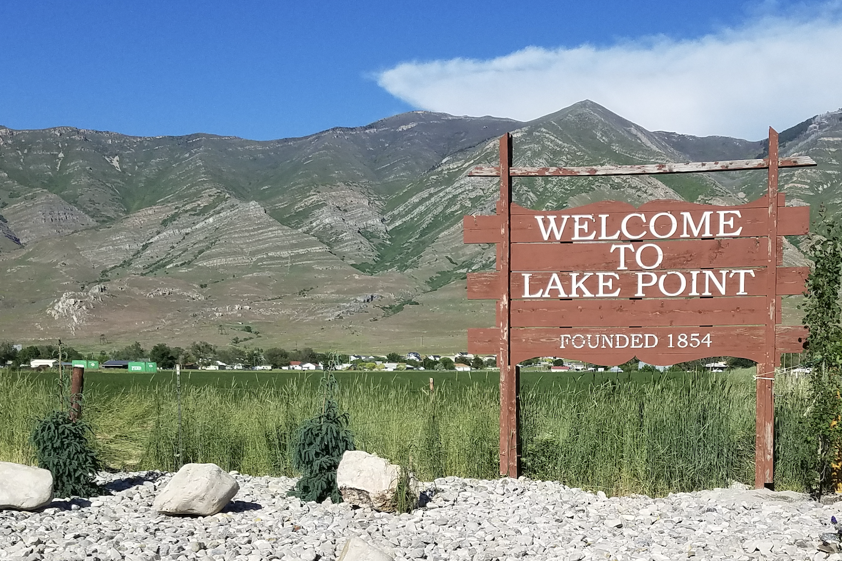

1 - COMMUNITY CONTEXT + VISION

1.02 Historical Settlement
- The Lake Point area in Tooele County, Utah, has a rich history that dates back to its original settlement in 1854. At that time, the area was established under the name of E.T. City. Early settlers were attracted to the region's open lands, proximity to water sources, and its potential for agriculture and livestock. They worked hard to establish a community, cultivating crops, raising livestock, and building homes. In order to establish the community, providing water for irrigation was critical. In June of 1879 work was completed on an earthen canal that would bring water to the early development of E.T. City. This canal was a little over 4 miles in length and dug in its entirety by the residents of the small community using teams of animals and manual labor to create the E.T. Canal company which provided water for irrigation and still serves Lake Point today.
- Over the years, the area experienced growth and development, evolving into a vibrant community. In 1923, the residents collectively decided to rename the settlement to Lake Point. The new name reflected the area's prominent feature, its proximity to the Great Salt Lake.

1.04 Prior General Plan
- The Lake Point area incorporated in late 2022. The land use planning done for the area prior to this initiative was conducted by the county and adopted in that same year. The general vision for that plan was to follow current land use trends (commercial corridor along the highway with residential areas to the east). The plan was not strongly supported by residents in part because of the higher level of intensity of residential that was outlined by that plan.

1.06 Current and Expected Development
- Lake Point has a high potential to experience significant commercial development in the near future. Recent developments in the Lake Point area have focused on expanding residential areas to accommodate the increasing population in the region.
- As a rapidly growing community, Lake Point should expect to see consistent growth in population and the requisite infrastructure improvements. The city is strategically positioned near the employment centers of the Wasatch Front and benefits from its proximity to major transportation corridors, including Interstate 80. Looking ahead, Lake Point is expected to continue its upward trajectory, with projected growth in both residential and commercial sectors.
- This was a section that had the 874 parcels of record…. With an average parcel value and a comparison to state avearge and Tooele count

Exhibit 1.06.1 Overview Map of Lake Point
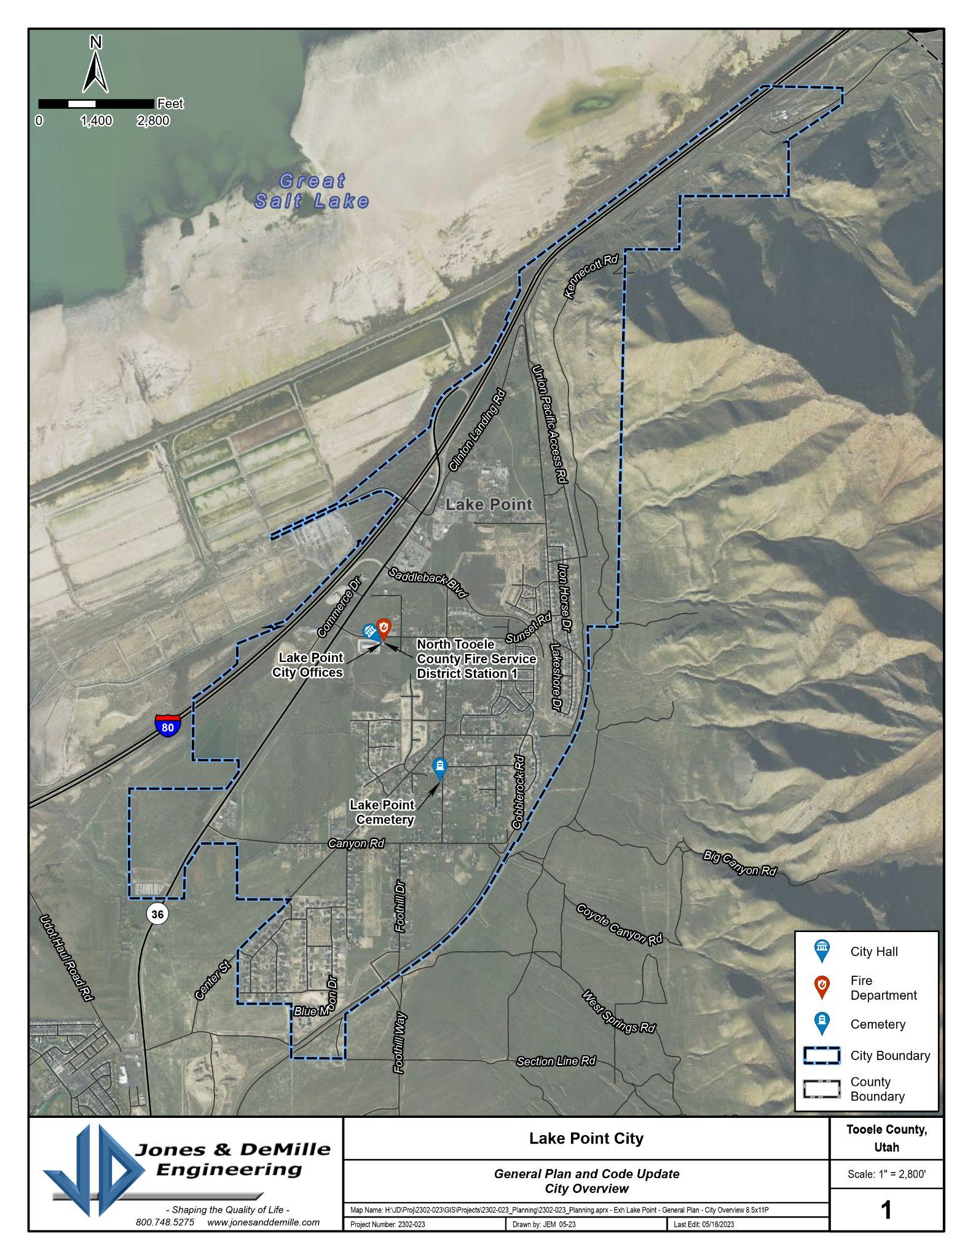
General layout of Lake Point, 2023. (click for original).

1.08 Population Estimate (2023) + Outlook
- Estimating Lake Point’s socioeconomic indicators is going to be a challenge until the next Census initiative. The 2020 Census tract that includes Lake Point also includes a significant amount of area that is outside of the actual City’s boundary (most of the east side of the Tooele metro area).
- As of the general plan’s adoption in early 2024, Lake Point estimates that its population is 3,700. This estimate is driven by the following considerations:
  - The Kem C. Gardner Policy Institute estimated that the July 1, 2020 population for Lake Point was 2,346 and that it grew by 505 people in the following two years (2,851 in July 2022).
  - The ESRI ArcGIS Business Analyst estimated a 2023 population of 2,988 when a polygon was drawn in the shape of the city boundary. The remaining socioeconomic indicator estimates produced by the ESRI model are shown in the infographic below.
  - The Incorporation Study conducted in 2021 estimated a 2023 population of 3,939. This calculation is based on an average household size of 4.12 and projected a rate of growth based on building permits issued for the area since 2016.
  - Lake Point initiated a new residential garbage collection service in 2023. They had 893 units sign-up. Assuming an average household size of 4.12, the population would be approximately 3,679.
- Appendix C provides a methodology for estimating a “build-out” population that could be done in the future. The table below presents a population scenario if the community developed completely and according to the designations of the future land use map (and within the current municipal boundary).

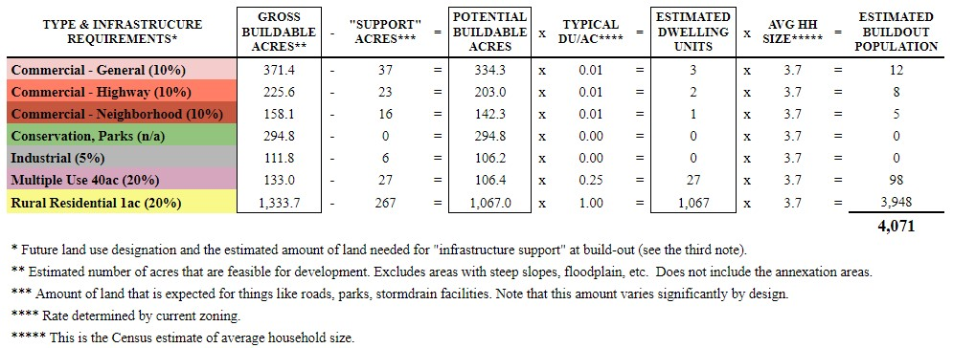

Exhibit 1.08.2 Socioeconomic Indicators (US Census)
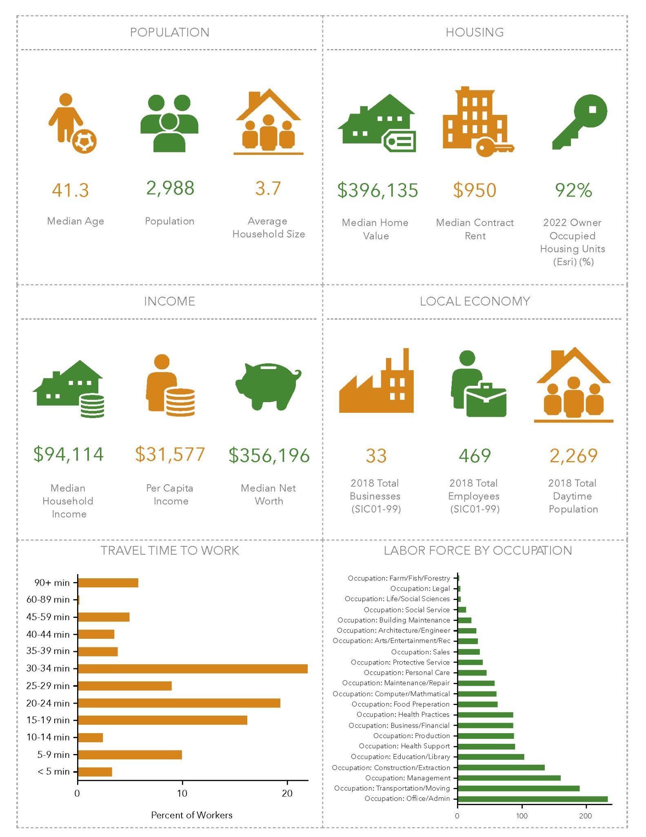Lake Point’s socioeconomic indicators as estimated by ESRI in June 2023 (click here for the original).

1.10 Land Ownership and Capacity
- The health, safety, welfare, liberty, freedom, and overall well-being of Lake Point citizens are high priority considerations. In land use decisions, special consideration should be given to the compatibility with neighboring land uses and infrastructure that is readily available within the municipality. Careful consideration should be taken regarding areas with potentially problematic slopes, soils, or drainage. All proposed uses should be properly vetted to ensure that they align with the general plan, while meeting current and future land use, zoning, and density regulations.
- Future growth should also take into consideration the impacts of water availability, the local economy, and traffic. Conscientious planning should protect the rural identity and the scenic beauty of the area.

Exhibit 1.10.01 Public Land Map
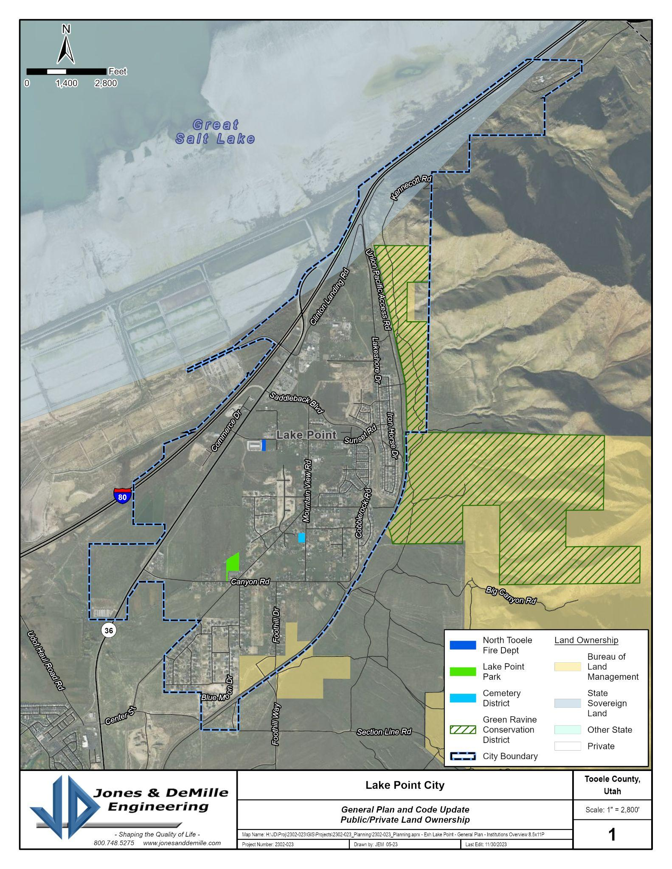
Areas of public ownership in and around Lake Point Utah (click here for original).

Exhibit 1.10.02 Development Suitability Map
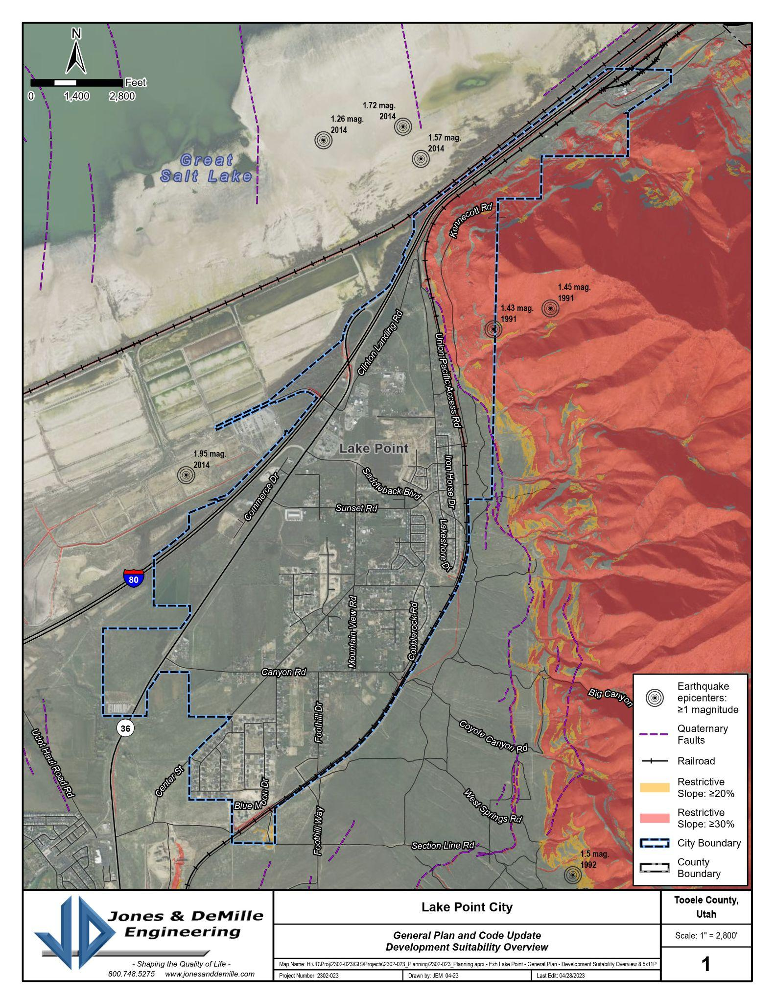
Development suitability in Lake Point Utah (click here for original).

1.12 Potential for Development
- As part of the community’s inaugural general plan initiative, residents and business owners were invited to help outline the assets and their perception of potential barriers to achieving the ideal community vision. This exercise generated a series of opportunities and constraints. These shaped the direction of the plan, and are summarized and addressed in each of the relevant chapters.
- It is widely recognized that Lake Point has a number of assets and areas of potential for future development. A few of these are illustrated in the graphic below. They include:
GENERAL OBSERVATIONS
- Availability of land for most land use types.
- The regional location of the city makes it a de facto gateway community. The area will continue to have strong demand for expanded commuter transportation investments.
- The current network of trails has significant options for expansion.
- Land ownership issues will significantly impact the rate and type of land use development into the future because there are large parcels under single ownership.
- The dependence on special districts for most utility services will require the city to maintain a high level of regional cooperation and coordination.
- Future annexation opportunities will be constrained by geography and the ability to provide services. Proposals need to be evaluated carefully to ensure that they are in the best interest of existing residents and business owners in the city.

AREA-SPECIFIC OPPORTUNITIES
1 - The undeveloped land along the commercial corridor presents a number of options for commercial, commercial-industrial, and/or mixed-use development.
2 - The western roundabout on Saddleback Blvd might be a good location for a community center.
3 - The BLM land on the south end of town might be a good location for a regional recreation facility.
4 - The existing roadways on Commerce Drive are desired to be connected into a frontage road that parallels the highway SR-36 on the east & west side.
5 - The mixed-use areas on the south end of the highway might provide an opportunity for a higher-intensity housing type (assuming that the sites can be served with sufficient utilities).
6 - The land east & west of Hwy36 and south of the current municipal boundary presents a good opportunity for community expansion.

1.14 Anticipated Changes + Future Scenario
- There will always be a gap between where the community is and where it wants to be. Getting from one to the other is the core of the city’s work. This can’t be done effectively without an idea of what the future might look like.
- There are things that the city can control, and there are things it can’t. Likewise, there are things they can be certain about, and things they can’t know for sure. While not followed strictly, the development of this plan was informed by a framework that considered those things that are more certain.
- In general, the future development scenario where Lake Point will “thrive”, “survive”, or “dive” will be driven by a number of key issues:
  - The proposed belt route along the foothill area (Oquirrh Expressway) will significantly impact the future development of the City in a negative way.
  - In order to thrive, Lake Point should thoughtfully shape its land use regulations, ensuring they embody the city's core values as a reflection of its community principles.
  - Future development of the Hwy36 corridor needs to be preserved for development and needs to have an effective transition of intensity between the commercial and residential areas.
  - There are various opinions from residents as to where the community center of Lake Point is currently.” In order to thrive, an area may need to be developed in a way that includes gathering spaces.

1.16 Community Input Summary
- Surveys were conducted as part of the general plan update in order to validate and clarify the findings of the previous plan, which was created by Tooele County when Lake Point was still unincorporated. They were used as guideposts for the general plan update and are summarized below:
  - Many residents are new to Lake Point, but they consistently identify the “rural quality of life” as the thing that drew them to the community and the thing that they want to maintain.
  - Residents are clear that they expect the Highway 36 corridor to continue to develop as infill commercial.
  - As expected in most communities, residents desire more trails, open space, and park amenities, but they are also concerned about the cost to operate them.
  - Most residents have expressed concern that residential growth has happened too quickly in the last few years and that commercial development has not kept pace.
  - There is support for code enforcement, beautification, and city cleanup efforts, but there is also a competing support for private property rights.

1.18 Vision Statement
- The community’s vision statement provides a linkage or overarching theme to the entirety of the general plan. The current community vision statement is:
“Lake Point envisions a city where Liberty and Freedom are the guiding principles that inspire us to continue the country lifestyle that is conducive to raising families. We value preserving our rural lifestyle and heritage, as well as our community's core values. We welcome new residents and ask for their help in sharing our commitment to maintain a peaceful and self-sufficient way of life.
We believe that the natural beauty, gorgeous sunsets, and resources of Lake Point provide ample opportunities for individuals and families to live fulfilling lives, free from the stresses and pressures of urban living. Our commitment to limited government, property rights, and free enterprise allows us to cultivate a community that values individual responsibility and initiative. We recognize that the more transparent our government is, and the more that we provide opportunities for the community to be involved, the better our city will become.
We envision a Lake Point where our children can thrive, our families can grow, and our community can prosper. Our commitment to preserving our rural way of life and promoting freedom and liberty for all is what sets us apart and makes Lake Point a truly special place to call home.”

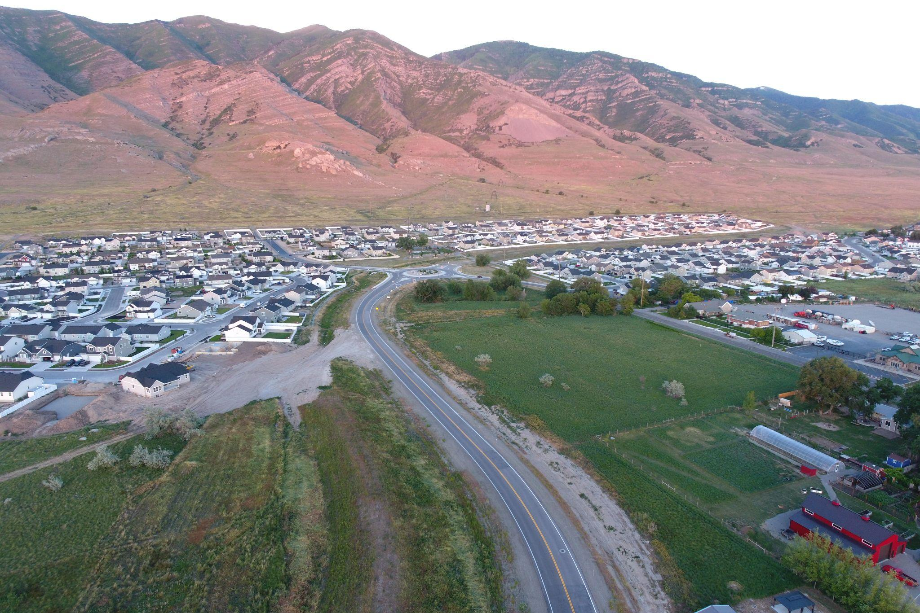

2 - LAND USE
- The Land Use Element is designed to promote sound land use decisions throughout Lake Point. The pattern of land uses—their location, mix, and density are a critical component of any planning area. The Land Use Element is meant to:
  - plan enough land for rural residential, agricultural residential, commercial, industrial, and public uses;
  - locate these uses appropriately to enhance community character;
  - preserve important natural resources; and
  - enable Lake Point to efficiently ensure adequate public services are provided for residents.

2.02 Current Conditions
- The land use chapter of the general plan considers the past and projected land use patterns of the city. It considers existing and potential conflicts between land uses, both current and future, and offers recommendations for guiding future decisions in the form of goals and objectives. The land use element of the general plan is the central element of the plan. The distribution, intensity and pattern of land uses provide the most vivid illustration of how the vision for Lake Point will be realized.
- The general plan, once adopted, should be reviewed against the current land use code of the city. While an advisory document, the general plan should align with the code and act as the rationale behind requirements in Lake Point. This chapter should be considered any time land use decisions are presented to the City although the timing of potential land use items contained in the General Plan is also important to consider as well.
- During the previous planning process that was conducted by the County, participants throughout Tooele County expressed an understanding that continued growth, when properly planned for and directed, does not have to create a conflict with maintaining the character and uniqueness of unincorporated areas of Tooele County. Participants also understand that proper rural residential and commercial growth can provide vitality to a community and add new positive opportunities.
  - Lake Point residents felt their voices were diluted and their concerns regarding increased density would threaten the existing rural character of Lake Point.
  - With the recent incorporation of Lake Point, residents now have more confidence in the City’s opportunity to manage residential and commercial growth in a smart manner that protects the rural character of the City.
Land Use OPPORTUNITIES | Land Use CONSTRAINTS
- As a new municipality, the city has the opportunity to establish very deliberate land use regulations.  - The commercial corridor along Highway 36 seems to be a natural land use pattern.  - Lake Point has potential opportunity for industrial expansion in areas with access to rail, air, and industrial-scale utilities with the likely zones for air, industrial, and rail development situated west of I-80.  - The industrial development northwest of Lake Point might be a strategic area for annexation (property tax revenue without high service requirements).  - Annexation of the area east of the railroad will help strengthen the city's position against a future Oquirrh Expressway project. | - Many residents expressed a strong concern about “runaway growth” and the need for mindful planning for the future in their responses to the general plan surveys.  - Public opinion surveys showed that less than 10% of residents can say that the land use regulations that were administered by the County had positively affected their quality of life in the past. There is significant concern about new regulation and its enforcement.  - The traffic volumes of the highway will serve as a barrier for residents and visitors to travel between the east and west portions of the city.  - The majority of the city (east of the highway) is only accessed from a few points along the corridor. New access points will need to be designed in such a way that they also provide access to the north and northwest areas.

Exhibit 2.02.1 Current Zoning Map
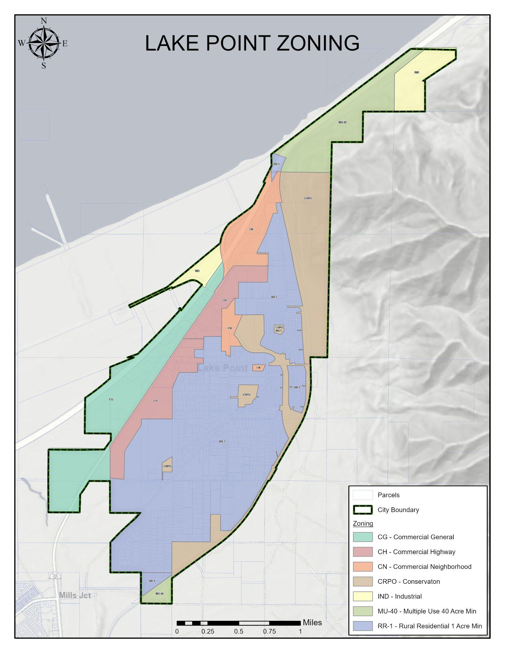
Lake Point zoning patterns as of December 2023. (click for original).

2.04 Desired Future - Land Use
- Residents and business owners expect the City to promote sound land-use decisions throughout Lake Point. The pattern of land uses—their location, mix, and density are critical components of any planning area. Principles should include:
  - Preserving historic and agricultural areas.
  - Review and consider the impact that various types of zoning and growth will have on existing rural character of the area, agriculture use, and rural residential neighborhoods with the goal of maintaining the rural small town character of the area and open feel.
  - Be mindful of land use changes as it impacts natural resources and the overall esthetic of the city.
  - Strengthen the city’s ability to benefit from sales tax revenue by encouraging growth in planned commercial areas and by developing a community core.

2.06 Anticipated Changes
- As a city (and its staff) grows, it has the opportunity to customize and refine its land use regulations and process.
- The demand for multifamily housing in the region will likely be absorbed by neighboring communities such as Stansbury Park. This would satisfy the majority of resident concerns about losing the rural atmosphere.
- As people continue to discover Lake Point, the pressure to develop land within current city boundaries is likely to increase.
- With several areas surrounding Lake Point unable to be developed due to natural barriers or ownership by federal or state agencies, the city will have to prioritize areas of value within their annexation area.
- Lake Point anticipates that landowners in unincorporated areas adjacent to the city will want to discuss annexation as the area continues to grow. As the city develops its policy on annexation, careful consideration will be given to constraints from both geography and the capacity to provide services.

Exhibit 2.06.1 Development Potential Illustration
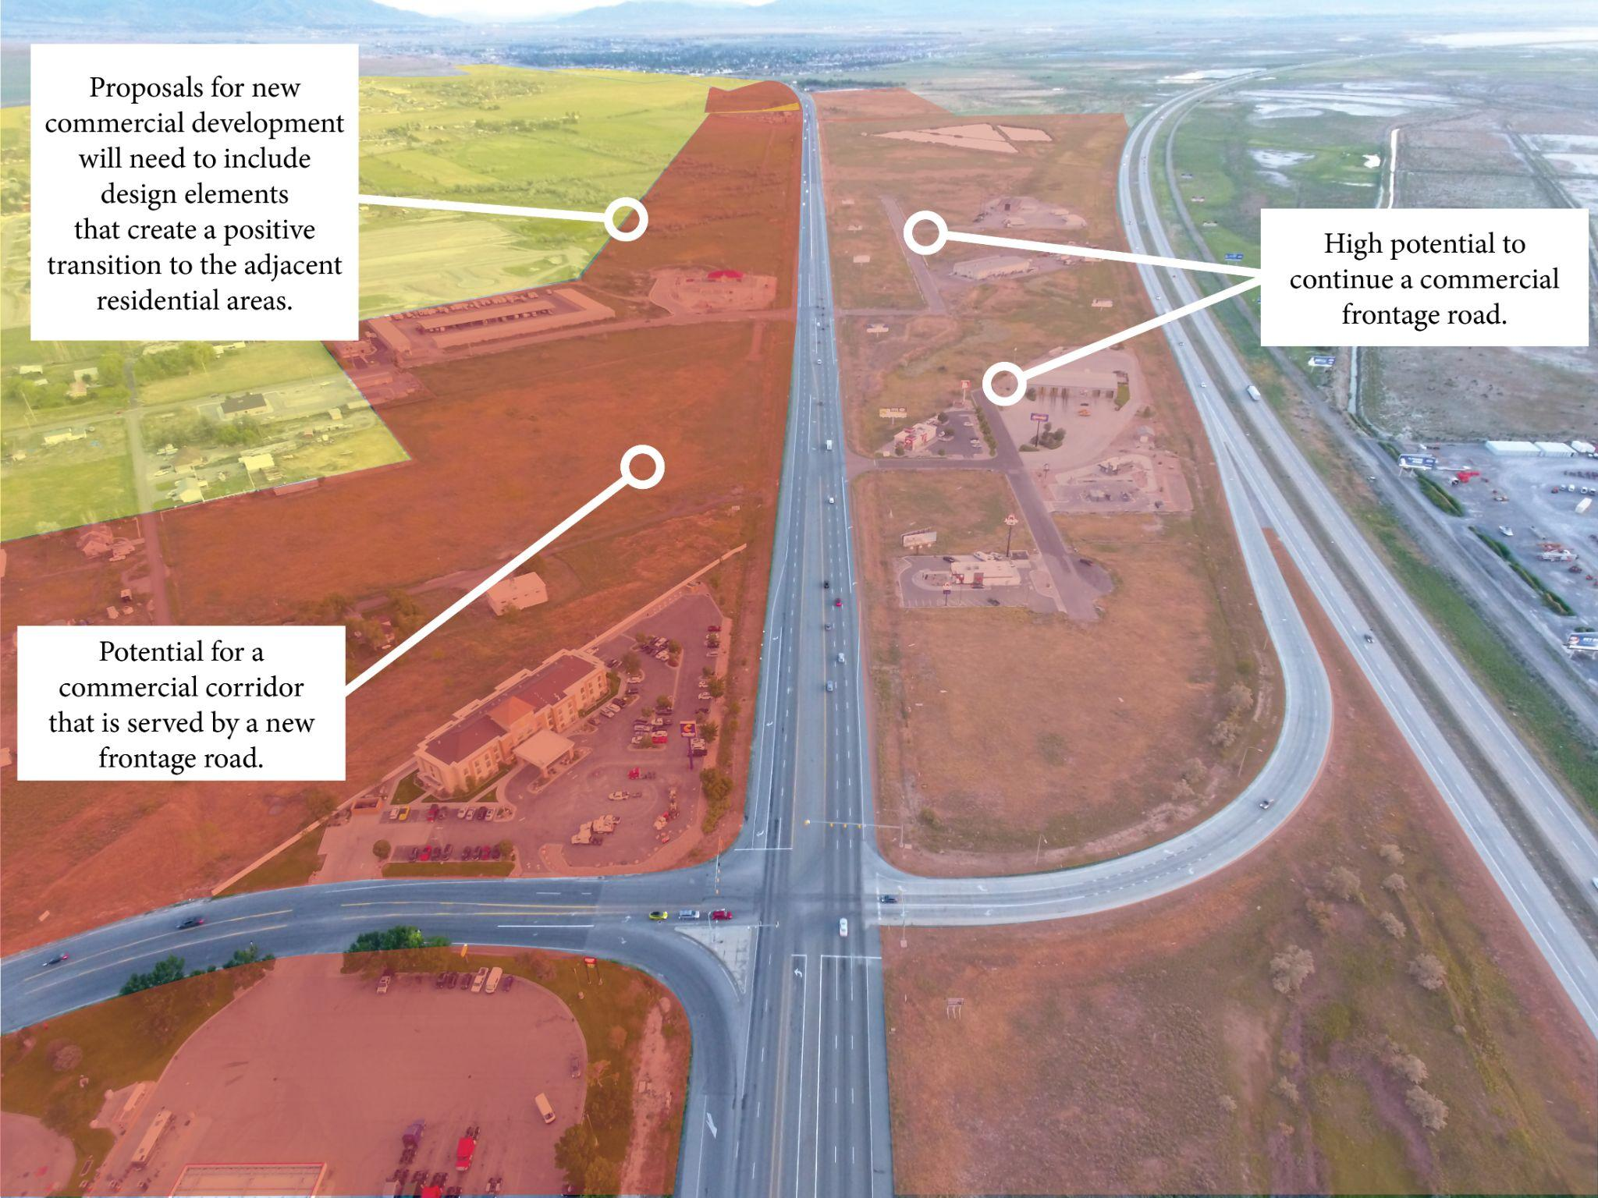
Illustration showing the potential for highway and general commercial development along Hwy36.
Note that the future commercial development will likely be best served with well-planned frontage roads.

2.08 Annexation Plan
- Responsibility of the City: Lake Point has a duty to prioritize its citizens' best interests while contemplating the city's future growth and boundary expansion. The City recognizes the importance of thoughtful planning and consideration in the annexation process to ensure responsible growth and development while respecting the desires of its citizens and preserving its rural character outlined in the general plan.
- Development of Lake Point Annexation Plan. Lake Point is in the process of developing an annexation plan with various considerations, such as the following, in mind to guide the city’s expansion of boundaries. These points collectively underscore the significance of strategic planning, community engagement, and responsible decision-making in the annexation process for Lake Point.
o Constraints on Expansion: Lake Point faces constraints on expansion due to its geographical surroundings, including the Oquirrh Mountains, the Great Salt Lake, the I-80 freeway, and the boundary with surrounding communities.
o Annexation Plan Guidance: The purpose of the annexation plan is to serve as a guide for decision-making regarding the future annexation of unincorporated lands into Lake Point. The plan should include specific details such as proposed annexation area boundaries, parcel lines, acreage, roadways, section lines, and other relevant features. The plan should also include objectives to keep land uses similar to surrounding and abutting parcels, as well as consideration for providing required utilities and services.
o Initiation of Annexation: Annexation can be initiated either by landowners expressing interest in joining the city or by the city itself initiating the annexation process for surrounding lands.
o Benefits and Responsibilities: Residents of newly annexed areas become part of Lake Point's citizenry, enjoying the benefits and sharing the responsibilities that come with citizenship.
o Landowner Petition: While there may be various considerations about a city's ability to include certain areas in its annexation plan, landowners retain the right to petition eligible cities for annexation, allowing them to explore their options for incorporation into different municipalities.

2.10 Areas with Development Potential
- Currently, there are a number of vacant lands within Lake Point limits. There are also parcels that are dedicated to agricultural use that could easily be subdivided.
- Most of the open spaces on the foothill and canyon areas are steep slopes that are adjacent to public (BLM) lands.
- Many residents in our rural community value the presence of open spaces, appreciating their contribution to the area's rural character. Infrastructure development needs a coordinated, thoughtful, and harmonious approach. The City is committed to preserving the rural charm, and although vacant or agricultural uses may generate limited tax revenue, we aim to strike a balance that sustains our open spaces while responsibly addressing the impacts associated with development.
- See also the map (Exhibit 1.10.01) of public/private land ownership in the local economy element of this plan.

2.12 Agricultural Protection Areas
- By State law, Lake Point is required to encourage the continuity, development, and viability of designated agricultural, industrial, and mining areas by not enacting a local law, ordinance, or regulation that would unreasonably restrict a farm structure or farm practice on designated agricultural land, industrial use on designated industrial land, or a mining use on designated mining land unless there is a direct relationship to public health and safety.
- Property owners may initiate a petition to create agricultural, industrial, and mining protection areas. Interested property owners are encouraged to contact the Utah Division of Agriculture and Food (as per UCA 10-9a-403(2)(c)).
- At the time of this planning initiative, there were no properties with formal agricultural protection areas within the municipal limits of Lake Point. However, residents and community leaders are clear in their support for agricultural activity in the region and even within the city limits.

Exhibit 2.12.1 Illustration of Agricultural Protection Areas
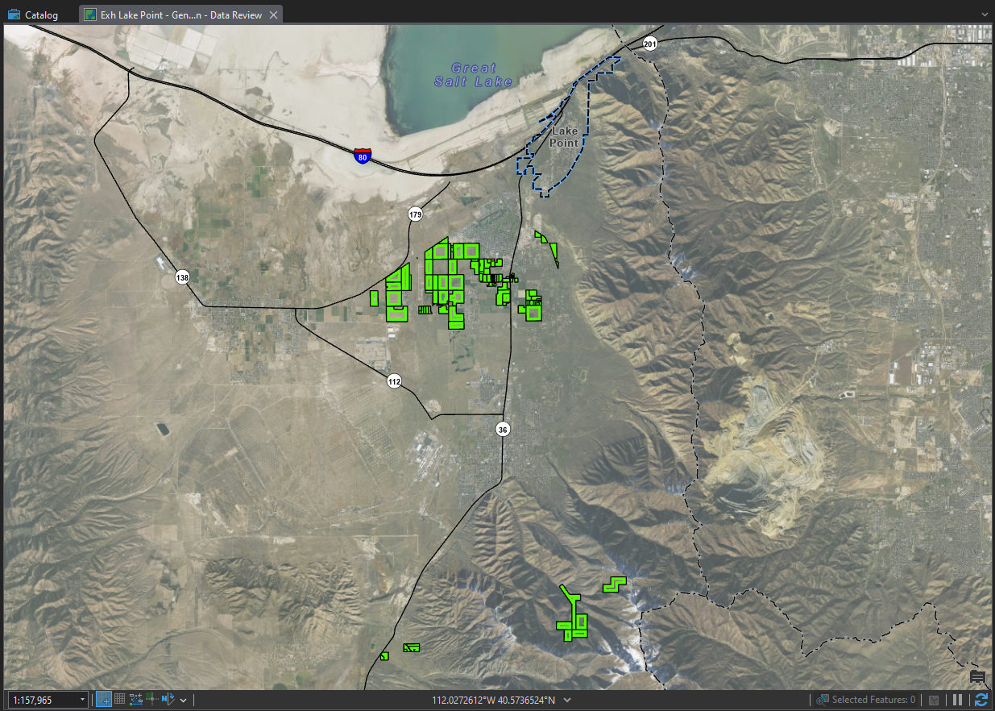Currently land designated with Agricultural Protection Areas (Utah Dept of Agriculture).

2.14 Site Planning Considerations
- The prescription of property rights on any given parcel is typically calculated in gross density. When a proposed development is located near high-capacity roadways and infrastructure systems, it may be in both the city’s and the developer’s best interests to program the site in a way that concentrates some of the use toward the infrastructure, such as a roadway. (This is particularly true of large parcels). The City encourages development that can maintain the required gross density within the zoning designation, but that transitions the intensity of use away from corridors into lower-intensity uses/zones.

2.16 Future Land Use Designations
- Land use designations are intended to promote sound land use decisions throughout the community. In the City, this is done through their zoning ordinance. The pattern of land uses—their location, mix, and density are critical components of any area. They do this by:
  - planning enough land for residential, commercial, industrial, and civic uses;
  - locating uses appropriately to enhance community character;
  - preserving important natural resources; and
  - enabling the City to efficiently ensure adequate public services are provided for residents.
- The land uses described in the tables below refer to the Future Land Use Map (Exhibit 2.18). They take into consideration private property rights, topography, the infrastructure/transportation system, and the local economy while addressing the community’s vision, values, and principles outlined in the remainder of this Plan.

Exhibit 2.16.1 Conservation (CRPO) Land Use Type
Areas dedicated primarily to open space, recreation, and agricultural pursuits (including the keeping of farm animals). City zoning laws should limit development in these areas in order to contribute to a distinctively rural environment. | - Preferred Design Elements -  - Land Uses: The conservation designation is intended to protect and preserve open space and agriculture uses that characterize the city and maintain a buffer between some uses. In many cases, these are also lands that have significant environmental issues such as a high water table, significant slopes, etc.  - Conservation easements are encouraged.  - Limitations to development in environmentally sensitive areas may also exist.  - Land use regulations for these areas should also consider agricultural protection issues.  - Public access to recreational open space should be a priority.
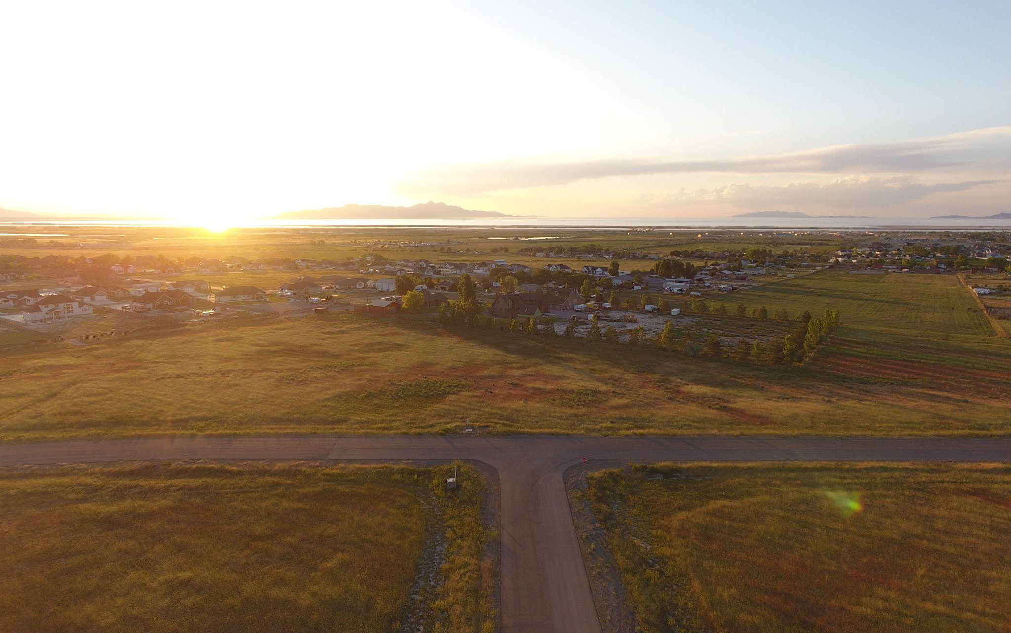
Example: undeveloped lands adjacent to neighborhood areas.
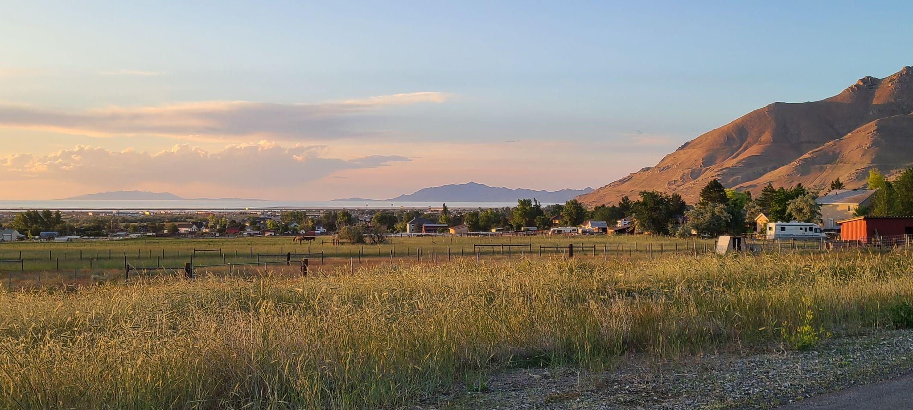 | 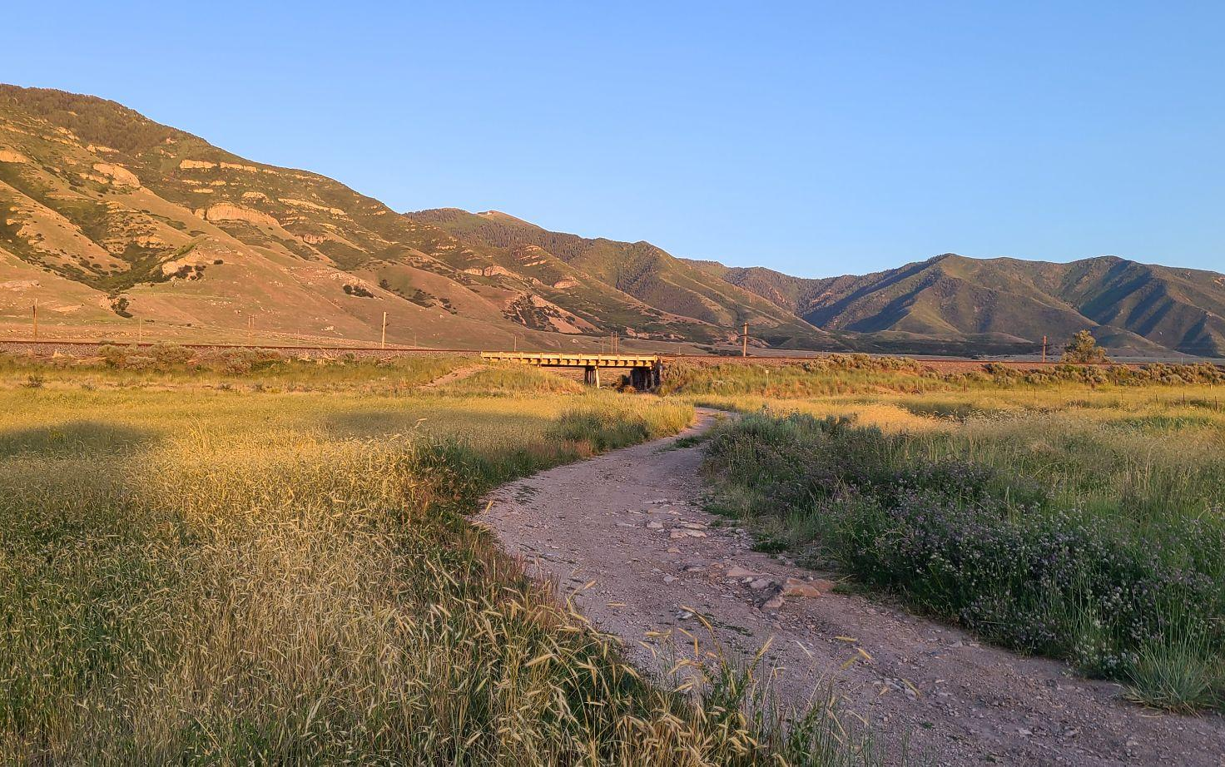
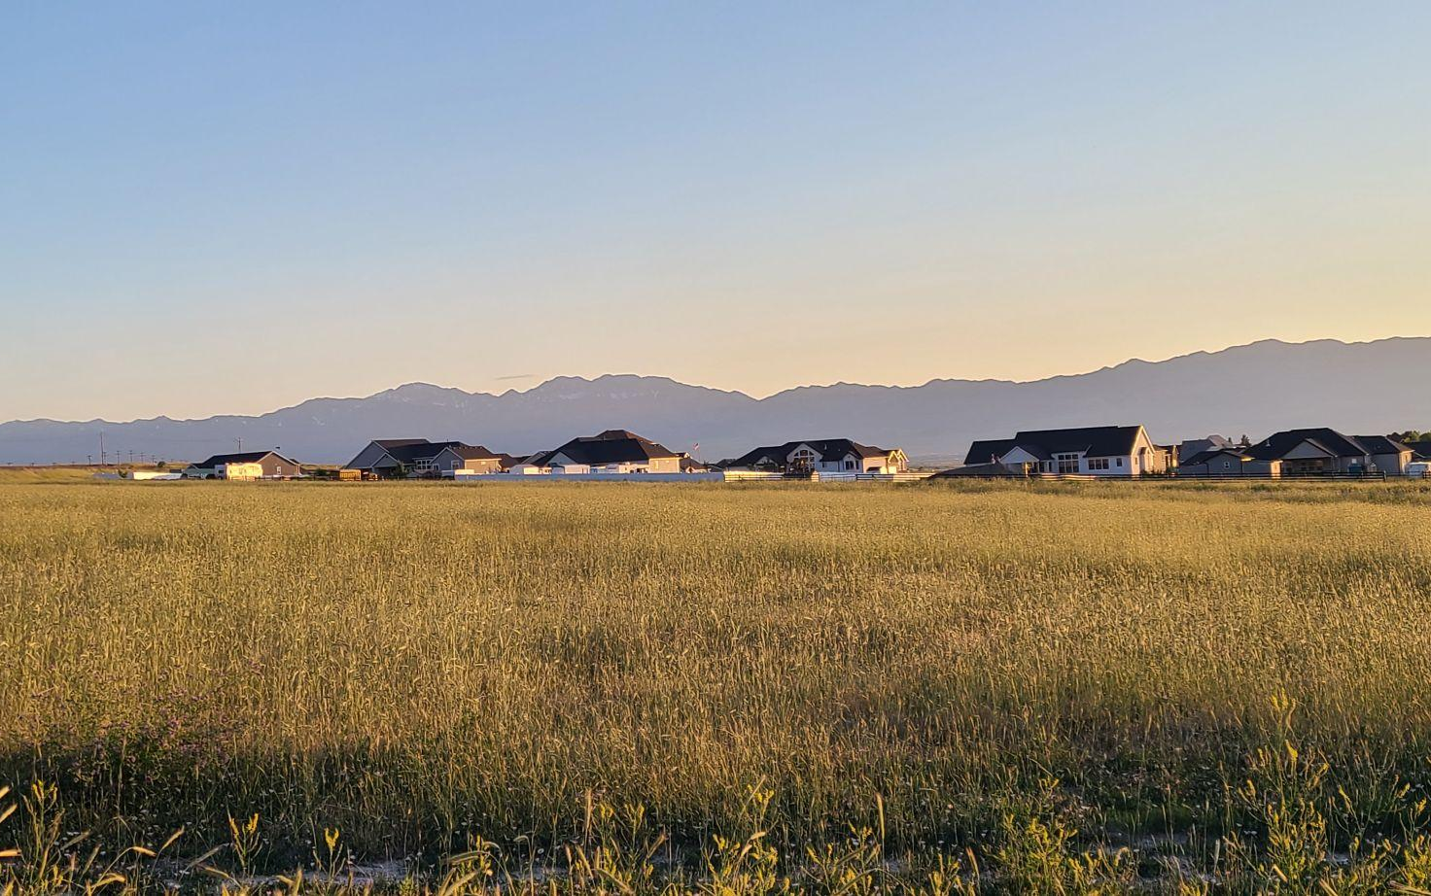 | 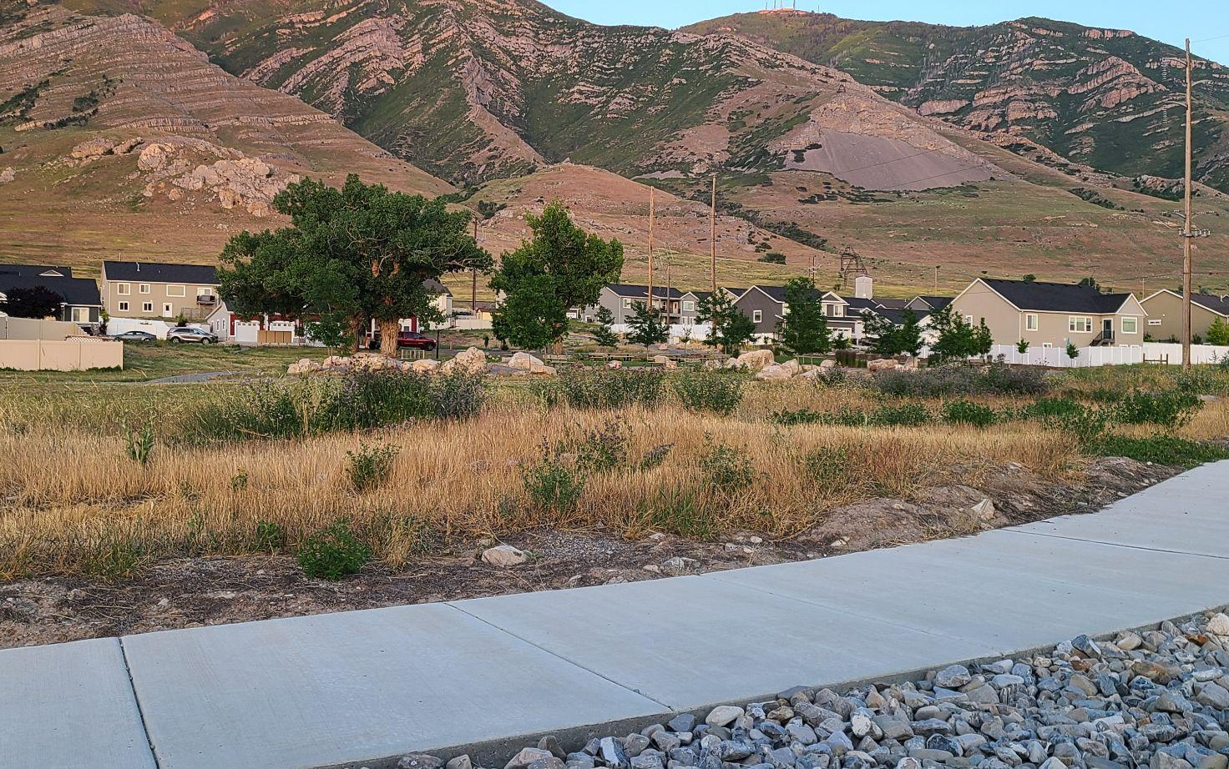

Exhibit 2.16.2 Residential (1 dwelling unit/acre) (RR-1) Land Use Type
Areas in the community characterized by low density residential development, (commingling of one-family detached dwellings and duplexes on individual lots), agricultural activities, parks, playgrounds, museums, libraries, senior citizen centers, schools, and churches. | - Preferred Design Elements -  - Building Design: Design projects to enhance the appearance of and contribute positively to the existing visual context of the neighborhood. The scale, massing, and height of new buildings should be considered in relation to adjoining buildings.  - Roadways + Parking: Roadway design should incorporate stormwater considerations and adequate sight distances. Beyond basic residential driveways, pervious paving is encouraged for parking areas to preserve stormwater infiltration.  - Landscaping: Require buffering, screening, and landscaping between major roadways and neighborhood areas that may include sound/safety walls.
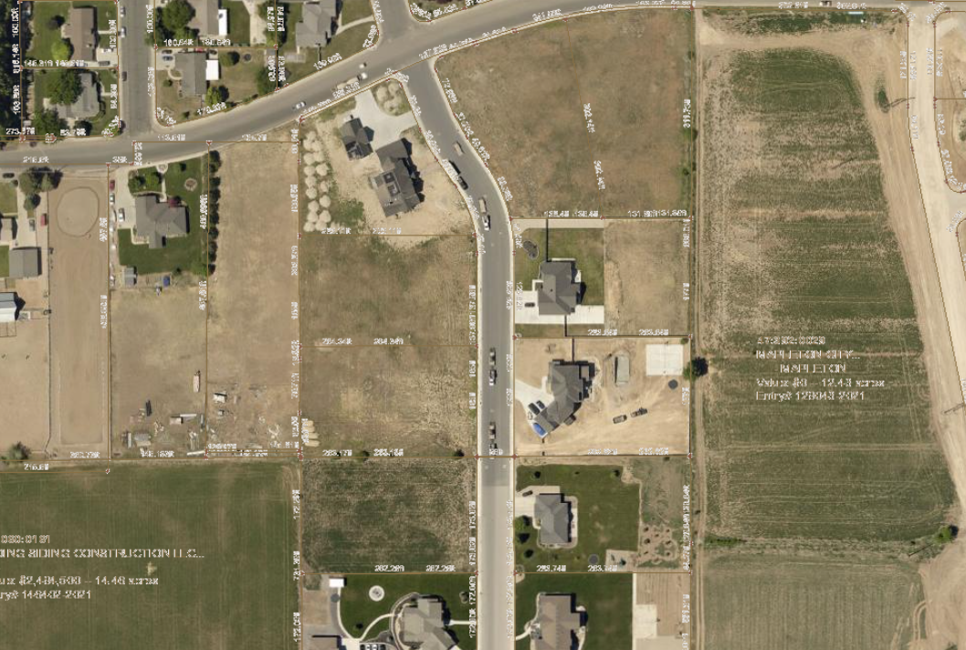
Example: detached units with 1 acre lots.
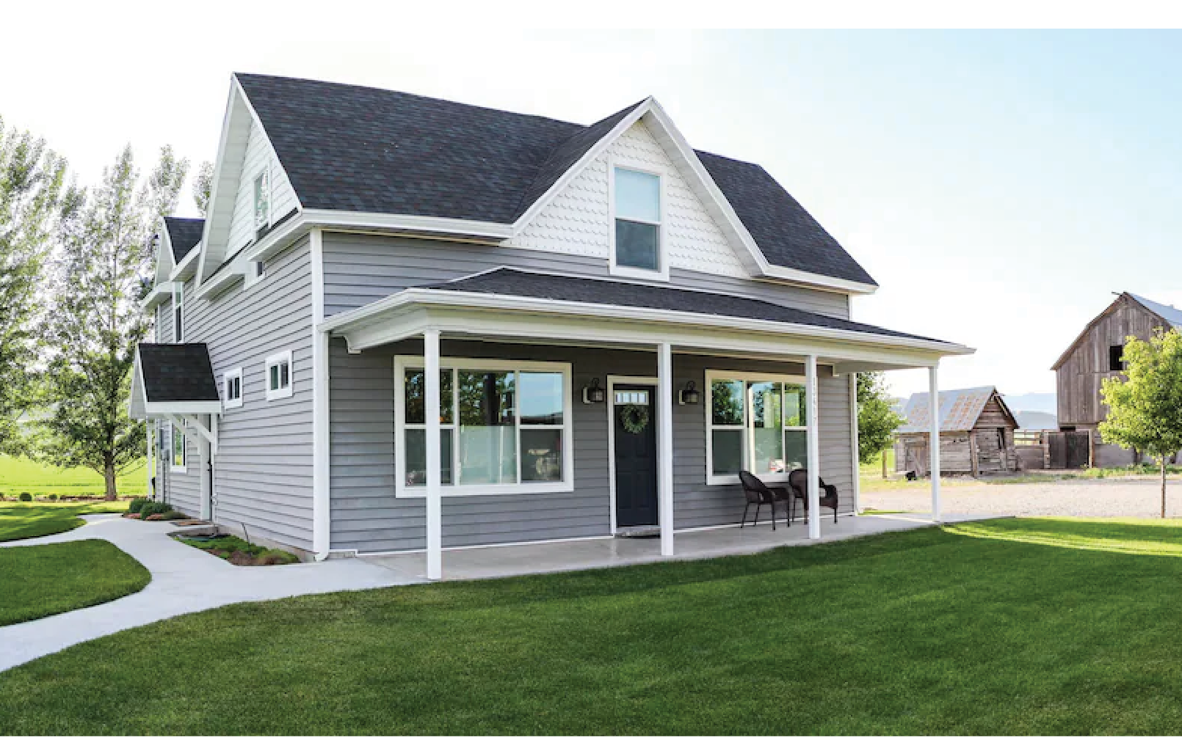 | 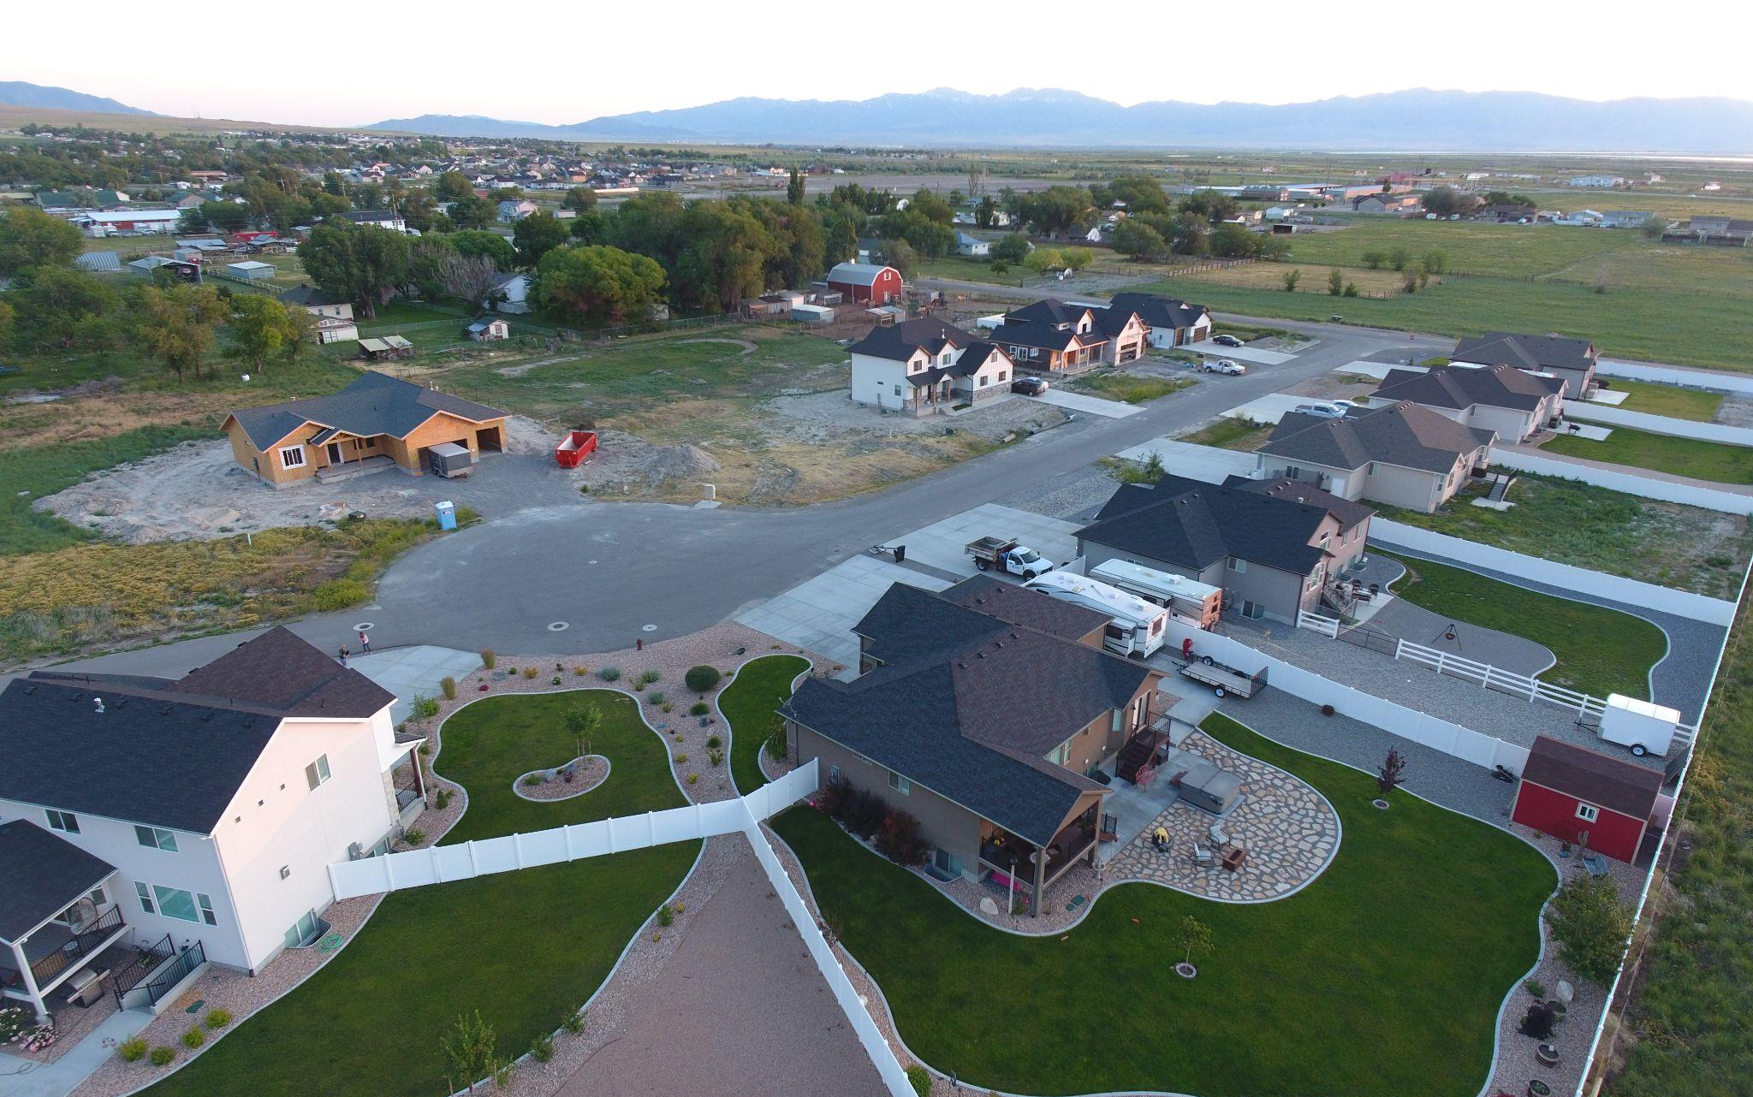
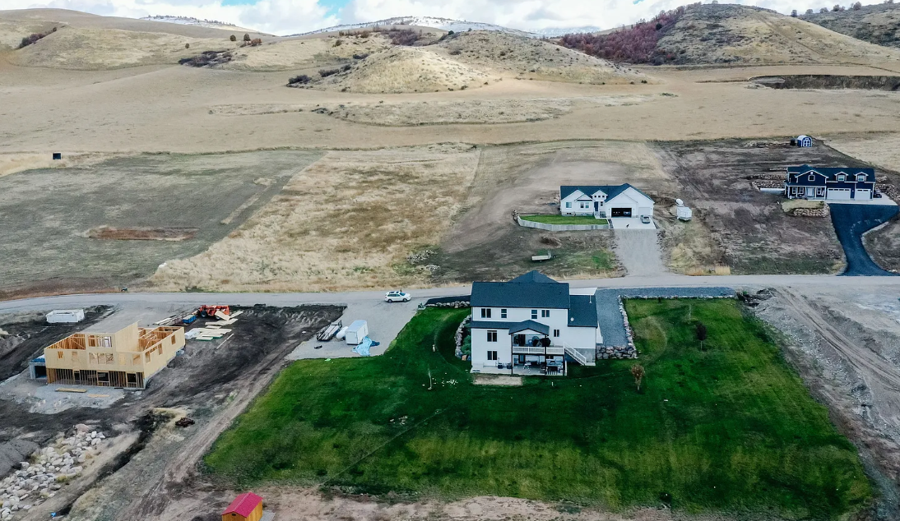 | 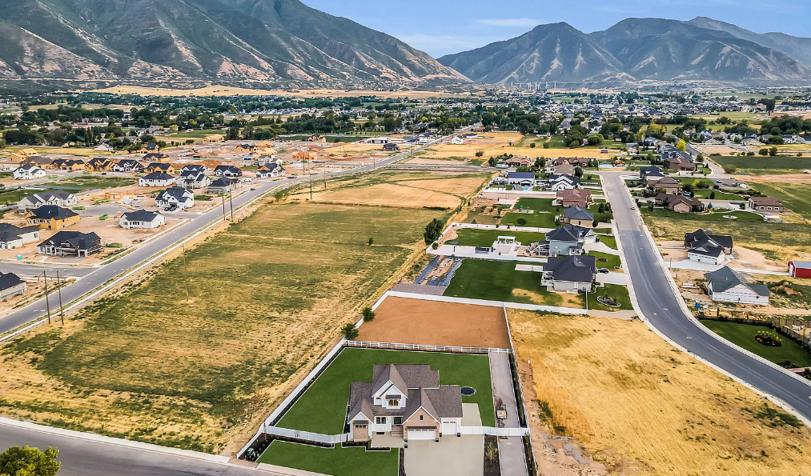

Exhibit 2.16.3 Commercial - Neighborhood (CN) Land Use Type
The purpose of the neighborhood commercial areas is to provide a combination of retail businesses which in character and scale are desired to meet day-to-day needs of area residents and harmoniously blends with residential zoning..  It is recommended to incorporate a vibrant pedestrian design element that fosters open spaces for pedestrians, including interconnected walking paths and trails linking diverse businesses within the district. Surrounding buildings should feature landscaping that evokes an open country ambiance, complemented by strategically placed benches to encourage leisurely enjoyment of the area.  Business establishments within this zone are encouraged to embrace a design aesthetic reminiscent of a rural agricultural atmosphere, drawing inspiration from country, cottage, rustic, farmhouse, and lodge design elements. It is advisable that businesses maintain a family-friendly environment, aligning with the character of areas near public or private schools, parks, and other family-centric destinations.. | - Preferred Design Elements -  - Building Design: Desirable characteristics include clean storefronts, limited signage, compatible scale/building design, and landscaping that improves the neighborhood character, rather than standardized corporate model buildings and logos.  - Roadways: The optimal site for this designation should be situated in close proximity to roadways, ensuring seamless access for both automotive traffic and pedestrians. It is crucial for developments in this area to prioritize creating a buffer between automotive and pedestrian traffic, fostering a secure and pleasant environment for walking.  - Land Uses: When commercial uses are adjacent to residential areas, special care must be taken to ensure privacy and to protect personal property with things such as increased setbacks, landscaping, diversion of traffic, controlled noise or light, or height limitations.

Example: the scale of neighborhood commercial along a main street
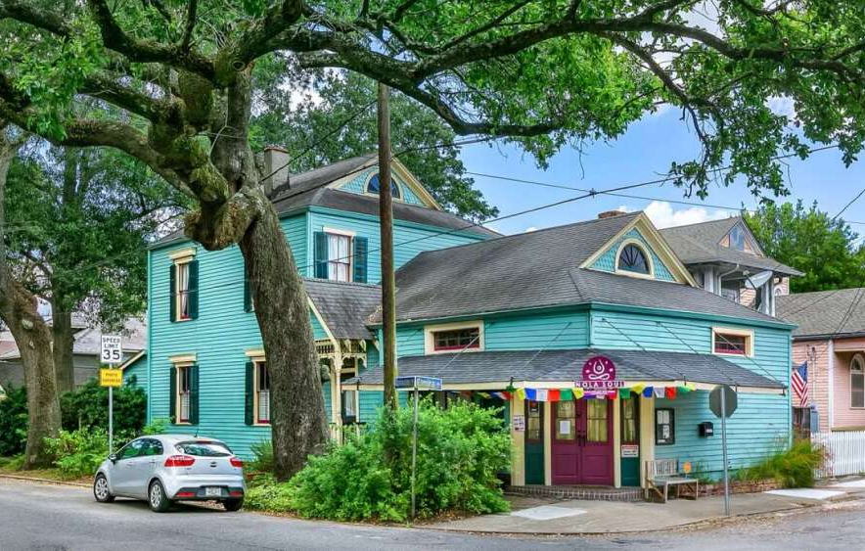 | 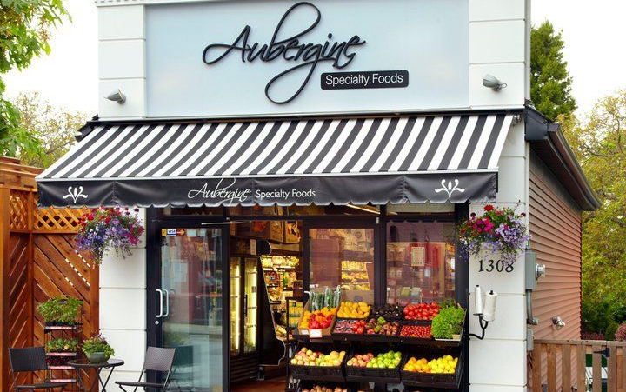
 | 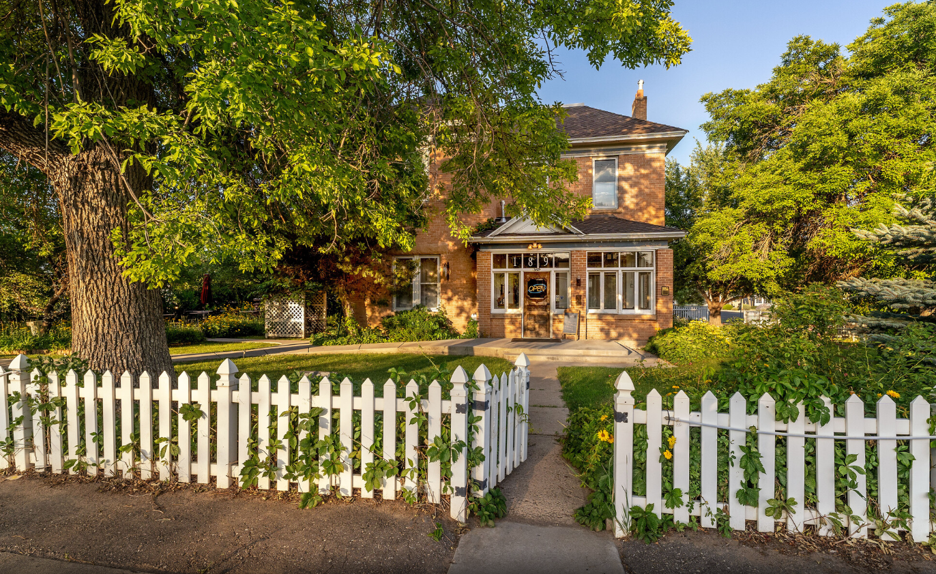

Exhibit 2.16.4 Commercial - Highway (CH) Land Use Type
The purpose of Commercial Highway (CH) areas are designed to strategically accommodate a blend of sales tax generating businesses, commercial enterprises, and entertainment venues, including comparison shopping centers, office buildings, and professional services. This provides a harmonious transition from residential and agricultural areas into these commercial zones.  It is recommended to integrate a vibrant pedestrian design element, featuring open spaces with walking paths/trails connecting various businesses, landscaping to evoke a rural ambiance, benches for leisure enjoyment, and clear crossings to enhance safety and minimize conflicts with traffic. Connectivity between existing and new businesses is encouraged. | - Preferred Design Elements -  - Building Design: Desirable characteristics include clean storefronts, limited signage, compatible scale/building design, and landscaping that improves the rural highway character, rather than large standardized corporate model buildings and logos.  - Roadways: This designation should be located close to highway interchanges and major arterial streets to provide convenient access for traffic volumes without traversing through residential areas. Carefully designed frontage roads, interconnecting parking lots, and clear pedestrian crossings are encouraged.  - Transition: When commercial uses are adjacent to residential areas, special care should be taken to ensure privacy and to protect personal property with things such as increased setbacks, landscaping, diversion of traffic, controlled noise or light, or height limitations.
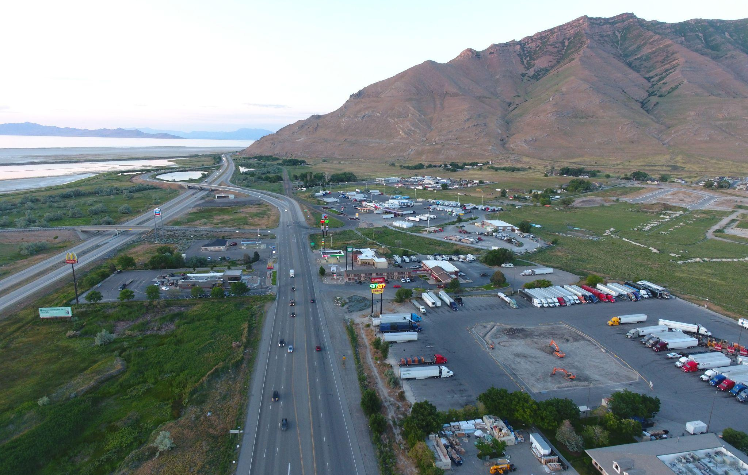
Example: highway commercial district with undeveloped parcels
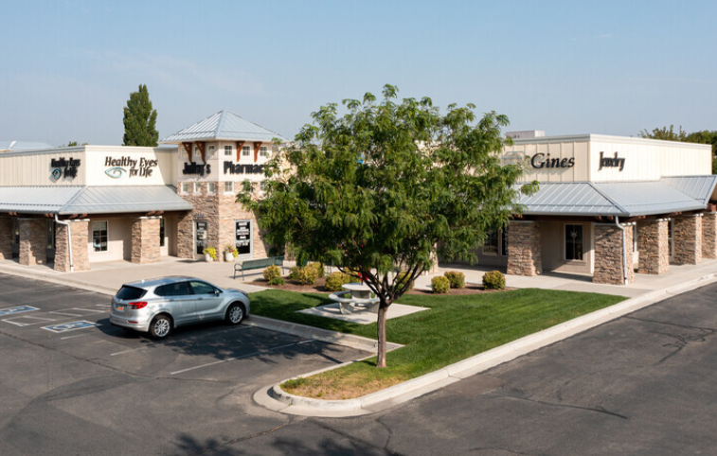 | 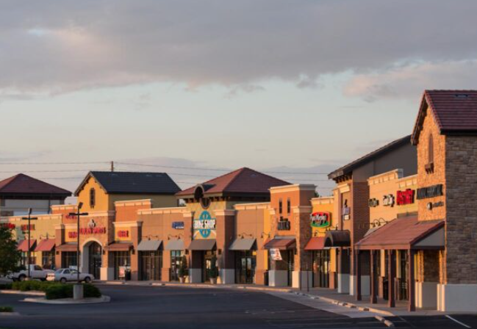
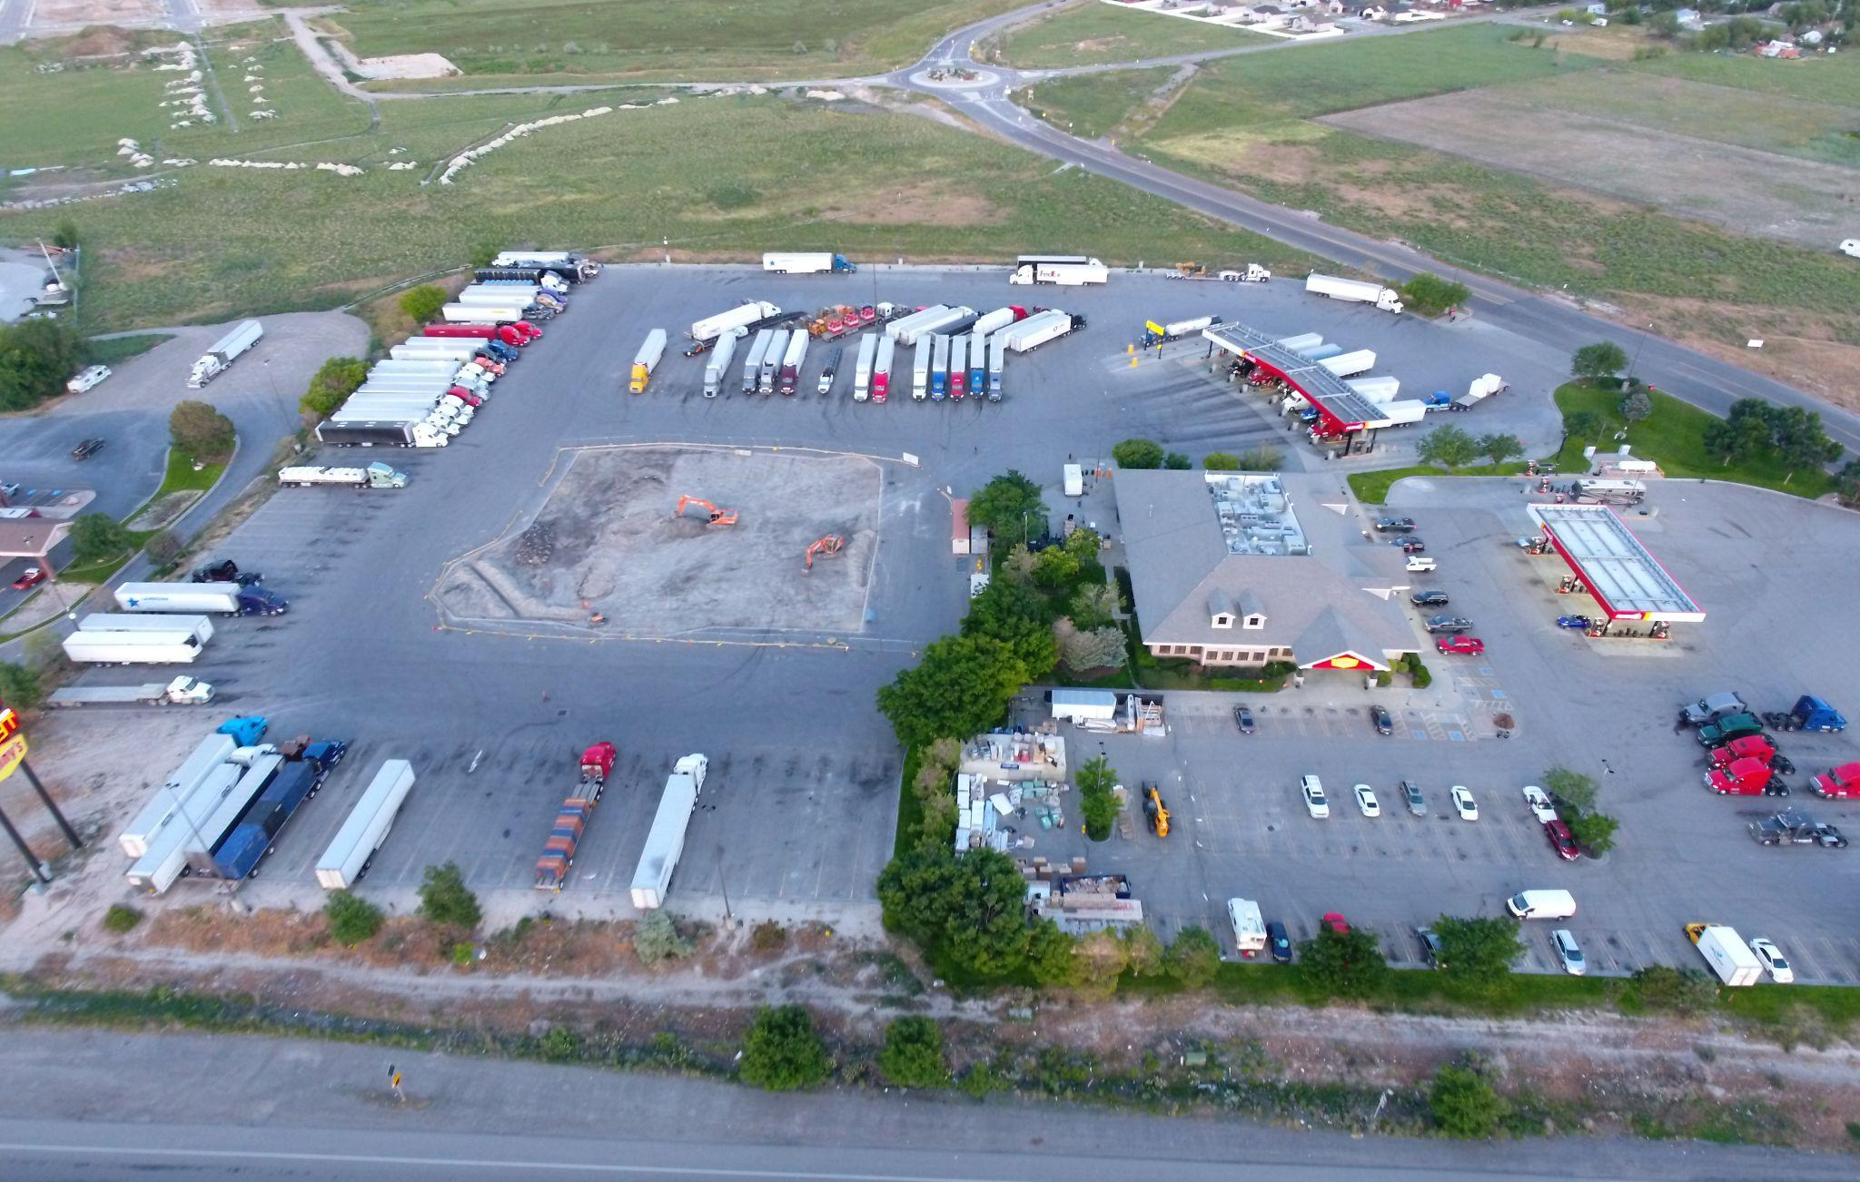 | 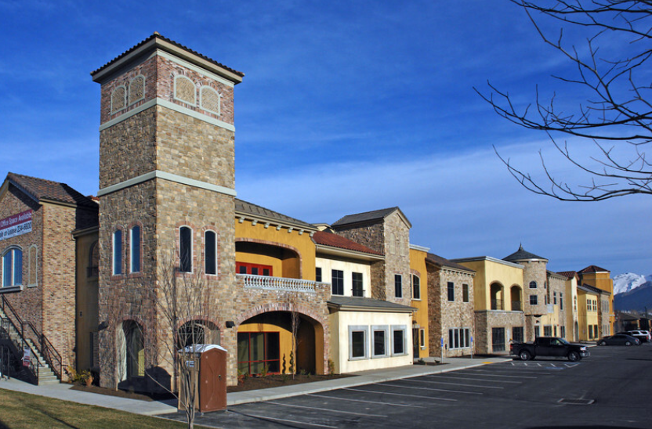

Exhibit 2.16.5 Commercial - General (CG) Land Use Type
The purpose of the general commercial areas aim to support a blend of business, commercial, entertainment, and related activities, along with automotive facilities, light manufacturing, light industrial processes, and light warehousing, with a focus on avoiding objectionable effects. Connectivity between existing and new businesses is encouraged.  The district's regulations are crafted to preserve environmental quality in the area and neighboring zones while fostering a conducive environment for crucial commercial and service activities. The district recognizes that certain activities may have a more significant impact than in the Commercial-Highway district. | - Preferred Design Elements -  - Building Design: Buildings shall be sited in such a way as to enhance relationships between buildings and facilitate vehicular circulation. Desirable characteristics include clean storefronts, limited signage, compatible scale/building design, and landscaping that improves the neighborhood character.  - Roadways: The location of this designation should be close to major arterial streets to provide convenient access for major traffic volumes without hazards and without traversing through residential areas. Carefully designed frontage roads are encouraged  - Transition: All site plans shall be designed to be integrated into a larger overall site. Driveways, landscaping and all other elements of the site plan shall be planned so that it will fit into a larger shopping center when adjacent parcels are developed.
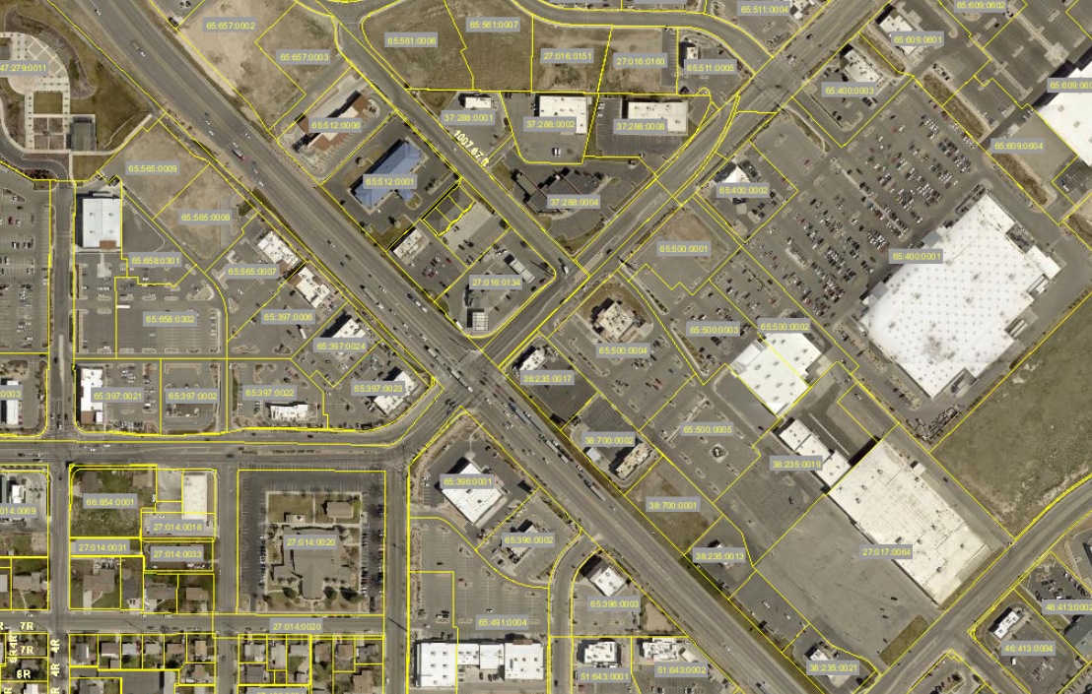
Example: commercial district with a variety of parcel and building sizes
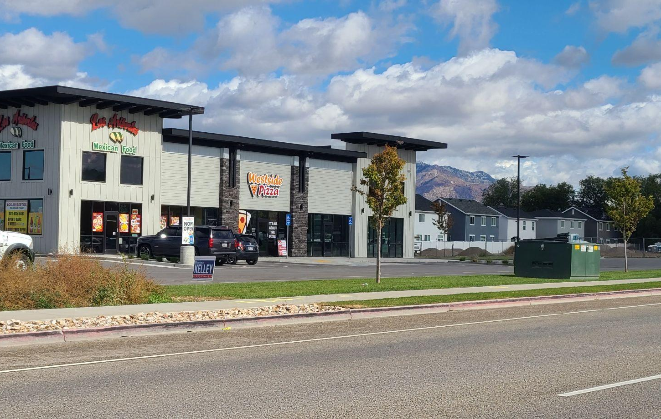 | 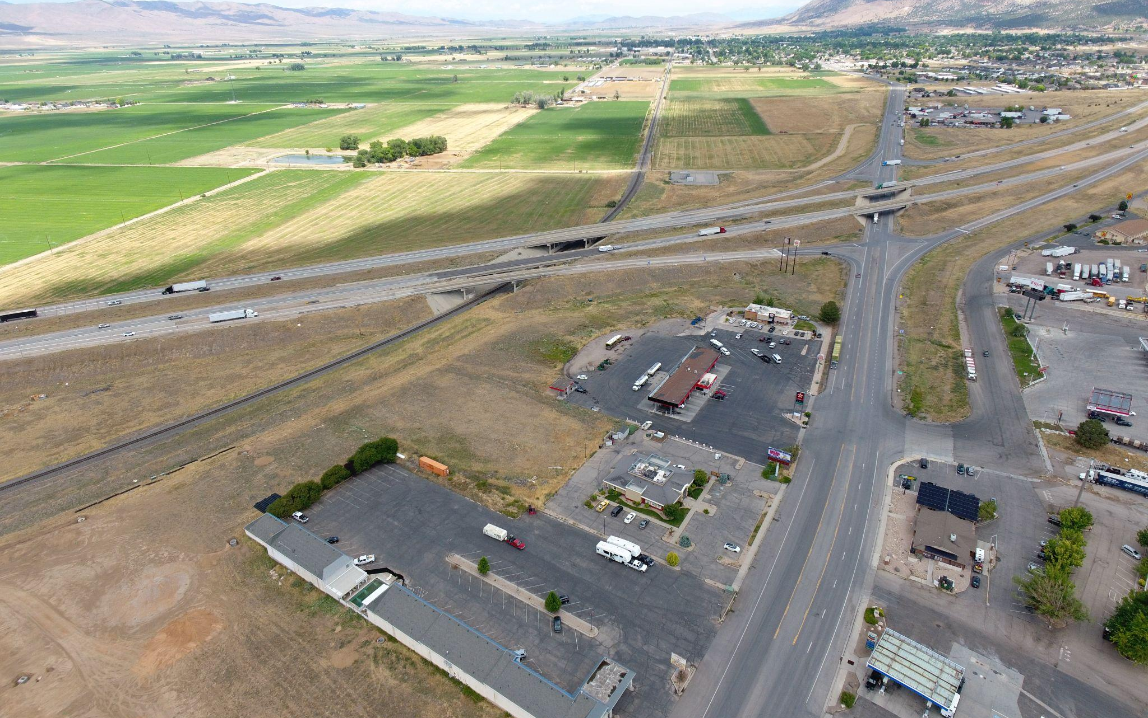
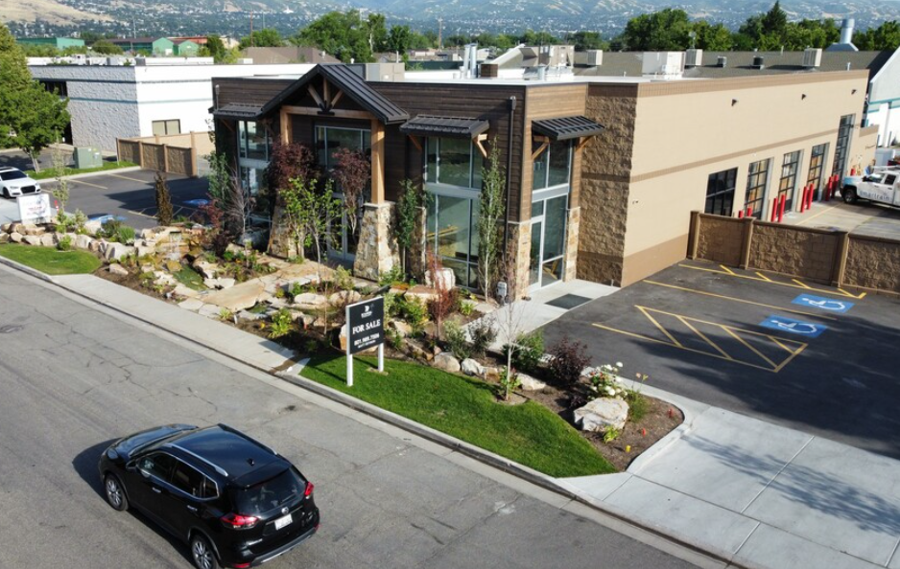 | 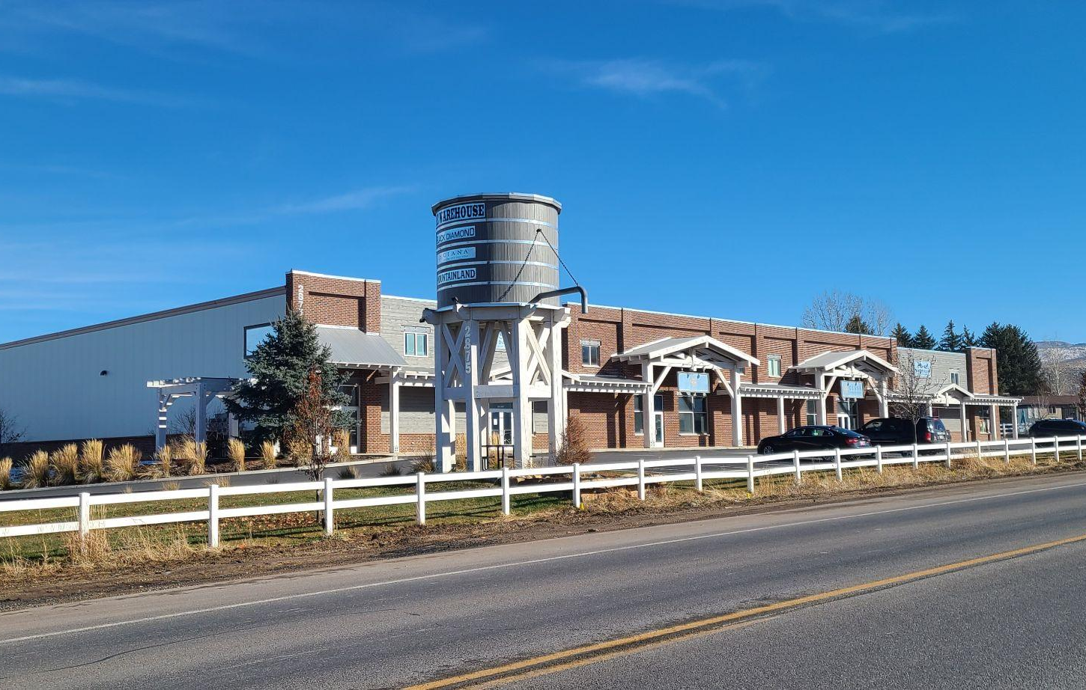

Exhibit 2.16.6 Industrial (IND) Land Use Type
The purpose of Industrial (IND) zoning districts is to designate suitable areas for conducting a compatible mixture of light industrial and heavy commercial uses, including warehouses, that are essential to the economy. These activities are characterized by not requiring intensive land coverage and not generating large volumes of traffic with obnoxious sounds, glare, dust, or odors. The regulations of this district are formulated to safeguard the environmental quality of both the district and its neighboring areas. | - Preferred Design Elements -  - Building Placement: While industrial buildings vary significantly in size, their design can improve integration into the larger community. Visible, distinctive entrances for customers, employees, and deliveries enhance their appearance and function.  - Access + Circulation: Road access should be as clear and direct as possible. Circulation design should accommodate current and anticipated traffic flow without over-building and be adaptable to the fluctuation of traffic loads resulting from changes in building uses.  - Landscaping: Functional landscaping elements include: street edge, site entries, building entries, service areas, and stormwater management areas (e.g., detention ponds).
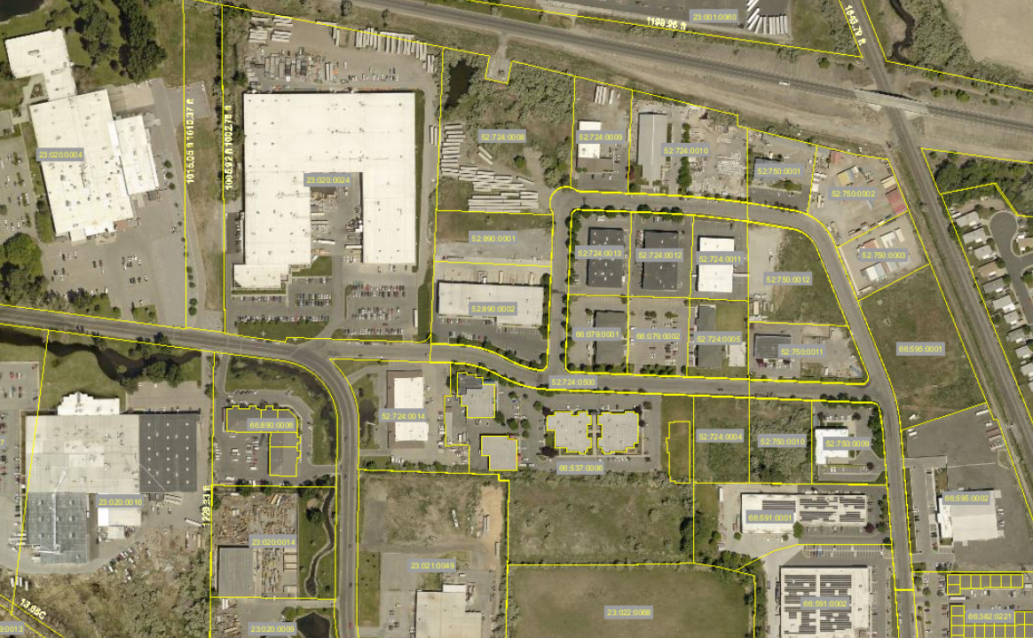
Example: industrial district with a variety of parcel and building sizes
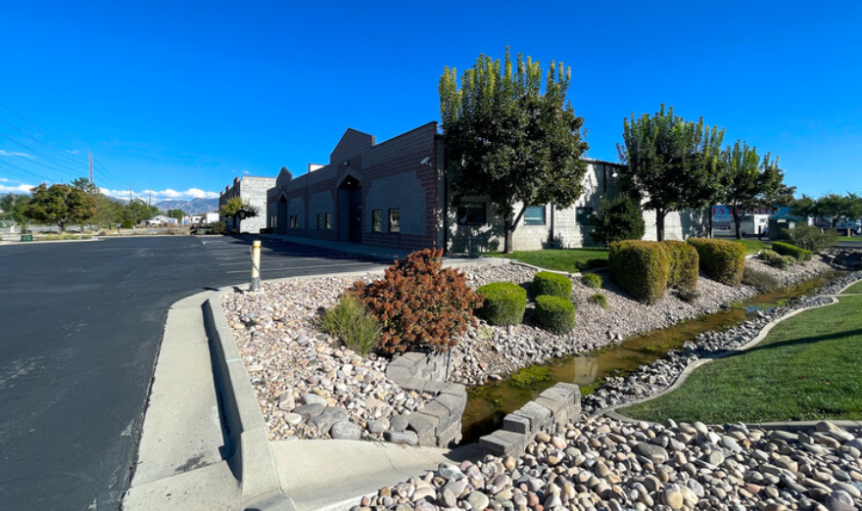 | 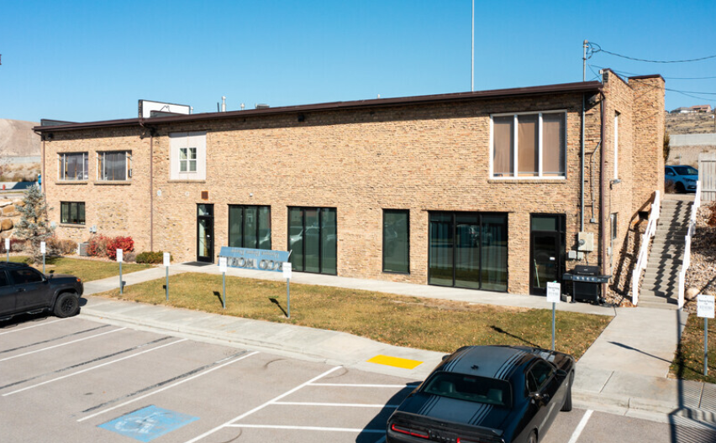
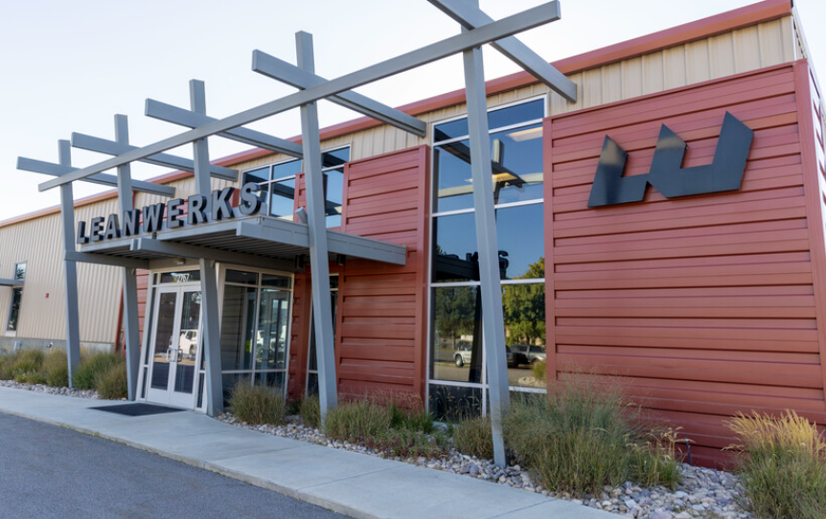 | 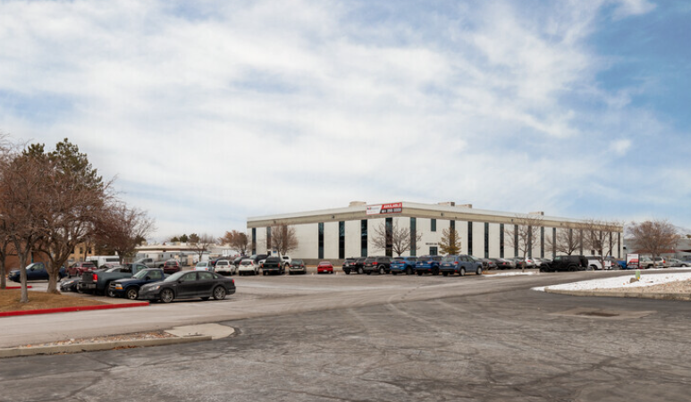

Exhibit 2.16.7 Multiple-Use Development (MU-40) Land Use Type
This land use designation allows the integration of higher-density residential and small business uses at ground floor levels. The intent is to provide design flexibility to support neighborhood business uses, provide more housing units, and expand the use of common public facilities such as libraries and schools. | - Preferred Design Elements -  - Building Placement: Residential buildings should be located close to the street in order to create vibrant neighborhoods by designing sidewalks to connect different activities.  - Land Use Mixing: Uses may include a combination of multi-family residential dwellings and office uses within a single structure. Live/work units are also encouraged.  - Roadways + Parking: Shared parking and shared access should be explored in these neighborhoods. In addition to angled on-street parking, parking lots should be located to the side and/or rear of buildings where possible.  - Landscaping: Incorporate usable open spaces along roadways to encourage street activity as well as provide a buffer for the residences.
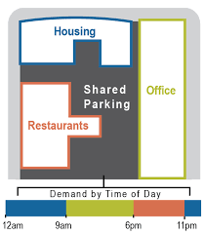
Example: diagram of “horizontal” mixed-use
 | 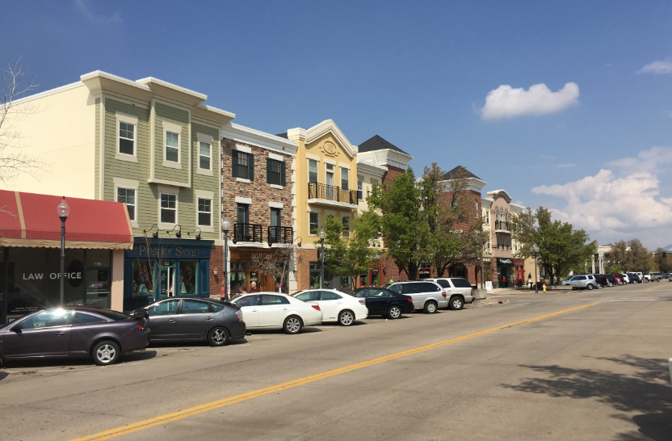
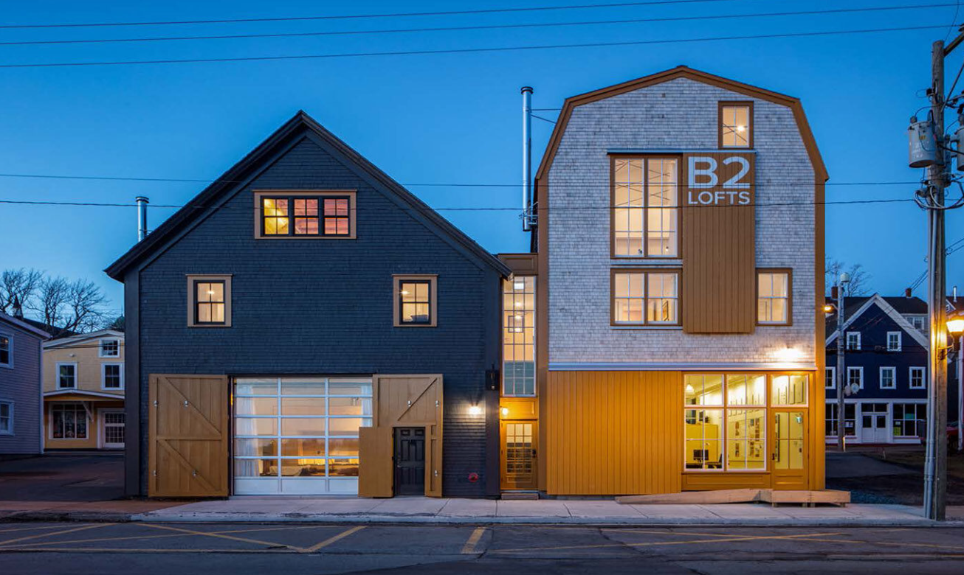 | 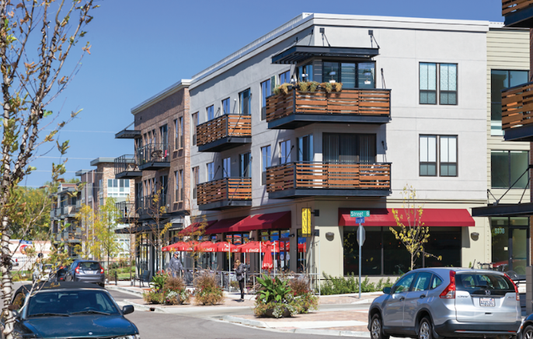

2.18 Future Land Use Map
- The Future Land Use Map serves as a guide to where future growth should occur. The map guides decisions about proposed intensities of development, the locations of future development, and general transportation corridors. The map lays the foundation for making changes to zoning in the future, but it is NOT zoning or the zoning map.

Exhibit 2.18.1 Future Land Use Map
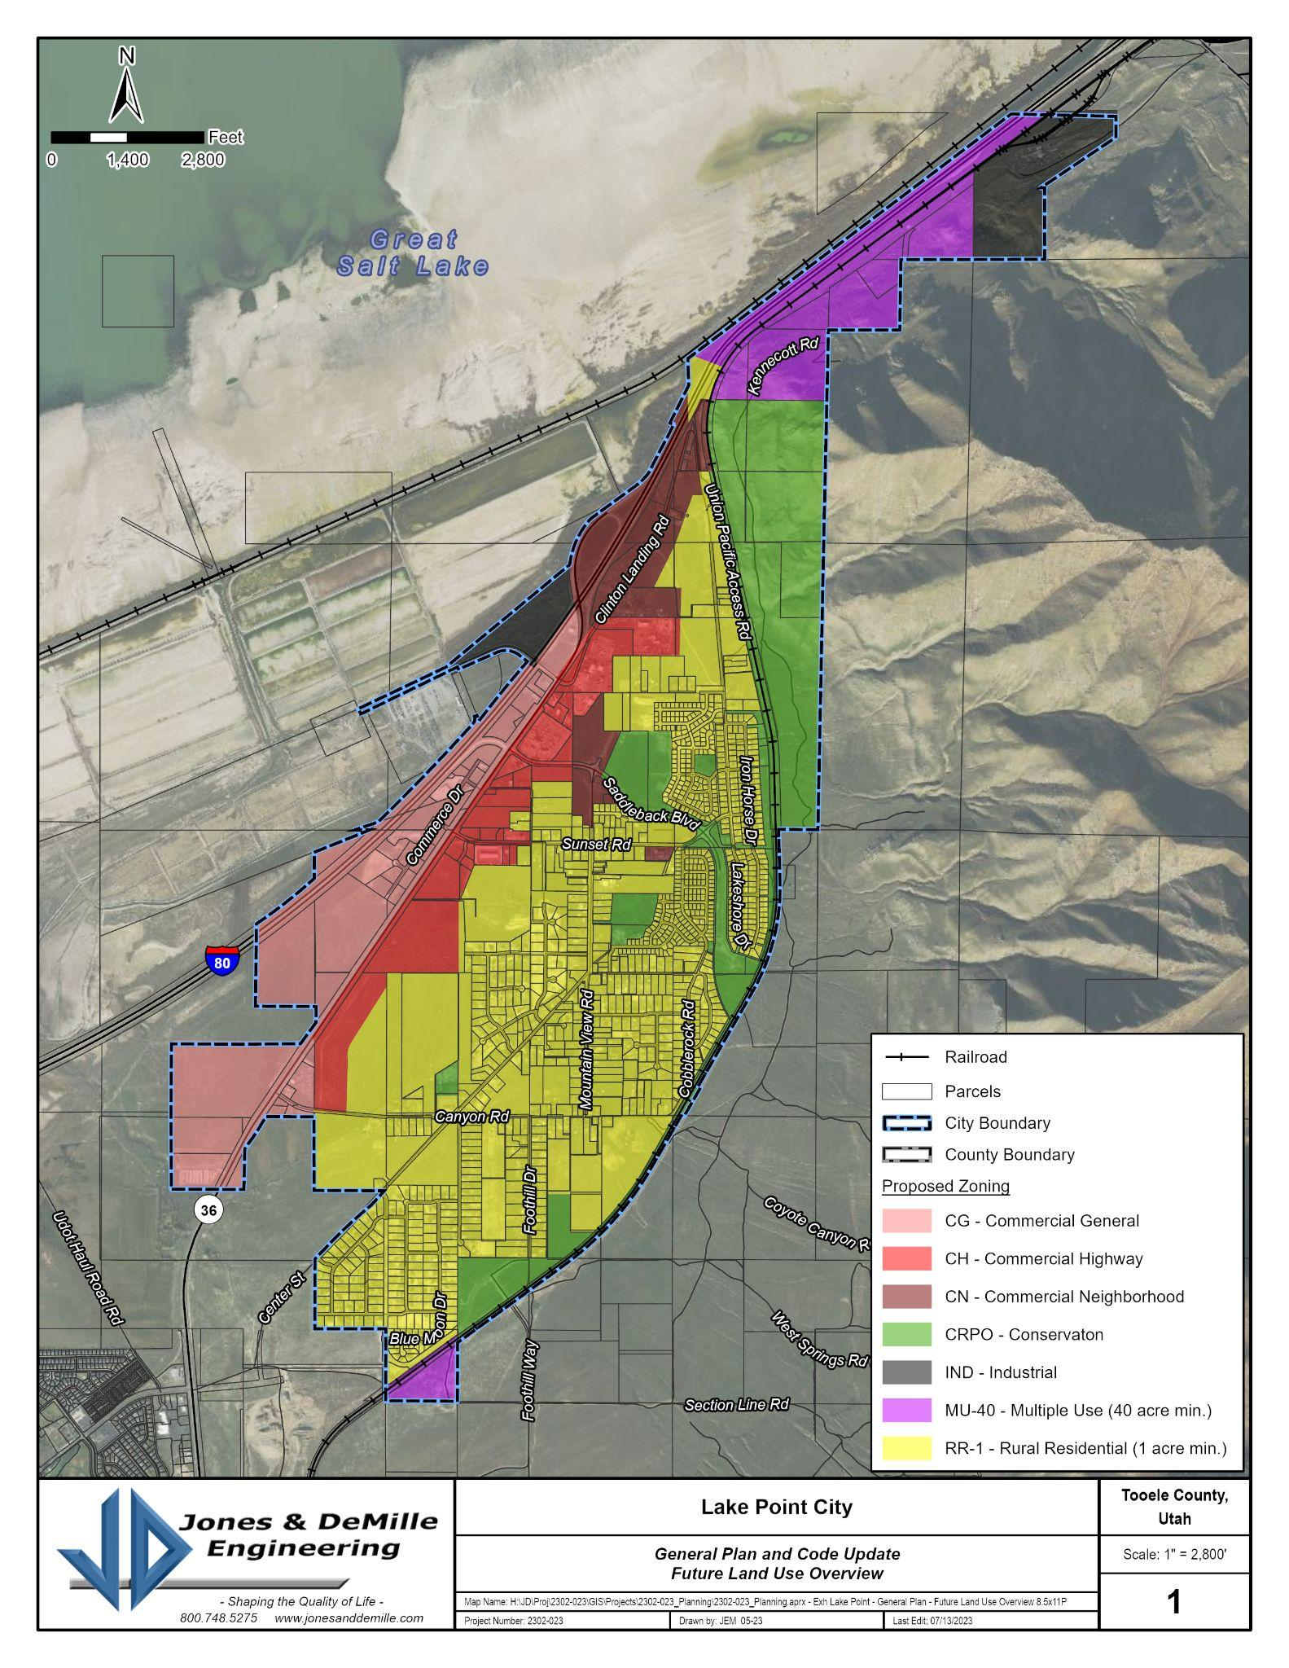
Lake Point’s intended future land use pattern. (click for original).

Exhibit 2.16.2 Parcel Map

Map showing recorded parcels, as of this plan’s writing. (Source - Tooele County GIS)

2.20 Goals + Objectives: Land Use
G2-1. Encourage appropriate land uses throughout the City, as identified and described in this General Plan. Provide for the regulation of these uses through appropriately-defined zoning districts and ordinances.
- O2-1.1 Regularly review existing zoning ordinance and zoning map. Update these documents where necessary to meet the goals of the General Plan.
- O2-1.2 Expand the zoning classifications to adhere to the rural-agricultural vision of residential and future expansion of commercial development in Lake Point.
- O2-1.3 Regulate setbacks, landscaping, art, appropriate lighting, signs, and other design amenities that complement and enhance the streetscape and design of new development through the zoning ordinance.
- O2-1.4 Encourage neighborhood connectivity and access to open space through the subdivision process.
G2-2. Review and identify the characteristics of residential, commercial and industrial land uses, and inventory those uses within the City on a systematic basis, allowing necessary changes to maintain the City’s Vision and Core Values (on a scheduled basis, i.e. every 2 years).
- O2-2.1 Consider updates to the various elements of the General Plan, the zoning ordinance, and the zoning map that address changing market and development trends while conforming to the goals of the General Plan. This will be an ongoing and continuous function of the Planning Commission and Staff.
- O2-2.2 Provide ongoing training for staff, planning commissioners, and City Council members in an effort to ensure an ever-increasing level of understanding of the factors involved in land development, to use in implementing quality development standards for the community.
G2-3. The City will promote a broad-based and informed decision-making process based on citizen participation at all levels of community governance.
- O2-3.1 Increase citizen involvement in the City’s decision-making processes by including both appointees and non-appointed resident-volunteers on committees.
- O2-3.2 Educate the public on the public-input process and the available avenues for discussion and comment.
- O2-3.3 Leverage the City website to publish the results of City initiatives, studies, designs, budgets, and other public documents.
- O2-3.4 Implement a formal “sunsetting” process for all City boards and committees to keep these bodies relevant and current while ensuring a consistent turnover of members as a means of providing diversity of thought that represents the entire community.

2.22 Implementation Action Steps: Land Use
- Short-Term Opportunities (1-5 years)
  - Apply for a planning grant from the State with the intent of developing and updating comprehensive city codes.
  - The City could establish a regularly-scheduled Planning Commission meeting dedicated to reviewing the land use ordinances for any inconsistencies with the different zones.
  - Consider updating the land use ordinance to require a master development agreement for large future developments.
  - Work with Tooele County parcel owners and neighboring communities to develop the City-wide annexation policy and map.
- Long-Term Opportunities (+5 years)
  - As resources become available, conduct an area master planning initiative for areas of strategic importance to the community (i.e. interchange area).
  - Lake Point should develop a long-term plan for prioritization of future annexation of property adjacent to City boundaries for the eventual inclusion of the city boundaries.

3 - COMMUNITY DESIGN
Community beautification issues focus on the visual appearance of the City (residential and municipal uses) as well as preserving historic and cultural assets. The community design element shapes, and is shaped by, other facets of planning (such as transportation, housing, and recreation). It is through this form-meets-function process that the City will be able to create, market and retain their unique character and appearance.

3.02 Existing Conditions: Community Design
- Participants in recent community surveys were asked to articulate their priorities generally. The clear message of Lake Point residents is that they want to maintain their rural character and open spaces.
- The neighborhoods located within Lake Point possess distinct identities that reflect the values of the community: stability, character, tradition, and “green space”. Encouraging the conservation of these qualities, and ultimately, improving the building upon them while preventing the onset of blight and deterioration are priorities of residents.
Community Design OPPORTUNITIES | Community Design CONSTRAINTS
- The City doesn’t currently require street trees along main roadways. An updated landscape ordinance could incorporate water wise design and xeriscaping that would ensure consistency.  - Lake Point seems to have a strong potential for dark sky preservation, and there is strong support for the strategy.  - There seems to be an opportunity for xeriscaping along public property (ideally roadway medians and public buildings). | - Lake Point doesn’t have a traditional “downtown” and/or community center area currently.  - Residents commonly identify with a “loss of rural character”. This trend could continue to increase as development occurs.  - Lake Point is the gateway to Tooele County for people traveling from the Wasatch Front. This will generate regional interest in new highway infrastructure in that area.

3.04 Desired Future: Community Design
- Design standards typically look at the area surrounding the proposed site to take visual clues as to what fits. Design standards typically address such issues as building materials, building height, roof lines, fenestration (windows), signage, pedestrian and vehicular access, and architectural style or building features.

3.06 Anticipated Changes
- Lake Point should probably expect new commercial development along the highway corridor. It is beneficial to the city to proactively seek commercial development that will increase sales-tax revenue to the city. The city will want to ensure that there are appropriate landscaping and lighting standards in place.
- The city is anticipating the creation of a new downtown area that is away from the highway. The design of it is likely going to be different from what the city will see along a high-traffic corridor.
- Residential neighborhoods are likely to see more development of accessory dwelling units.

3.08 Beautification + Nuisances
- Community beautification issues focus on the visual appearance of the city (residential and municipal uses) as well as preserving historic assets. Community design shapes, and is shaped by, other facets of planning (such as transportation, housing, and recreation). It is through this unique form-meets-function process that the City will be able to create, market, and retain their unique character and appearance.
- Well-planned community design improves both the visual and functional characteristics of the city. It can make the city more aesthetically pleasing while enhancing the flow of goods and people. The term “nuisances” refer to conduct or use of land that interferes with another’s ability to enjoy and use their property, and they can negatively impact area property values.
- Nuisances will be addressed through code enforcement efforts. There are also opportunities for investment in beautification initiatives that were expressed by residents. These include:
  - Neighborhood clean-up efforts.
  - Establishing standards to avoid light pollution.
  - Investing in traffic mitigation measures that can help manage through-traffic from non-residents.
  - There were mixed responses on the demand for “code enforcement” due to the concerns that enforcement can go too far and become government overreach that infringes upon individual rights. This underscores the essential equilibrium between safeguarding individual rights and fostering a harmonious community where the well-being of each resident is considered alongside the rights of others.

3.10 Dark Sky Preservation
- Dark Sky is becoming increasingly recognized as a valuable natural resource, and Lake Point has opportunities to maintain conditions in selected areas of the City to benefit from this resource. The City can look for ways to promote a dark sky environment with regulations that consider the following:
  - Reducing, eliminating, or preventing light trespass;
  - Reducing, eliminating, or preventing unnecessary or inappropriate outdoor lighting;
  - Reducing, eliminating, or preventing the effects of outdoor lighting on wildlife;
  - Preventing unsightly and unsafe glare;
  - Promoting energy conservation;
  - Maintaining nighttime safety, utility, and security;
  - Encouraging a minimal light footprint of land uses in order to reduce light pollution; and
  - Promoting and supporting astrotourism and recreation, including the pursuit or retention of accreditation of local parks by the International Dark-Sky Association.

3.12 Goals + Objectives: Community Design
G3-1. Identify the cultural and visual qualities and attributes that contribute to the unique character of Lake Point and endeavor to retain and enhance these qualities.
- O3-1.1 Regularly identify the cultural attributes that contribute to the unique character of Lake Point. Preserve and enhance these characteristics through specific planning and zoning ordinances and design standards that guide current and future development.
- O3-1.2 Educate property owners about incentives that encourage the preservation of historic or unique architecture, vegetation, or spaces within the community. Preservation should be accomplished through a program of incentives rather than rigid requirements or restrictions.
G3-2. Recognize unique areas or districts within Lake Point and develop design guidelines, development standards and ordinances, as appropriate, to protect the qualities within these areas that are valued by the citizens.
- O3-2.1 Identify architectural and other visual qualities that will contribute to the understanding of the City’s unique identity within Tooele County.
- O3-2.2 Develop ordinances for lighting that preserve the community’s dark sky amenities while maintaining neighborhood safety.
G3-3. Establish methods of way-finding within the City to identify unique districts and to guide tourists and visitors to their destinations.
- O3-3.1 Utilize parks and trail systems to create or enhance key entry points in residential neighborhoods.
- O3-3.2 Encourage both new and existing neighborhoods to create a unifying identity through street lighting, signage and plantings. Encourage cohesive neighborhoods as a means to preserve housing stock and its associated value.
G3-4. Create a more pedestrian-friendly community that promotes an active lifestyle.
- O3-4.1 In residential areas, support developments that incorporate shade trees, a landscaped buffer from traffic, ornamental plantings with year-round appeal, public art, and site furniture.
- O3-4.2 All commercial and industrial developments will provide adequate buffer and screening treatments to protect the desirability and amenities of adjoining properties.

3.14 Implementation Action Steps: Community Design
- Short-Term Opportunities (1-5 years)
  - As resources become available, the City could develop a tree planting and replacement program and policy for residential and commercial areas.
  - The City should implement landscape standards as appropriate for specific areas of the City.
- Long-Term Opportunities (+5 years)
  - The City’s land use ordinances should be reviewed regularly to make sure that standards for parking and landscaping are clearly stated and continue to be enforced.

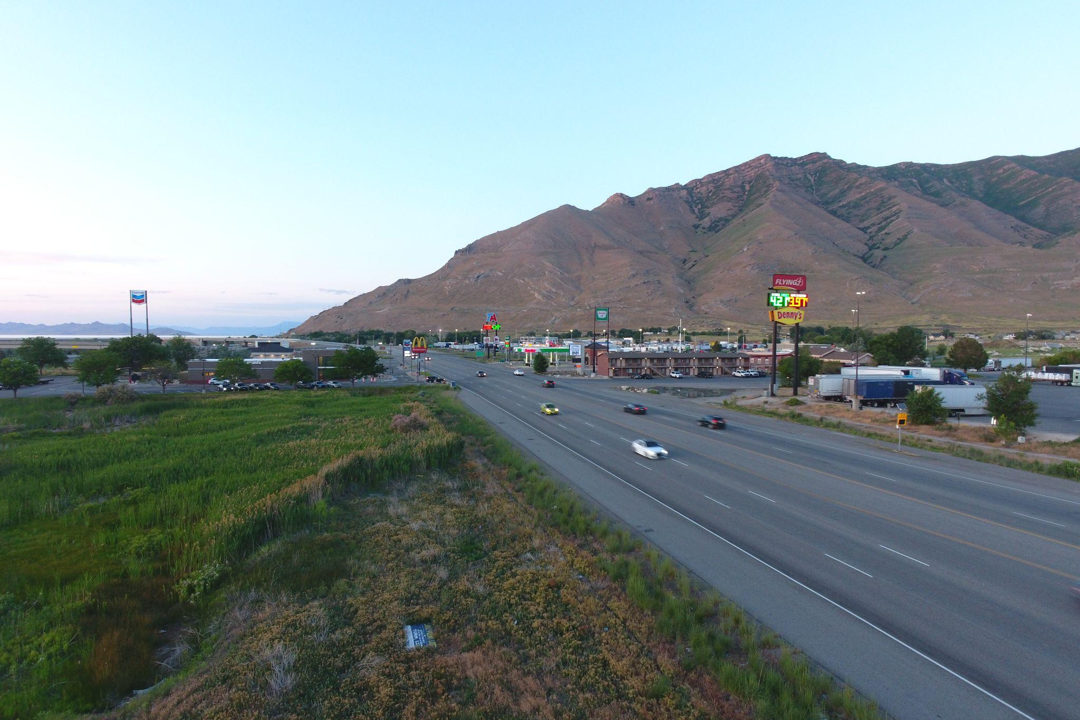

4 - LOCAL ECONOMY
Communities need to discuss the trade-offs of providing the physical locations and competitive financial environment necessary to attract various types of economic development to the area. The intent of the local economy element of the general plan is to explore community priorities, but not necessarily outline a tactical economic development plan.

4.02 Current Conditions
- One of the survey questions residents were asked was to identify areas for potential economic development and what type. Roughly 3/4 of respondents identified infield commercial along Highway 36, with a strong support for grocery retail. There was also support for the idea of a compact village center.
Local Economy OPPORTUNITIES | Local Economy CONSTRAINTS
- The City can reduce sales tax leakage by promoting the development of restaurants and other entertainment venues.  - Commercial development near the interchange area could become more feasible with new traffic control investments made by UDOT and development of frontage roads.  - Proximity to the SLC area, but with a rural atmosphere.  - Lake Point currently has a number of undeveloped parcels in its commercial corridor.  - There may be an opportunity for the development of an RV resort on the north end of town. | - As the gateway to the Tooele valley, Lake Point will need to address significant traffic counts that will continue to increase over time.  - The developing inland port will draw truck traffic and industrial development potential away from the Tooele / Lake Point area.  - When residents were asked if ”Lake Point should be promoted as the commercial center of northern Tooele County”, less than 15% of survey respondents provided a positive response.  - Residents also provided weak support for the idea of attracting jobs to the community.

4.04 Desired Future: Local Economy
- Lake Point's unique amenities, lifestyle, infrastructure, available workforce, and environment make it attractive to a diversity of economic developments. The desired future success of the area includes an economic environment that inspires entrepreneurship, facilitates growth in various industries, and improves the average wage rate for the area.

4.06 Anticipated Changes: Local Economy
- All indications are that Lake Point will see a positive growth trend in the coming years. Lake Point offers low energy costs, low local taxes, a young, educated workforce, population growth for the workforce of tomorrow, competitive land costs, and excellent quality of life.
- Lake Point is attractive to remote (virtual service) workers, but the City will need to continue with efforts to develop amenities in order to keep those employees over time.

4.08 Goals + Objectives: Local Economy
G4-1. Expand employment opportunities within Lake Point through effective planning and zoning supporting economic development activities.
- O4-1.1 Promote Lake Point as an excellent business location with quality infrastructure, a skilled workforce, convenient transportation system, and superior lifestyle.
- O4-1.2 Provide planning and zoning protections for business investment (preventing residential encroachment on business and manufacturing properties - particularly along the Hwy36 Corridor).
G4-2. Increase the tax base of the City through expanding commercial development that broadens the retail diversity, and limits sales taxes leakage.
- O4-2.1 Provide commercial zoning in compliance with the general plan at a pace that supports economic expansion that is based on population growth and community needs.
- O4-2.2 Identify new retail and lodging opportunities that could be supported in Lake Point. Provide the necessary zoning.
- O4-2.3 Periodically survey residents to identify sales leakage, the size and sales potential in the effective retail shopping area, and other important details needed to attract retail and other commercial opportunities.
- O4-2.4 Periodically survey commercial users and operators to identify needs and market-based demands that could be supported by City policy in an effort to attract new business while also supporting the City’s existing commercial ventures.
G4-3. Recognize economic opportunity areas identified by the community, and prioritize them for long-term development.
- O4-3.1 Lake Point will review its business, commercial, and industrial policies regularly to ensure the most effective areas of the City are used in promoting business opportunities.
- O4-3.2 Lake Point will continue to maintain an efficient business and development permitting process, and desires to be a business friendly community.
- O4-3.3 Lake Point will support cooperation, communication, and coordination of local, county and area leaders.

4.10 Implementation Action Steps: Local Economy
- Short-Term Opportunities (1-5 years)
  - Map priority areas selectively and prioritize incentives and investments to those areas.
  - Apply for EDA’s Public Works and Economic Adjustment Assistance (EAA) programs to implement projects in opportunity zones.
- Long-Term Opportunities (+5 years)
  - Develop and maintain an economic development strategic plan.
  - Conduct marketing research and prepare essential information regarding Lake Point and Tooele County.

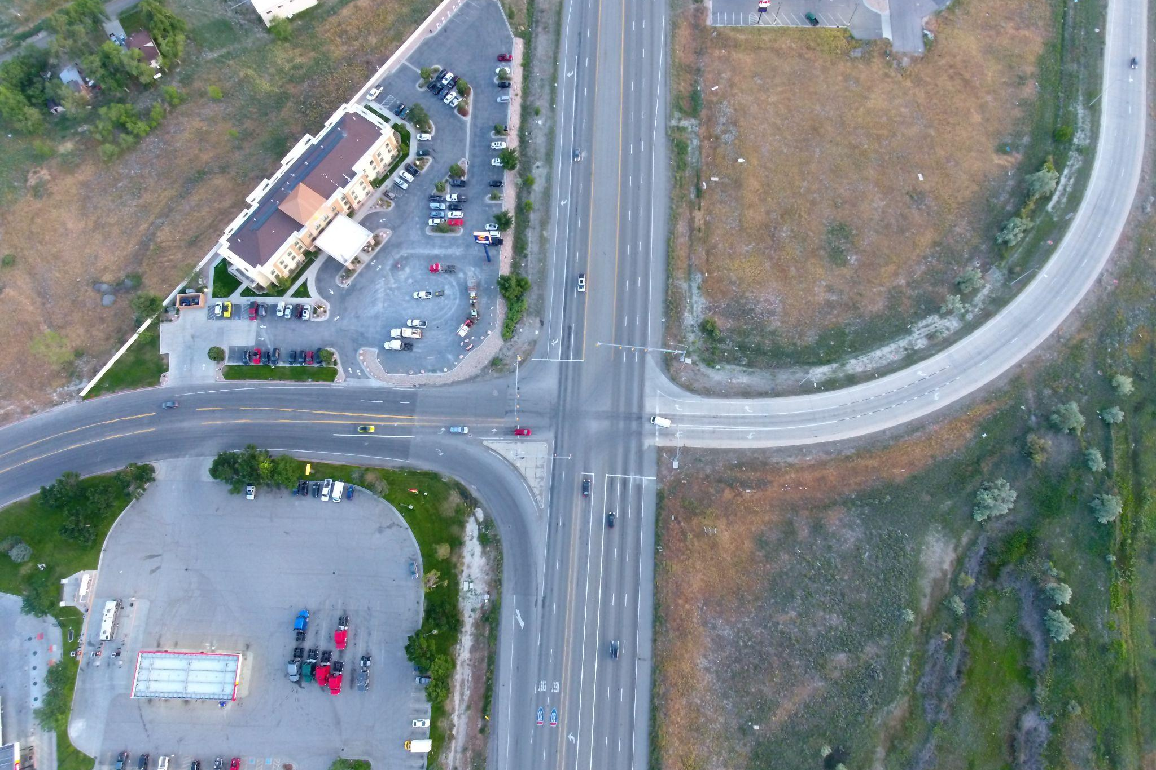

5 - TRANSPORTATION
The intent of the transportation chapter of the general plan is to address all modes of transportation using the public rights-of-way in the city and surrounding vicinity. This includes motor vehicles, pedestrians, and bicyclists. Transportation issues are closely connected to other elements of the general plan because land near transportation corridors typically have a higher development potential than those that will need access investments.

5.02 Current Conditions + Regional Plan
- The goal of Lake Point is for improved circulation and mobility for all modes, the general plan addresses the potential for additions to the road network, as well as improvements to other means of transportation (including ATV, bicycle, equestrian, and pedestrian).
- During the public comment period, the strong majority of residents stated that the current conditions of the transportation system in the City was “good” or “fair”.
- Toward the conclusion of the general plan drafting initiative, Lake Point received funding that will allow them to develop a transportation master plan (TMP). The TMP is expected to provide more detail and refinement to this element in particular once it is completed.
Transportation OPPORTUNITIES | Transportation CONSTRAINTS
- There seems to be land available for the development of frontage roads which is desired and being planned for. Frontage roads would parallel the highway and create new commercial corridors that would be attractive to commercial / industrial development.  - When asked which type of transportation improvement residents would most like to see over the next 10 years, residents expressed very strong opinions on more walking paths, equestrian access trails, and bike trails.  - If future transportation corridors need to be located in the area, there is an opportunity for them to be developed and focused in the area west of Highway 36, through industrial land instead of on the east foothills. | - The highway corridor through Lake Point has the heaviest traffic counts in the County.  - Tooele County has presented ideas for a new major corridor that would provide access to I-80 through the east bench area of Lake Point. This will significantly constrain the city’s capacity to promote strategic development and will negatively impact the area wildlife, open space, recreational opportunities, dark skies, and the quiet rural character of the area.  - Half of the survey respondents expressed concern about the City's transportation infrastructure as it grows into the future.  - The connection between east and west sides of Highway 36 will only become more difficult for pedestrians and bikes without a significant investment.

Exhibit 5.02.1 Traffic Count Map
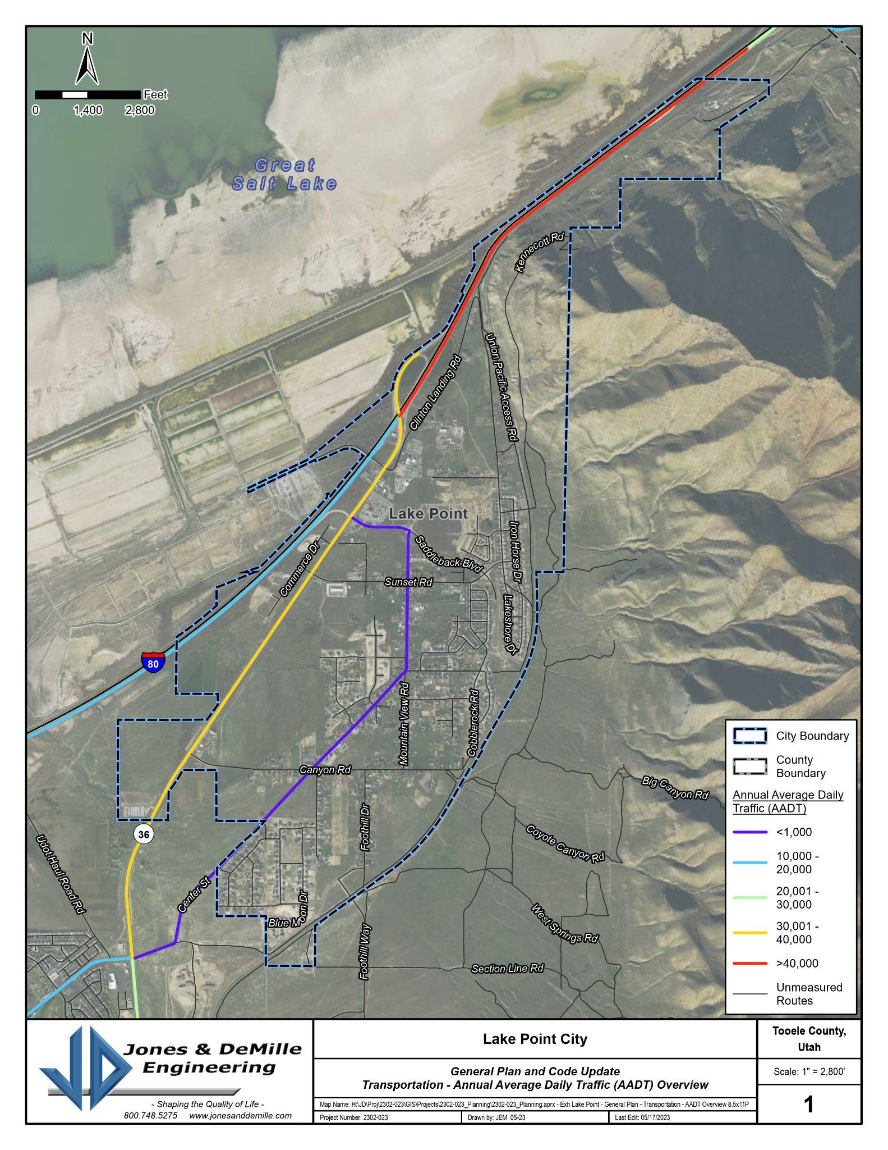Average annual daily traffic counts (AADT) for Lake Point (click for original.)

Exhibit 5.02.2 Vehicle Accident Map
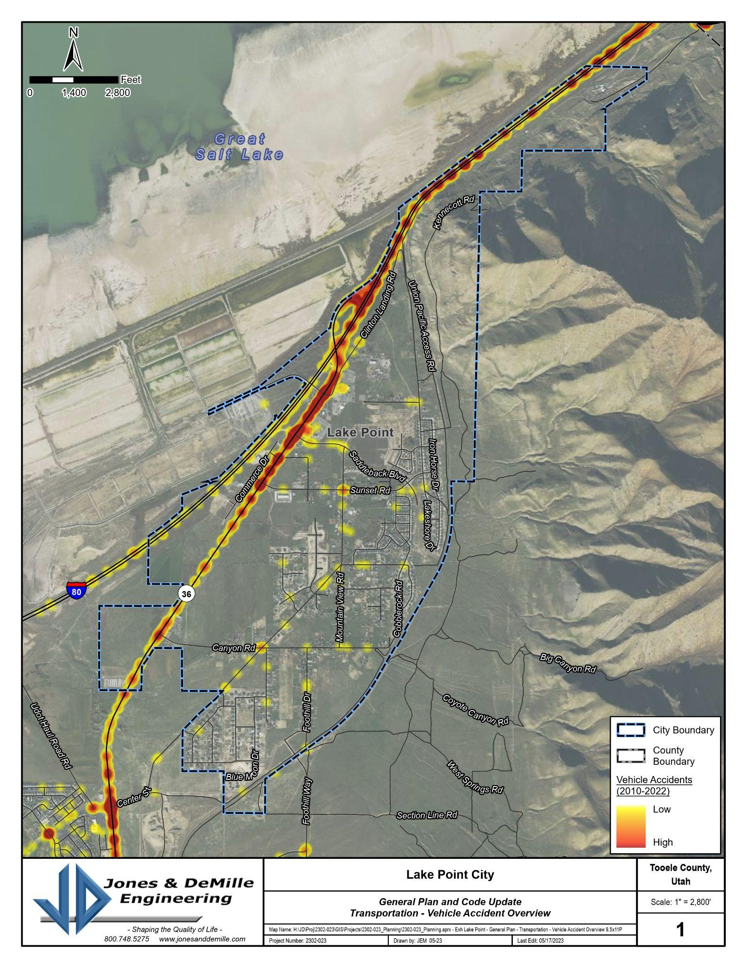Traffic accident rates by location for Lake Point (click for original).

5.04 Desired Future
- Transportation issues will largely determine the quality of life for residents in and around Lake Point for the foreseeable future. Lake Point will continue to address the increased needs of a growing population by seeking a variety of funding options to upgrade and plan for roadway improvements and alternate modes of transportation to avoid unnecessary traffic caused by a growing population.
- At the time of the development of the general plan, the County was in the process of developing a transportation master plan. Lake Point was actively working with the County to explore their options because the City will be significantly affected by future development decisions.

Exhibit 5.04.1 Concepts for Future Transportation Plan
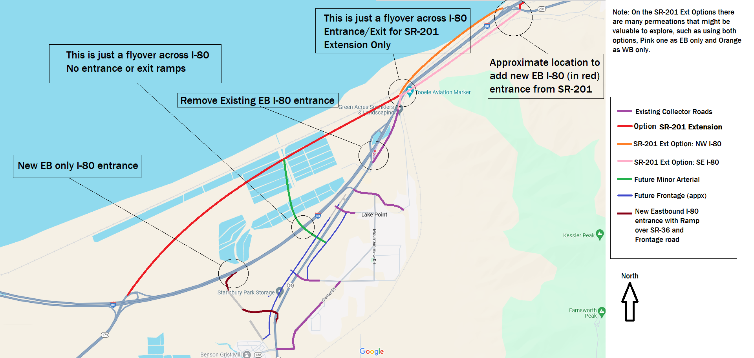
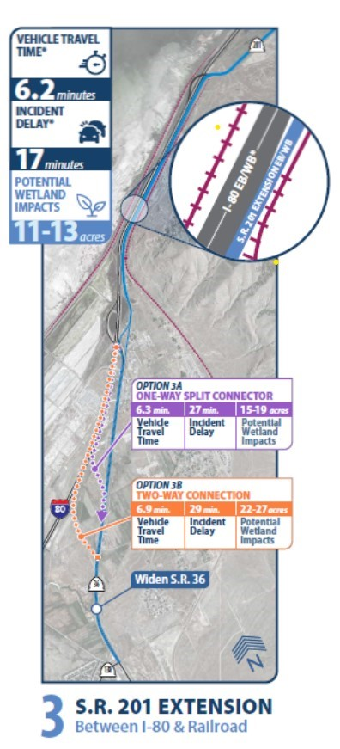
Ideas for alignments that Lake Point would like to explore further in its transportation master plan initiative.

5.06 Transportation Network Map

Exhibit 5.06.1 Future Transportation Corridor Map
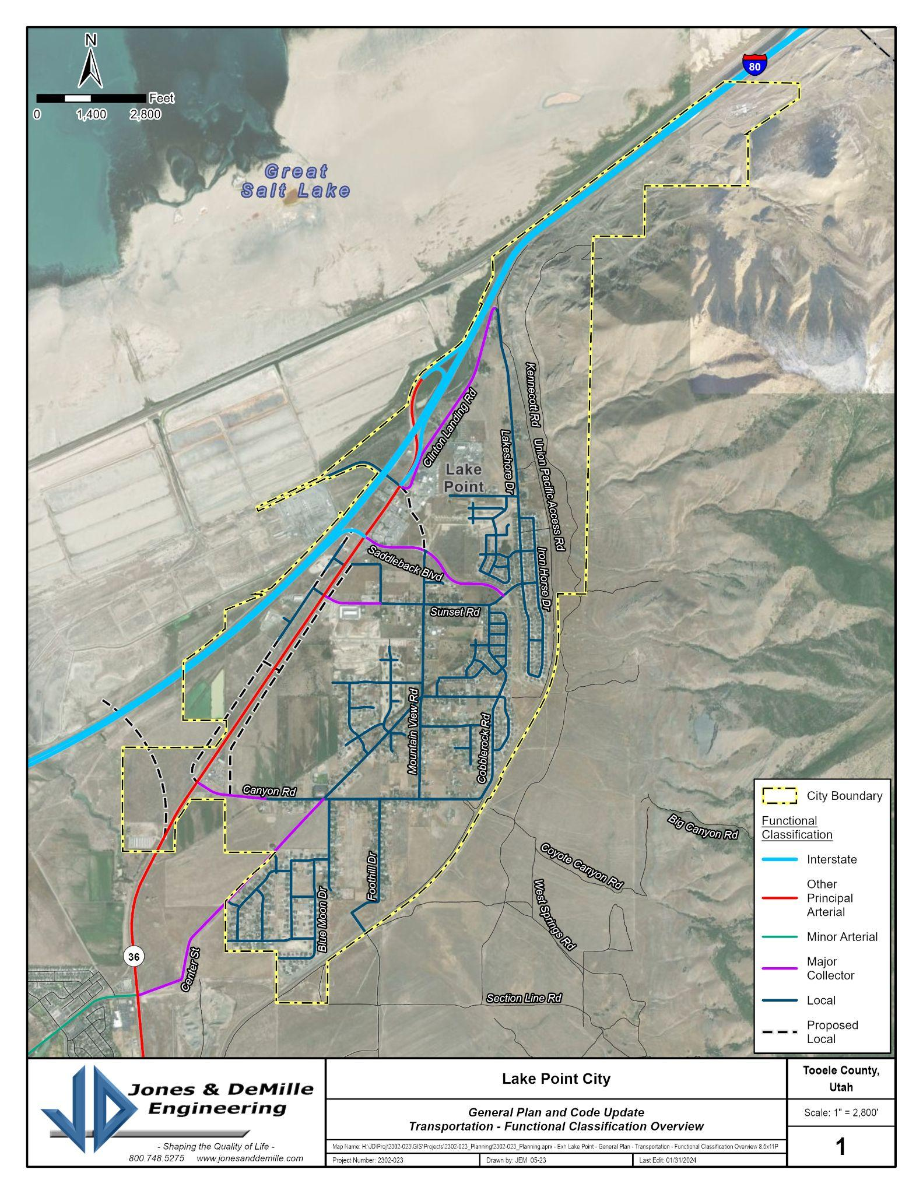
Transportation network for the Lake Point area (click for original).

5.08 Anticipated Changes + Future Growth
- Regional growth of industrial, residential, and commercial traffic will increase the amount of pressure on Lake Point’s transportation systems.
- Based on current land use zoning, growth pressure for residential development to the north and west of Lake Point will need to be a priority to avoid increased traffic.
- Lake Point will need to address road conditions and alternative routes and modes of transportation within these high-growth areas to avoid high traffic and poor road conditions.
- UDOT is likely going to continue to restrict access along Highway 36 over time. This will lead to new intersections.
- As the population in Tooele Valley grows, the potential for improved transit is expected.

5.10 Impact Fees + Traffic Impact Studies
- Lake Point does not currently have a street impact fee for transportation improvements. The impact fees are meant to assist in building the necessary roadway improvements to handle the increased growth and mitigate congestion that is currently being realized on the roadways in the City. Proposed roads on the future roadways map can be funded by these fees.
- In conjunction with the adopted General Plan, the City should work with UDOT to create an Access Management Plan for the Hwy 36 corridor.
- As part of furthering this plan and deciding how to use funds wisely, Lake Point may elect to update the impact fee after completing a fee study for any new development and for larger developments a Traffic Impact Study (TIS). A TIS is a specialized study of the impacts that a certain type and size of development will have on the surrounding transportation system. It is specifically concerned with the generation, distribution, and assignment of traffic to and from a new development. Since residential and private roads are not part of the Future Roadway map, TIS reports allow the City flexibility when deciding these smaller road locations.

5.12 Roadway Design
- A safe transportation system is one of the top priorities of Lake Point. New roads should be designed to give proper access to emergency vehicles and should be well maintained. Also, roadways, bikeways, and walkways should be designed in a way that all people can equally access and use the transportation system.
- Specific areas of concern are residential neighborhoods and schools. A reduction in the use of cul-de-sacs should be considered in order to provide greater traffic circulation. Streets that serve schools should encourage traffic mitigating measures and have well-designed pedestrian street crossings. Minor collectors should maintain the current grid system.
- Overall, the roadway network should focus on connectivity. This means that block sizes should not be too large, and important collectors should not dead end or terminate in a cul-de-sac. This is best achieved by utilizing a hierarchical grid system of roadways, which Lake Point already has in some parts of the City.

5.14 Active Transportation Facilities
- An important part of the transportation element of the city is the ability to provide for the needs of the citizens that includes biking, walking, and equestrian options throughout the community. The ability of Lake Point to become a walkable and bikeable community has multiple benefits to the community including less pollution, traffic, and the many health benefits to the citizens. Striking thoughtful balance will be crucial to ensure positive outcomes for both residents and the environment. Current data suggests those areas near a future downtown core would provide the most walkable/bikeable areas of the city for employment.. The City will explore active transportation opportunities that will connect its future downtown core with the trails, bikeways, and recreational facilities that surround the city.

5.16 Goals + Objectives: Transportation
G5-1. Provide and maintain a transportation system that promotes the orderly and safe transport of people, goods, and services while preserving the residential character of neighborhoods in Lake Point.
- O5-1.1 Develop a surface transportation network that minimizes congestion and provides for safely-designed neighborhood streets with minimal through-traffic flows.
- O5-1.2 Require all new development to follow the transportation element of the General Plan (and the most current Transportation Master Plan when available) while allowing some flexibility in the final design.
- O5-1.3 In lieu of isolated subdivisions dependent on master planned roads, the City shall encourage connectivity through the subdivision process.
G5-2. Plan for a multi-modal transportation network.
- O5-2.1 Assess transportation demand by reviewing system capacity, trip dynamics, travel behavior, land use, employment centers, retail centers, and residential density.
- O5-2.2 Adopt and maintain a transportation project priority list to ensure early acquisition of right-of-ways. Use the priority list in coordinating with elected officials and county, state or federal agencies.
- O5-2.3 Enhance connectivity between neighborhoods, open spaces, and city destinations. Encourage vehicular connectivity between commercial developments and minimize driveway access points to minimize turning conflicts.
- O5-2.4 Traffic impacts should be evaluated on a project-by-project basis.
G5-3. Designate and support the development of major arterial roadway corridors that are vital to the long-range transportation plan. Protect the viability of those corridors.
- O5-3.1 Coordinate with Tooele County and neighboring jurisdictions on the extended alignment of SR 36 through the City.
- O5-3.2 Continue to clearly state the City’s position on the proposed highway on the east side of the community. (Reference Resolution No. 2023-24 that was established at the time of this plan’s development).
G5-4. Preserve the existing rail service corridors and adapt these rights-of-way for future transportation services where feasible.
- O5-4.1 Preserve rail access to the City as an economic development tool. Limit encroachment on this line through land use limitations where appropriate.
- O5-4.2 Encourage land uses that currently exist east of Interstate 80, to expand their operations in appropriate areas west of the interstate highway.
- O5-4.3 Preserve elements of the existing rail corridor for use as an expanded transportation network that may include a multi-use trail system and/or future mass transit operations between the Tooele valley and Salt Lake County. In regards to future Mass Transportation (Rail, Highway Extensions, and freeway access points) Lake Point prefers such expansion to be located near the GSL, following I-80 westward and utilizing the Mid-Valley Highway corridor to service Tooele Valley communities. Lake Point desires trail development along the rail corridor by the foothills.
G5-5. Expand mass transit opportunities as the community grows.
- O5-5.1 Support the expansion of bus service as demand grows.

5.18 Implementation Action Steps: Transportation
- Short-Term Opportunities (1-5 years)
  - As resources permit, conduct studies that can evaluate conditions and gaps in the current network:
    - SR36 Corridor Study
    - Access Management Plan
    - Design Standards and Cross-Sections Update
    - Lake Point Trail Study
    - Regional Transit Study
- Long-Term Opportunities (+5 years)
  - Make regular updates and steady investments in the recommended capital improvement project list.

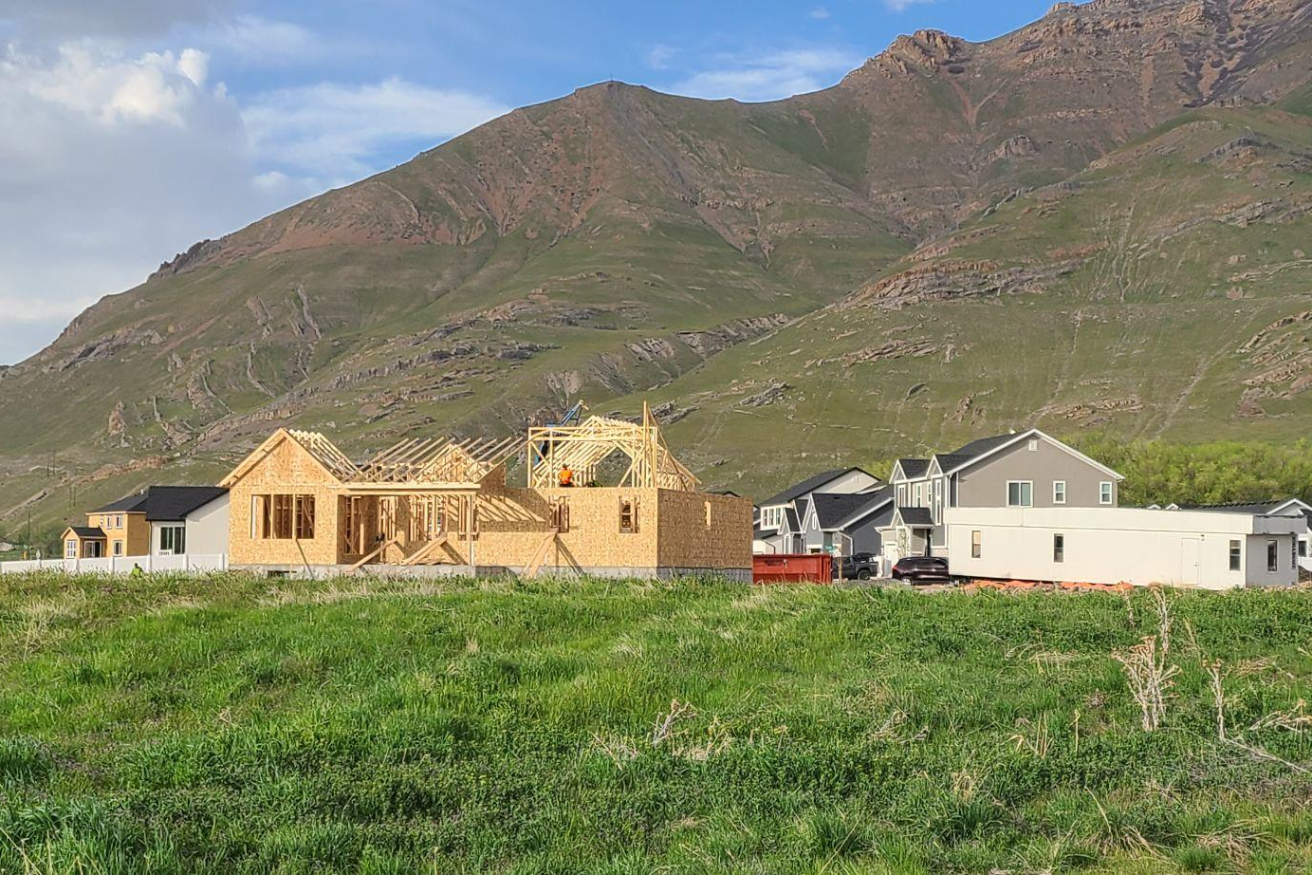

6 - HOUSING
High-quality and affordable housing is at the foundation of the quality of life of every community. The condition of neighborhoods has direct and indirect links to all aspects of the community, especially economic development. This chapter is meant to serve as a guide for the elements of the housing market that community leaders can influence in their area.

6.02 Current Conditions
- The future vitality of the community is directly tied to the health and viability of its residential neighborhoods. In turn, neighborhood quality is dependent upon housing and environmental conditions, other physical amenities, community services, and social and economic factors.
- A significant assumption of this section is the maintenance and enhancement of the residential environment. This can be achieved only when the objectives and implementation are aligned integrally with the major goals of the general plan.
Housing OPPORTUNITIES | Housing CONSTRAINTS
- There is clear and strong support by the public to maintain the community's rural atmosphere with large lot residential development.  - The interchange areas can provide for mixed-use development that can accommodate attainable housing with the expected commercial build-out. | - The city controls a limited number of elements involved in the larger housing market.  - Without a significant shift in the area’s employment opportunities, the gap between average wage rates and average home prices will continue to widen.  - There is concern about the aquifer’s water supply. Future development might be constrained if they are not able to access sufficient culinary water resources.

6.04 Desired Future: Housing
- The City aims to attract young families, retirees, and individuals who are interested in living in a rural community that offers a high quality of life. The city also seeks to maintain its agricultural character while promoting economic development.

6.06 Anticipated Changes
- The population of Lake Point is projected to continue to increase substantially by the year 2030, however, it is not clear that the potential for income growth will increase at the same rate.
- Moderate income housing will continue to be an important issue for Lake Point as the population of the community increases.
- City leaders should expect significant public opposition to any multi-family development that is not located in a mixed use zone. City leaders should also expect the desired location for multi-family development to be outside the core of rural Lake Point and west of Highway 36.

6.08 Goals + Objectives: Housing
G6-1. Preserve and strengthen Lake Point’s existing neighborhoods while allowing the formation of new neighborhood centers.
- O6-1.1 Through appropriate zoning and City ordinances, protect residential areas from inappropriate or detrimental, non-residential encroachment.
- O6-1.2 The City will establish clear and precise land use regulations as a means of ensuring fairness and neighborhood stability.
- O6-1.3 Coordinate regularly with the WFRC and others to ensure access to federal and regional housing assistance programs, grants, residential rehabilitation loans, and down-payment/closing cost assistance programs, etc. [as per UCA 10-9a-403(2)(b)(iii)(S)].
G6-2. Protect the individual resident’s investment in the Lake Point community that is represented by the existing housing stock and neighborhood environments.
- O6-2.1 Enforce existing building codes and zoning ordinances to protect residential investments.
- O6-2.2 Limit a widespread conversion of existing single-family homes that are categorized as moderate-income housing into a duplex or multiple unit rentals through appropriate ordinances and routine enforcement procedures to preserve Lake Point’s existing single-family rural residential housing.
- O6-2.3 Provide land use planning that results in safe, traffic-calmed residential streets and balancing transportation and fire safety with neighborhood values and pedestrian safety.
- O6-2.4 Continue monitoring streets and public infrastructure needs. Prepare long-term plans and budgets necessary to provide and ensure adequate levels of service.
- O6-2.5 Regularly review and implement refinements to the process of development proposal reviews in order to make the process more efficient for the applicant and city leaders.
- O6-2.6 Identify areas of the community to allow internal and external accessory dwelling units that meet the character and environment of the neighborhood and within residential zones of the City.
G6-3. Facilitate a reasonable opportunity for a variety of housing, including moderate income housing to meet the needs of people desiring to live, benefit from, and fully participate in all aspects of neighborhood and community life.
- O6-3.1 Continue to monitor and review the moderate income housing needs within the City.
- O6-3.2 Continue to address moderate-income housing needs in coordination and cooperation with the Tooele County Housing Authority and other such entities. In conjunction with the availability of the most current data from the U.S. Census and ongoing demographic information, update and expand the City’s housing element of the general plan.
- O6-3.3 Expand the variety of housing opportunities, with a balance of housing styles and price points. This might be accomplished through an expansion of zoning categories west of Highway 36, or through the zoning ordinance allowing for greater flexibility in design, including lot sizes and setbacks.
- O6-3.4 Utilize the City’s housing policy to support economic development activities, as well as the needs of community services such as education.
G6-4. Identify potential areas of blight that may affect the community and establish goals and standards for improvement of these areas or structures.
- O6-4.1 Provide information for property owners regarding housing rehabilitation methods and safety inspections.
- O6-4.2 Support housing developments that are constructed out of high-quality materials and are intended for owner occupancy, especially in the case of multi-family developments.
G6-5. Evaluate zoning applications and decisions from a perspective of preserving and improving the quality of life for residents of existing neighborhoods.
- O6-5.1 Implement programs to protect purely residential areas from commuter traffic including the effects of traffic generated by schools, hospitals, businesses, and government facilities.

6.10 Implementation Action Steps: Housing
- Short-Term Opportunities (1-5 years)
  - Explore the Community Facilities Grant program from the Rural Community Assistance Corporation (RCAC). Funds can be used to aid in the development of assisted living, transitional housing, etc.
  - Work with NGO and area stakeholders to incorporate the Community Development Block Grant Program (CDBG) from HUD into the City’s moderate-income housing strategy.
  - Develop a grant strategy for USDA Rural Development’s “Rural Community Development Initiative” (RCDI) with the goal of helping non-profit housing and community development organizations with their housing projects.
- Long-Term Opportunities (+5 years)
  - Explore methods and programs that encourage homeownership counseling and mutual self-help housing.
  - Investigate the creation of incentives for the development of lower-cost housing, such as: smaller single-family homes, height flexibility, partnerships, programmatic incentives such as grants, and contributing vacant City-owned land.
  - Lake Point has a range of housing options, including smaller, older homes that are currently considered affordable within the city. As part of our commitment to preserving diverse housing choices, let's explore incentives that encourage the maintenance and retention of these existing homes, ensuring they remain affordable options for the future.
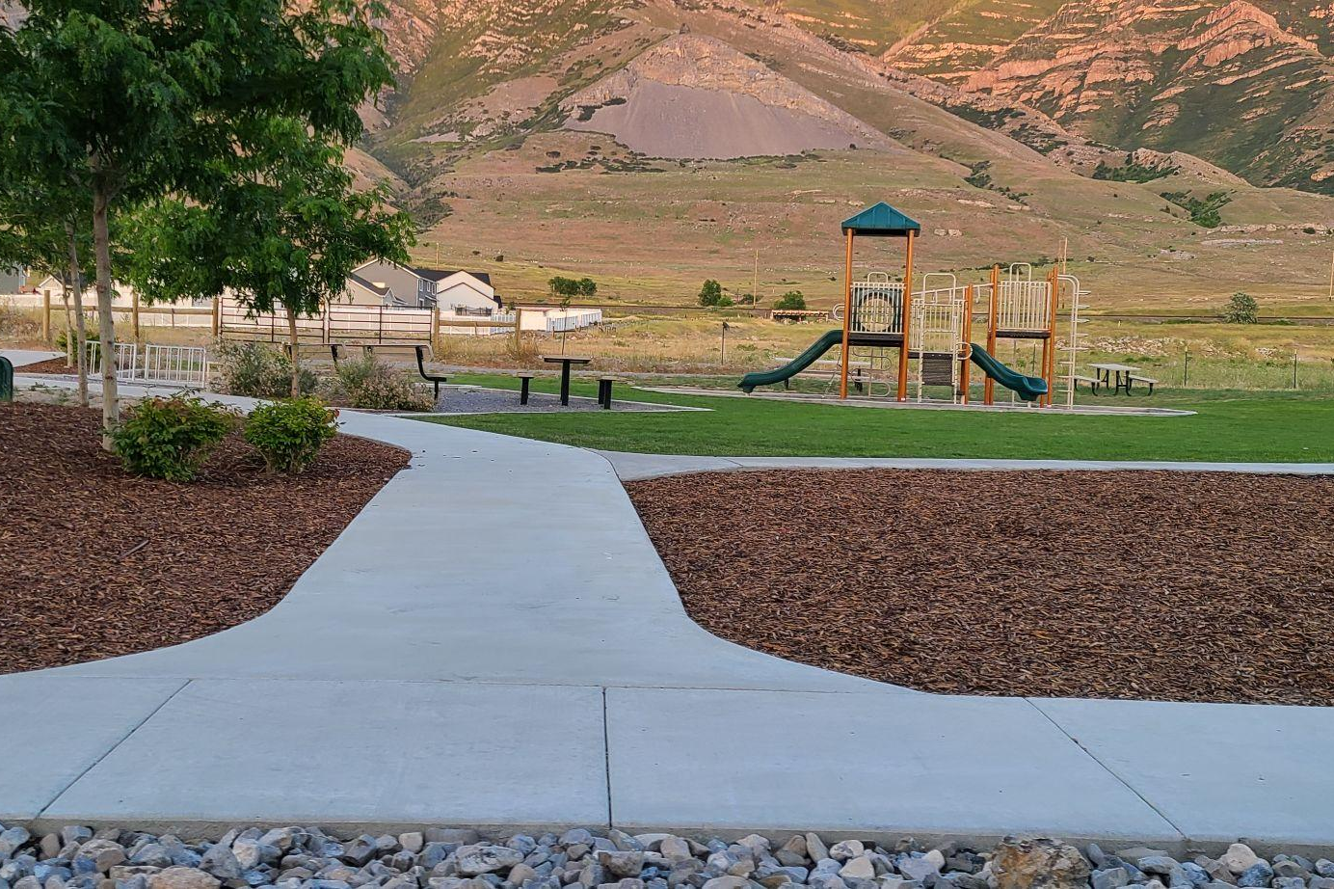

7 - PARKS + RECREATION
The parks and recreation element of a general plan represents an important step in the City’s efforts to enhance the public’s ability to enjoy the natural beauty and extensive recreational opportunities in Lake Point. The previous plan recognized the importance of the City forming a partnership with private and public entities that represent the variety of resources that complement the goals, and objectives.

7.02 Current Conditions
- One of the surveys asked what residents thought the land east of the railroad should be used for. Most responded that it should be conserved for outdoor recreation over housing (hiking, wildlife, equestrian, etc).
Parks + Recreation OPPORTUNITIES | Parks + Recreation CONSTRAINTS
- The City could encourage developers to include immediately-adjacent play areas in their developments (i.e. trading front and side setbacks for larger backyards, shared areas for townhomes, etc).  - The Lake Point area is home to a number of regional points of interest (i.e. Adobe Rock, equestrian trails, and petroglyphs in the foothills). | - Park services are currently provided by a district, not the City itself.  - When residents were asked what Lake Point's greatest challenges were in the context of growth and development, half of the respondents identified adequate amenities as their highest concern.

Exhibit 7.02.1 Parks and Recreation Map
Existing parks and trails in Lake Point, 2023 (click for original).

Exhibit 7.02.2 Existing Walking / Running Route Map
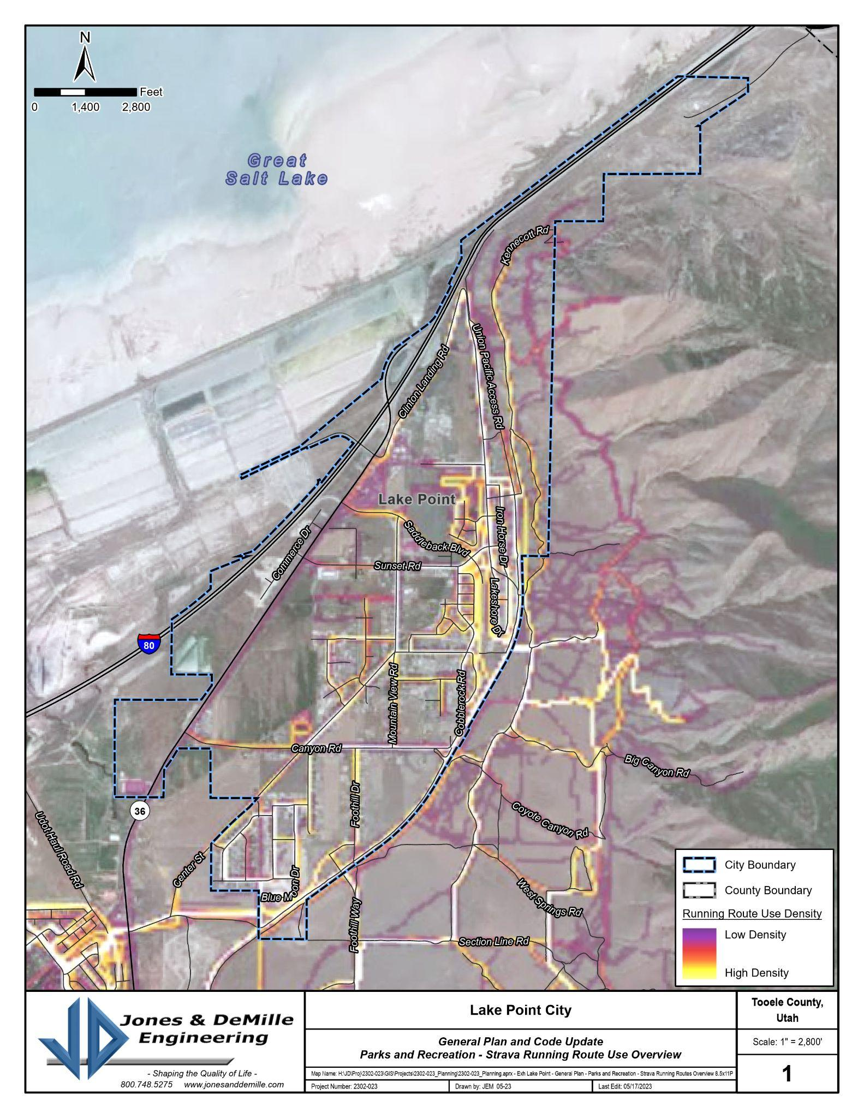
Walking/running routes in the Lake Point area, 2023 (click for original).

Exhibit 7.02.3 Existing Biking Route Map
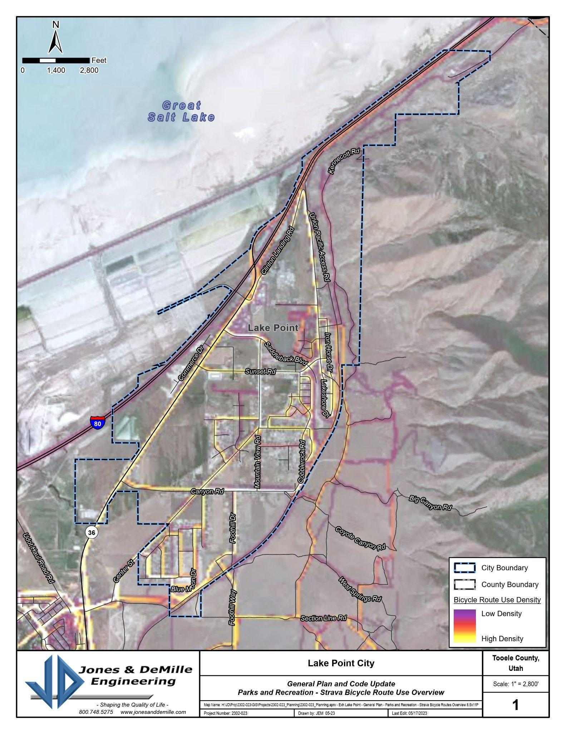Existing biking routes in the Lake Point area, 2023 (click for original)

7.04 Desired Future
- With projected growth comes the added responsibility to plan for and protect outdoor opportunities citizens and visitors have come to enjoy. The City also wants to work toward the development of multi-purpose recreation amenities of a quality and quantity sufficient to draw users from outside the community.

7.06 Anticipated Changes
- Sports, exercise, and other recreational leagues will continue to serve an important role in the community.
- The City should carefully examine the opportunity for more year-round recreational facilities for the residents of Lake Point and to attract more visitation from outside the area.
- The City should work closely with all stakeholders to expedite the identification and confirmation of future city and regional parks' locations. Additionally, the City emphasizes working closely with the Parks District and developers, integrating park development seamlessly into the broader development process. Lake Point’s ordinances should be crafted to mandate the inclusion of parks and essential amenities before progressing to the next stage of development. This approach not only reflects the vision for vibrant and well-planned communities but also ensures that parks are integral components, thoughtfully integrated from the inception of new developments.

7.08 Goals + Objectives: Parks and Recreation
G7-1. Expand recreational opportunities throughout the City.
- O7-1.1 As resources become available, work with the Parks District to establish additional recreational amenities such as primitive camping, nature trails around historic sites, a shooting range, pickleball courts, etc..
- O7-1.2 Develop a broad network of trails for a variety of users including riding opportunities for equestrian and off-highway vehicles.
- O7-1.3 Create a policy for neighborhood parks, including operations and maintenance, and work with new development to implement these policies.
- O7-1.4 Enhance and protect quality of life for Lake Point residents of all ages, incomes, and abilities by providing access to parks, open space, and a choice of recreation opportunities.
- O7-1.5 Consider the needs of disabled citizens when making improvements and developing new facilities. Explore the options to reinstate access to existing roads in the foothills to allow citizens to enjoy open areas that border Lake Point such as the Petroglyphs that are no longer accessible to disabled citizens due to locked gates.
G7-2. Protect, conserve, and enhance the natural beauty of Lake Point, and improve the recreational facilities and opportunities for residents and visitors to enjoy.
- O7-2.1 Create development incentives in the City’s land use regulations for the preservation of strategic natural open space areas.
- O7-2.2 Protect hillsides where trails have developed informally.
- O7-2.3 Respect private property rights when preserving or developing open space. Work to bring balance and equity for both the landowner and the community into the negotiations to secure open space or greenbelts.

7.10 Implementation Action Steps: Parks and Recreation
- Short-Term Opportunities (1-5 years)
  - Conduct a study to identify free or low-cost land for recreational opportunities. Consider all aspects of acquiring open space including donations, conservation easements, property trades, existing rights-of-way and opportunities within new developments.
- Long-Term Opportunities (+5 years)
  - As resources become available, purchase land and develop parks in the City.
  - Actively participate in the statewide trail system planning to ensure connections to Lake Point.

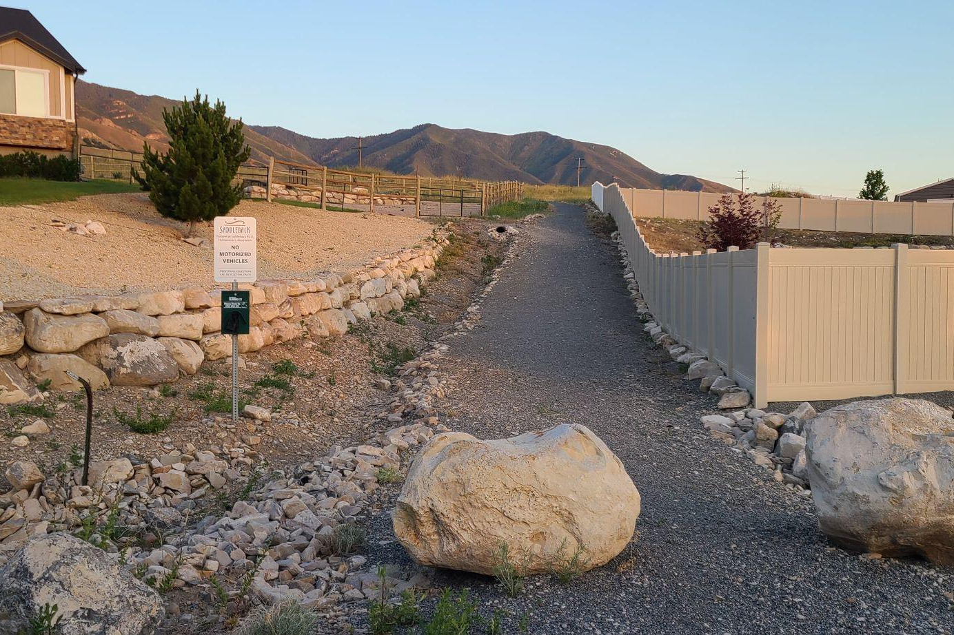

8 - TRAILS
Trails are typically publicly‐held improvements providing opportunities for passive and active recreation. They may range from paved corridors to dirt paths in a natural setting, and they provide important open space that would otherwise disappear as development occurs within the City. They are an important measure of quality of life within the community and contribute to the overall well‐being of the citizens by providing places to recreate. The Lake Point general plan contains a trails element that is distinct from parks and recreation issues because the level of development pressure in the area warrants focused goals.

8.02 Current Conditions
- Generally, the city's location at the northeast corner of the county and its proximity to the foothills make it a strong candidate for a network of regional trails. The trail amenity in the Saddleback area of the city is a popular asset for local residents.
Trails OPPORTUNITIES | Trails CONSTRAINTS
- Many roads within Lake Point have sufficient width to incorporate pedestrian, equestrian, and bike lanes.  - Community residents believe that there is an opportunity for new trailheads along foothills on the east-side of town. | - Access to trail amenities in and around the foothills is constrained by the railroad.  - Some of the local trails are managed by a homeowners association and not the city or another public entity.

Exhibit 8.02.1 Proposed Trail Map
Northern Tooele County’s planned active transportation facilities (click for original).

8.04 Desired Future
- Lake Point’s residents and visitors enjoy easy access to quality outdoor spaces and recreational opportunities through a system of interconnected trails for pedestrian, bike, equestrian, and motorized activity. Developing and maintaining a connected network of trails throughout and around the city allows alternative options for residents to travel while enjoying the beautiful scenery of Lake Point.

8.06 Anticipated Changes
- The population of Lake Point is expected to continue to grow. This will create development pressure around areas that could be potential trail amenities. The City will need to plan now to preserve those areas and corridors.

8.08 Goals + Objectives: Trails
G8-1. Create a transportation network that is balanced, incorporates multimodal corridors and facilitates local circulation.
- O8-1.1 Locate major transfer points and connections to multiple-use transportation networks, to facilitate movement between major focal points throughout the city.
- O8-1.2 Coordinate the placement and location of roads and future transit lines with state, county and regional planning agencies.
- O8-1.3 Establish a separate, but integrated, network of pedestrian, equestrian, and bicycle paths providing safe and suitable walking and biking access throughout the city.
- O8-1.4 Encourage landscaped separation buffers when trails are adjacent to master planned roads.
- O8-1.5 Encourage the separation of trails from roadways in the subdivision process.
G8-2. Expand transportation planning to include all methods of transport; including pedestrian trails, bikeways, equestrian trails, and off-road vehicle routes.
- O8-2.1 Develop an integrated network of pedestrian trails, equestrian trails, and bikeways to provide safe, non-vehicular access throughout Lake Point.
- O8-2.2 Provide for equestrian trails from residential developments with equestrian use, to equestrian facilities and outlying equestrian trail areas, lessening the need to trailer and transport the animals. Include additional equestrian trails where appropriate.
- O8-2.3 Continue to develop routes within the City to provide for direct ATV access to ATV trails both within and outside of the City.
- O8-2.4 Minimize conflicts between motorized, non-motorized, and equestrian users by separating them where possible.
- O8-2.5 Provide adequate wayfinding signage throughout the city to guide residents and pedestrians to the available active transportation and parking amenities.

8.10 Implementation Action Steps: Trails
- Short-Term Opportunities (1-5 years)
  - Identify routes to schools (along state highways) where sidewalks do not currently exist and where major construction or reconstruction of the route, at that location, is not planned for ten or more years. Apply to UDOT’s Safe Routes to School Program for an implementation grant.
  - As resources become available, provide improvements at trailheads to include restrooms, parking, and water.
  - Support the statewide trail planning initiative that is described in the Unified Transportation Plan 2023-2050.
- Long-Term Opportunities (+5 years)
  - Maintain the City’s trails master planning efforts and incorporate the grants from the Utah Office of Outdoor Recreation.
  - Incorporate the Recreational Trails Program from Utah State Parks to help with the construction and maintenance of trails and trail-related facilities, including the development of staging areas, trailheads, restroom facilities, etc

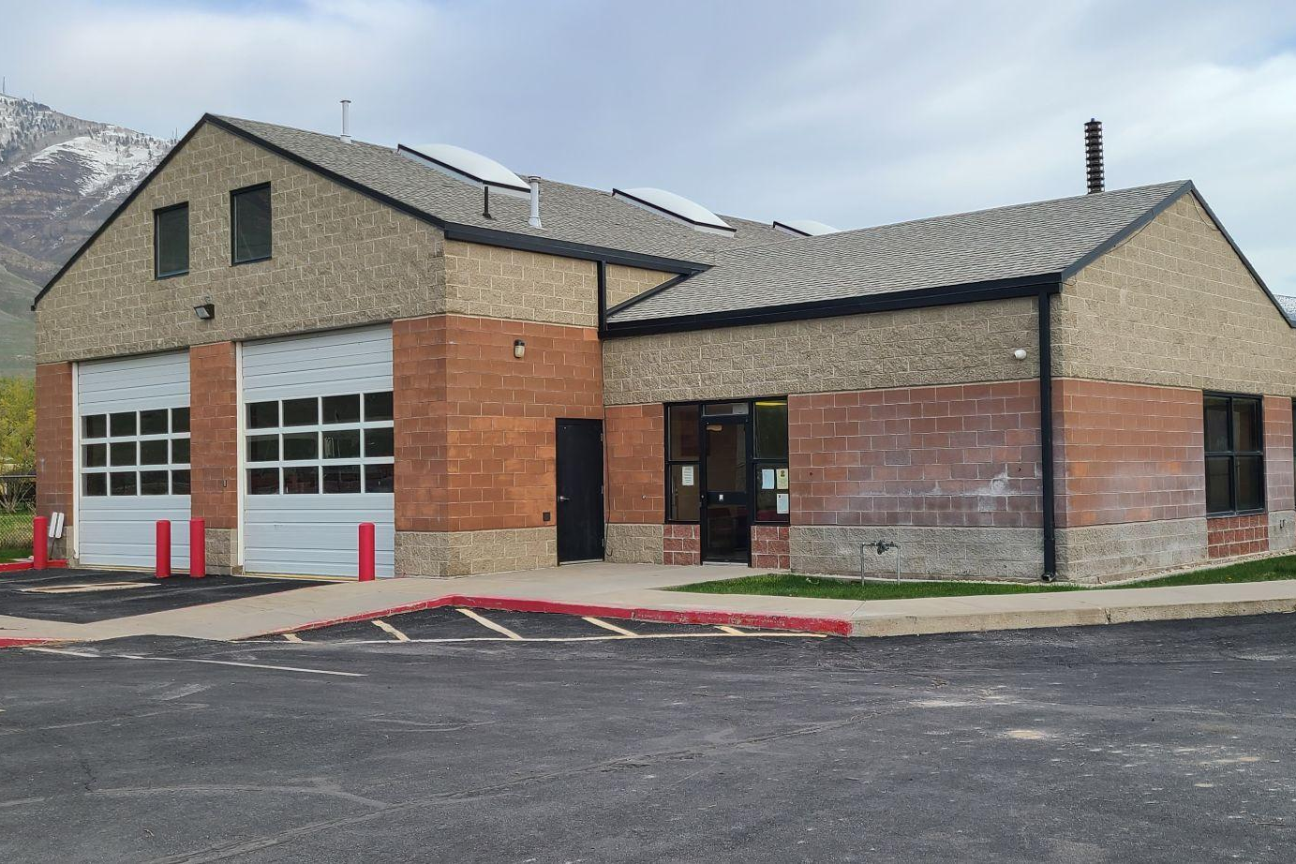

9 - INFRASTRUCTURE + PUBLIC FACILITIES
This element of the general plan addresses issues related to public buildings, facilities, and services that are necessary to the vitality of the community. It includes schools, libraries, civic buildings, fire stations, social service centers, distribution systems for culinary water, wastewater and storm drainage systems, parks, golf courses, recreational fields and the city cemetery. Because Lake Point has incorporated so recently, it doesn’t currently control many of these systems and facilities.

9.02 Current Conditions
- There are a number of Special Service Districts (SSDs) that serve the Lake Point community. These SSDs are independent entities established to provide specific services to a defined geographic area within Tooele County. These districts include entities like fire protection districts, water and sewer districts, mosquito abatement districts, cemetery, and parks and recreation districts. They are responsible for providing and maintaining specialized services tailored to the unique needs of the communities they serve.
- The systems serving the area are performing well generally, but deliberate consideration of the lifecycle of infrastructure assets (i.e. replacement or upgrading) needs to be included in development decisions in order to minimize the financial impact to current users.
Infrastructure + Public Facilities OPPORTUNITIES | Infrastructure + Public Facilities CONSTRAINTS
- The City might consider developing an online information portal that also includes information from neighboring jurisdictions that help utility providers improve their potential to coordinate maintenance and expansion activity. (Alternatively, the jurisdictions might also establish a “joint utilities commission” to address this issue).  - The City is not currently responsible to fund infrastructure improvements directly.  - The City can partner with districts to assist with funding and resources to support their district area of responsibility.  - The City can create ordinances and requirements to assure infrastructure for districts is paid for and completed by development. (For example parks and sewer). | - Until infrastructure systems come under the City’s direct control (instead of special districts), it will be difficult for the City to offer strategic economic development incentives.  - The age and extent of infrastructure systems is an issue that increases over time, and the City doesn’t own or control many of their services.  - Continued growth will put additional pressure on the area’s existing infrastructure. Specifically, water sources.

9.04 Desired Future
- Infrastructure improvements will be planned to support the needs of Lake Point's growth as well as the replacement of existing facilities that have deteriorated due to age. Careful planning is conducted so that the costs for such improvements will be shared by new development and existing residents and businesses.

9.06 Anticipated Changes
- The City is positioned to take a stronger role in creating better communication and a better working relationship between local major developers, contractors, SSD / utility providers, and citizens. The goal of this effort will be to maintain an ongoing dialogue in order to help all parties maintain current investments, reduce costs, and maintain quality of life in Lake Point.
- The City is expecting aggregate water usage to continue to increase with population increases.
- FEMA’s recalculation of flood potential could have a significant impact on many properties.
- The Lake Point area might be a key location for some of the County’s infrastructure and service investments (i.e. new libraries).
- As the population grows, the need for a larger cemetery facility will grow as well.

9.08 County Public Works
- Tooele County Public Works is responsible for managing and maintaining the county's transportation infrastructure, including roads, bridges, and transportation planning. They ensure safe and efficient transportation systems for residents and businesses in the region.

9.10 Culinary Water
- All residents of Lake Point own their own water through either private water rights or through shares in a co-op organization. Roughly 1/3 of the residents of Lake Point today have a private well and their own water shares. The Oquirrh Mountain Water Conservancy District is a mutual non-profit co-op with a metered system that provides service to residents and businesses on the east side of Hwy 36. Some of the development along the highway is served by the Stansbury Water District.
- At the time of writing this plan, new private water rights were not available in Lake Point and transfers of water rights between aquifers is prohibited. This may limit future development within the city.
- There are also preliminary discussions of the feasibility of a county-wide water system, but its implementation would be beyond the time horizon of this plan.
- These two Districts are currently served by five wells and they have been experiencing a steady increase in demand for service.
- Currently, there are 594 connections with a mix of residential, commercial, and institutional users. Water usage for these connections was determined based on water usage reports provided by Oquirrh Mountain Water Company.
- There are no secondary water systems in the residential areas community, but the Stansbury Park Improvement District has the capacity within its service area (as of 2023).

Exhibit 9.10.1 Oquirrh Mountain Water Connections
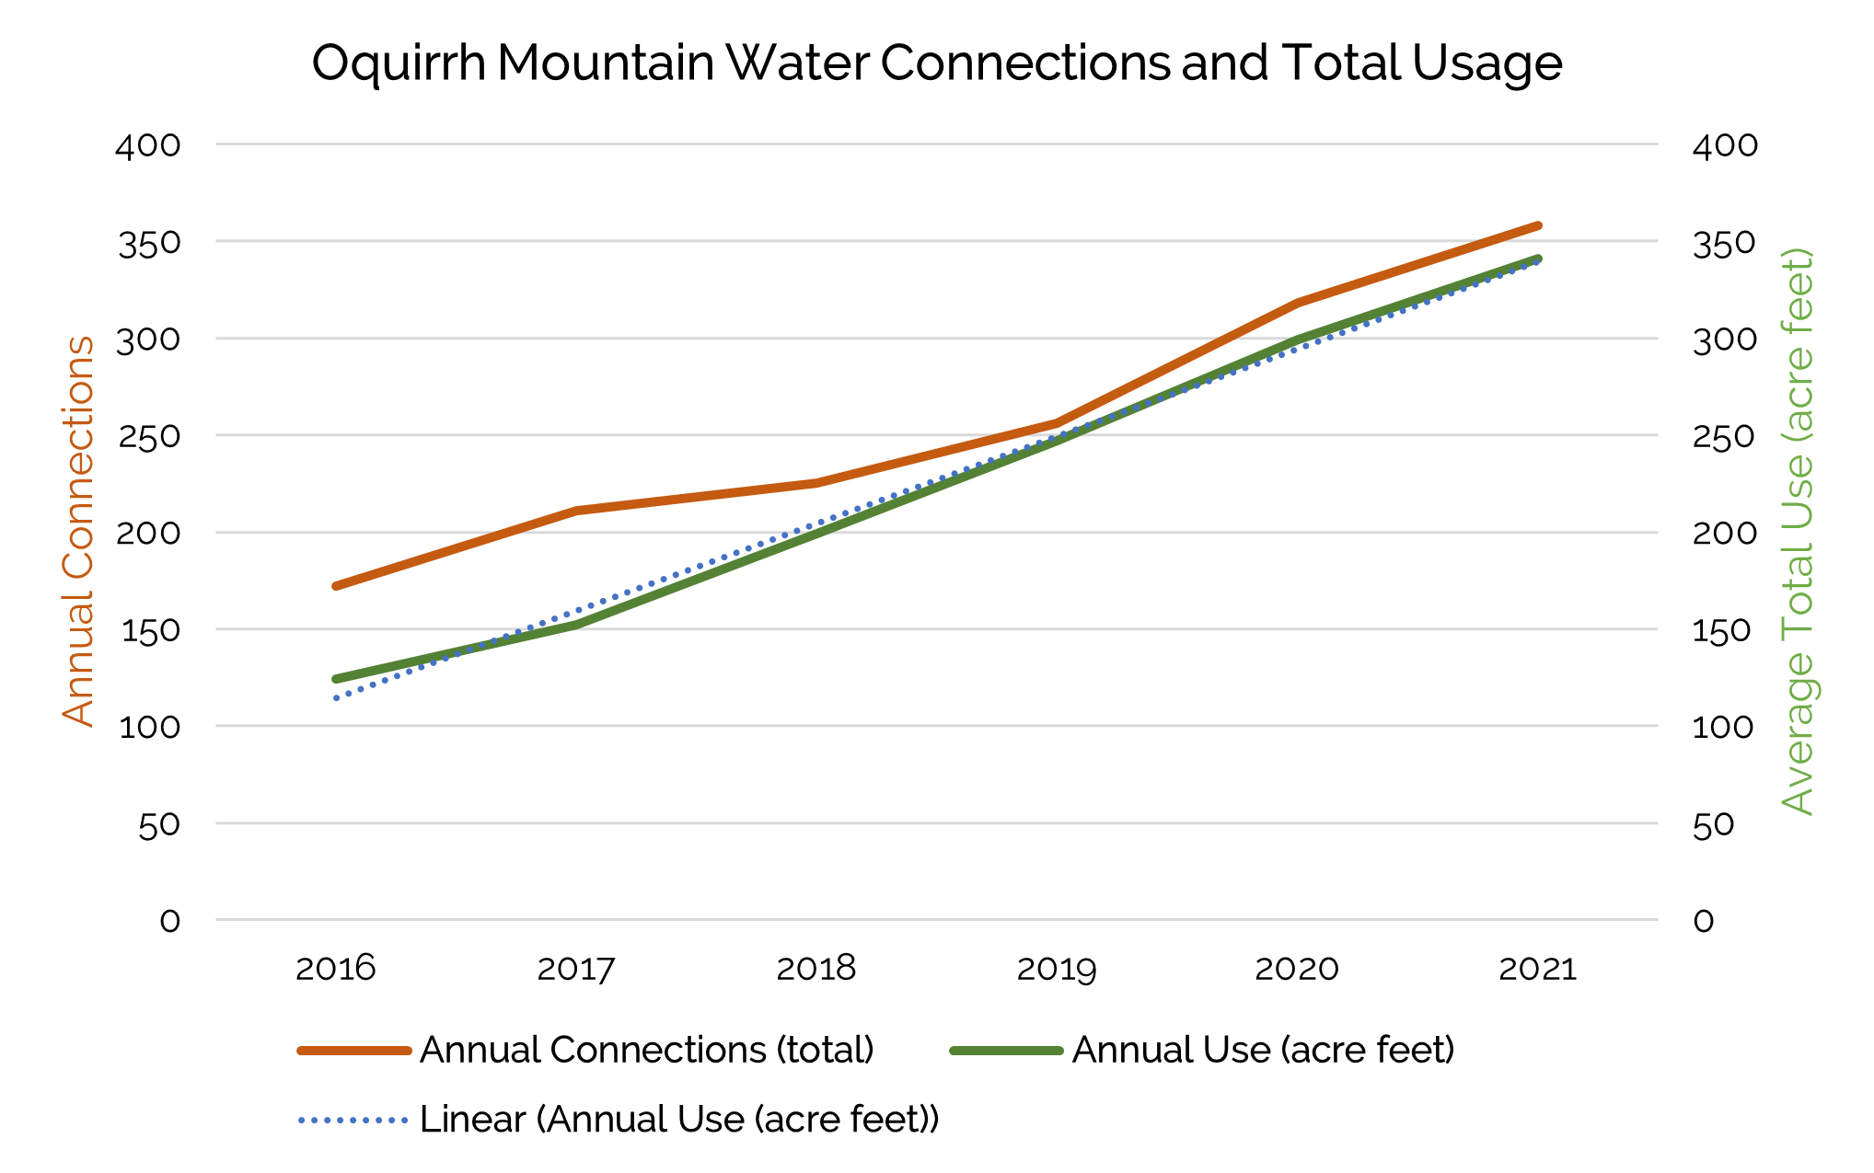
Chart showing Oquirrh Mountain’s trending annual water usage and total connections.
(Source: Utah Division of Water Rights - waterrights.utah.gov)

Exhibit 9.10.2 Map of Water District Service Areas
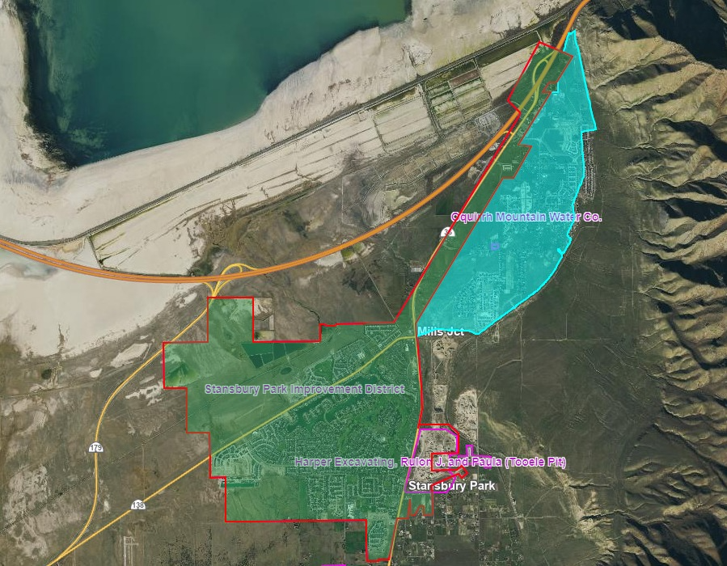
Service area of the Oquirrh Mountain Water Company (serving the residential areas) and the Stansbury Park Improvement District (serving the commercial corridor), as of 2019. (Source: Utah Div of Water Resources).

9.12 Solid Waste
- Lake Point contracts with a private company to provide waste management services for residents and businesses within city limits. Residents have the ability to take items to the Tooele County Landfill as well.
- Tooele County does not offer Lake Point recycling cans to individual households. Currently Lake Point provides a recycling dumpster in two locations, it is anticipated that this service will continue in the future,unless improper usage occurs (recycling items/trash left outside of the container or non-recyclable materials placed in the container).

9.14 Sewer System
- The Lake Point Improvement District provides sewer service to Lake Point and the surrounding area. The District has a discharge permit that expires in 2025. The lagoon facility is located south and west of the junction of the Tooele City exit off Interstate 80 and HSR36. The facility serves the community of Lake Point. The design capacity is 0.392 MGD (million gallons of flow per day), over the last five years the annual average flow rate was 0.1975 MGD with a maximum daily flow rate of 0.219 MGD.
- There is a potential opportunity, with proper planning and development, that the lagoons could be converted to a sewer treatment facility.

9.16 Cemetery
- The City is located within the Lake Point Cemetery and Parks service area. The cemetery is provided and maintained by the Lake Point Cemetery and Parks Service Area, which is a special service district.

9.18 Goals + Objectives: Infrastructure
G9-1. Provide public facilities and services that aid in furthering development while maintaining the quality of life in the City and increase its attractiveness.
- O9-1.1 Review and determine appropriate levels-of-service for all public services and work with service providers to set goals to achieve those levels throughout the City.
- O9-1.2 As a first priority, the City will make infrastructure and service investment decisions that meet the needs of existing and potential City residents. The City will also plan for appropriate expansion of public facilities and service needs ahead of actual growth demands. Require all new developments to pay for their proportionate share of expansion.
G9-2. Support the development of adequate systems to handle culinary water, wastewater and stormwater that promote safe and appropriate support for the activities and needs of the community.
- O9-2.1 Continue to monitor utility system demands to ensure that the desired level-of-service commitment is maintained as new growth occurs.
- O9-2.2 Balance the costs and operational impacts of new growth proposals on system expenditures relative to both existing and future infrastructure development plans. Develop a service extension policy relative to future annexations and development.
- O9-2.3 Lake Point intends to preserve the integrity of its infrastructure systems by permitting orderly growth that synchronizes development with the availability of public facilities such as road, sewer, public safety, and water service needed to support it.
- O9-2.4 Identify groundwater recharge areas, springs, and well sites in order to work with the appropriate private or public interests to manage these areas for adequate protection.
G9-3. Support the development of a plan to maintain and improve the existing stormwater and drainage facilities and associated infrastructure and to develop necessary facilities and infrastructure for future development.
- O9-3.1 Protect existing stormwater and drainage channels to maintain capacity for future development.
- O9-3.2 Encourage sustainable development practices that incorporate on-site stormwater detention facilities to reduce peak discharge flows while providing opportunities for ground water recharge throughout the City.
- O9-3.3 Identify storm water recharge methods and standards appropriate for use in both new and existing developments and locations.
- O9-3.4 Study drainage patterns within the City and annexation policy areas to accurately identify the 100-year flood plains based on the current levels of development. Work with FEMA to update the appropriate plans where changes are warranted, unless the city council chooses another direction.
- O9-3.5 Coordinate the improvement of detention areas and flood channels with the development of trails and parks.
- O10.3.6 Work with Tooele County to establish a consistent buffer between development and stormwater systems.
G9-4. Continue to support the improvement of telecommunications and digital access systems to enhance both quality of life and commercially viable communications within the City.
- O9-4.1 Continue to monitor and evaluate technology applications within the community to provide better telecommunications opportunities for residents as well as businesses.
- O9-4.2 Work with telecommunications providers to understand avoidable hindrances that might limit or delay the delivery of services.
G9-5. Implement a capital improvement plan to develop, maintain, and improve public facilities, services and infrastructure, including schedules, budgets and potential funding sources.
- O9-5.1 Monitor existing systems within the City and develop a program, including budgets, for systematic maintenance and upgrades.
- O9-5.2 Prioritize infrastructure improvements in areas of the City where existing, substandard utility systems have been identified.
- O9-5.3 Establish realistic budgets and timeframes for the expansion and maintenance of all public facilities and services within the City. Provide balance between new areas of development and existing areas of the community.
- O9-5.4 Develop and maintain a schedule to conduct updates to infrastructure master plans that will help the City adjust their investment priorities.

9.20 Implementation Action Steps: Infrastructure and Public Facilities
- Short-Term Opportunities (1-5 years)
  - Partner with the USDA’s Natural Resources Conservation Service to plan and implement watershed projects with the PL-566 Watershed grant/loan program.
  - Explore a policy to incorporate Low Impact Development (LID) techniques to control on-site runoff, return stormwater to the aquifer, and improve water quality.
  - City can work with the County to designate a drop-off location for hazardous household waste.
- Long-Term Opportunities (+5 years)
  - Toward the end of the City’s current water master plan, apply for funds to update it from the Utah DEQ’s State Revolving Fund (SRF - Drinking Water).
  - Support the work of the Water Conservancy Districts
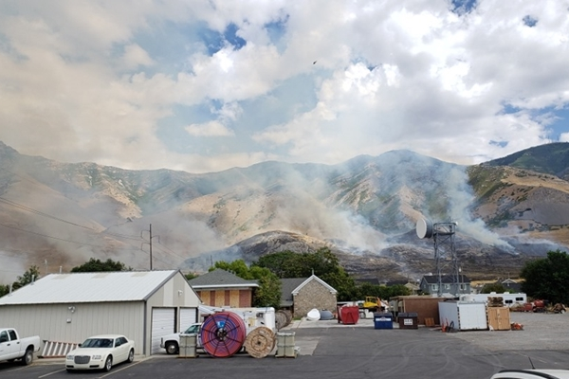

10 - RISK + RESILIENCE
The “community resiliency” element of the general plan is a discussion about the ways that the city is working to adapt well in the face of adversity and about their capability to bounce-back from major events. Though the city can’t accurately know all of the risks it might face in the future, there are meaningful and intentional actions that can be taken before events occur. These include: event forecasting, mitigation planning, system integration, target hardening, and maintaining effective communication between entities. Much of this plan will focus on anticipated hazards.

10.02 Current Conditions
- Lake Point faces various potential natural and manmade disasters. Natural disasters in the region can include wildfires, severe storms, flooding, and earthquakes. The County has emergency management plans in place to mitigate the impacts of these events and coordinate response efforts. Local authorities work closely with the county and state agencies, such as the Utah Division of Emergency Management, to ensure preparedness and response capabilities.
- There is 1 fire station in Lake Point, and 3 others in the District. (Stansbury Park is the only one that is manned 24/7 ISO class 5). In order to achieve this rating, residences and businesses have to be 5 miles from the station in Lake Point and 1,000 feet from a hydrant. Most homes in Lake Point qualify on both accounts.

Risk + Resilience OPPORTUNITIES | Risk + Resilience CONSTRAINTS
- The Police and Sheriff could expand their program to leverage community volunteers (VIPS).  - Community residents commonly express interest in learning more about the risk-related plans and decisions of the City. | - The proximity to the GSL can lead to severe weather conditions.  - The difficulty in crossing the railroad can be a hindrance in wildland fire responses.

10.04 Desired Future: Risk + Resilience
- Lake Point intends to position its systems and services in a way that it will be able to support individuals to cope, recover, and change following a significant event. The City will maintain its resiliency by integrating its efforts in land use planning, capital investment, maintaining natural systems, and raising awareness of risk.

10.06 Anticipated Changes
- As the region continues to grow, Lake Point (and Tooele County) will need to increase its investment in public safety services.
- At the time of the general plan update, the city recognizes that certain areas within our community may not currently have fire hydrant coverage within 1000 feet. These areas would benefit from the placement of additional, strategically placed fire hydrants. This future process may involve North Tooele Fire District, developers, water companies, property owners, and the city.
- At the time of the general plan update, FEMA was developing new modeling and mapping for floodplains. The City is anticipating that this work will result in the need to develop an ongoing, proactive strategy to mitigate the risks identified by it.
- In 2021, County planners estimated that new residential development of approximately 1,000 homes would be seen in the area between Lake Point and Pine Canyon. Each of these homes could potentially be affected by wildfire and geologic hazards.

10.08 Community Risk Analysis
- Lake Point partners with Tooele County for public safety services. This relationship is described as good currently, but future growth will add stress to this arrangement.
- There are opportunities for the City to contract with other providers of Public Safety Services.

10.10 Public Safety Capabilities
- Currently, the City benefits from a good working relationship with Tooele County for public safety service, but future growth will add stress to this arrangement.
- Lake Point has adopted Tooele County’s Emergency Operations Plan (EOP). In the coming years, the City may choose to develop their own EOP with primary goals to:
  - Develop citizen self-sufficiency.
  - Develop first-responder capabilities.
  - To have a plan (framework, strategy) that will guide organizational behavior (response) during an emergency or disaster.
  - Create a framework of interagency and community-wide cooperation to enhance disaster mitigation, preparedness, response, and recovery.

10.12 Emergency Preparedness + Hazard Mitigation
- In 2021, Tooele County and most of the municipalities were significantly involved in the development of a PreDisaster Mitigation Plan (PDM). FEMA requires these plans as a prerequisite for any future hazard-related financial assistance the county might need, and these plans are required to include a significant amount of analysis on the types, likelihood, and potential impacts of different disaster scenarios.
- Lake Point was not an incorporated entity at the time of this plan, but the risks located in the area were identified during that initiative.
- In that plan, the Lake Point area showed that hazard types with the greatest potential for “overall risk” include wildfire, flooding, wildlife auto, areas with both high and moderate risk for landslides, and other geologic hazards. Most of the county area also showed large areas with “engineering problem soils” (which just requires more careful consideration to building and infrastructure design). The land on the southern border of Lake Point was identified as having the potential for being in a dam inundation area from a failure in the GSL.
- The County’s plan identified a number of goals designed to mitigate these risks. Lake Point now has its own mitigation plan based on the County's identified goals and Lake Point may adjust it as needed or desired.

Exhibit 10.12.1 Fire Risk Estimate Map
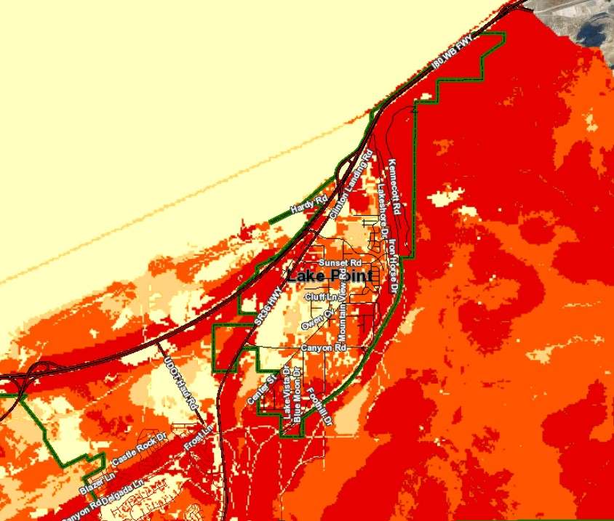
Fire hazard risk estimates in Lake Point and surrounding areas (click for source).

10.14 Goals + Objectives: Risk and Resilience
G10-1. Provide for an orderly means to prevent or minimize, prepare for, respond to, and recover from emergencies or disasters.
- O10-1.1 Encourage citizen self-sufficiency.
- O10-1.2 Develop first responder capabilities.
- O10-1.3 Develop and maintain an emergency operations plan that will guide organizational responses during an emergency or disaster.
- O10-1.4 Maintain a framework of interagency and community-wide cooperation to enhance disaster mitigation, preparedness, response, and recovery. Support the County in maintaining its PreDisaster Mitigation Plan (PDM).
- O10-1.5 Adopt by reference Utah’s Wildland Urban Interface Code (WUI). The City will continue to implement the requirements of the code, and adopt amendments as approved by the State of Utah.
- O10-1.6 Consider all possible levels-of-service related to public safety including police and fire protection when considering new development proposals. Develop and adopt a public safety plan that establishes minimum acceptable levels-of-service, requiring all new development to meet or exceed the standards of that plan to be reviewed regularly (typically every 2-years).
- O10-1.7 Plan for public safety facilities commensurate with the city's growth patterns.

10.16 Implementation Action Steps: Risk and Resilience
- Short-Term Opportunities (1-5 years)
  - Conduct an audit on the City’s various emergency-related interlocal and mutual aid agreements. Ensure that the terms are still valid for all parties.
  - Develop and maintain a functional EOP (in compliance with HB96, 2021). Partner with the Utah Department of Public Safety (Division of Emergency Mgt) to obtain grant funding for mitigation projects.
  - Maintain an inventory and replacement schedule of emergency equipment (i.e. communication and vehicles) that is also coordinated with the City’s expected growth.
- Long-Term Opportunities (+5 years)
  - Approach Tooele County and the WFRC about their plans to update the current PDM. If either of those entities intends to develop and maintain that plan, then ensure that Lake Point is well represented in it. If Lake Point desires to create its own PDM plan, then partner with the Utah Department of Emergency Management to apply for FEMA’s “advanced assistance” grant to fund the initiative.
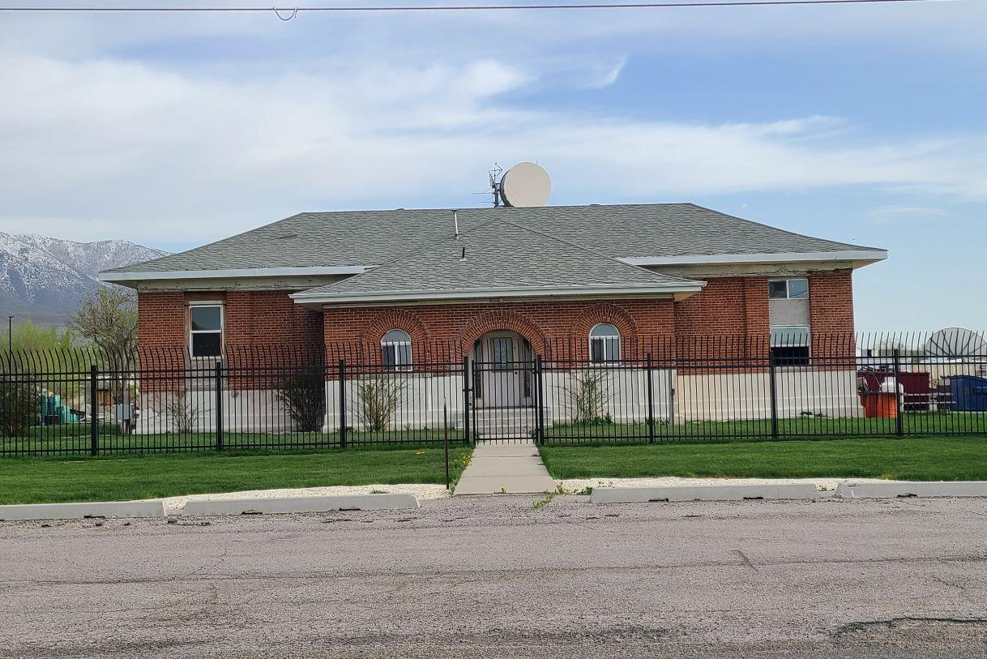

11 - HERITAGE + CULTURE PRESERVATION
Historic and cultural preservation, as well as the management of Lake Point’s unique resources in the performing arts, represent a responsibility of the present generation for the use, edification, and enjoyment of both present and future generations. The General Plan seeks to identify and protect areas, activities, sites, and structures possessing architectural, historical or cultural significance, and to reaffirm their continuing value as a resource that contributes to the vitality and quality of life in Lake Point.

11.02 Current Conditions
- Though Lake Point has only recently been incorporated, it has a strong tradition of community involvement and events.
Heritage + Culture Preservation OPPORTUNITIES | Heritage + Culture Preservation CONSTRAINTS
- The preservation of the Adobe Rock area has wide support among residents regionally.  - Though Lake Point doesn’t have a high number of historic buildings, there is one that might be repurposed into a city hall. | - The City’s priority to preserve private property rights can conflict with historic preservation goals.

11.04 Desired Future
- Residents and business owners are supportive of policies and investments that preserve and enhance Lake Point’s small town feel and quality of life through investments in neighborhood assets and amenities.

11.06 Anticipated Changes
- The strong growth pressure that Lake Point is expecting creates a risk that the community will lose a connection to their history over time. Without targeted protections and investments into its unique cultural/historical assets, Lake Point has the potential to become “Anytown USA”.

11.08 Goals + Objectives: Heritage and Culture
G11-1. Preserve and enhance the City’s notable historic buildings and sites (both public and private); recognizing that they represent a source of community identity, pride and heritage.
- O11-1.1 Provide information on incentives as a means of encouraging the preservation of significant buildings, on a voluntary basis.
- O11-1.2 Identify historic resources and cultural landscapes that meet national, state, or local criteria for designation and protection from demolition or detrimental modification. Study available methods and incentives that may encourage preservation.
- O11-1.3 Work with the State Historic Preservation Office to designate historic structures and areas in order to preserve older buildings, and transition them to new uses.

11.10 Implementation Action Steps: Heritage and Culture
- Short-Term Opportunities (1-5 years)
  - Educate developers and residents within historical areas that may be eligible for tax credits as related to historic preservation.
  - Explore opportunities to establish additional locations for farmer’s and gardener’s markets in order to support local agriculture.
- Long-Term Opportunities (+5 years)
  - Look for ways to protect the petroglyphs and trails and open space on the foothills.
  - Discourage future planning of the Oquirrh Mountain Express and from utilizing the BLM land on the east side of Lake Point.
  - Establish protection for the open space on the foothills east of town in order to protect the wildlife and the quiet rural atmosphere and character of Lake Point.
  - Take steps toward the preservation of the old Rock Church.
  - Promote the preservation and history of Adobe Rock.

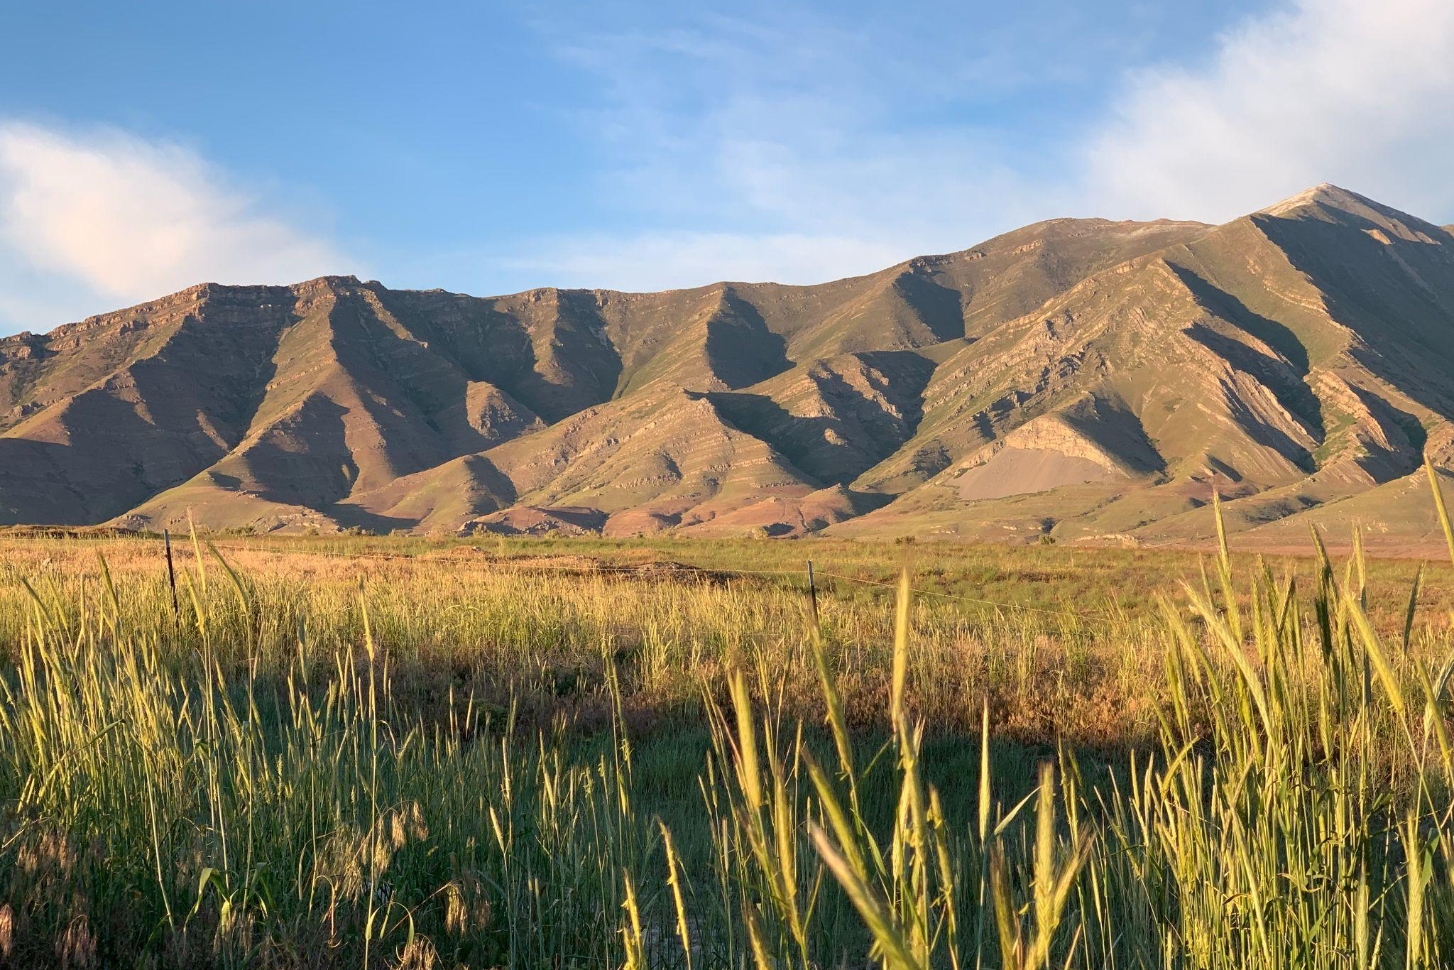

12 - ENVIRONMENT
The factors affecting environmental quality within Lake Point are important to everyone, and therefore, directly affect the quality of life for its residents. ‘Environmental quality’ refers to the values related to natural resources, retention and enhancement of the existing open spaces, special geological elements, energy, scenic corridors, environmental hazards, conservation efforts, water resources, and air quality.

12.02 Existing Conditions
- The Lake Point area of Tooele County is a beautiful and diverse area with mountains, hills, valleys, and proximity to the Great Salt Lake shoreline. It has a semi-arid climate with hot summers and cold winters. The region offers wide open spaces, desert vegetation, and a range of wildlife.
- Northern Tooele County is known for its wide-open spaces and relatively low population density, which can contribute to cleaner air quality compared to more urbanized areas. However, certain pollution sources, such as industrial facilities or transportation emissions could potentially impact air or water quality in the Lake Point area.
- The eastern side of the County (including the Lake Point area) is in an alluvial fan study area. In terms of development, alluvial fans present both opportunities and challenges. In some cases, the loose nature of the sediments may require additional engineering measures to ensure stability and mitigate the risk of erosion, especially in areas closer to the foothills.
- In recent years, studies that were done referenced other environmental conditions such as quaternary fault lines, poor soil conditions, high water table, and wildfire potential.
Environment OPPORTUNITIES | Environment CONSTRAINTS
- Recycling services in Lake Point are currently available from private companies. Facilitating expansion of this service has the potential to reduce stress on the landfill.  - The community has the opportunity to protect the visibility and quality of its night skies.  - The City considers the preservation of the open land along the east bench as critical for the protection of wildlife corridors. | - Occasional concerns related to air quality may arise due to natural phenomena like dust storms or air inversions. These events can temporarily affect air quality by trapping pollutants near the surface.  - The proximity to the Great Salt Lake brings with it higher-than-normal presence of midges and biting gnats.  - The level of the Great Salt Lake also affects the climate and air quality.

12.04 Desired Future
- Lake Point’s environmental conditions and “green infrastructure” functions so well that the community is known for more than its beautiful location. Lake Point values the environment and works to preserve water resources, maintain clean air quality and seeks to preserve areas to enjoy nature.

12.06 Anticipated Changes
- Continued demand for community growth will put a strain on the function of the area's natural systems (i.e. water supply).
- Air quality is not currently a high concern in Lake Point, but steps need to be taken now to ensure that the City protects it into the future.

12.08 Groundwater + Water-Related Land Use
- Groundwater quality in the area is generally considered to be good. The region benefits from underground aquifers that provide a reliable source of clean water for various uses, including drinking water, agricultural irrigation, and industrial purposes. Local water providers and regulatory agencies ensure that water quality meets established standards through regular testing and monitoring.
- In terms of groundwater quantity, the availability of water in the region is influenced by factors such as precipitation, recharge rates, and water usage patterns. Sustainable water management practices are in place to ensure the responsible use and conservation of groundwater resources. These practices include promoting water-efficient technologies, implementing water conservation measures, and monitoring water extraction to prevent overuse or depletion of the aquifers.
- Water-related land uses in the area consist primarily of irrigation for farmland as well as municipal and industrial applications.

Exhibit 12.08.1 Water-Related Land Use Map
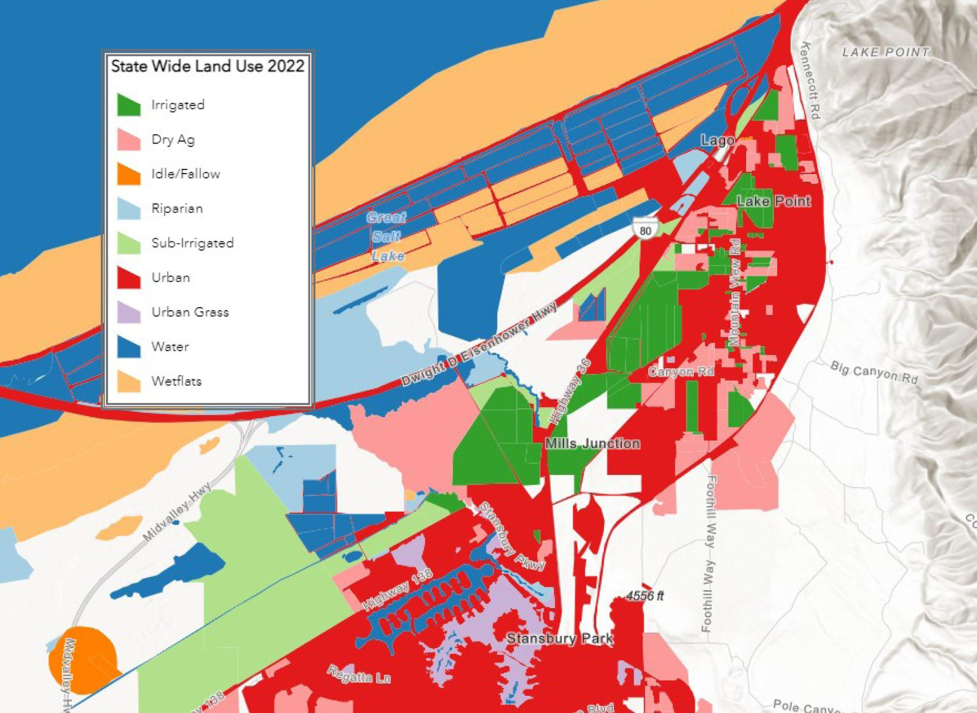Lake Point area water-related land uses, 2022. Source: Utah Division of Water Resources.

12.10 Air Quality
- Air quality in northeastern Tooele County is generally cleaner compared to more urbanized areas. However, occasional concerns may arise related to natural phenomena such as dust storms or air inversions. These events can temporarily impact air quality by trapping pollutants near the surface.
- Additionally, the county's proximity to the Great Salt Lake may contribute to occasional changes in air quality. The lake's unique characteristics, including its size and composition, can influence air patterns and potentially lead to localized air quality issues.

12.12 Wetlands
- Lake Point’s proximity to the GSL creates potential wetlands. Future development in these areas might require careful mitigation for individual parcels.

Exhibit 12.12.1 Wetlands Map
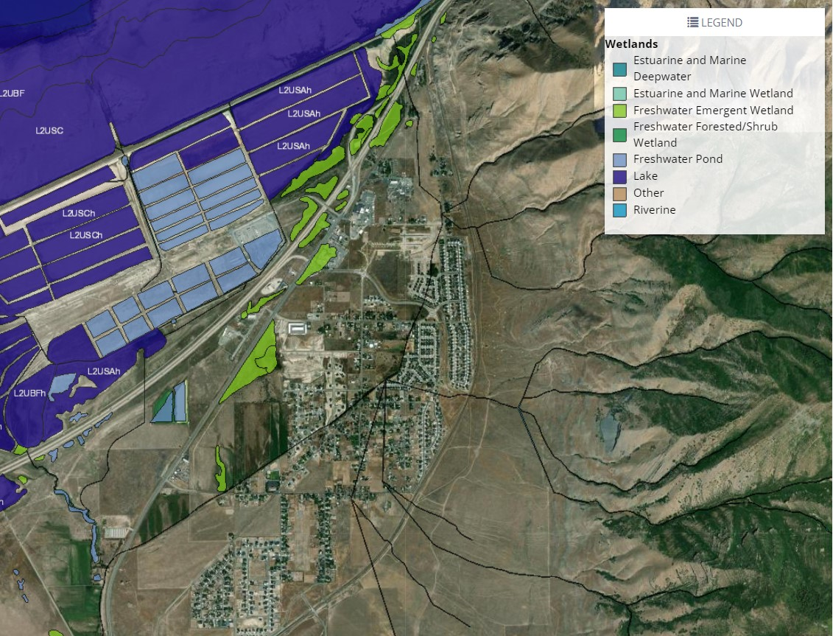Surface waters and wetlands inventory from the US Fish and Wildlife Service.

12.14 Goals + Objectives: Environment
G12-1. Clearly define natural or environmental hazards within the City affecting health, safety and quality of life.
- O12-1.1 Assist federal, state and county agencies in their identification of floodplains that may represent a hazard. Adopt development standards based on professional risk management standards. Work with FEMA to update the appropriate panels within the City and annexation policy areas.
- O12-1.2 Work with appropriate agencies and professionals to identify geologic hazards that may represent a hazard to the community. These may include landslides, steep slopes, unstable soils, high-water tables and fault lines. Adopt development standards based on professional risk management standards. Work with Tooele County officials, where appropriate, to provide protection from risks located outside of the city.
G12-2 Continue expanding and developing the quality, availability, delivery and use of water resources consistent with the highest professional standards and community expectations.
- O12-2.1 Continue identifying and developing additional sources of City water. Work to acquire local water rights and develop a partnership with the District to evaluate other water acquisition and development opportunities.
- O12-2.2 Continue improving water delivery systems for existing and future developments. Partner with the district to develop and maintain Water Infrastructure Master Plan as needed.
- O12-2.3 Identify areas of the community that are suitable for groundwater recharge and apply best management practices to protect and enhance these areas.
- O12-2.4 Prioritize water quality from the production, storage, protection, and delivery stages in the capital budgeting process. Supporting the Districts’ procurement of additional water rights should also have a high priority.
G12-3. Control and monitor surface and groundwater pollution sources to provide a healthy environment.
- O12-3.1 Establish and maintain protection zones and policies for all municipal sources of water serving Lake Point.
- O12-3.2 Identify critical stormwater conveyance channels and adopt development standards protecting these channels.
- O12-3.3 Require Storm Water Pollution Prevention (SWPP) plans for all new development and grading activities in compliance with Federal EPA requirements.
- O12-3.4 Work to minimize potential groundwater or surface water pollution sources within the City, including, but not limited to, increased levels of nitrate concentrations.
G12-4. Protect, conserve, and enhance the natural beauty and ecological assets of Lake Point, and improve the opportunities for residents and visitors to enjoy them.
- O12-4.1 Establish open space corridors that provide connectivity between all areas of the City and surrounding public lands. This should be especially considered with any new development.
- O12-4.2 Establish protections for the foothill areas that will maintain the open spaces as the city develops.
- O12-4.3 As resources become available, implement and update a comprehensive recreation, parks, trails, and open space policy and strategic plan.
G12-5. Encourage and promote Lake Point as an environmentally-responsible community.
- O12-5.1 Embrace and practice environmentally-responsible community development by promoting native and suitable substitute landscape materials.
- O12-5.2 Demonstrate environmentally-responsible examples in the City’s development projects.

12.16 Implementation Action Steps: Environment
- Short-Term Opportunities (1-5 years)
  - Develop a policy to utilize swales to retain runoff water from streets and adjacent development in low density areas.
  - Promote tree planting in residential and commercial frontages /yards in developed areas.
- Long-Term Opportunities (+5 years)
  - Implement a dark skies policy for developing areas.
  - Partner with state agencies that are exploring the possibilities of utilizing gray water as a secondary water source.
  - Lake Point can explore ways to support more recycling services.

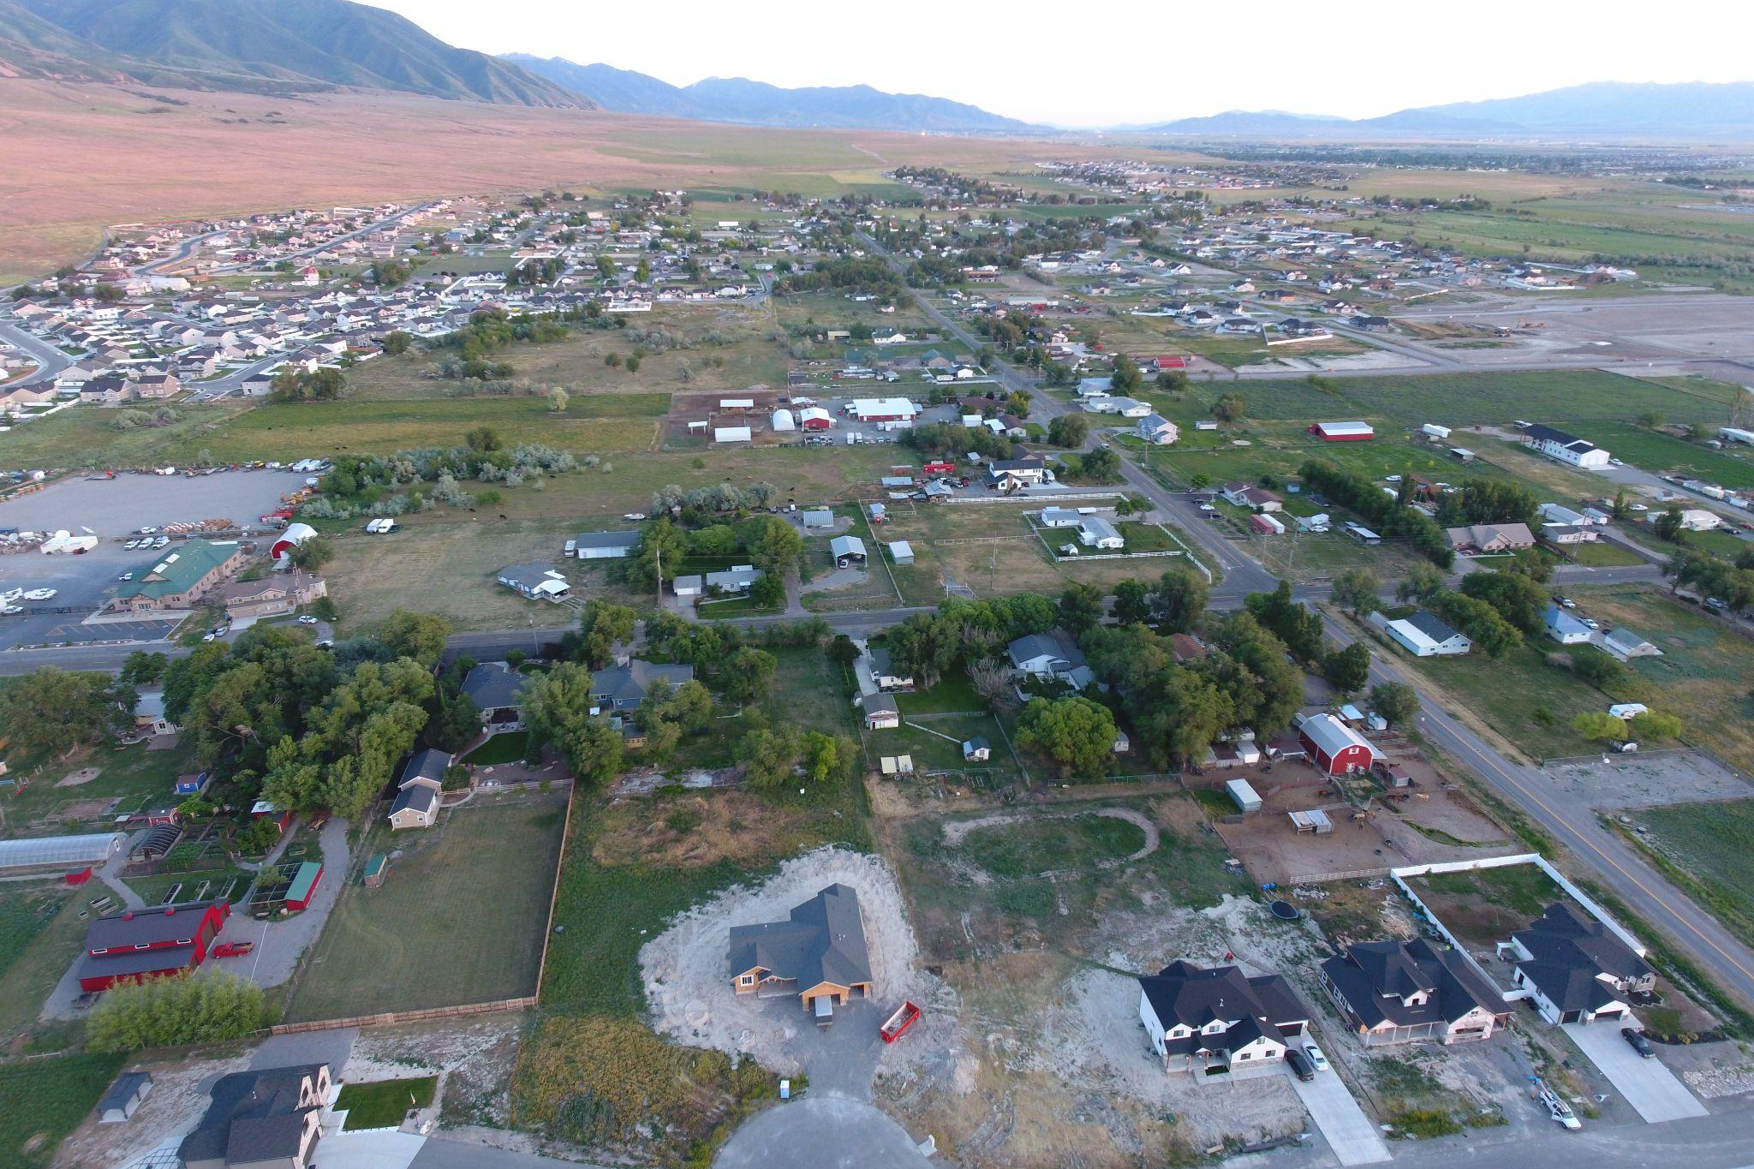

APPENDIX A: PLAN AUTHORITY

A.02 Introduction
- The General Plan is used to guide the decisions that a community makes as it addresses future growth and development. Some of the aspects of the General Plan are related to physical improvements such as roads and utilities. Many of the components of the Plan are based on quality of life issues such as education, culture and recreation. Other key elements relate to jobs, economic development and the need to provide a balance of land uses/natural resources that allow these activities to grow in a responsible manner.
- There will always be a gap between where the community is and where it wants to be. Getting from one to the other is the core of the city’s work. This can’t be done effectively without an idea of what the future might look like.
- A general plan is a legal policy document reflecting the general interests of the community. It is designed to guide decisions and establish priorities affecting the future development within the city and thereby, assist in defining the character of the community.

A.04 State Law and the General Plan
- Lake Point recognizes the need to be proactive about community-level planning and land use management, ensuring that the community's vision and goals for the near and distant future are met. This general plan will serve as a framework for Lake Point decision makers as the community continues to experience change altering future land use, development, and other decisions. The plan is designed to provide a formal policy foundation for enhancing community relations, pursuing economic development activities, coordinating infrastructure planning, and fostering city and county/state cooperation.
- This plan is supported by Utah State Law (Title 10 Chapter 9a) which requires local plans and development guidelines to address general health, safety, morals and welfare issues. It becomes a legal document which is formally-adopted by the Lake Point Council. The law also requires public participation in the planning process through adequate public notice and open public meetings. The information outlined in this document represents the general consensus and vision for the community; as well as the goals for the near and distant future.
- The ultimate outcome of this planning process is for the city’s elected officials to adopt policy priorities that will help the organization act deliberately towards goals that will make a real impact for the community.

A.06 Past Planning Efforts
- Lake Point was incorporated at the end of December 2022. Prior to this incorporation, the area was planned and regulated by Tooele County.

A.08 Development of this Plan
- Public participation in formulating this plan shaped its content and direction. All information outlined was prepared based upon, and incorporating much of the public’s valuable feedback.
- The Lake Point Planning Commission and City Council placed a high priority on public involvement in the development of this plan, requiring a thorough and detailed public awareness and input campaign to be completed. Public participation strategies utilized in the formulation of this plan were provided through public surveys and open house events, stakeholder meetings, website content, and public hearings.
- A summary of the results from each format of community input can be found in the appendix section of this document.

A.10 Amending the General Plan
- The Lake Point City General Plan is intended to be a steady, but not static, foundation for future planning. Great care should be taken when amending the Plan to avoid drastic changes in direction, while also not hesitating to update goals and policies as the landscape shifts. The amendments should remain aligned with the core vision and rural preservation values that were fundamental when the original plan was created and when the city determined to incorporate to protect these. This approach ensures the General Plan's ongoing relevance to the strategic planning process. It is intended to be reviewed annually and updated at least every ten (10) years, or more frequently as the need arises. This iterative process aims to provide responsible and well-formulated public policy direction to guide community decisions, fostering sustainable growth while maintaining the city's unique character

A.12 Implementation of the Plan
- A parcel's property rights are directly governed by its zoning designation. This designation is driven by the community's general plan. Changes to the zoning for parcels are initiated by property owner requests and/or when a municipality undertakes an initiative to update its land use codes. In either case, the community land use authority's (i.e. Planning Commission or City Council - depending on the type of application) decisions regarding the regulation of property are influenced by the vision in the plan.
- Implementation of the General Plan by the City Council, Planning Commission, and city staff fulfills the Plan’s purpose and ensures that the community’s voice and vision are heard. Each element of the comprehensive plan provides background and context materials, as well as goals, policies, and potential action steps for the community to undertake to achieve the plan’s vision.
- It is recommended that implementation of the strategic plans vision or goals be reviewed annually and amended as needed to ensure the goals are being met. To prepare the community for implementation, it is recommended that the community be invited to participate to provide feedback during future strategic planning efforts completed to rank and prioritize projects as well as determine the roles and responsibilities for each task.
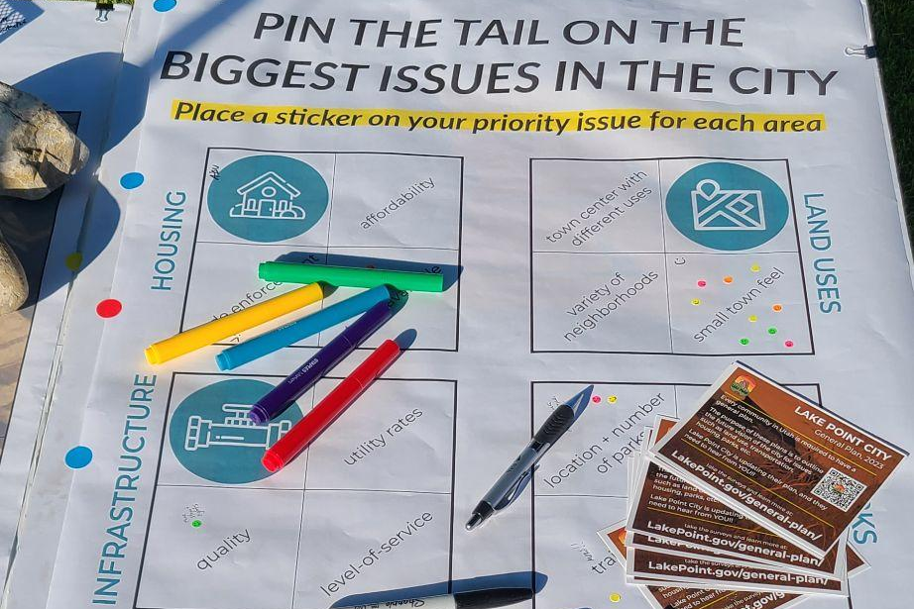

APPENDIX B: PLAN DEVELOPMENT

B.02 Public Interaction
- Facilitating community involvement and input opportunities was a high priority for the Lake Point Council. Webpages were created to post working documents, surveys, interactive maps, and project updates. This information hub was provided so the public could follow along and be kept up-to-date throughout the initiative. Social media campaigns were also used to generate interest and awareness of the site.

Exhibit B.02.1 Public Website
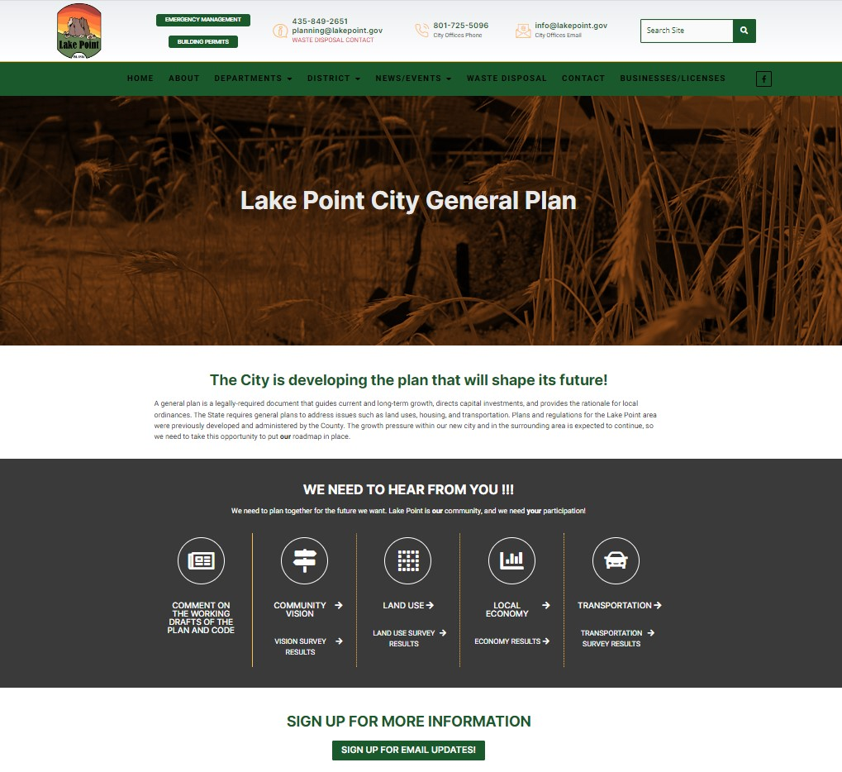
Screen capture of the website that was developed as part of the general plan initiative.

Exhibit B.02.2 Public Outreach Materials
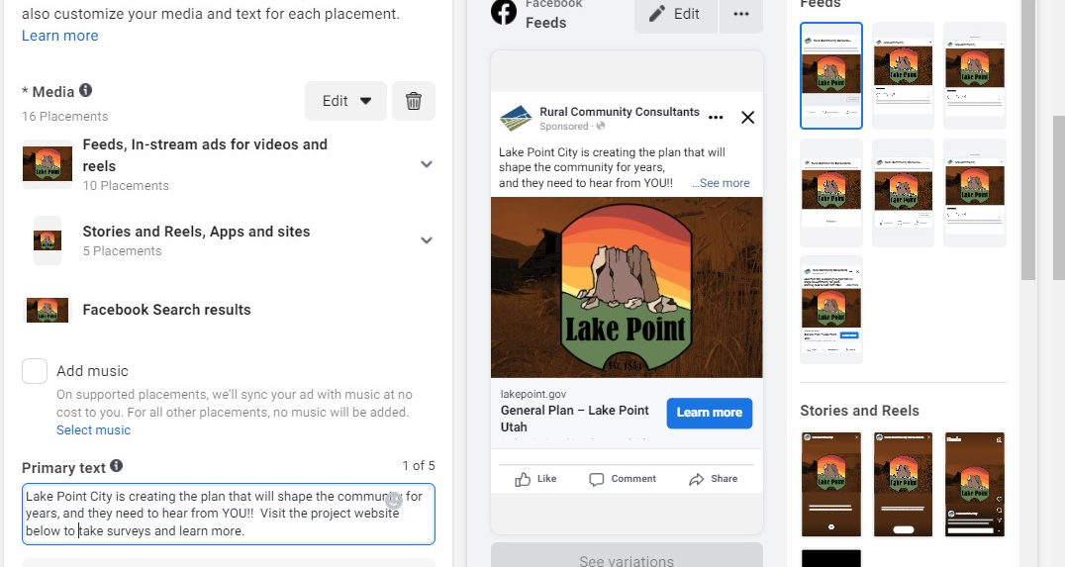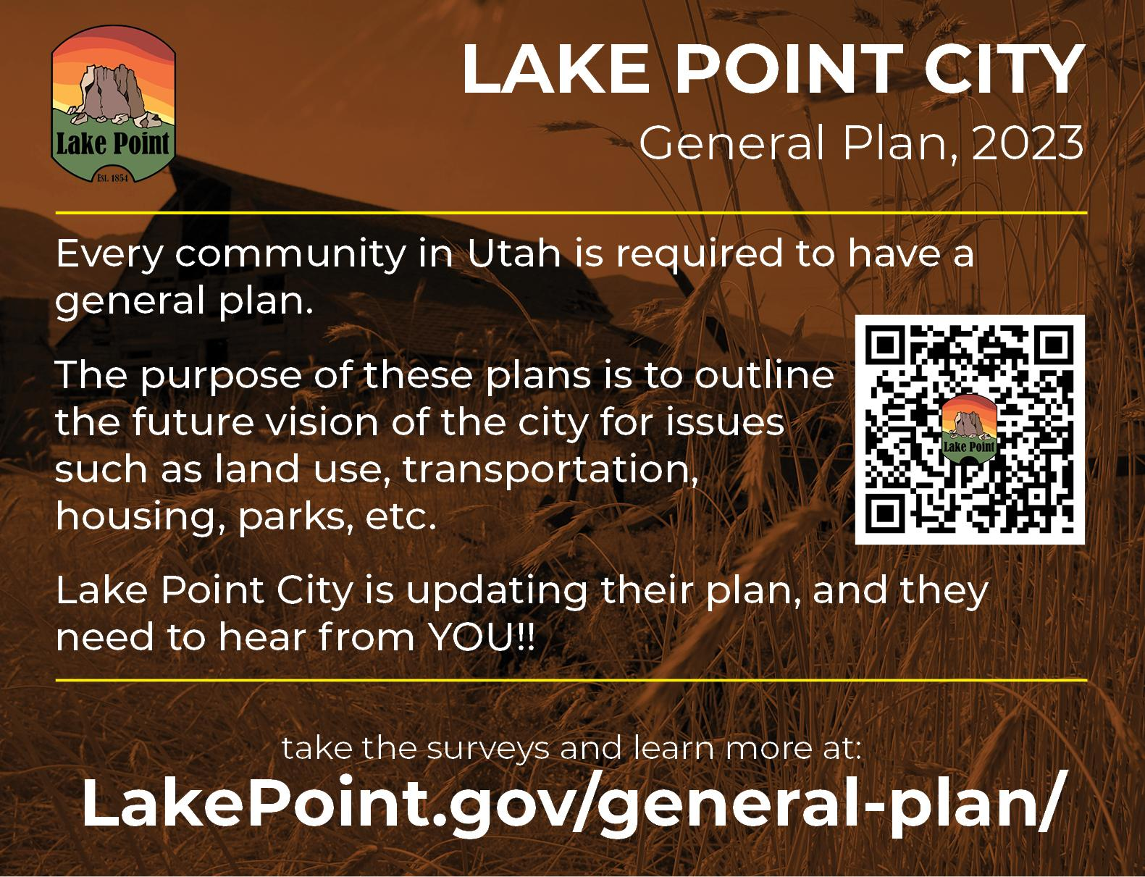
Screen captures of some of the marketing efforts made to invite public participation in the plan.

Exhibit B.02.3 Public Interaction Graphics  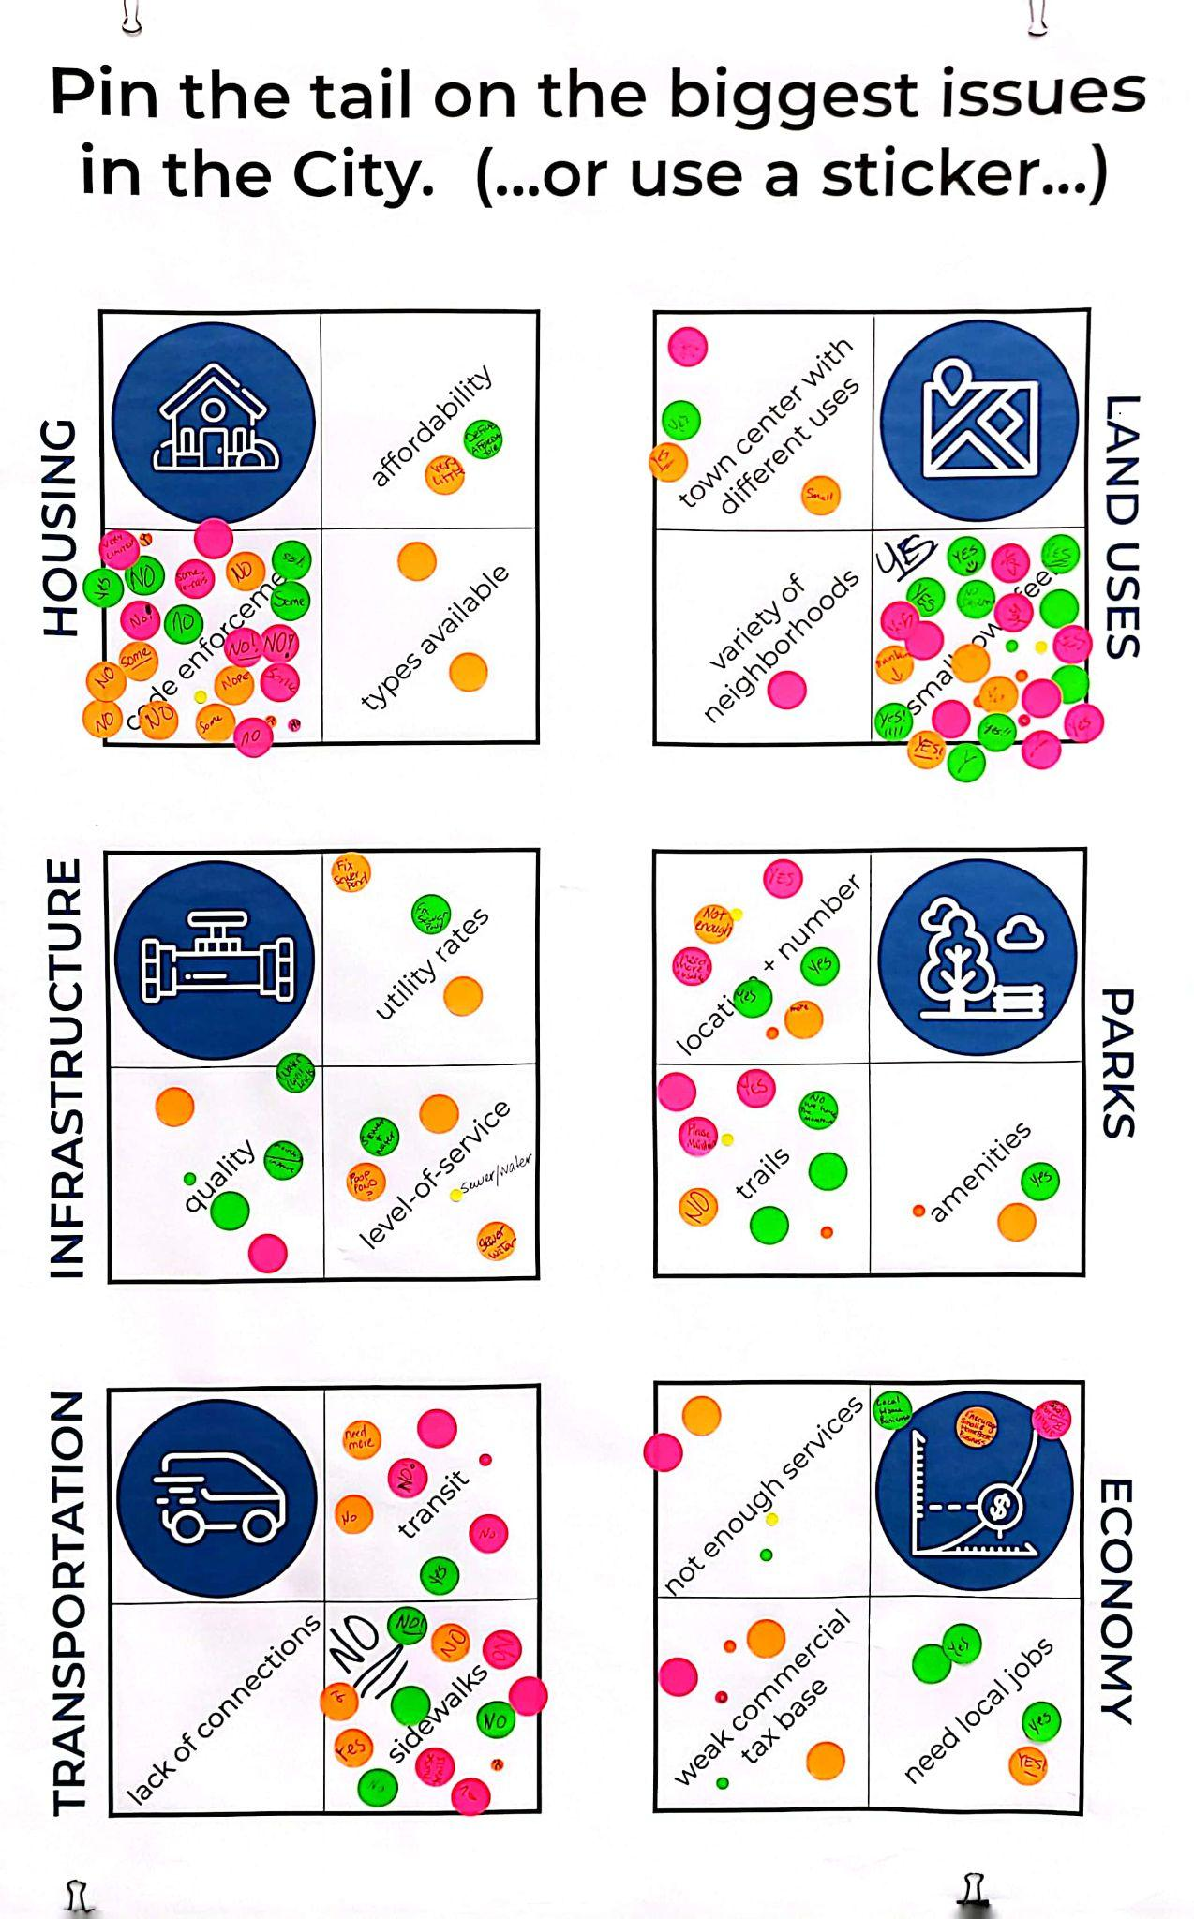 | 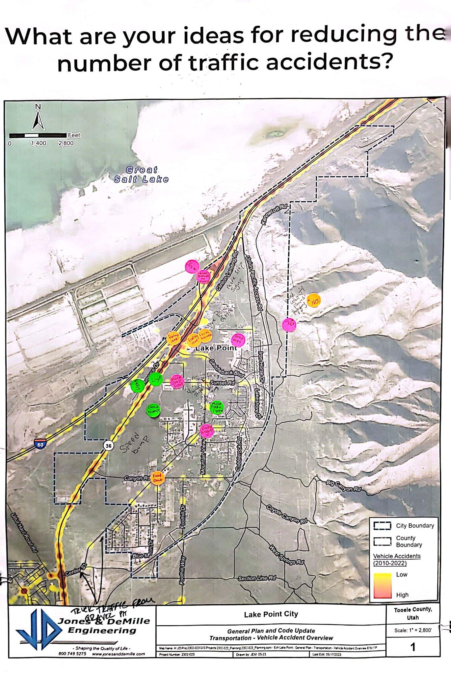
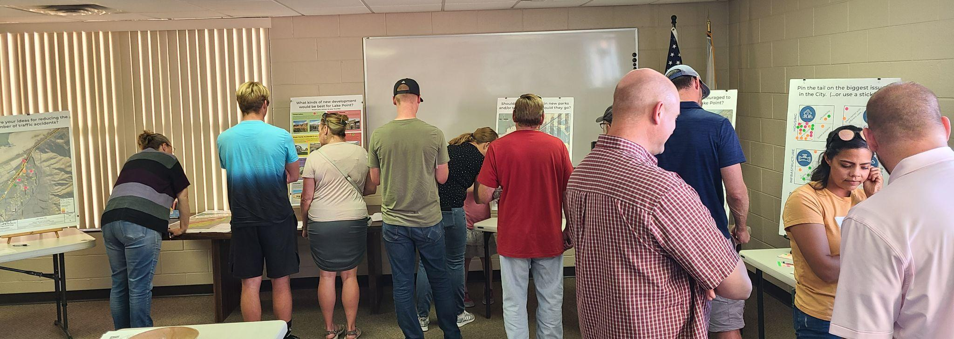
Images from one of the public workshop events.

B.04 Community Surveys
- There were a number of surveys that were advertised to the public throughout the planning initiative. The purpose of these surveys was to gauge trends and patterns in public opinion. The City website hosted links to both the survey questions as well as the real-time responses (to the multiple-choice questions). Each survey asked residents for an email address if they wanted to participate further.
- The content of these surveys was incorporated into the planning discussion (particularly the “anticipated changes” and “desired future conditions” elements).
  - “Vision and Core Values” document is available at this link.
  - The charts showing the responses to the Likert scale and multiple choice questions are available at the following links:
    - General Direction (131 responses)
    - Land Use (89 responses)
    - Local Economy (61 responses)
    - Transportation (73 responses)

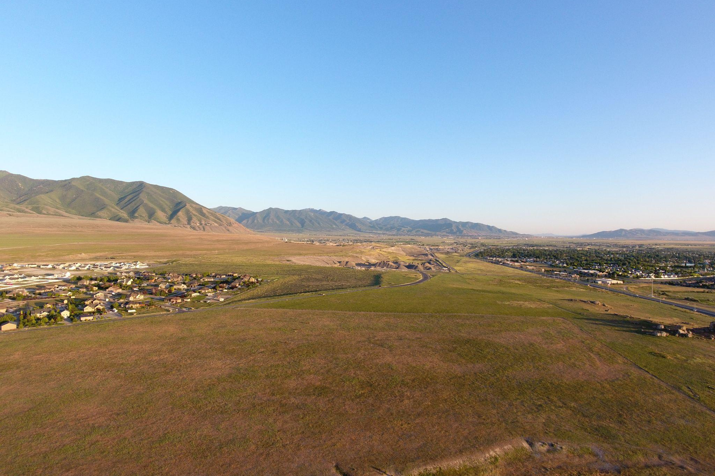

APPENDIX C: DEMOGRAPHIC PROJECTION METHODOLOGY

C.02 Future Analysis
The following methodology for estimating the residential population of the city should be considered after Lake Point has had some years to implement and refine its land use regulations and after the market has had time to respond to them. This should provide the City with better expectations for demographic trends (i.e. what type of households are moving into Lake Point):
- Analyze Zoning Regulations: Review the city's zoning regulations to identify the maximum allowable density and land use mix for each zone. Understand the different residential zones and their associated development potential.
- Evaluate Building Permits and Construction Timelines: Gather data on building permits and construction timelines for residential projects within the city. Assess the historical rate of construction and the types of residential units being built.
- Project Residential Unit Additions: Use the building permit data and construction timelines to project the rate at which residential units will be added in the future. Consider factors like ongoing and planned developments, as well as any potential changes in development patterns.
- Incorporate Demographic Trends: Utilize historical demographic data, such as population growth rates and household size, to project the composition of households in the future. Consider how demographic trends may impact the demand for residential units.
- Account for External Factors: Take into account external factors that can influence population growth, such as economic conditions and migration patterns. Be aware of potential changes in the economic landscape and the attractiveness of the city for migration.
- Calculate Future Population Estimates: Combine the projected residential unit additions and the expected household compositions to estimate the future residential population of the city once it is fully developed.
Limitations and cautionary points:
- Changing Zoning Regulations: Be cautious about assuming that zoning regulations will remain static over time. Changes in zoning policies can significantly impact the potential density and land use mix, affecting population estimates.
- Economic and Real Estate Market Uncertainty: Recognize the inherent unpredictability of economic conditions and the real estate market. Economic downturns or shifts in the market can substantially alter development rates and, consequently, population growth.
- Demographic Behavior and Unforeseen Events: Understand that demographic behaviors and migration patterns can be influenced by unforeseen events, natural disasters, or policy changes. These factors can make long-term population projections uncertain, requiring ongoing monitoring and updates to maintain accuracy.

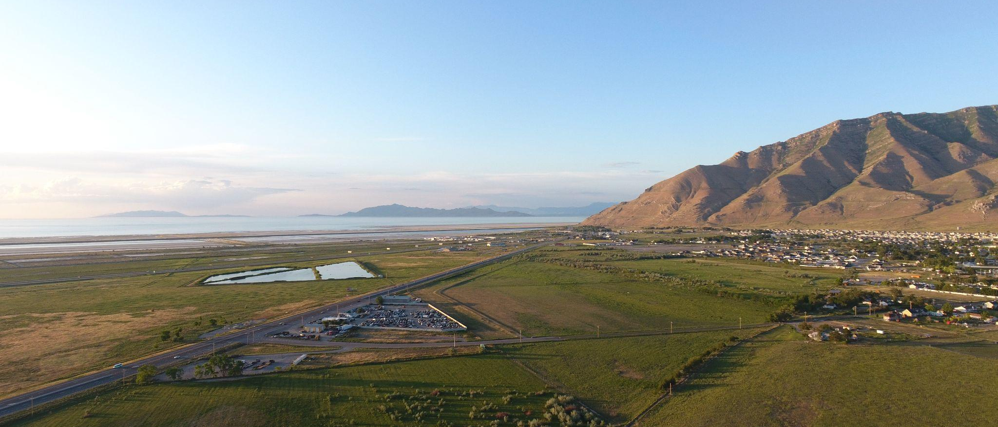

APPENDIX D: STATE COMPLIANCE

D.02 State Statute Compliance
- This plan was developed in 2023 and early 2024. The table below illustrates its compliance with the most relevant State statutes that were effective at the time:
GENERAL PLAN ELEMENT | REVIEW
Current General Plan (10-9a-401) | Adopted in 2024
Transportation (10-9a-403(2)(a)(ii)) | See section 5
Affordable Housing (10-9a-408) | See section 6
Land Use (10-9a-403(2)(a)(i)) | See section 2
Current official map (10-9a-401, -407, 10-9a-103(45)) | See section 2.16
Agriculture/Industrial protection area (10-9a-403(2)(d)) | None in town limits, see section 2.10
Capital improvements plan (aligned to GP 10-9a-406) | City will update after adoption
Water use and preservation element (10-9a-403(2)(a)(iv)) | Not required, but see section 9 and 12.08
Publicly available plans and ordinances | Final will be posted online
General plan was submitted to AOG (10-9a-203(3)) | Final will be sent
Implementation steps | Each section has strategies

