Present: Zachary Posner (Information Technology), Chris Stavros (Assessor), Reid Demman (Surveyor), Chris Harding-online (Auditor), Javaid Lal-online (Administrative Services), Joey McNamee (Community Services), Lisa Ashman-online (District Attorney), Beth Graham-online (Human Services), Hoa Nguyen-online (Council), Katy Fleury – online (Mayor Administration), Talia Butler-online (Public Works), Will Kocher-online (Recorder), Phil Conder-online (Treasurer)
Representation Absent: Clerk, Sheriff
Staff Present: Tony Jolley-online, Mark Evans-online, Rina Shipley-online, Cindy Beck, Andrew Dudley-online, Lee Wilstead-online, Mark Miller-online, Mike Bailey-online, Kira moody, Valina Eckley-online, Jon Thelen-online, Trevor Hebditch, Cherie Root, Cindy Beck, Armando Reyes-online
Resident online: Steve Van Maren
TOPIC | POINTS OF INTEREST
Welcome & Remote Meeting Instructions | Reid Demman opened the meeting.  Trevor Hebditch shared the following slide:  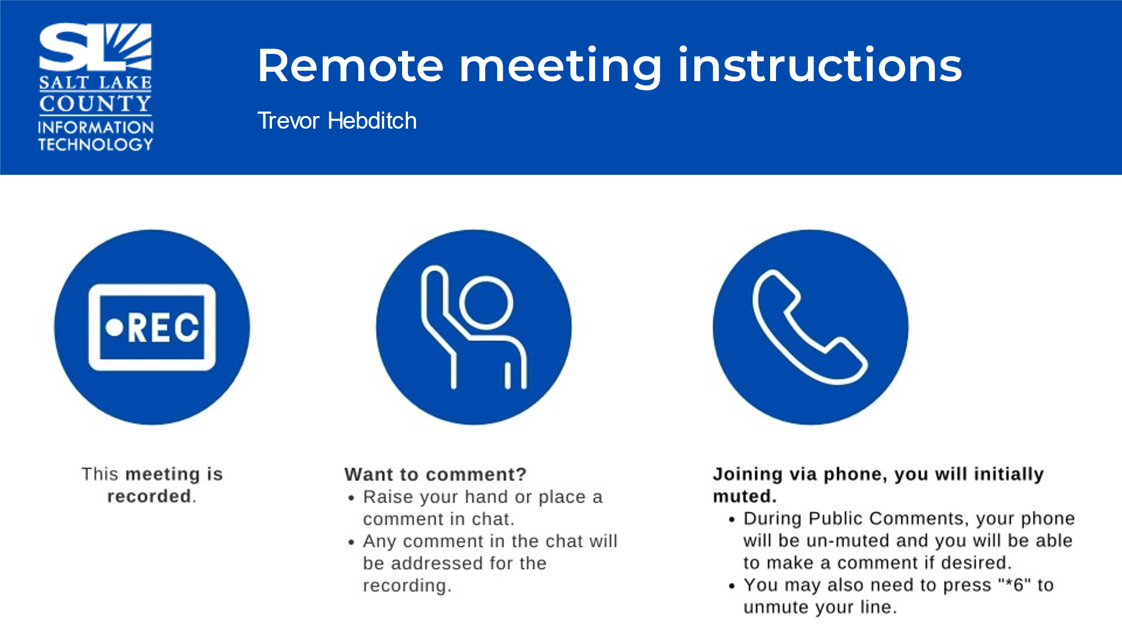
Public Comments  (Reid Demman) | No other comments.
Approval of minutes from October 26, 2023, meeting | Motion to accept the minutes by Chris Stavros, Joey McNamee, seconds the motion. No discussion.  Motion passed unanimously.
Follow-up Items (Cherie Root) | 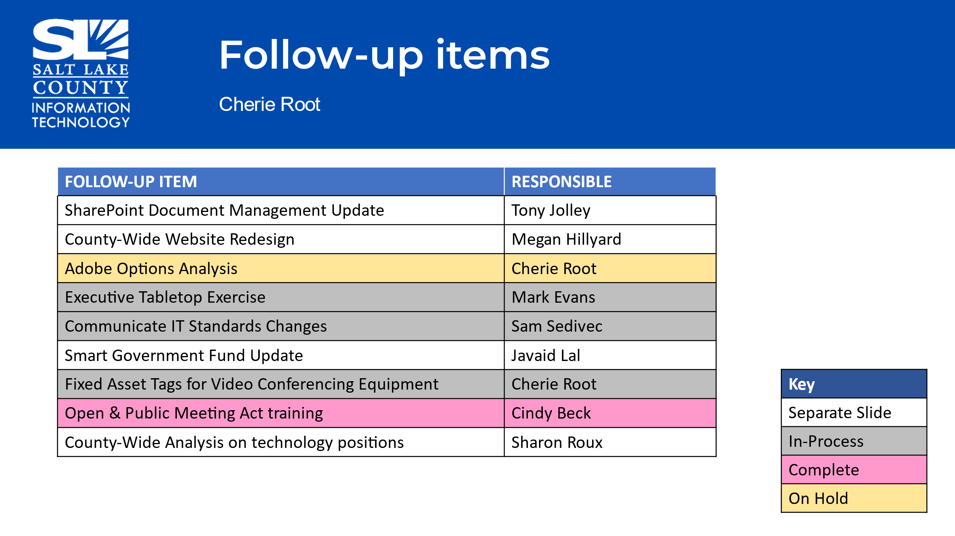
SharePoint Update (Informational) (Tony Jolley) | 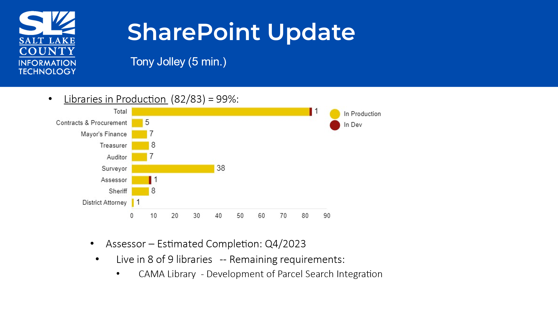  - The acronym for CAMA stands for: Computer Assisted Mass Appraisal.  - Phil Conder, Treasurer’s Office, inquired about a Phase Two. Mark Miller (BRM) followed up with Phil Conder right after the TAB meeting.
Website Redesign Update  (Katy Fleury) | 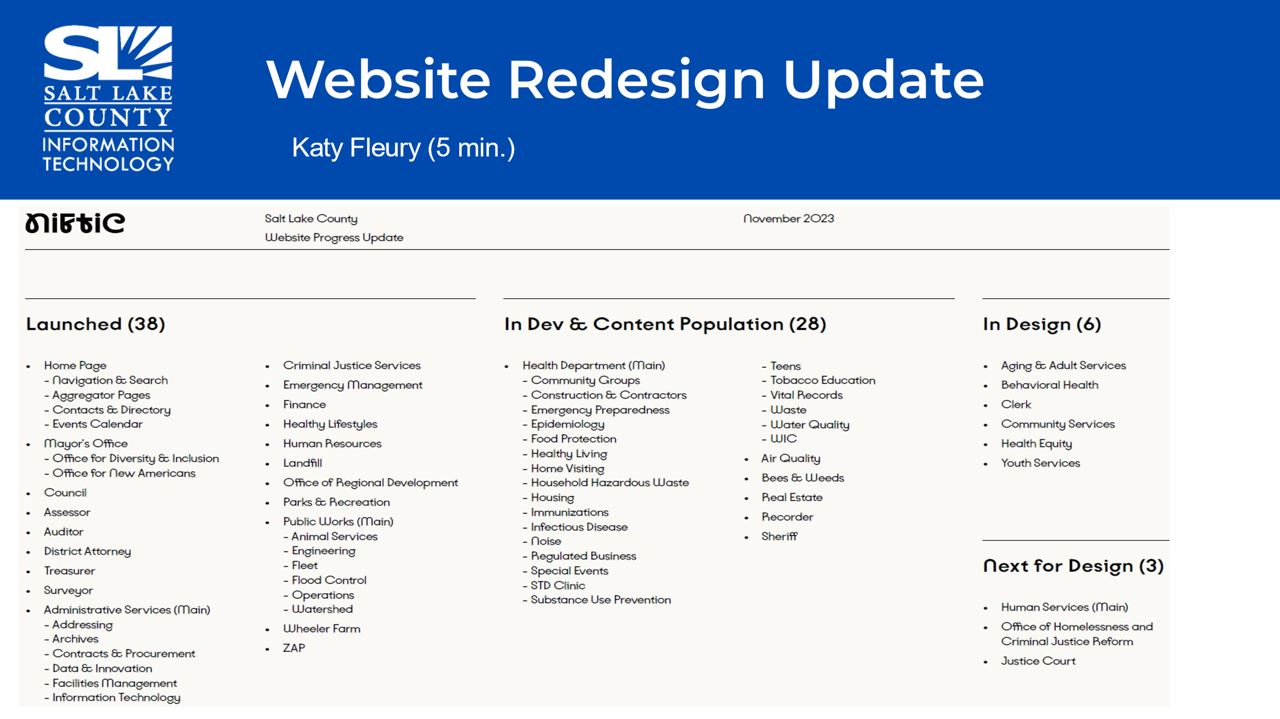  - Less than 10 sites in design or “next” in queue.  - The estimate of completion with the redesign is approximately 90%.  - NIFTIC will be reaching out to Human Services in the new year about the start date for their dept.
Technology Positions County-Wide  (Sharon Roux) | 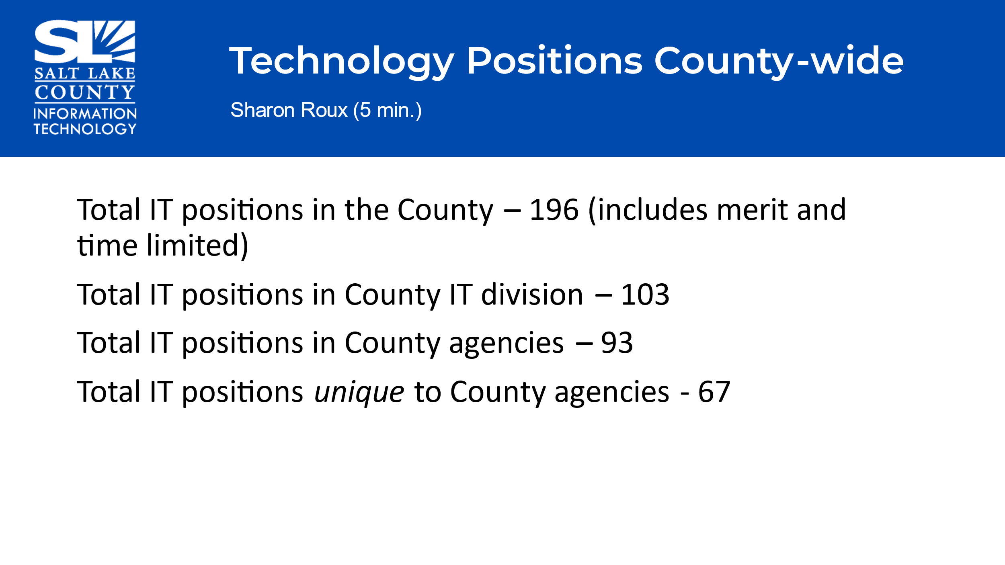  - Unique Position: Anything that lives in an agency that is very specific work to what the agency does. Some examples are GIS related roles, Regression Modeler, and Library IT techs, etc.
2024 Budget Update (Cherie Root) | 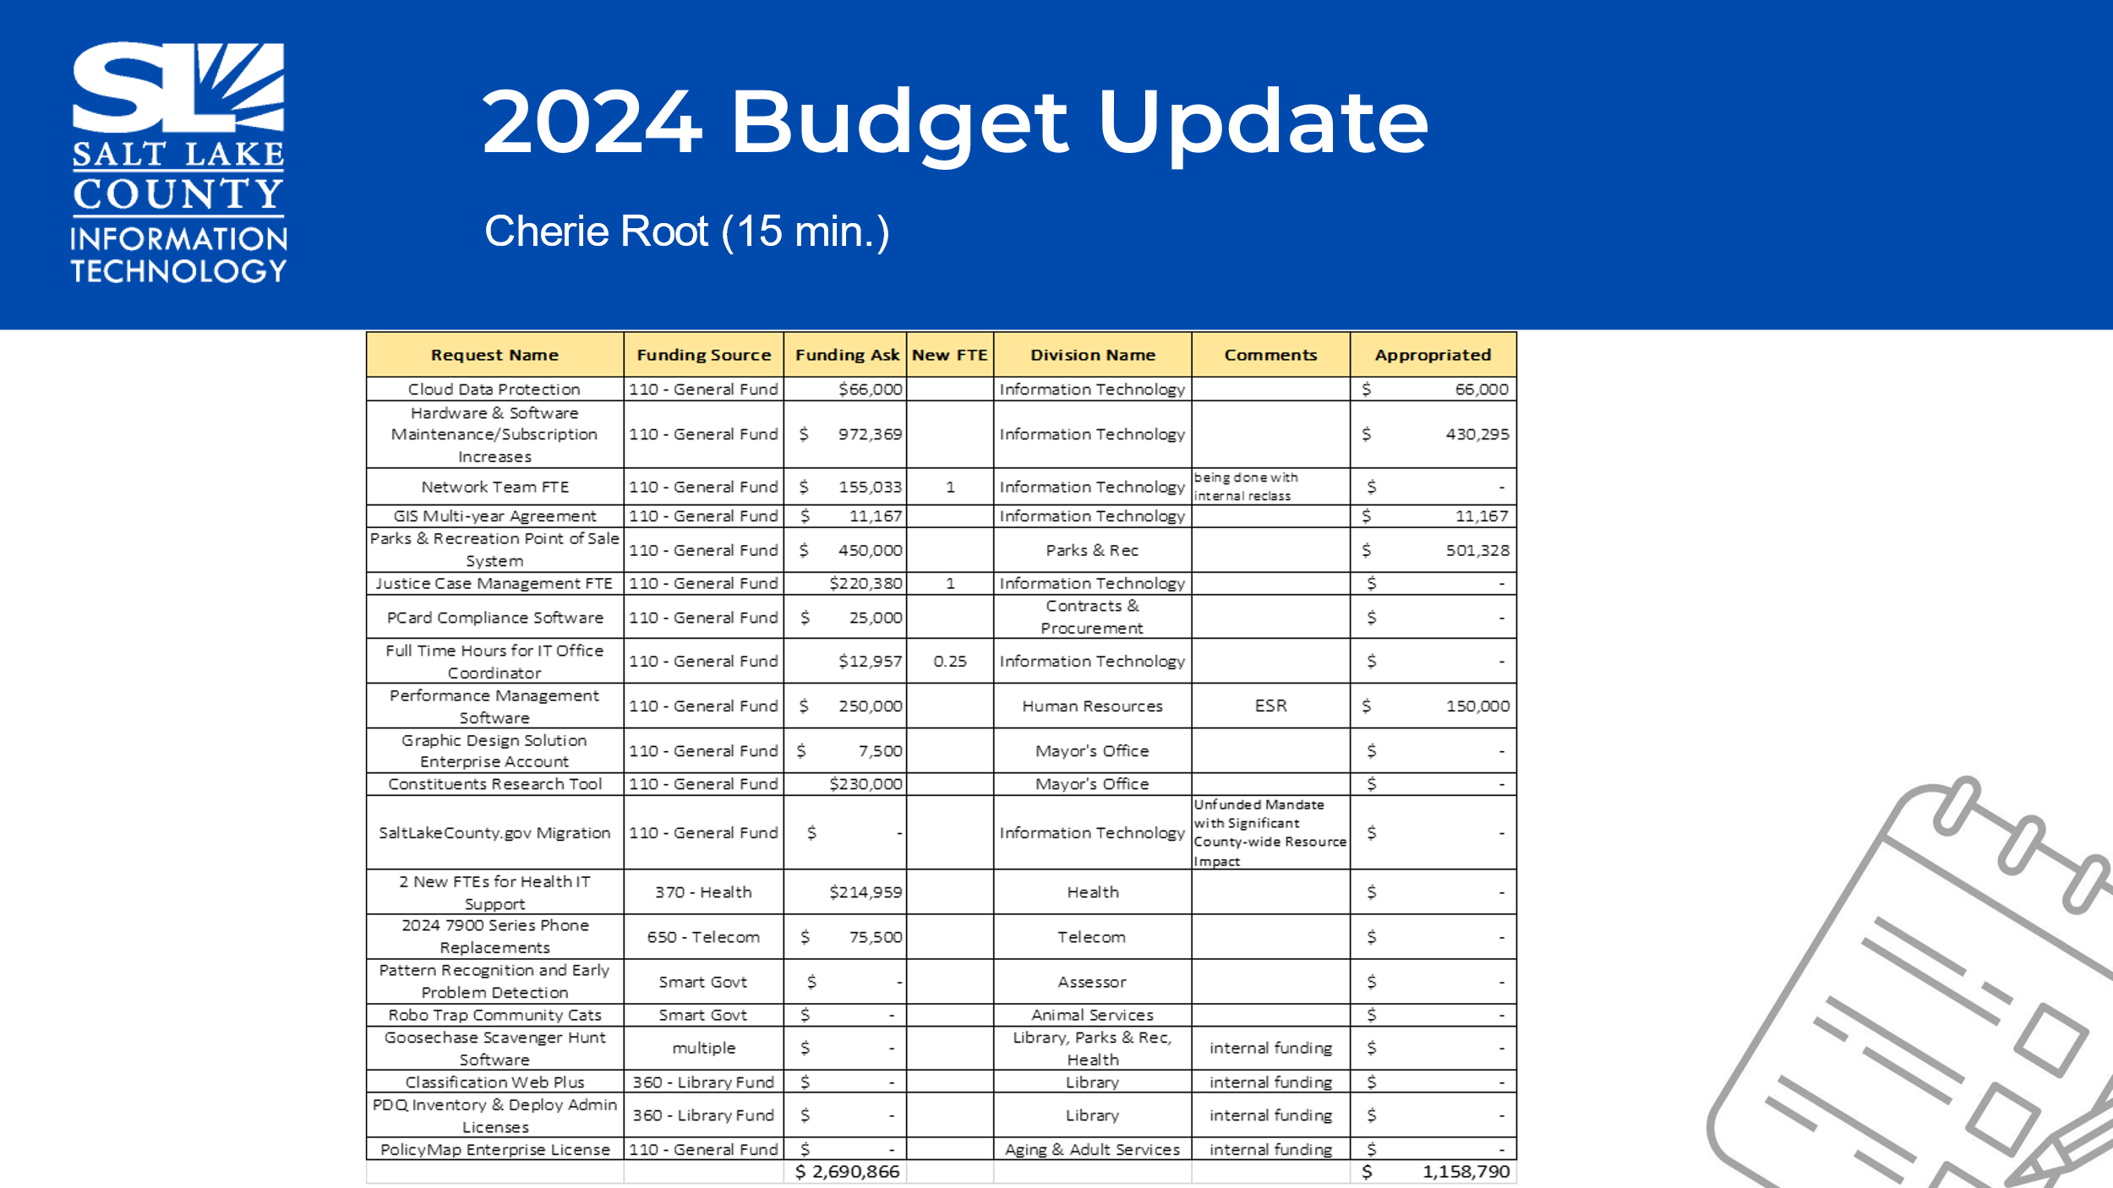  - Two major projects that were approved: Performance Management Software for Human Resources and the Parks and Rec Point of Sale system.  - For items NOT funded, The BRM’s will follow up with those agencies to see if they want to request them again for next year.  - Due to budget constraints, the 3% gap for personnel, like most agencies we will look at delays in hiring and losing some of the open FTEs.
BRM Reports (Mark Miller & Lee Wilstead) | 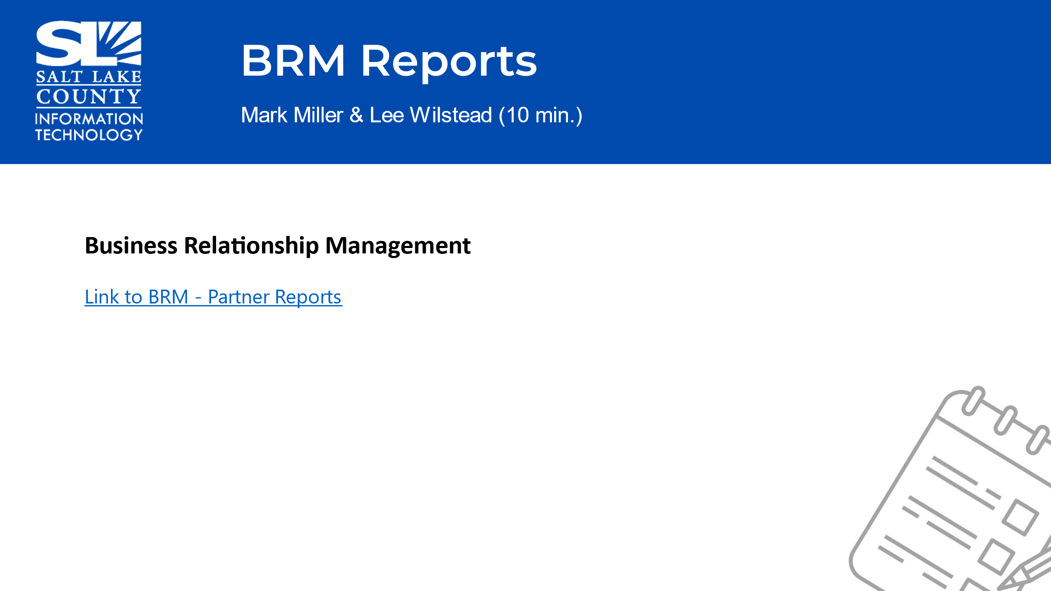  - Link: https://powerbi.slcounty.org/Reports/powerbi/Information Technology/BRM/BRM Partner Report  - Reviewed the Executive Summary gives the overall breakdown and status of a request/case/project. It will be emailed monthly to the agency.  - The BI Reports have some custom functions, ability to change filters, and sort the data.  - Encouraged agencies to review the deactivated accounts as these directly affect billing.
Portfolio Working Group Update (Tony Jolley) | 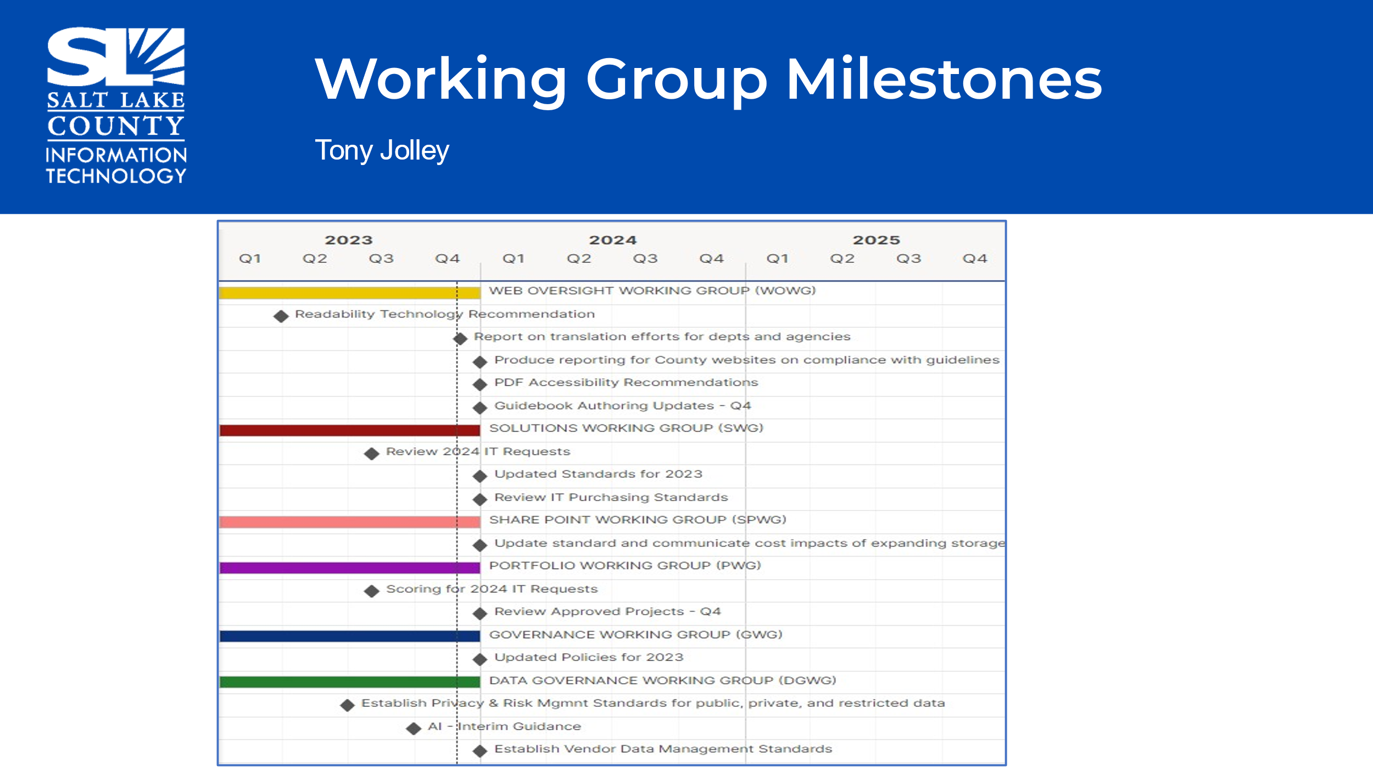  - We appreciate all the work the working groups do throughout the year.  - If an agency wants someone from their department to be a part of a working group, please let us know. Each working group has specific responsibilities/focus.
Portfolio Working Group Update (Tony Jolley)  Advises on what projects are being worked on and which projects that should be worked on. | 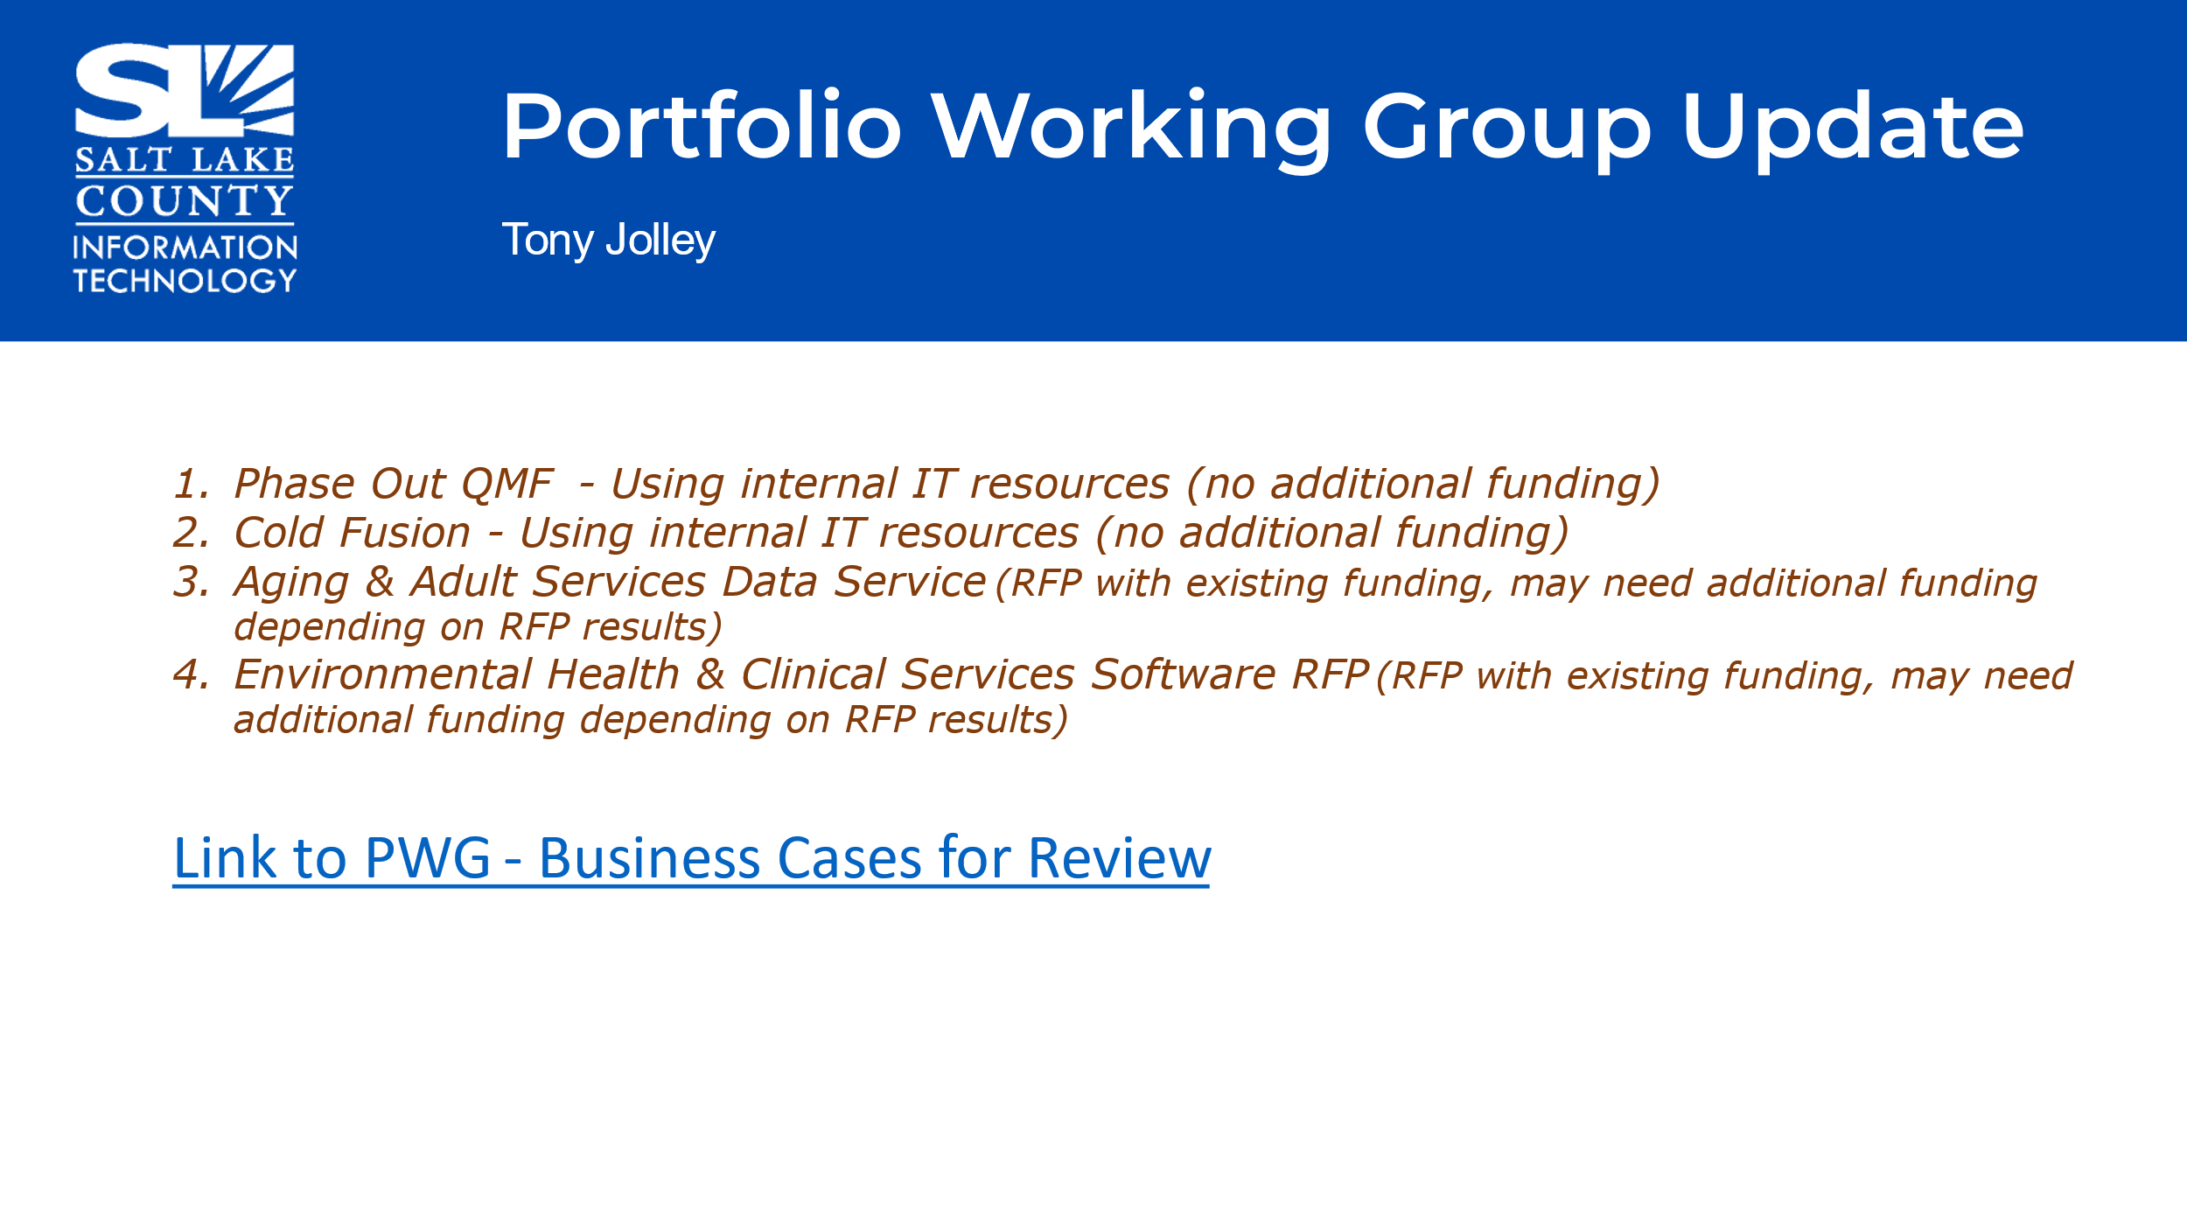  - Reviewed the four projects in the month of December 2023.  - Link to Business Cases: Technology Advisory Board (TAB) Working Groups - BRM IT Governance Requests - Governance Review (sharepoint.com)
Governance Working Group Update (Cherie Root) | 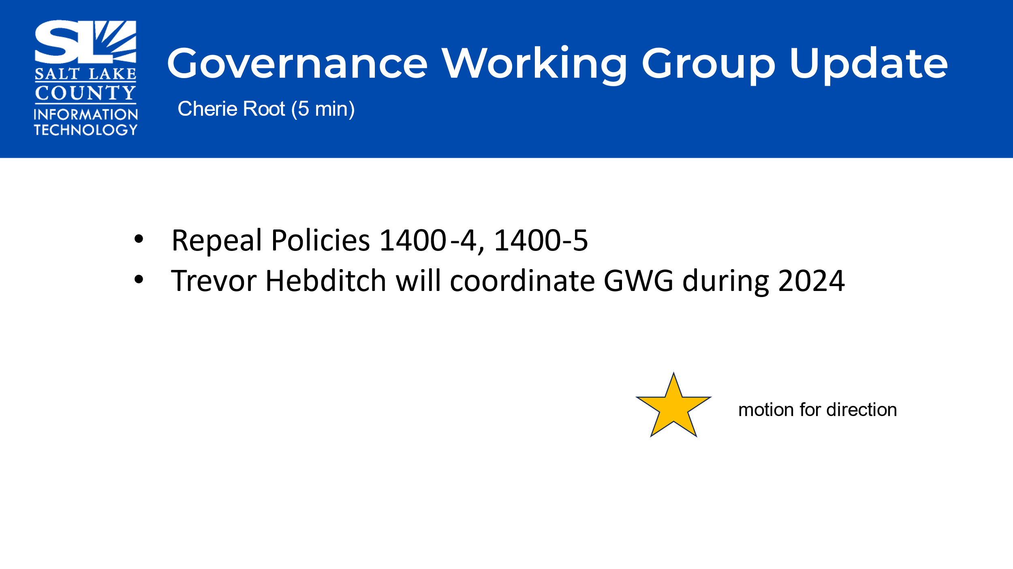  - The standards that were voted on in October cover what was in (the outdated) policies 1400-4 and 1400-5.  - Trevor Hebditch will coordinate this working group in 2024.
Recommendation to Council of Repealing Policies 1400-4 and 1400-5. | Motion to repeal policies 1400-4 and 1400-5 by, Joey McNamee, Chris Stavros, seconds the motion.  Motion passed unanimously. Motion carries.
Web Oversite Working Group (Valina Eckley) | 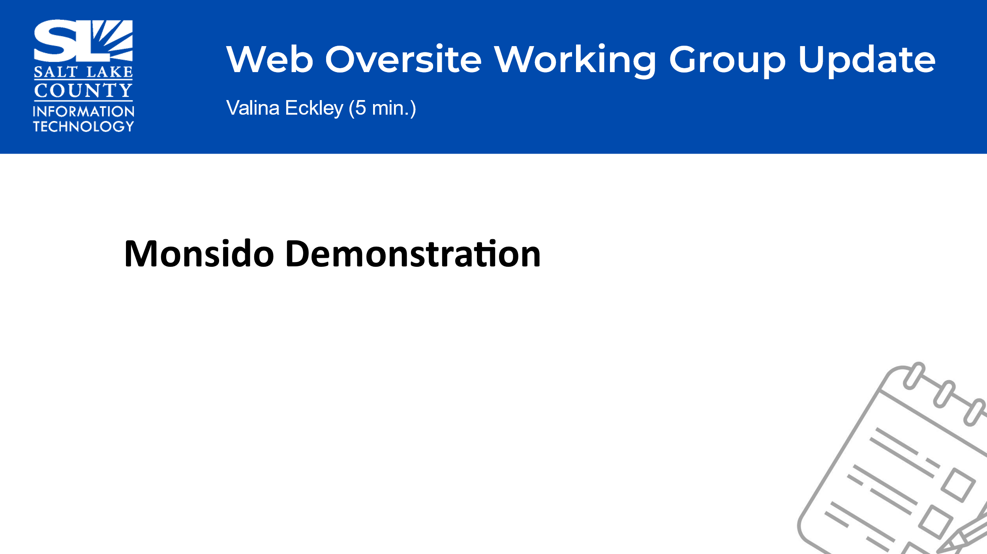  - Monsido is a website governance scanning tool that checks for quality assurance, are policies being met, accessibility scans, and search engine optimization.  - The disadvantage of this tool is that is cannot tell context, so web authors need to log in and check off what the scans discover.
Web Oversite Working Group (cont.) (Valina Eckley) | 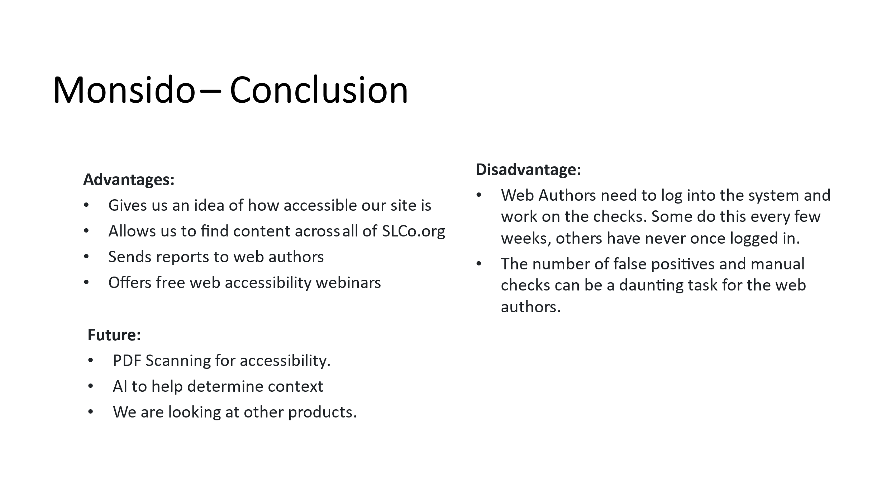
Smart Government Fund Update (Javaid Lal) | 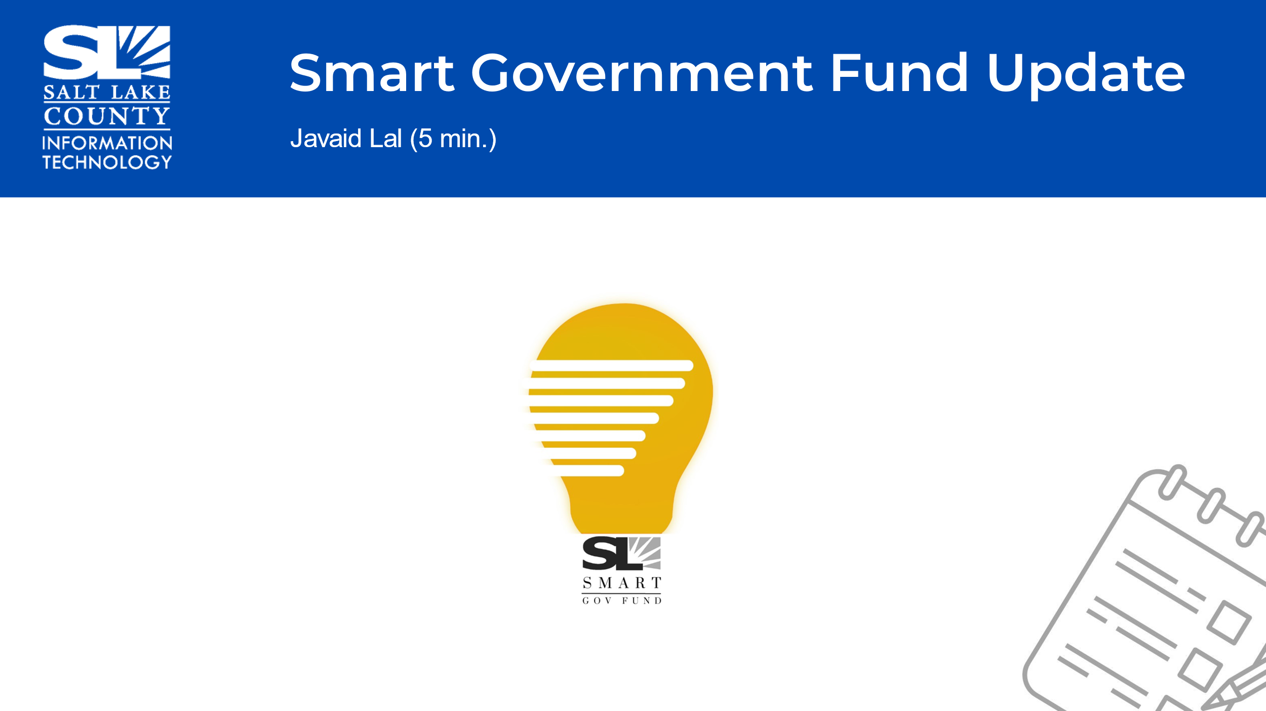  - Thirty-Five idea submissions were submitted for funding in 2023. Twenty-Seven ideas were not considered in 2023.  - Currently the total funded amount for 2023 is $285,189. Here are the projects:  - AI Tax Valuation  - Asset Tracking  - Robo-Trap  - *Constituents Communication Tool (contingent on availability of matching funds)  - The Mayor and Council has approved funding to continue in 2024. The funding request ask was $500k. Mayor proposed $250k to Council. Council approved. Given the current budget situation this is great news to have the opportunity to work on more projects.
Security Update (Mark Evans)  Communication Items (Chair & Co-Chair) | 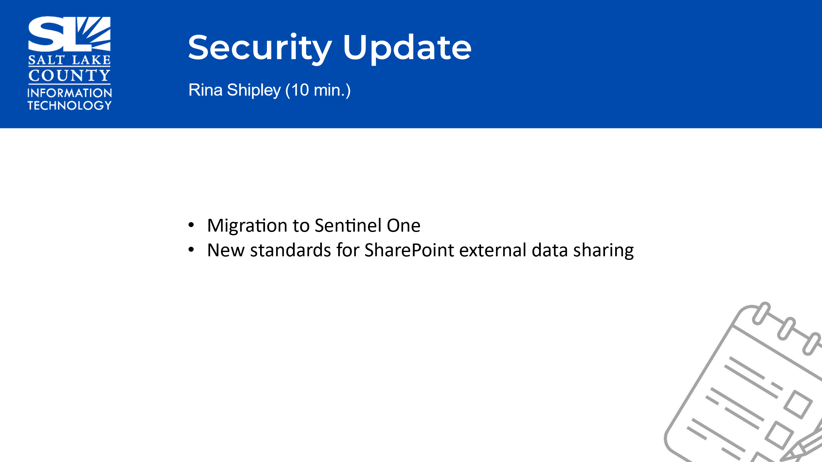  - Changed vendors from Cyber Reason to Sentinel One  - We have over 5200 devices moved with only a few servers that need a little additional time.  - A new standard for SharePoint will be brought up in the February 2024 TAB meeting.  - The new standard will be about setting up best practices on “how” agencies share their data in SharePoint with external parties.  - Multi-Factor Authentication Single Sign-On project – This is a project TAB supported for 2023 and funded. This is probably the BIGGEST security improvement we have made in the last three years. MFA is now in front of our Office 365 which was one of our biggest holes. Thank you for TAB for your support.  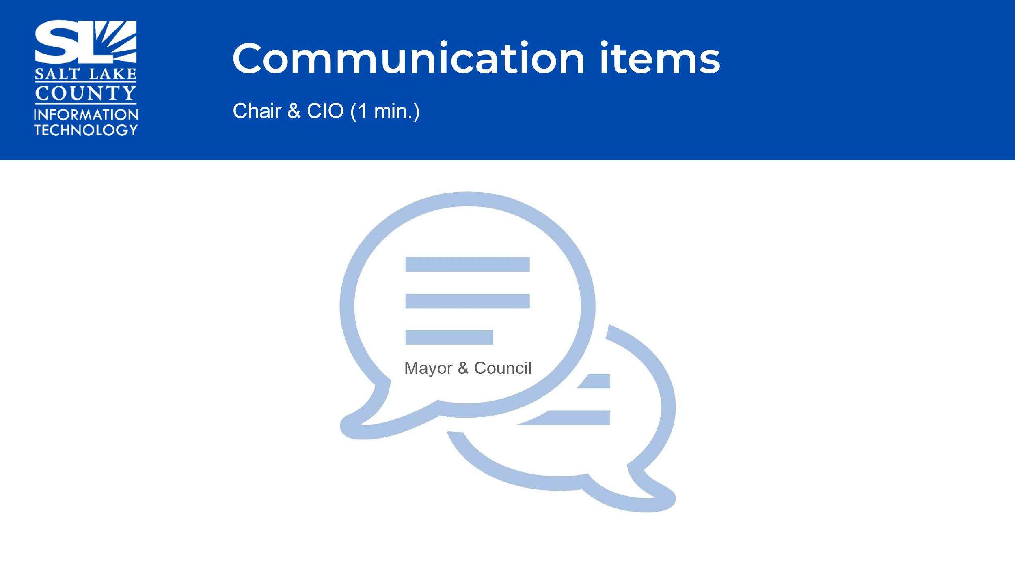  - We will go to Council in January 2024 to repeal the two policies (1400-4 and 1400-5).
Upcoming Meeting Schedule (Cindy Beck)  . | 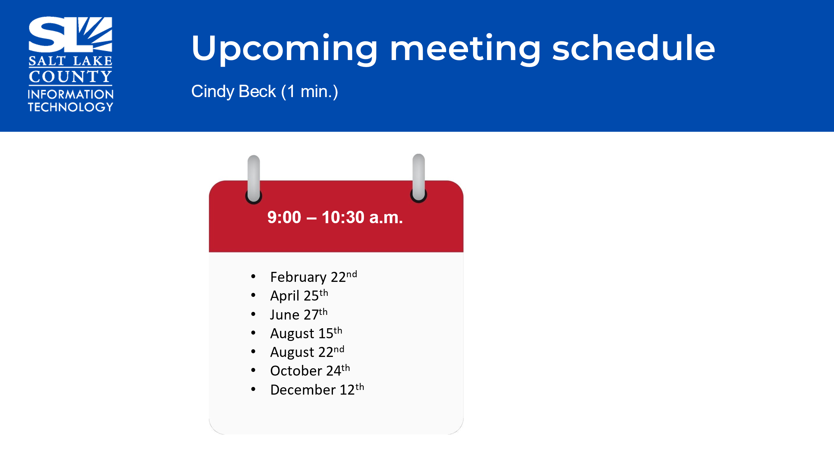  - It is noted both August Meetings will be combined with GIS Steering and TAB.
Review Action Items (Cindy Beck)

Next TAB Meeting February 22, 2024 | 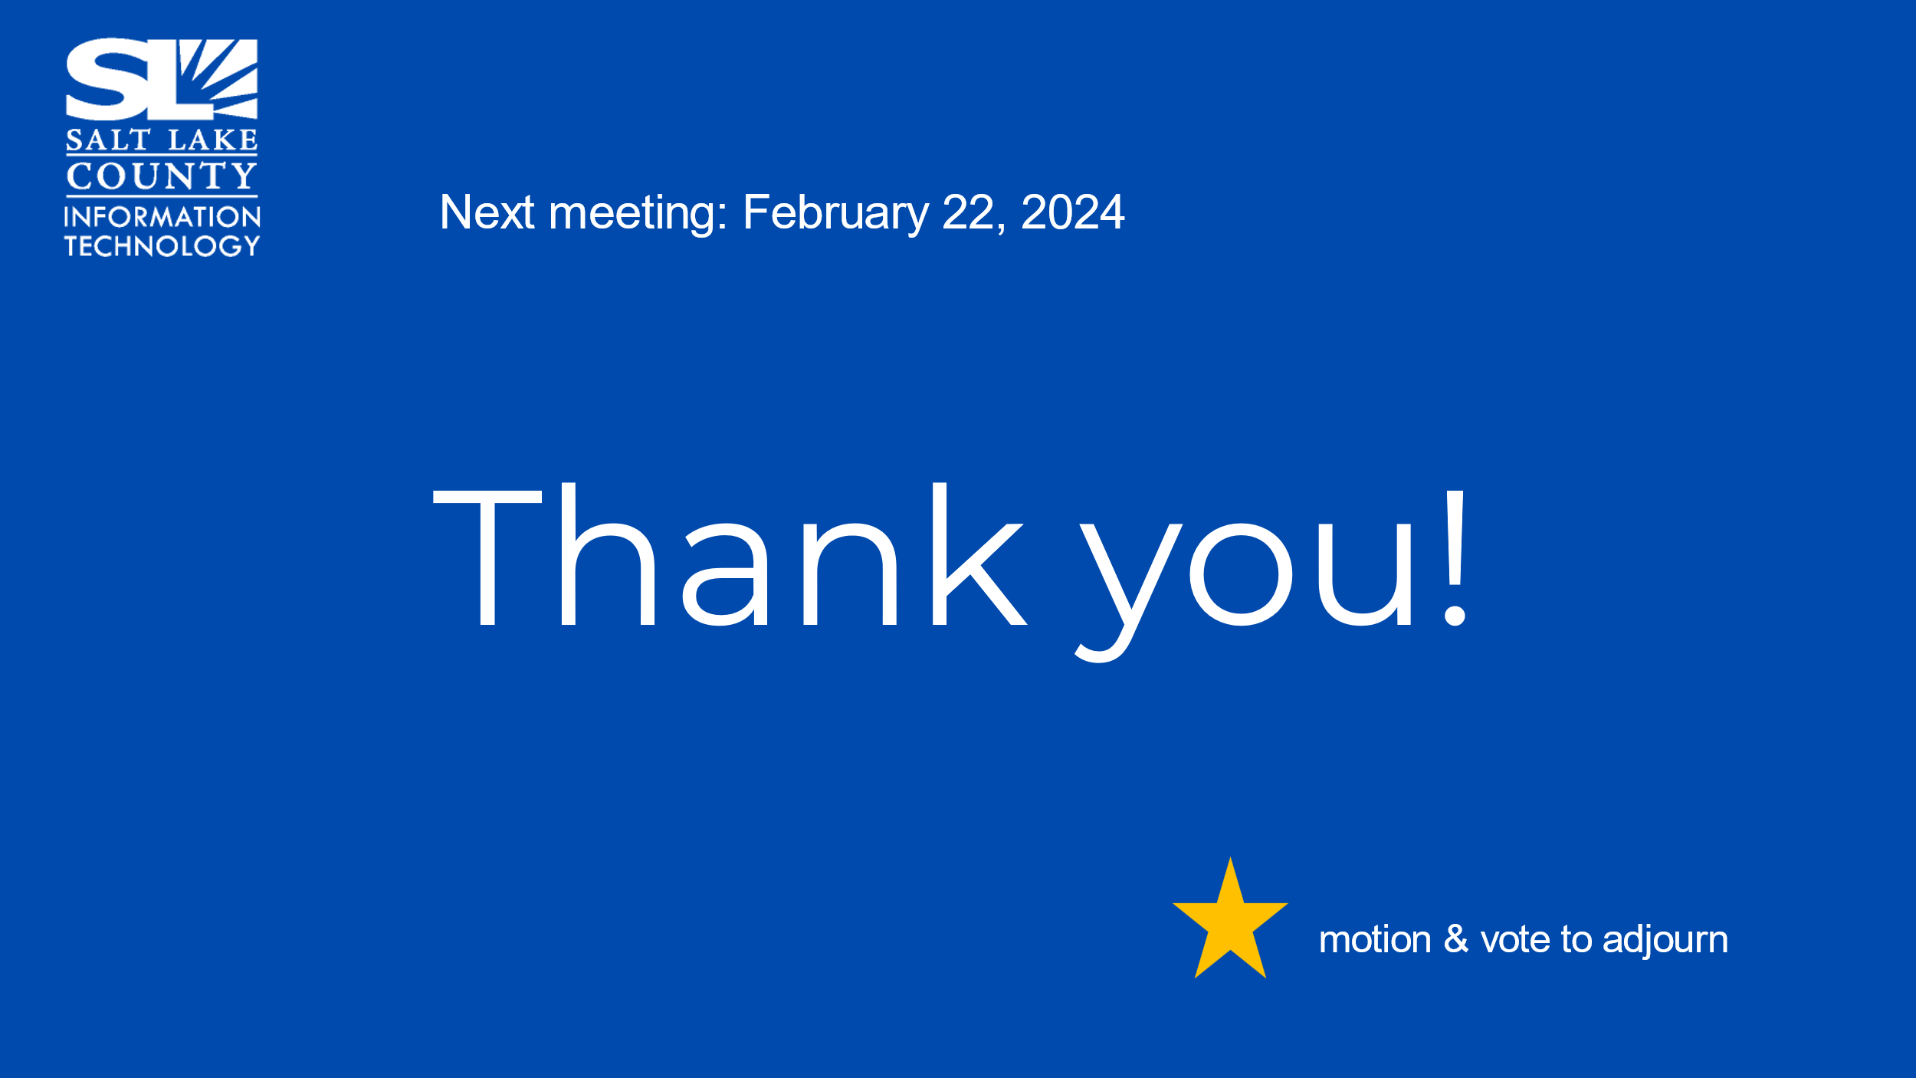
End of Session | Motion to adjourn the meeting by Chris Stavros. Meeting adjourned. So moved.  It has been noted there were no online conversations in the chat section to include for this meeting.
Next Meeting | - February 22, 9:00 – 10:30 AM
Submitted by Cindy Beck

