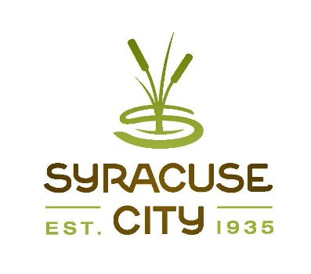SYRACUSE CITY
Syracuse City Redevelopment Agency (RDA) Meeting March 12, 2024 – immediately following the City Council Business Meeting, which begins at 6:00 p.m.

In-Person Location: Syracuse City Hall, 1979 W. 1900 S. Electronic Via Zoom
Connect via telephone: +1-301-715-8592 US, meeting ID: 886 8775 4688 Streamed on Syracuse City YouTube Channel

Meeting called to order. Adopt agenda.
- Authorize Administration to execute Reimbursement Agreement with Syracuse Flex, LLC for A flex/industrial project located near State Road (SR) 193 and 1000 West. (10 min.)
- Authorize Administration to execute Reimbursement Agreement with Trico Holdings, L.C. for a flex/industrial project near Antelope Drive and Bluff Ridge Road. (10 min.)
- Adjourn.
~~~~~
In compliance with the Americans Disabilities Act, persons needing auxiliary communicative aids and services for this meeting should contact the City Offices at 801-825-1477 at least 48 hours in advance of the meeting.

CERTIFICATE OF POSTING
The undersigned, duly appointed City Recorder, does hereby certify that the above notice and agenda was posted within the Syracuse City limits on this 7TH day of March, 2024 at Syracuse City Hall on the City Hall Notice Board and at http://www.syracus eut.gov. A copy was also provided to the Standard- Examiner on March 7, 2024.
CASSIE Z. BROWN, MMC SYRACUSE CITY RECORDER

