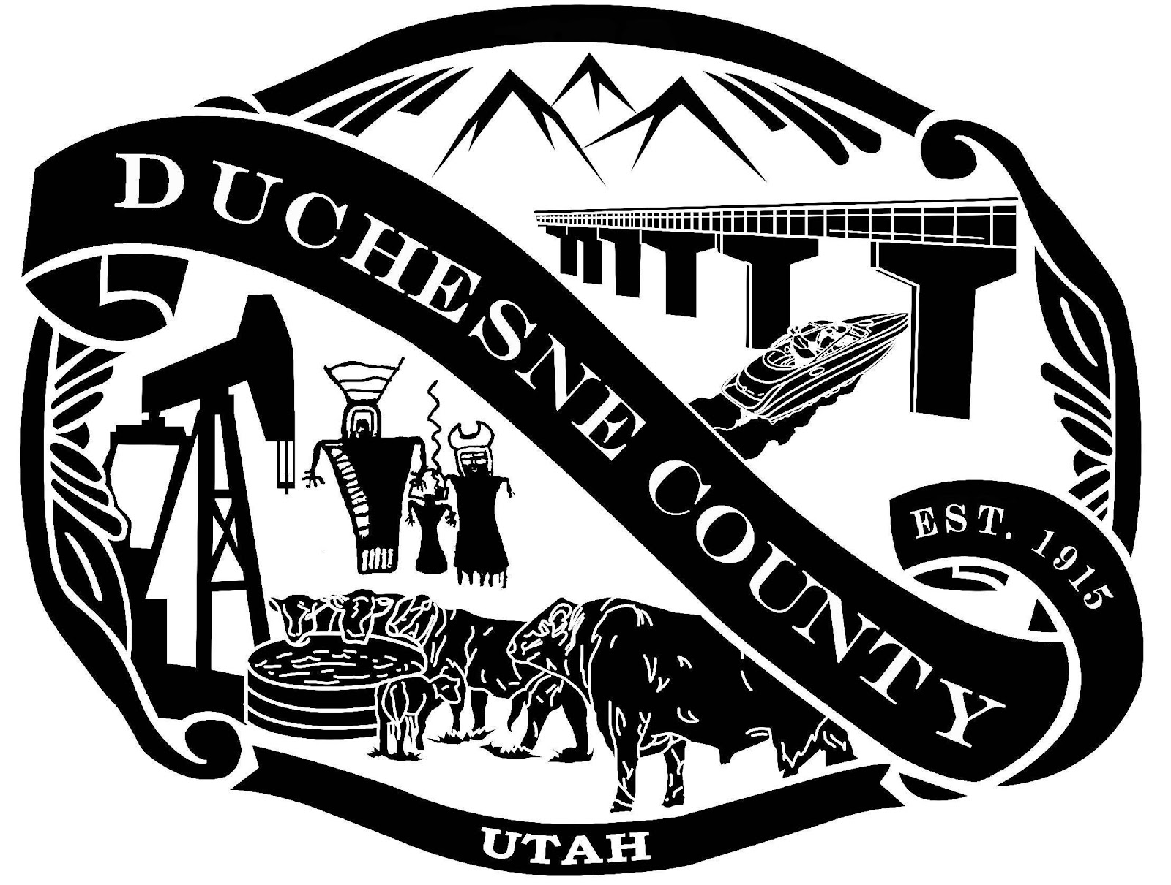
NOTICE OF A MEETING WITH THE DUCHESNE COUNTY ECONOMIC ADVISORY BOARD

PUBLIC NOTICE is hereby given that the Duchesne County Economic Advisory Board will meet on Wednesday, March 13, 2024, beginning at 2:30 p.m. in the Duchesne County Administration Building at 734 North Center Street, Duchesne, Utah, as well as on Zoom (please see information below on how to join the meeting) to discuss and act on the following:

- Opening Comments & Welcome
- Approval of Minutes from the June 6, 2023, Meeting
- Approval of Minutes from the August 18, 2023 Meeting
- Review the Business Grant Applications
- Customer Service Restructure
- Round Table Discussion
- Set a Date for the Board Work Session
- Adjournment

Topic: Duchesne County's Zoom Meeting
Time: March 13, 2024, 02:30 PM Mountain Time (US and Canada)
Join Zoom Meeting
https://us02web.zoom.us/j/89563569230
Meeting ID: 895 6356 9230
One tap mobile +16699009128,,7230771778# US (San Jose) +12532158782,,7230771778# US (Tacoma)
Dial by your location +1 669 900 9128 US (San Jose) +1 253 215 8782 US (Tacoma)
+1 346 248 7799 US (Houston) +1 646 558 8656 US (New York) +1 301 715 8592 US (Washington DC)
+1 312 626 6799 US (Chicago)
Meeting ID: 895 6356 9230
Find your local number: https://us02web.zoom.us/u/kbKTZYyfYK

I, Melissa Hughes, Duchesne County Commission Executive Assistant, certify that on March 7, 2024, pursuant to U.C.A., 52-4-202, this notice was posted 24 hours prior to the meeting time. Notice is also given to the Radio Station, KNEU, and the Uintah Basin Standard.

______________________________________
Melissa Hughes, Duchesne County Commission Executive Assistant

IN COMPLIANCE WITH THE AMERICANS WITH DISABILITIES ACT, PERSONS NEEDING AUXILIARY COMMUNICATIVE AIDS AND SERVICES FOR THIS MEETING SHOULD CALL THE DUCHESNE COUNTY CLERK’S OFFICE (435)738-1100

