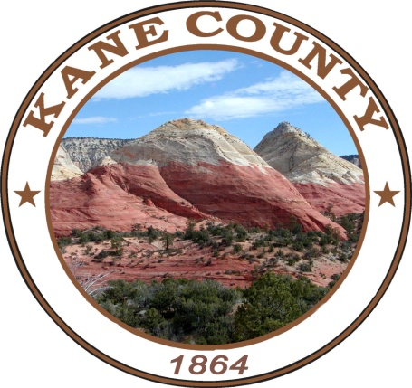

ATTENTION
Kane County Voters
Presidential Primary Election
March 05, 2024
7:00 a.m. to 8:00 p.m.

Last day a voter can register to vote for the Presidential Primary Election by mailing a
Registration form, Online or in-person is February 23, 2024
The Kane County Clerk’s Office is open from 8:00 a.m. to 5:00 p.m Mon-Thur, 8:00 a.m to 4:00p.m Friday.
Public Logic & Accuracy Testing will take place on February 09, 2024 at 10:00 a.m.
Board of Canvassers will meet on March 12, 2024 at 2:00 p.m.

*****************************************
The 2024 Democratic Presidential Primary Election will be held on Tuesday, March 5, 2024. Ballots will be mailed out to eligible voters starting on February 13, according to the voter’s party affiliation or if the voter requests a Democratic Ballot. Voters must be of legal voting age, citizens of the United States, and reside in the precinct in which they are registered.

Early Voting will begin on February 20, and ends on March 01, 2024, from 9:00 a.m. to 3:00 p.m. at the County Clerk’s Office, 76 North Main Street.
All Voters will need a photo ID

*****************************************
If you choose not to vote your "Absentee/By Mail" Ballot you may vote in person at the "Kanab Election Center" located at the "Kane County Courthouse" 76 North Main Street on Election Day or at the "Valley Vote Center" located at the "Kane County North Event Center" located at 475 East State Street on Election Day. You will need to bring in your "By Mail Ballot" to the election center with you where you will be issued a "PAPER BALLOT".

You can also choose to vote early in person at the Kane County Clerk/Auditor's Office by bringing in your "By Mail Ballot" to cast your vote in person on a "PAPER BALLOT".

Ballot Drop Box Locations: 76 N Main St in Kanab; 11 1st W ST in Alton; 60 Aaron Burr in Big Water; 90 E Center St in Glendale & 425 E State St in Orderville. Ballot Drop Box’s will be available beginning February 13, 2023 at 8:00 A.M and Closing March 05, 2024 at 8:00 P.M.

Voters can verify their party affiliation, registration status, and view a sample ballot online at www.vote.utah.gov or Contact Kane County Clerk’s office at 435-644-2458.
*****************************************
SAMPLE BALLOT
Races that will be on the Primary Election

Federal Office Races
Precincts: All Precincts
Democratic for U.S. President
Vote for One
JOSEPH R BIDEN JR
GABRIEL CORNEJO
MARIANNE DEBORAH WILLIAMSON
FRANK LOZADA
DEAN BENSON PHILLIPS

