RIVERDALE CITY COUNCIL AGENDA CIVIC CENTER - 4600 S. WEBER RIVER DR. TUESDAY – FEBRUARY 20, 2024

5:30 p.m. – Work Session
No motions or decisions will be considered during this session, which is open to the public.
6:00 p.m. – Council Meeting (Council Chambers)

- Welcome & Roll Call
- Pledge of Allegiance – Stacey Haws
- Invocation – TBA, by invitation
- Public Comment
(This is an opportunity to address the City Council regarding your concerns or ideas. No action will be taken during public comment. Please try to limit your comments to three minutes.)
- Presentations and Reports
  - Mayor’s Report
  - Bonneville High School seniors
  - UDOT 5600 South Project Update
  - City Administration Report
    - Department Reports January
    - February Anniversaries Employee Recognition
    - Staffing Authorization Plans
    - Community Development Report

- Consent Items

- Action Items
  - Consideration of Resolution 2024-03 adopting a Consumer Protection Privacy Policy.
Presenter: Steve Brooks

  - Consideration of Resolution 2024-04 amending Riverdale City Personnel Policy Chapter 2: Employee Classifications and Chapter 4: Employment Status.
Presenter: Steve Brooks

- Consideration of Ordinance 978 approving proposed code addition of Title 10, Chapter 13, Article I. “Airport Overlay Zone and Airport Area Special Regulations” ordinance to be added to the Riverdale City Code, as requested by the Community Development Department, and required by the State of Utah.
Presenter: Steve Brooks

- Discussion and possible action regarding 1500 West Road Project.
Presenter: Steve Brooks

- Comments
  - City Council
  - City Staff
  - Mayor

I. Adjournment

In compliance with the Americans with Disabilities Act, persons in need of special accommodation should contact the City Offices (801) 394-5541 at least 48 hours in advance of the meeting.

Certificate of Posting
The undersigned, duly appointed City Recorder, does hereby certify that the above notice and agenda was posted within the Riverdale City limits on this 16th day of February 2024 at the following locations: 1) Riverdale City Hall Noticing Board 2) the City website at http://www.riverdalecity.com/ 3) the Public Notice Website: http://www.utah.gov/pmn/index.html.

Michelle Marigoni Riverdale City Recorder

**The City Council meeting on February 20, 2024 is viewable electronically and may be accessed by clicking on the link below. The regular City Council Chambers will be available for in-person participation. The agenda for the meeting is also attached above. **

https://www.youtube.com/channel/UCegcYe-pIXSRZGd5llencvA/videos?view_as=subscriber



Riverdale City Council Presentation
Feb. 20, 2024

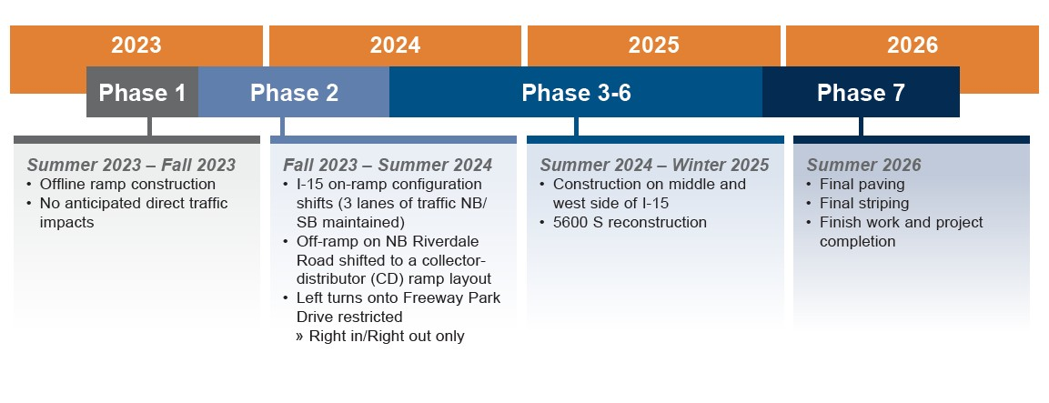
Project Schedule

*Construction schedules are subject to change

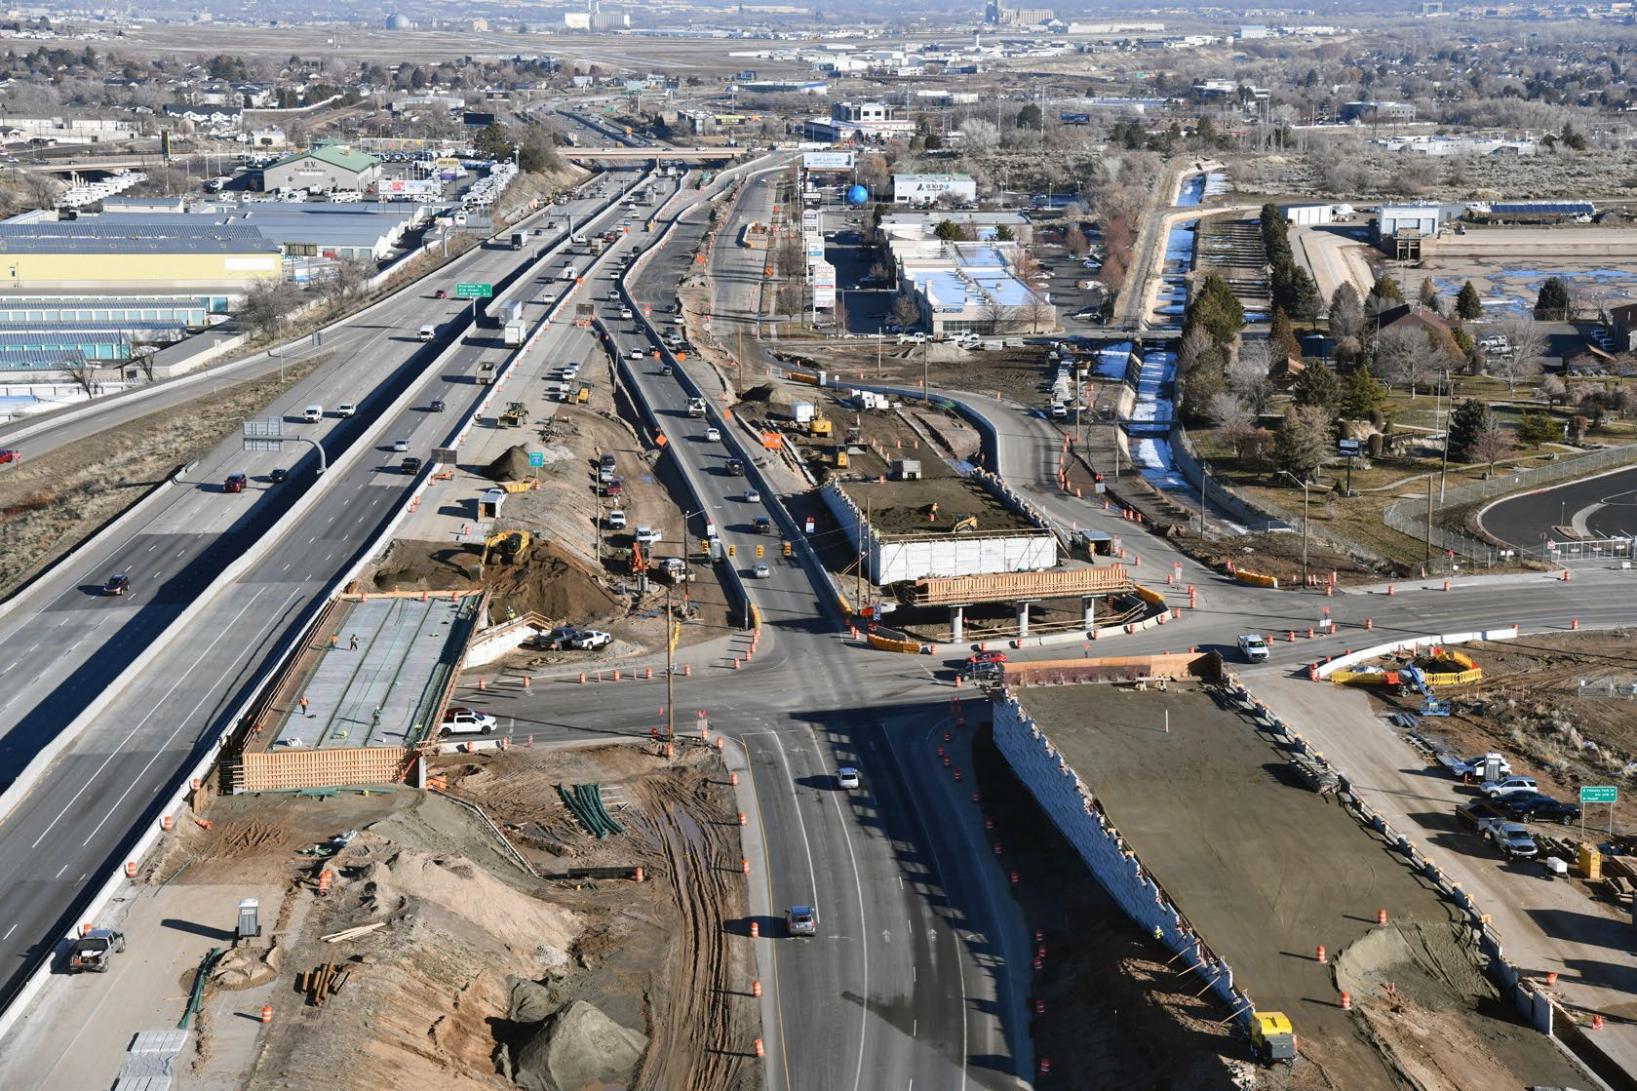
Construction Update

I-15 NB Structure & CD Road
- Freeway Park Dr.
- Along 5600 South

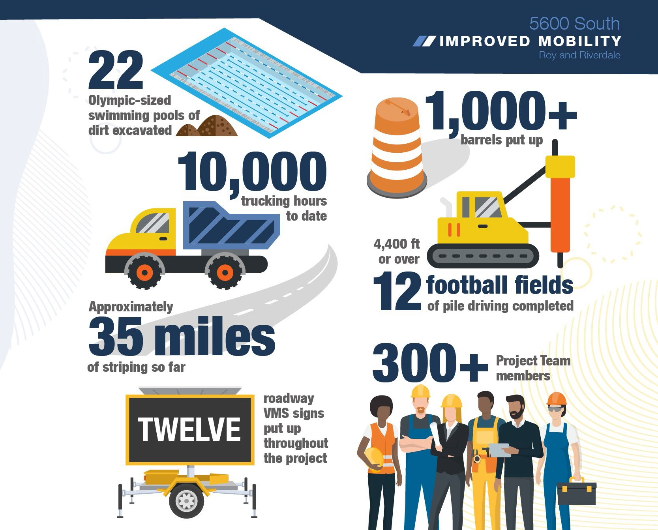
Public Involvement Update

Email Campaigns
  - Real-time UDOT Traffic Alerts
  - Website
  - Canvassing
  - Meetings
One-on-One Stakeholder Community Leadership City Council
Emergency Services

Upcoming Involvement
  - School Safety Assemblies
  - Career Fairs
  - Community Events

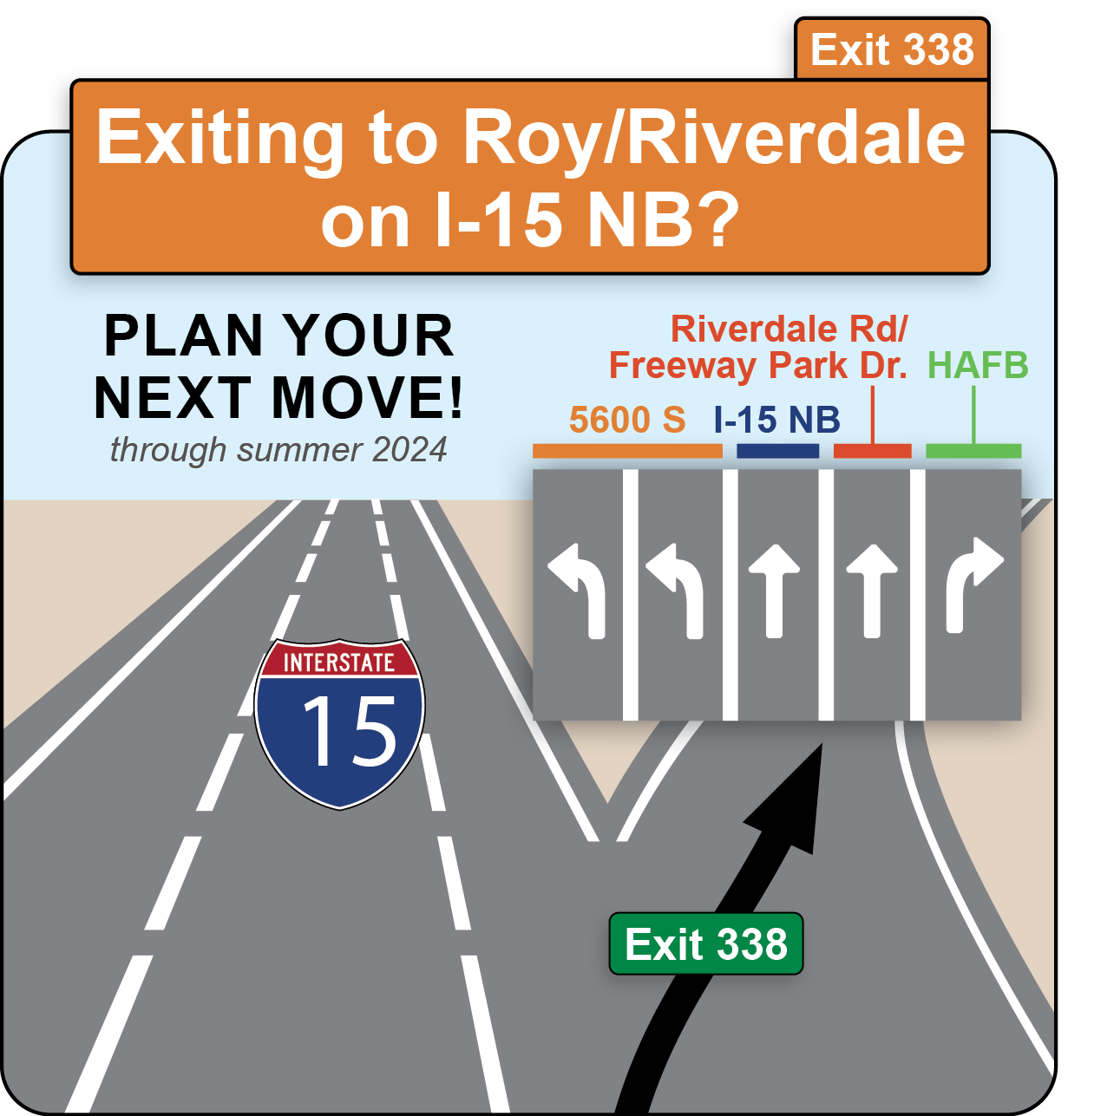
Public Involvement Update


Questions?


Contact Us! Sign-up for Updates

RIVERDALE CITY SALES TAX REPORT
AS OF JANUARY 31, 2024

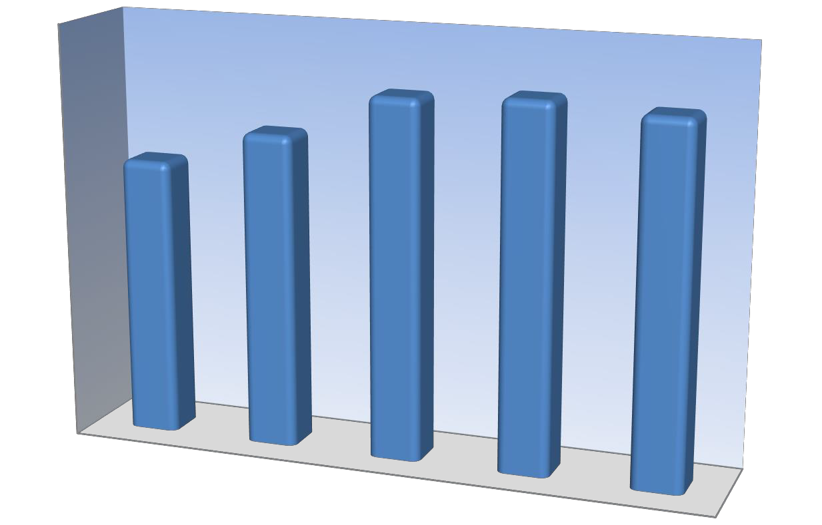
Sales Tax
June

May April March February January December
November
FY2024
FY2023 FY2022 FY2021 FY2020
October

September
August July
0
200,000 400,000 600,000 800,000 1,000,000 1,200,000
Sales Tax FYTD
6,000,000
5,166,339
5,254,156
5,000,000
5,151,769
4,525,005
4,010,732
4,000,000

3,000,000

2,000,000

1,000,000

0
YTD FY 2020
YTD FY 2021
YTD FY 2022
YTD FY 2023
YTD FY 2024

Sales Tax | July | August | September | October | November | December | January | February | March | April | May | June Totals
FY2020 | 546,902 | 612,157 | 591,696 | 573,327 | 519,064 | 610,719 | 556,867 | 657,308 | 615,264 | 472,239 | 559,456 | 644,897 6,959,896
FY2021 | 635,065 | 659,853 | 632,737 | 610,213 | 698,778 | 612,021 | 676,337 | 799,676 | 619,991 | 547,110 | 799,140 | 963,922 8,254,844
FY2022 | 731,834 | 799,292 | 708,575 | 743,276 | 718,470 | 701,211 | 763,681 | 853,569 | 653,055 | 663,354 | 816,853 | 777,539 8,930,709
FY2023 | 706,230 | 848,891 | 712,030 | 745,634 | 746,684 | 718,029 | 776,658 | 796,621 | 605,948 | 617,847 | 762,406 | 595,908 8,632,886
FY2024 | 668,597 | 798,228 | 717,698 | 722,394 | 741,783 | 685,830 | 817,239 |  |  |  |  | 5,151,769

Sales Tax FYTD | YTD FY 2020 | YTD FY 2021 | YTD FY 2022 | YTD FY 2023 | YTD FY 2024
 | 4,010,732 | 4,525,005 | 5,166,339 | 5,254,156 | 5,151,769

RIVERDALE CITY MONTHLY UTILITY REPORT FOR MAYOR & CITY COUNCIL
JANUARY 2024

e Bill Per omer
Water Fund
Average Gallons use  Total Gallons Used Total Customers Per Customer (in thousands) Total Billings Billed (in thousands) |  |  |  | d  Averag  Cust
Residential 10, | 860 $ | 51,557 | 2,187 5 | $ | 23.57
Commercial 12, | 448 $ | 36,953 | 260 48 $ |  | 142.13

e Bill Per tomer
Sewer Fund
Total Customers Averag Total Billings Billed Cus
Residential $ | 63,922 | 2,165 $ | 29.52
Commercial $ | 52,132 | 230 $ | 226.66

e Bill Per tomer
Storm Water Fund
Total Customers Averag Total Billings Billed Cus
Residential $ | 7,026 | 2,183 $ | 3.22
Commercial $ | 19,303 | 203 $ | 95.09

Garbage Fund
Total Customers

Average Bill Per

Total Billings
Billed
Customer

Residential - Garbage Residential - Recycling Commercial - Garbage Commercial - Recycling

$ 35,645
$ 7,475
$ 26
$ 21
2,151 $
1,854 $
2 $
3 $
16.57 * 4.03
12.98 * 7.10

- Some garbage utility customers have more than one garbage can, this is an average of all customers.

70.00

Residential Average User Fees Fiscal Year 2023 & 2024

60.00

50.00

40.00
Average Utility Fees

30.00

20.00

10.00

-
July August Sept. Octob. Novem. Decem. January Febr. March April May June
Water Fee Average -Res. - Prior Year Water Fee Average -Res. - Current Year Sewer Fee Average -Res. -Prior Year
Sewer Fee Average -Res. - Current Year Storm Water Fee Average -Res. -Prior Year Storm Water Fee Average -Res. - Current Year Garbage Fee Average - Res. -Prior Year Garbage Fee Average - Res. - Current Year Recycling Fee Average - Res. - Prior Year Recycling Fee Average - Res. - Current Year

500.00

Commercial Average User Fees Fiscal Year 2023 & 2024

450.00

400.00

350.00

300.00
Average Utility Fees

250.00

200.00

150.00

100.00

50.00

-
July August Sept. October Novem. Decem. January Febr. March April May June

Water Fee Average -Comm. - Prior Year Water Fee Average -Comm. - Current Year Sewer Fee Average -Comm.Prior Year
Sewer Fee Average -Comm. - Current Year Storm Water Fee Average -Comm. -Prior Year Storm Water Fee Average -Comm. - Current Year Garbage Fee Average - Comm. - Prior Year Garbage Fee Average - Comm. - Current Year Recycling Fee Average - Comm. - Prior Year Recycling Fee Average - Comm. - Current Year

Business Administration:

Cody Cardon:
- Routine phone & computer problem resolution throughout the city.
- Routine management issues and resolution.
- Various meetings and training courses attended.
- Working on Monthly Accounting.
- Interviewing for part-time Court Clerk to replace Raelyn.
- Various IT projects.
- Began preparations for FY2025 budget preparation.

Stacey Comeau:

New Hires: Promotions:
Terminations: Raelyn Boman Court

- Random drug testing for the month.
- Processed semimonthly payroll.
- Responded to job inquiries.
- Updated Staffing Authorization Plan.
- Prepared Employee Recognition.
- Completed monthly payroll reconciliation.
- Conducted exit interview with terminating/retiring employees.
- Prepared ACH files for Rent, RDA, and Early Retiree payments.
- Notarized various documents.
- Responded to requests for RDA loan payoff and verification of employment, both verbally and in writing.
- Prepared RDA loan disbursements.
- Responded to inquiries on Purchase Assistance Program and RDA Loan Program.
- Worked with various personnel to resolve issues and concerns.

Chris Stone:
- Worked with Music Village to complete the new speaker installation in the Court / Council foyer.
- Worked on the updating of the Riverdale Business Promotion brochure.
- Snow removal as needed.
- Set up council/court room for various meetings and court.
- Order and pick up of custodial supplies.
- Covered for part-time custodial staff off sick or on vacation.
- Various updates to the city website and social media sites.
- Completed the city newsletter for February.
- Completed the employee newsletter for February.

Mayor & City Council Monthly Summary Report January 2023

Community Development Department:
  - Review of sign permit requests and issuance of permits
  - Meeting with property owners and developers to discuss project plans and concepts
  - Review and commentary reporting on subdivision and development submittals
  - Design Review Committee meeting re: Chuck E. Cheese
  - Meeting with Brett Kenley and Ernie Schneiter re: Schneiter’s Bluff parking lot project
  - Meeting with Adam Andeson and Thatiam Falls re: Coleman Vu Estates status
  - Meeting with Kent Hill re: Property development planning and discussion
  - Meeting with Northern Utah Chamber Coalition Committee, AFCU Team, and AWA Engineering Team re: West Bench RDA/Development Area and infrastructure needs
  - Meeting with UDOT Traffic Team re: West Bench and 550 West RDA Development Areas
  - Meeting with Weber County Commissioners re: West Bench RDA/Development Area and infrastructure needs
  - Meeting with AWA and Hales Engineering re: RDA area development planning
  - Department heads meetings attendance by department member
  - Geographical Information Systems training and work by department member
  - Legislative Policy Committee meeting attendance by department member
  - Attendance at 5600 South Transportation Subcommittee meeting

•
SENIOR CENTER
Monthly Report

985
Ai\\
- fl SERVED
MEALS
served busi est day
We
62 meals on our

The Rh"rdalf'
980
PEOPLE
attended our programs

HOURS
or volunteer service
Stonior {f'l'llf'r
.rida)s at Ul:OO am IM-1dm1hlJl
Jant1ar) 5th



SENIOR SPOTLIGHT: KATHY PADRON
Kathy is a retired recreation therapist.She has 3 daughters and 8 grandchildren.She has been volunteering at the Front Desk and helping with Lunch money. She enjoys making friends and serving
o ers.

{l.•"'"lll lw lt•tl ll\
\1IJ 1>.1..Id \\ 1•1,i.u11r

We added a Meditation class to the weekly schedule.


FAVORITE PROGRAMS
I "

I
Yoga
Cards Bingo
Mindful Meditation
Zumba Gold Men's Fitness
January
202ll

MONTHLY ATTENDANCE
56ll
1899

PEOPLE
PEOPLE at.tended our programs

RESERVATIONS
0 21 this month
Includes 12 large meeting room and 9 small meeting room reservations

A FEW PROGRAMS OFFERED
Flip Flop Tumbling Pickleball Jr. Jazz Basketballl Group Fitness
Piclcleball/ Game Night Kids Open Pla.y,..
L!J

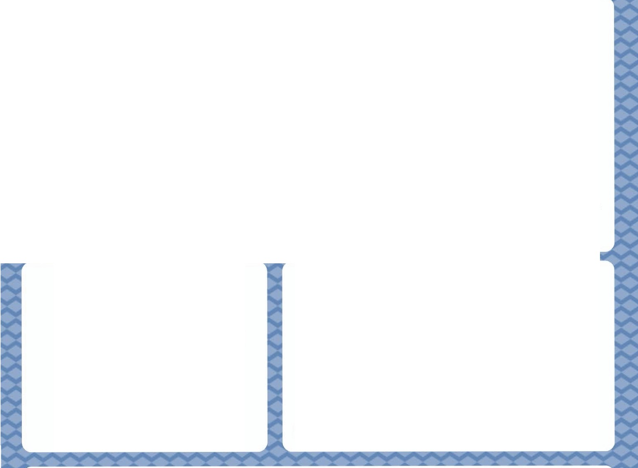

SPOTLIGHT PROGRAM: FLIP FLOP TUMBLING
We partnered with a tumbling teacher to offer tumbling classes. The classes are scheduled during a time the rooms have historically been empty.We are able to collect additional revenue and orrer a new program. It has been a great partnership.

Monthly report – January, 2024

Legal Dept., City Attorney, City Admin. – Steve Brooks:
- Resolutions/Ordinances work–
  - Work concerning – Mid-term appointment material, Fire dept., Grama, Court audit, Zoning, Nuisances, Design reviews, UDOT (WB), Legislative affairs, 5600, Garff, 550 West, Farmers market, Disc golf, Subdivisions, Financial sustainability, Fire district, Personnel, New member orientation, Coleman, Trader joes, RDA, Panera, UDOT, development agreements, Code enforcement, Zoning, Snow removal, Public defender, PID, Senior Center, Subpoenas, Betterment agreement, budget, Bach, Justice Court,
- Legal research/review –
- Legal Department meetings/work –
- Planning commission review/ordin/mtgs/minutes
- Walk-ins/Police reviews/Court/Court screenings/Court filings
- Formal training attended-
- RSAC- Drug Court – Graduation
- Legal reviews of minutes/resolutions/ordinances
- Records request reviews

COURT MONTHLY REPORT
382 Total traffic cases YTD 382 (Jan. 1, 2024 to December 31, 2024) 5 DUI 142 Moving violations 0 FTA
0 Reckless/DUI red. 170 Non-moving violations 0 Other
52 License violations 13 Parking

54 Total Misdemeanor cases YTD 54 (Jan. 1, 2024 to Dec. 31, 2024)

2 | Assault | 0 Ill. sale Alc. | 0 | Dom. animal | 4 Dom. violence
18 | Theft | 0 Other liq. viol. | 0 | Wildlife | 17 Other misd./infrac
0 | FTA | 10 Contr. subst vio | 0 | Parks/rec.
3 | Public intox | 0 Bad checks | 0 | Planning zon./Fire/Health
363 Total cases disposed of this month 3122 Total number of cases disposed of for the year (July 1, 2023 to June 30, 2024)
434 Total offenses this month 3630 Total offenses for year (July 1, 2023 to June 30, 2024)

Small Claims Total number of cases for the year (Jan. 1, 2024 to Dec. 31, 2024) -- Filed=2 Settled/Dismissed=0
2 Cases filed 0 Trials
0 Settled/dismissed 0 Default judgment

# CITATIONS BY AGENCY |  | YTD (July 1, 2023 to June 30, 2023)
Riverdale City | 177 | 1499
UHP | 132 | 1100

REVENUE/MISC. YTD (July 1, 2023 to June 30, 2024)

Total Revenue collected | $ 71,454.99 | $ 362,776.28
Revenue Retained | $ 48,851.12 | $ 235.322.18
Warrant Revenue | $ 29,010.80 | $ 276,660.57
Issued warrants | 65 | 599
Recalled warrants | 106 | 791
RSAC MONTHY REPORT
10 participants 58 drug tests given 1 ordered to inpatient
2 orientations 1 in jail/violations 0 other
0 new participant 2 positive UA’s/dilutes
3 graduates 0 incentives/ gifts
0 terminated/quit/walked away 0 spice tests given

Steve Brooks

From: Sent: To:
Cc:
Subject:
James Peters <jamesp@ utcourts.gov> Wednesday , January 31, 2024 5:30 PM Braden Mitchell
Judge Paul Olds; Joan Dailey;Steve Brooks; DeeDee Sonntag Re: Recertifying the Riverdale Justice Court

Good afternoon! The Utah Judicial Council has considered Riverdale's request to recertify its justice court. Based on the informat ion it received from courts around the state, the JudicialCouncil has granted extensions for alljustice courts to comply with two requirements:

• The first is that court staff complete the training required by the Board of Justice Court Judges. Court staff now have untilMarch 15 to complete alltraining required from January 2022 (or the month after startingwith the court-whichever islater) through September 2023. Court staff who failto comply with this requirement willlose access to CORIS on March 15. Court certification will then be reviewed in April.
- The second requirement is that the court have access to UCJIS. The Judicial Council granted no exceptions to this requirement, but it gave courts until July 1, 2024 to comply.

In addition, the Judicial Council has temporarily suspended the requirement that digitalrecording equipment meet the specifications set forth in (2)(Q)(i) and (2)(Q)(ii) of Appendix B to the Code of Judicial Administration . More information about a new requirement willbe provided in the near future.

Subject to the foregoing, the Riverdale Justice Court has been recertified for a four-year term that will expire on January 31,2028. In the meantime, if there's anything the Administrative Office of the Courts can do to support you in the operation of your court, please reply to this email or callme at (801) 578- 3824. Thank you for your ongoing commitment to Utah's Justice Courts.

Best regards,

James M. Peters
Justice Court Administrator Administrative Office of the Courts

On Tue, Oct 24, 2023 at 3:30 PM James Peters <jamesp@utcourts .gov> wrote:
Mayor Mitchell,good afternoon! As you probably know, state statute requires that municipal justice courts be recertified by the Utah Judicial Council every four yea rs. Because certification of the Riverdale Justice Court expires on January 31, 2024, Iam sending the attached application to explain the recertification process and all the requirements for maintaining a justice court. By copy of this email, the city's justice court judge, court administrator and my administrative assistant are receiving it as well. As Idon't have contact information for the city's attorney or council members, Iwould ask that you please forward this emailto them to ensure that they understand their role in recertifying the justice court.

In order to be recertified, the Judicial Council requires that Riverdale submit the following:
1

- an affidavit completed by Judge Olds,
- an opinion letter from the city's attorney, and
- a resolution adopted by the city council.

Each of these items is described in more detail in the attac hed packet. To ensure that the Board of Justice Court Judges has sufficient time to review your application and make a recommendation to the Judicial Council,allmaterials must be received by the Administrative Office of the Courts no later than December 15, 2023. They can be mailed to my attention at 450 South State Street in Salt Lake City, Utah 84111 or scanned and emailed to Dee Dee Sonntag at doriss@utcourts. gov. Thank you for allyou do to support the justice courts. If you have any questions about this process, please reply to this email or callme at (801) 578-3824.
Sincerely, James M. Peters
Justice Court Administrator
Administrative Office of the Courts

2

Public Works Monthly Report January 2024
- Continued work with Weber Basin to discuss alternatives for them providing additional water, instead of drilling well.
- Continued Storm Water review to meet new state regulations.
- Continued design work on 1050 W Ritter Dr. Roundabout.
- Continued work on UDOT 5600 S project.
- Continued inspections on AFCU Campus.
- Continued design work on 2024 Storm Drain Projects.
- Continued inspections on Tesla project.
- Continued reviews Riverdale Apartment project.
- Snowplowing.

- Continued inspections America First Road
Project.
- Continued 2023 waterline project.
- Started design work on 2024 Sanitary Sewer Projects.
- Continued reviews on Coleman Vu.
- Continued design work on 2024 street projects.
- Continued project for Freeway Park Drive Project.
- Continued work on utility capacity evaluations for 1500 W development.
- Started review and engineering for capital improvement plan for Sanitary Sewer and Water.

Fire Department: February 2024
Chief Jared Sholly

151 Calls for Service

Fires
2 Building Fires
1 Cooking Fire
1 Passenger Vehicle Fire

Total: 4

Rescue & Emergency Medical Service Incidents
62 EMS Call, Excluding Vehicle Accidents with Injuries
5 Motor Vehicle Accidents with Injuries
7 Motor Vehicle Accidents without Injuries
- Trench Below Grade
- High Angle Rescue

Total: 77

Hazardous Condition
2 Gas Leak
1 Carbon Monoxide Incident
1 Building Structural Weakened or Collapse

Total: 4

Service Call
1 Assist Citizen

Total: 1

Good Intent Call
50 Cancelled Enroute
2 No Incident Found
- Hazmat Release Investigated w/no Hazmat.
- Good Intent

Total: 55

False Fire Alarm & False Call
- Smoke Detector Activated due to Malfunction
1 Alarm System Sounded due to Malfunction
- CO Alarm Sounded due to Malfunction
- Detector Activation Unintentional
- Alarm System Activation, No Fire Total: 10

Department Report:

  - State Chiefs Legislative Meeting (Weekly)
  - Business Fire Inspections for Entire City Started by All Crews
  - Region 1 USAR Meeting
  - Ogden Regional EMS Case Review
  - EMS Committee Meeting
  - Weber County Heavy Rescue Meeting
  - City Staff Meeting
  - Meet with Bonnie Young on CERT
  - Weber County Fire Chiefs Meeting
  - Operational Dispatch Committee Meeting
  - County Wide Ice Rescue Training
  - Swift Water Deployment Meeting
  - Weber County Heavy Rescue Budget Meeting

INVESTIGATIONS MAJOR INCIDENTS/ARRESTS FOR 1/2024

Kidnapping – A juvenile foreign exchange student was reported as missing and possibly kidnapped after the juvenile’s school contacted the host family advising family in a foreign country was contacted by an unknown person claiming the juvenile was kidnapped and demanded ransom. Detectives were called out and contacted FBI and learned of “Cyber Kidnapping”. Video was found of the juvenile leaving home alone. Detectives wrote multiple warrants, one which was a GPS history on the juvenile’s phone and found multiple visits near Brigham City. Investigators searched the area and located the missing juvenile and found the kidnapping was a hoax and family was being scammed for money in China. Information obtained by warrants showed the suspects communication originated in China. The juvenile returned home with family.

Child Abuse – A male was reported for grabbing his 7yr old child in an aggressive manner and throwing him on the bed. Detectives interviewed the male who disclosed he grabbed his child in a disciplinary manner and escorted them to their room after having a physical altercation with another sibling. The case is being screened for charges.

Aggravated Murder – Riverdale PD officers responded to a 911 unknown where a child was found unresponsive. Upon PD arrival the child was found to be deceased. Investigators responded and observed signs of abuse. Parents were taken to the PD and questioned, where ultimately the mother admitted to physically abusing the child while the father was at work. The force the mother confessed she used was consistent the injuries which caused the death of the child. The mother was arrested and booked into jail for aggravated murder.

Theft – A male stole a tablet from the counter at Walmart. Detectives were able to identify the suspect as a person the PD had recent interaction with. The suspect was found to be incarcerated in jail and was interviewed. The suspect admitted to stealing the tablet and was charged with theft.

Fraud – A male used a lost/stolen credit card at a business in Riverdale and Ogden. The assigned detective was able to identify two suspects. The suspects were located and interviewed where one admitted to using the card and the other making a comment of finding the card. Both suspects were summoned for charges of Unlawful Acquisition and Unlawful Use of a financial card.

Vehicle Theft- An auto dealership had a vehicle stolen from their lot in July 2023. A male was identified as the suspect after being involved in an accident in November 2023. Investigators interviewed the incarcerated suspect who admitted to stealing the vehicle off of the dealership’s lot. Due to being incarcerated, the suspect is being referred to the county attorney’s office for theft of an operable vehicle.

Fraud – A female reported her father’s credit card was stolen from an assisted living facility in Layton. The credit card was used at two businesses in Riverdale City. Riverdale Investigators were able to identify the female suspect through video surveillance. The female was a previous employee of the care facility the victim lived in. Investigators located the female suspect and booked her into jail. She was found in possession of a fraudulent Colorado identification card at the jail. She was booked on two counts of Unlawful Acquisition of a Financial Card, two counts of Unlawful Use of a Credit Card and Forgery.

January 2024
Report #24-1
RIVERDALE POLICE DEPARTMENT CRIME BULLETIN

January Police Calls
- 1375 Calls for Service:
  - 45 Animal Complaints
  - 324 Crime Reports Written
    - 8 Forgery/Fraud
    - 26 Retail Thefts
    - 7 Family Offenses
    - 14 Burglary/Theft Complaints
    - 2 Stolen Vehicle Complaints
    - 4 DUI
    - 11 Damaged Property
    - 48 Arrests

The remainder of calls involved Welfare Checks, Disorderly Conduct, Suspicious Activities, Citizen
Assists, Lost/Found property, Trespassing, Medical Assists, Warrant Services, etc.

Traffic Patrol and Enforcement
- 366 Traffic Stops resulting in:
  - 285 Citations
  - 397 Total Violations
  - 112 Warnings Issued

FOR LAW ENFORCEMENT USE ONLY!

January 2024
Report #24-1
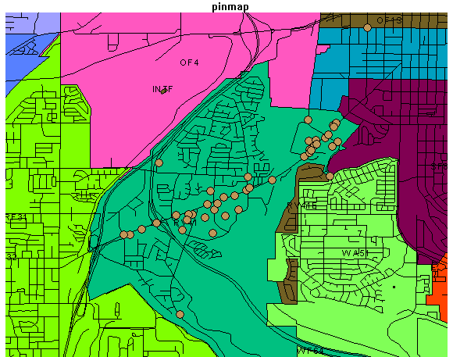o
56 Traffic Accidents
RIVERDALE POLICE DEPARTMENT CRIME BULLETIN

- 25 New Cases sent to Investigations.
- 28 Investigative Cases Closed

*Code Enforcement 3 New Cases
10 Cases still active

FOR LAW ENFORCEMENT USE ONLY!

Patrol Report January 2024 Patrol

Agency assist: Riverdale Oﬃcers assisted in a pursuit that ended in Riverdale. The subjects of the vehicle were taken into custody.
DUI: Oﬃcers responded to inves�gate a vehicle that was high centered on a median barrier. The vehicle le� but was found at the registered owner’s home. The driver was iden�ﬁed and deemed to be DUI.
The driver was taken into custody and the DUI process was completed.
Disturbance: Oﬃcers responded to a business where a vehicle was damaged, and a confronta�on occurred between the owner and the other person. There was no evidence to suggest the subject kicked the vehicle.
Trespass: Oﬃcers responded to a business where three people were trespassing on the property. The subjects were contacted and iden�ﬁed. They were trespassed from the property at the request of the management.
The�: A resident reported property was stolen from inside their home. Possible suspects were iden�ﬁed, and the case is being inves�gated. The stolen property was listed NCIC.
Suspicious person: Oﬃcers responded to a home where the resident reported seeing a male atemp�ng to break into his vehicle. The subject le� prior to police arrival. The surrounding area was checked, but the subject was not located.
Suspicious person: Oﬃcers atempted to contact a subject in a wooded area behind a business. The subject ﬂed on foot and was not located. There was no evidence of any burglaries or the�s in the immediate area.
Disturbance: Oﬃcers responded to a residence on a report of a family ﬁght. An arrest was made for domes�c violence related charges.
Assault: Oﬃcers responded to a home on an assault complaint. The inves�ga�on was completed and the complaint of assault could not be substan�ated.
Disturbance: Oﬃcers responded to a home on a family ﬁght complaint. One person was taken into custody for domes�c violence related oﬀenses.
Order viola�on: Oﬃcers responded to a residence on a report of an order viola�on. The subject was taken into custody and charged with viola�ng the order.
Disturbance: Oﬃcers responded to a business a�er a male caused a disturbance with employees over the business hours. The subject was contacted and educated about his behavior and poten�al repercussions.
The�/Fraud: A ci�zen reported having her purse stolen while she was shopping inside of a business. Her credit cards were then used at nearby businesses.
Recovered stolen vehicle: Oﬃcers recovered a stolen vehicle at a business. Drug and weapon possession charges against the suspect were forwarded for prosecu�on.

Trespass: Oﬃcers responded to a business for a trespass complaint. A subject had been on the property for an extended amount of �me and refused to leave. The subject was iden�ﬁed and found to have an outstanding warrant for their arrest. The subject was taken into custody and transported to jail.
Trespass/assist: Oﬃcers responded to a residence where a male had entered the backyard and was ac�ng strange and was possibly under the inﬂuence of drugs or alcohol. The male was located and he ul�mately was taken to the hospital for exposure.
Overdose: Oﬃcers responded on an overdose where an individual inten�onally took too much medica�on. The subject was taken to the hospital for treatment.
The�: A ci�zen reported a package was stolen from her front porch. It was possible that it was misdelivered to another home. Several people were contacted, but the property was not found.
Suspicious person: A resident reported that an uniden�ﬁed person was allowed to go into their home by an elderly family member. There were no crimes known to occur and the male was not located.
Vehicle the�: A ci�zen reported that their vehicle was stolen several months before making a report. It was discovered that an agreement was made to purchase the vehicle and that the agreement had not been fulﬁlled. The complainant was advised this will need to be handled as a civil mater.
Overdose: Oﬃcers responded to an overdose where the complainant asked to be taken to the hospital. She was transported at her request.
The�: Oﬃcers contacted a pedestrian leaving a business that had a fair amount of property from the store. It was found a�er the contact with the pedestrian that the the� occurred. The subject was located and charged for the the�, along with a the� that occurred at another nearby business.
The�: Oﬃcers responded to a business a�er a customer failed to pay for mul�ple items. The subject was charged with the the� and trespassed from the store.
The�: A ci�zen reported having his phone stolen from a restaurant. The phone was tracked to an address in Roy where the person in possession of the phone stated they found the phone in the bathroom and were going to turn it in. The phone was returned to the owner.
Agency assist: Oﬃcers assisted several other agencies in a shots ﬁred at a business involving police oﬃcers from an outside jurisdic�on. Riverdale Oﬃcers assisted by securing the scene and obtaining warrants.
Homicide: Oﬃcers inves�gated a homicide involving a child. A suspect was taken into custody and charges were ﬁled.
Disturbance: Oﬃcers responded to a restaurant where a customer was causing a disturbance with employees and refused to leave. The subject agreed to pay for her food and leave the property.
Disturbance: Oﬃcers responded to a residence on a family ﬁght. The subject involved alleged assault against the other. Charges were forwarded for screening.
Assist: Oﬃcers assisted the ﬁber op�c company a�er a gas line was ruptured. Riverdale Fire and Public Works responded to address the leak.

Welfare Check: Oﬃces responded on a welfare check on a juvenile at the request of the school. The student was contacted and conﬁrmed the student was okay.
Fire assist: Oﬃcers responded to a business on a car ﬁre. The car was a total loss. The owner made arrangements with the business and their insurance company to have the vehicle removed.
Suspicious person: Oﬃcers checked the river trail a�er a male was reportedly running the trail wearing a ski mask. The subject was not located.
The�: Oﬃces responded to a business on a the� complaint. The two subjects were contacted, and they were issued cita�ons for the the�.
Disturbance: Oﬃcers responded mul�ple �mes to two separate businesses on a report of juveniles causing problems inside. Oﬃcers remained on scene and were able to clear out the juveniles.
The�: Oﬃcers responded to a business where it was reported two employees had been stealing from the business. The two suspects were not able to be contacted. The case is ac�ve.
Disturbance: Oﬃcers responded to a residence on a family ﬁght complaint. An assault and criminal mischief were reported by each party. The case is being followed up on by the ini�al oﬃcer.
Runaway: Oﬃcers responded to a residence on a report of a runaway that failed to return home from school. The juvenile was located and taken to the appropriate facility.
Unknown problem: Oﬃcers responded to a business on a report of a person unconscious in a vehicle. The subject was contacted and was highly intoxicated. The subject was taken to the hospital.
The�: Oﬃcers responded to a business on a the� complaint. The subject detained had commited a total of three the�s on separate days. The subject was issued cita�ons for all three the�s.
Assault: Oﬃcers responded to a business on an assault complaint. The vic�m reported being assaulted by her boyfriend. The assault allega�ons could not be corroborated. The vic�m was provided with resources and shelter to be separated from the other party.
Vehicle the�/burglary: Oﬃcers responded to a residence where the vic�m reported his truck keys were stolen by gaining access through a window in his home. The suspect was contacted and admited to the the� and burglary. Charges were forwarded to the prosecutor’s oﬃce.
The�: Oﬃcers responded to a business a�er a male took property and le� the store. He was located and found to be in possession of property that was stolen from another business also. The male was charged and booked for the the�s.
Suspicious person: Oﬃces contacted a subject that was yelling about hearing a baby crying from a long way away. The subject is known to have mental/psychiatric problems. No crying children were located, and no other reports were received of this nature.
The�/Drug viola�on: Oﬃcers responded to a business on a the� complaint. The subject was found to be in possession of illegal drugs. A summons was issued for the the� and drug oﬀense.
Criminal mischief: Oﬃcers responded to a business a�er employees reported a customer became upset and damaged a glass door. The suspect was gone prior to arrival. The case is being inves�gated.

Disturbance: Oﬃcers responded to a residence a�er the homeowner was upset about possible damage that would be done to his lawn while ﬁber op�c cable was installed. A discussion was had with the company supervisor and all of the concerns were addressed.
Drug viola�on: Employees of a business found a small bag of narco�cs on their property. They turned over the bag to oﬃcers and the property was placed into evidence to be destroyed.
Assault: Oﬃcers responded to a residence on an assault complaint. The vic�m reported being struck by an object thrown by a roommate during an argument. The other party was taken into custody and charged with assault.
Assist/Psychiatric: A ci�zen called police for assistance as they were having some mental problems. Oﬃcers assisted her by pu�ng her in contact with M-COT.
The�: Oﬃcers responded to a business a�er a customer failed to pay for items he selected. The subject was detained by employees and a�er his true iden�ty was conﬁrmed, he was found to have warrants out of another state. He was booked for the the� and warrants.
Drug viola�on: While conduc�ng traﬃc enforcement, a vehicle was stopped by oﬃcers and a search of the vehicle was performed. Paraphernalia and various illegal drugs were found in the vehicle. The driver was arrested and charged accordingly.
Disturbance: Oﬃcers responded to a residence on a family ﬁght. An assault was alleged to have occurred days prior to this call. Charges are being screened due to conﬂic�ng statements. The par�es separated un�l the case is resolved.
Fraud: A ci�zen reported losing her wallet at a gas sta�on and her credit cards were used at various businesses. A suspect has not yet been iden�ﬁed.
The�: Employees from a business reported having an expensive tool stolen from them. The property was located in Roy and the case is being inves�gated to contact the suspect.
Drug viola�on: While conduc�ng traﬃc enforcement, a vehicle was stopped, and the odor of narco�cs was coming from the vehicle. It was found that a passenger in the vehicle was in possession of illegal drugs. The drugs were seized and booked into evidence.
Community Policing

Oﬃcers have been teaching NOVA at the elementary schools.
Oﬃcers con�nue to make their presence known while the school zones are ac�ve.
Code Enforcement

Oﬃcers and Code Enforcement addressed mul�ple parking problems in rela�on to the snowstorms and winter parking ordinance.

ment
Employee Recognition – February 2024 Anniversaries
Years | Employee Depart
6 |  | Michael McNeely Police
1 |  | Lindsey Bird Police
1 |  | Noah Shears Police
1 |  | Nathen Zaugg Police





Staffing Authorization Plan

As of January 31, 2024
Department | FTE Authorization | FTE Actual
City Administration | 2.00 | 2.00
Legal Services | 4.50 | 3.50
Building | 1.50 | 1.50
Community Development | 1.00 | 1.00
Business Administration | 7.00 | 7.00
Community Services | 13.50 | 11.00
Public Works | 11.00 | 11.00
Police | 26.00 | 24.00
Fire | 22.50 | 16.00
Total | 89.00 | 77.00

Staffing Reconciliation – Authorized to Actual
Department | FTE Variance | Explanation
City Admin | 0.00
Legal Services | (1.50) | City Administrator/City  Attorney/PT Court Clerk
Community Development | 0.00
Community Services | (3.00) | Recreation Assistants
Business Administration | 0.00
Public Works | 0.00
Police | (1.00)
Fire | (6.50) | PT Firefighters/Inspector
Totals | (12.00) | Staffing under authorization

Actual Full Time Employees | 58.00
Actual Part Time Employees | 39.00
Seasonal Employees | 0.00
* 2 part time FTE can not be converted to 1 full time FTE


COMMUNITY DEVELOPMENT PROJECTS STATUS REPORT
February 15, 2024

OPEN FOR BUSINESS

Utah Furniture Direct has opened a new store in Riverdale located at 4050 South Riverdale Road.

NAPA Auto Parts has opened a store at 4040 Riverdale Road, Suite B.

ONGOING DEVELOPMENTS

Bricks & Minifigs will hold a grand opening on February 26th. They are located at 4074 S. Riverdale Road.

Tesla has started construction on the Tesla Riverdale Automotive
Center to be located at 4581 South 1500 West.

Chuck E. Cheese is working on tenant finish construction of a space located at 4101 South Riverdale Road.

America First Credit Union has started construction of their new Administrative Operations building at 4624 South 1500 West.

Thrive Appliance will open a new store in Riverdale located at
4071 S. Riverdale Road.

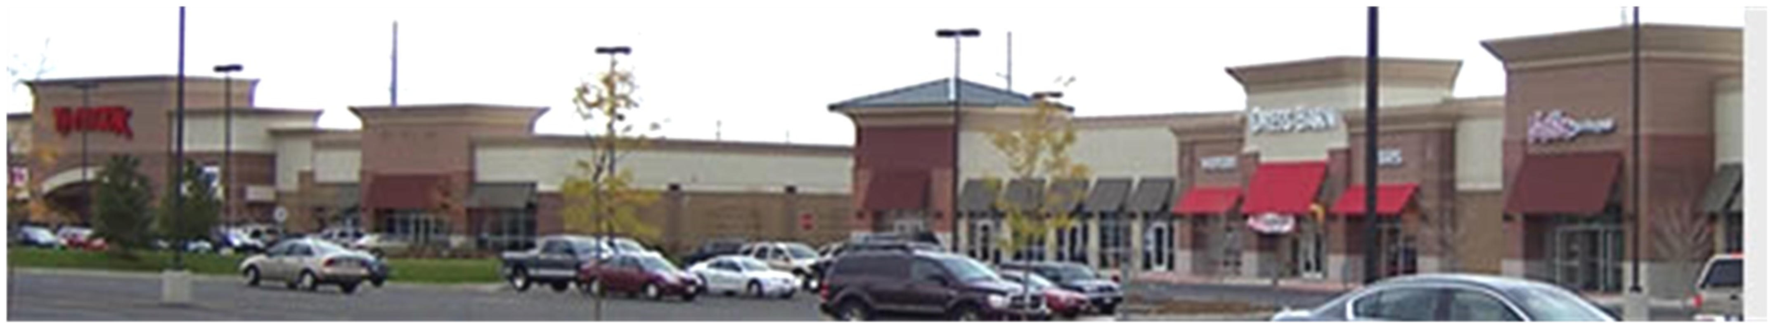
II.D.K. Barbeque has started construction on their new restaurant located at 1140 W. Riverdale Road #E .

Ashley Furniture will open a store in the old Shopko building at 4060 South Riverdale Road.

RIVERDALE CITY CITY COUNCIL AGENDA
February 20, 2024

AGENDA ITEM: G1

SUBJECT: | Consideration of Resolution #2024-03 approving a Consumer Protection Privacy Policy
PRESENTER: | Steve Brooks, City Administrator

INFORMATION: a.
b.
c.
Executive Summary Resolution #2024-03
Proposed Consumer Protection Privacy Policy

BACK TO AGENDA


City Council Executive Summary
For the Council meeting on: | Petitioner:  Steve Brooks, City Administrator/Attorney
Summary of Proposed Action
Consideration of Resolution 2024-03, Adopting a Consumer Protection Privacy Policy for the City.
Summary of Supporting Facts & Options
In 2023, the Utah State legislature pass a law that requires businesses and legal entities to adopt policies that govern the protection of private information of consumers.

This policy meets all the requirements set for by the Utah Consumer Protection Act. Once adopted the City will post this notice on our website and use the criteria in all of our business dealings as set forth therein.
Legal Comments – City Attorney
 | Steve Brooks, Attorney
Fiscal Comments – Business Administrator/Budget Officer
 | Cody Cardon, Business Administrator
Administrative Comments – City Administrator
 | Steve Brooks, City Administrator

RESOLUTION NO. 2024-03

A RESOLUTION FOR A CONSUMER PRIVACY POLICY TO BE USED BY RIVERDALE CITY

WHEREAS, Riverdale recognizes the importance of safeguarding the rights and interests of consumers within our jurisdiction and the consumers right to know the extent the city may be using personal information; and

WHEREAS, consumer protection policies are essential for ensuring fair and transparent business practices, fostering consumer trust, and promoting economic well-being within our community; and

WHEREAS, the Utah State legislature passed the Utah Consumer Protection Act (UCPA) in 2023, which requires all businesses and entities to protect personal data and provide consumers with information about how they can exercise their rights of protection under the Act; and

WHEREAS, it is the responsibility of local government to enact measures that promote consumer confidence and mitigate risks associated with deceptive or unfair trade practices; and

WHEREAS, Riverdale City wishes to adopt a Consumer Protection Policy that conforms to the requirements outlined in the UCPA and provides guidance and information of the rights and processes for the consumers to obtain information and guidance on how to protect the confidentiality and integrity of the consumer’s personal data.

NOW, THEREFORE, BE IT RESOLVED by the City Council of Riverdale City that:

- The City Council hereby adopts a comprehensive consumer protection policy aimed at safeguarding the rights and interests of consumers within our jurisdiction.

- The City Council directs the appropriate departments to collaborate in the implementation and enforcement of the consumer protection policy, ensuring its effective execution and compliance with relevant regulations.

- The City Council shall regularly review and update the consumer protection policy as needed to address emerging issues and adapt to changing market dynamics, ensuring its continued relevance and effectiveness.

- The policy attached hereto as Attachment A and titled the “Riverdale City Consumer Privacy Policy” and incorporated herein by reference, is hereby adopted by Riverdale City and that the Mayor is authorized and directed to execute any related documents on

behalf of the City and shall take effect immediately on passage and acceptance as provided herein.

- That the Riverdale City Council hereby affirms their willingness to continue to meet all the requirements set forth by this policy and for continued protection of the personal data of consumers and citizens of and in Riverdale City except as may be exempted otherwise by law or statute.

BE IT FURTHER RESOLVED that a copy of this resolution shall be transmitted to all relevant stakeholders and made available to the public through appropriate channels.

PASSED, APPROVED AND SIGNED this day of February, 2024.

Attest
Braden Mitchell, Mayor

Michelle Marigoni, City Recorder

VOTE:

Alan Arnold Yea Nay Absent Bart Stevens Yea Nay Absent Stacey Haws Yea Nay Absent Anne Hansen Yea Nay Absent Michael Richter Yea Nay Absent

Attachment A

Riverdale City Consumer Privacy Notice

Riverdale City (City) understands the importance and sensitivity of
personal information. Access to personal information is limited to those who need it to perform assigned tasks. Riverdale restricts access to work areas and use security measures and password-protected
computer systems to keep personal information secure. We follow
federal and state laws that govern the use of personal information. We use this information in written, oral, and electronic formats (and allow others to use it) only as permitted by federal and state laws. These
laws provide certain rights regarding personal information.

Purpose of Privacy Notice
The City is committed to protecting the personal information of those accessing its website and those accessing City government services in person. The purpose of this Notice is to inform those accessing the
City website and those accessing government services in person
regarding the collection and use of personally identifiable information.

Definition of Personally Identifiable Information
For purposes of this Notice “personally identifiable information” means any information relating to an identified or identifiable individual who is the subject of the information. This information could
include information that identifies a user by name, account number,
physical or mailing address, email address, telephone number, Social Security number, credit or debit card information, or bank account
information. This information may include any combination of the above or other personal information that could be used to determine identity.

Personally Identifiable Information Not Routinely Collected
Visitors to the City website do not have to routinely provide personal
information to visit the website or to download information. Government agencies may request personally identifiable information from you to provide requested specialized services, but such information is
managed as it would be as if obtained during an in-person visit to a government office.

Riverdale City does not collect any personal information from a visitor to our site unless that visitor explicitly and intentionally provides it.
Under no circumstances does Riverdale City collect any personal data revealing political opinions, religious or philosophical beliefs, health status, or sexual orientation. If you are simply browsing our site, we do not gather any personal information about you.

Information We Gather from You
The City only collects personally identifiable information that is
required to provide services. You can decline to provide us with any personal information on the website or in person at any time. However, if you choose to withhold requested information, we may not be able to provide you with the online services or government-provided services, dependent upon the collection of that information.
There are several ways in which you affirmatively provide us with and consent to our collection of certain personal information:
Use r Sub m iss ion s - Some of our online City services allow users to submit suggestions, comments, or requests to us. This could be by emailing us, filling out an online form to provide comments and
suggestions, or reporting a problem. This data may include personally identifiable information such as name and email address. We will use the information you send us to respond. We may also direct your
message to another government agency that can help in addressing your request.
U s er A c c o u nts - Some digital City services involve the creation of user accounts. Creating an account may involve the submission of
personally identifiable information. This could include a username, password, email address, mailing address, telephone number, full name, employment, and other history, etc. We do not use this information to send to commercial and/or marketing companies or purposes. We will only use this information to provide you with government services.
The City will make every reasonable effort to protect your privacy. It restricts access to your personal identifiable information to those
employees that will respond to your request or inquiry. The City does not intentionally disclose any personal information about our users to
any third parties inside or outside the City except as required by law or to provide a service for which the City has contracted with a third party.

Information We Automatically Collect and Receive
Like most other websites, the City’s website collects certain
information automatically and stores it in log files. The information may

include internet domain and internet protocol (IP) addresses of the device or network you are using to access our site, the region or

general location where your computer or device is accessing the internet, browser type and operating system used to visit our site, the date and time of when you access our site, other usage information about the use of the City’s website, and information on the history of the pages you view. This information does not identify you personally. We do not collect this information to provide targeted advertising. The data collected serve as part of our statistical analysis about the use of our website so we may better design online services and improve
access to them. We analyze traffic to our services in several ways, including using third-party services.

U s e of C ook i e s
We use “persistent cookies” and “temporary cookies” on some parts of our website and such temporary cookies expire upon the end of the browsing session. The use of cookies is a standard practice among
Internet websites. Most Internet web browsers may be customized to reject cookies, to only accept or reject cookies by user intervention, or to delete cookies. Rejecting and/or removing cookies, however, may lead to loss of functionality on selected pages requiring cookies to function fully.

Access to Personally Identifiable Information From
Governmental Websites and the Governmental Records Access and Management Act
As a municipal government, the City is a public governmental body subject to Chapter 2, Title 63 of the Utah Code, which is the law
entitled the Government Records Access and Management Act (GRAMA). Information about GRAMA can be found on the Utah State Legislature website
at h t t p s : / / l e . uta h.g ov/ x c o d e/Tit l e63G/ C h a pter2/63G - 2.htm l. If an
appropriate request is made to the City for information that is subject to disclosure under Chapter 2, and not made confidential elsewhere in the Utah Code, the City may be required to disclose the information
requested, even if it may include your personally identifiable information. While Chapter 2 sets the general policies for access to government records in the state of Utah, other sections of the Utah
Code as well as other federal laws also deal with confidentiality issues.
All records that are prepared, owned, received, or retained by a
governmental entity that may be reproduced by certain means are

considered public, unless they are private, controlled, or protected, as outlined in GRAMA, or are records to which access is restricted according to court rule, other State law, federal law, or federal

regulation. Information that is considered public record under GRAMA and not made confidential elsewhere in the Utah Code or by federal law, may be subject to electronic access through the City’s website.
Personally identifiable information is not a classification of records under GRAMA.

Use of e-mail addresses
E-mail addresses obtained because of a request to the City website will not be sold or provided to private companies by the City for
marketing purposes. The information collected is subject to the access and provisions of GRAMA, other applicable sections of the Utah Code or federal law. E-mail or other information requests sent to the City website may be maintained in order to respond to the request, forward that request to the appropriate department, communicate updates to the City webpage that may be of interest to citizens, or to provide the City web designer with valuable customer feedback to assist in
improving the site. Individuals will be provided with the ability “opt out” at any time of any communications regarding new service updates.

Third-party Services
The City and elected offices contract with third parties for certain services such as web traffic monitoring, website optimization form
submissions, and workflow tools and financial transactions. Some user accounts created on contracted third-party systems may be linked with other third-party websites, such as social media networks. To link your accounts, you must provide your display name or user ID to those
third-party websites. You may also be required to engage in an
authorization process with each of those websites. We do not receive or store your password from those websites.
Whenever you use a third-party service, you are also agreeing to that service’s Privacy Policy. The City’s website uses YouTube API
Services to help retrieve and display YouTube videos and video information. The data used is all publicly available information,
including the following for videos and playlists: titles, descriptions, IDs, channel IDs, and thumbnails.
Usage of YouTube videos and YouTube video information is subject to the (www.youtube.com). The City does not access, use, or collect any personal information in its use of YouTube API Services, but Google

may do so. Please see G o ogle P r i v acy a nd
T erm s (h t t p s : / / poli c i es. google.c o m / p r i v acy ?hl= e n - U S) for more information on

how Google might use your personal data when interacting with its services.

What Happens After You Provide Personal Information
Our intention in collecting information is to provide users with smooth and efficient online City service experiences. We generally respond to
any e-mail questions, requests for services, and other inquiries that we receive. We may retain this correspondence to improve our services, our website, and for other disclosed purposes. We may retain contact information so that we can send individual updates or other important information.

Data Security
The City is committed to data security and the data integrity of
personally identifiable information that is either available from or
collected by governmental websites and takes reasonable precautions to protect personally identifiable information from loss, misuse, or
alteration. We maintain physical, technical, and administrative
safeguards. We update and test our security technology on an ongoing basis. We restrict access to personal data to those employees who
need to know that information to provide benefits or services to you. When a City application accepts credit cards or any other
particularly sensitive information for any of its services, it encrypts all ordering information, such as your name and credit card number, to protect its confidentiality. However, as with any transmission over the Internet, there is always some element of risk involved in sending personal information. Unless otherwise prohibited by state or federal
law, rule or regulation, an individual is granted the ability to access and correct personally identifiable information whether the information
inaccuracy was accidental or by created unauthorized access. Visitors should be aware, however, that even though protections are in place, the City cannot guarantee against the occurrence of hardware failure, unauthorized intrusion, or other technical problems.

Non-City Websites
Various web sites may be linked through www.riverdalecity.com. Many of these sites, including private sector sites, are not subject to GRAMA

and may also not be subject to other sections of the Utah Code or federal law. Visitors to those sites are advised to check the privacy notices of these sites and be cautious about providing personally identifiable information without a clear understanding of how the

information will be used. Visitors may want to consult guidelines on protecting your personal information such as those recommended by the Privacy Alliance, at htt p:/ / w w w . pri v a c y a l l i a nce . org/prote c t i o n/.
The City is not responsible for privacy practices, privacy notices or content regarding these other sites.

Information Storage
Retention of records obtained from the City’s website and other sources follows the City’s records retention schedule. Retention
timelines can vary depending on what kind of information you provide.

Sharing Information
We may share information or statistics with third parties or the public in an anonymous form that does not directly identify you. This would
typically be done to assess an online City service. No personally
identifiable information would be released. Additionally, if a user is having issues with an online City service, we may share information with outside parties to the extent necessary to troubleshoot the issues or enhance the performance of the system.

If We Are Required by Law to Disclose Information
Under certain circumstances we may be required by law to disclose certain information to law enforcement authorities. Suspicious email, electronic threats, unauthorized access, or any information on illegal activity may be provided to the appropriate authority.

Children’s Information
Our online City services are intended for use by adults. We do not
knowingly collect personal information from children under 13 years of age. However, we also do not try to determine whether a visitor is underage, therefore users should be aware that personally identifiable information submitted to the City by minors will be treated as
information given by an adult and may become subject to Public Records Requests as controlled primarily by GRAMA. If you are a

parent or legal guardian of a child under the age of 13 who you believe has submitted personal information by use of our Services, please
contact the City’s Legal Counsel immediately.

Changes to this Privacy Notice and Security Policy
The City may change this Privacy Notice from time to time and reserves the right to do so without notice.

How to Contact Us
Questions regarding this Privacy Notice should be directed to the Legal Counsel for the City. Please specify in the subject line of your e-mail “Privacy Notice.” You may also contact us at the following:
City of Riverdale
Attn. City Attorney-Privacy 4600 South Weber River Drive Riverdale, UT 84405
(801) 394-5541
Email: info@riverdalecity.com

Effective Date of this Notice: February 21, 2024.

RIVERDALE CITY CITY COUNCIL AGENDA
February 20, 2024

AGENDA ITEM: G2

SUBJECT: | Consideration of Resolution 2024-04 amending Riverdale City Personnel Policy Chapter 2: Employee Classifications and Chapter 4: Employment Status.
PRESENTER: | Steve Brooks, City Administrator

INFORMATION: a.
b.
c.
d.
e.
f.
Executive Summary Resolution 2024-04
Chapter 2: Employee Classification proposed changes. Chapter 4: Employment Status proposed changes.
UCA 10-3-1105
UCA 10-3-1106

BACK TO AGENDA


City Council Executive Summary
For the Council meeting on: February 20, 2024 | Petitioner: Stacey Comeau
Summary of Proposed Action
Motion to approve resolution 2024-04 amending Personnel Policies Chapter 2 Employee Classifications, and Chapter 4 Employment Status.
Summary of Supporting Facts & Options
- Amending these policy chapters to clarify language and bring our personnel policies in line with Utah Code.
Legal Comments – City Attorney
 | Steve Brooks, Attorney
Fiscal Comments – Business Administrator/Budget Officer
 | Cody Cardon, Business Administrator
Administrative Comments – City Administrator
 | Steve Brooks, City Administrator


RESOLUTION NO. 2024-04

A RESOLUTION ADOPTING AN AMENDMENT TO THE RIVERDALE CITY PERSONNEL POLICIES & PROCEDURES HANDBOOK

WHEREAS, Riverdale City has previously adopted a Personnel Policy Handbook which includes Employee Personnel Policies and Procedures; and

WHEREAS, it is necessary, from time to time, to make amendments to the Personnel Policy Handbook to supplement, change, clarify, or revise certain sections of the Handbook; and

WHEREAS, the City Council has reviewed the affected sections of the Personnel Policy and has determined a need to amend said sections; ands

WHEREAS, the City finds the amendment of this policy to be in the best interest of Riverdale City and the employees of Riverdale City; and

WHEREAS, this amendment to the Personnel Policy Handbook will be made available to all City employees.

NOW, THEREFORE, BE IT HEREBY RESOLVED by the City Council of the City of Riverdale that the amendment to the Riverdale City Personnel Policies Handbook as set forth in the attached Exhibit A (Chapter 2 - Employee Classifications and Chapter 4 – Employment Status), are hereby adopted and the Policy Handbook shall be amended with these changes incorporated therein and now read as outlined in said Exhibit A, as an amendment to the policy.

All other title, chapters, sections, and terms in the Personnel Policy Handbook shall remain the same, in full force and effect, unless specifically amended hereby.

This resolution shall take effect immediately upon its adopting and passage.

PASSED AND ADOPTED this day of February, 2024

Attest:
Braden Mitchell, Mayor

Michelle Marigoni, City Recorder

VOTE:

Alan Arnold Yea Nay Absent Bart Stevens Yea Nay Absent Stacey Haws Yea Nay Absent Anne Hansen Yea Nay Absent Michael Richter Yea Nay Absent

Exhibit A

Chapter 2 EMPLOYEE CLASSIFICATIONS

  - Full-time Employees

Full-time employees are those who are regularly scheduled to work at least 2080 hours per year for the City on a continuing basis, and who have successfully completed their new hire probationary period as of 3-20-07. Full-time non-appointed employees shall be entitled to due process appeal procedures as set forth in Utah Code 10-3-1106. Appointed employees are those listed in Utah Code 10-3-1105 subsection 2 (c) and (d). Appointed employees are at-will employees and are not entitled to due process appeal procedures as set forth in Utah Code 10-3- 1106.

  - Part-time Employees

Part-time employees are those who were hired to work less than 2080 hours per year on a continuing basis, and who have successfully completed their new hire probationary period. Part-time employees may be terminated at will, with or without cause or prior notice, for any reason or no reason at all, and shall not be entitled to due process appeal procedures as set forth in Utah Code 10-3-1106.

  - Temporary or Seasonal Employees

Temporary or seasonal employees are hired to work for a limited and specifically defined period of time for the City, not to exceed six (6) in a budget year. Temporary or seasonal employees are always in a probationary status and may be terminated at will, with or without cause or prior notice, for any reason or no reason at all, and shall not be entitled to due process appeal procedures as set forth in Utah Code 10-3-1106.

  - Exempt Employees

The following employees are specifically designated as Exempt:

    - City Administrator
    - Department Heads
    - Judge
    - Fire Chief
    - Police Lieutenant/Assistant Police Chief
    - Community Development Director/RDA Deputy Executive Director
    - Community Services Coordinator

Exempt employees are classified as such if their job duties are exempt from the overtime provisions of the Federal and State Wage and Hour Laws. Exempt employees, by definition are not eligible for overtime pay or compensatory time off work unless specifically approved by the City Administrator.

*(For purpose of the PPACA (Patient Protection Affordable Care Act) any employee who averages 30 hours per week over a one year measurement period may be considered full-time for Health Insurance purpose.)

And

Chapter 4 EMPLOYMENT STATUS

  - Appointed Positions

Appointed employees as listed in Utah Code 10-3-1105 subsection 2 (c) and (d) are part of the pay and benefit system applicable to all employees and shall be subject to policies contained in this manual, with the following exceptions:

Appointed employees are at-will employees and are appointed and may be suspended or terminated by the appointing authority with or without cause or prior notice. As at-will employees, appointed employees shall have no right to appeal the suspension or termination of their employment as stated in Utah Code 10-3-1106, but may, upon their own request, have a name clearing hearing before the governing body.

  - Probationary Employees

All new full-time employees who are hired with intention of becoming regular full-time employees, are required to serve at least six (6) months in new hire probationary status.

During this new hire probationary period, except probation due to promotion, the employee may be terminated at will, with or without cause or prior notice, for any reason or no reason at all, and shall not be entitled to due process appeal procedures as set forth in Utah Code 10-3-1106.

An unpaid leave of absence shall not be considered part of any new hire probationary period.

Promotion Any promotion to a position with significant differences in job responsibility shall be subject to a new probationary period of three (3) months. During the probationary period the employee’s abilities and performance will be evaluated by the supervisor. If, in the sole discretion of the City, the City determines that the employee’s performance is unsatisfactory, the City shall notify the employee in writing of his/her failure to complete the probationary period and the employee will be reinstated, if available, to their previous position, or if available to another position for which they are qualified. However, if the cause for rejection during the promotional probationary period was sufficient grounds for dismissal from both positions, the employee may be dismissed in accordance with the City’s formal disciplinary procedures.

Reinstatement The new hire probationary period for a former employee being reinstated shall be for a period of:

three (3) months if being reinstated in the same department and to the same position previously held; or
six (6) months if the reinstatement is to a different department or to a different position within the same department to which the employee was previously assigned.

Disciplinary Probation A timeframe during which an employee is expected to make enough
progress that the grounds for discipline no longer exist. Employment is not guaranteed during
or after probation. Immediate and continuous improvement is expected. Unimproved
performance, unacceptable behavior, and other setbacks may lead to termination before an
employee’s disciplinary probation is complete in accordance with the city’s formal disciplinary
procedures. Being put on disciplinary probation as a form of discipline is different than
probationary employment for new hires or probationary periods for employees who are
promoted to a position of significantly different duties and responsibilities. Disciplinary
probation may last from thirty (30) days up to one (1) year.

Utah Code

Effective 5/5/2021
10-3-1105 Municipal employees -- Duration and termination of employment -- Exceptions.
(1)
    - Except as provided in Subsection (1)(b) or (2), each employee of a municipality shall hold employment without limitation of time, being subject to discharge, suspension of over two days without pay, or involuntary transfer to a position with less remuneration only as provided in Section 10-3-1106.
    - Subsection (1)(a) does not apply to an employee who is discharged or involuntarily transferred to a position with less remuneration if the discharge or involuntary transfer is the result of a layoff or reorganization.
- Subsection (1)(a) does not apply to:
  - subject to Subsection (3), a person appointed by the mayor, city manager, or other person or body with the power to appoint in the municipality if:
    - the appointment is made in writing;
    - the person's written job description identifies the person's position as exempt from the protections described in Subsection (1)(a); and
    - the position is described in an ordinance as exempt from the protections described in Subsection (1)(a);
  - a member of the municipality's police department or fire department who is a member of the classified civil service in a first or second class city;
  - a person who holds a position described in Subsections (2)(c)(i) through (xii) or an equivalent position designated in a municipal ordinance or personnel policy:
    - a police chief of the municipality;
    - a deputy or assistant police chief of the municipality;
    - a fire chief of the municipality;
    - a deputy or assistant fire chief of the municipality;
    - a head of a municipal department or division;
    - a deputy head of a municipal department or division;
    - a superintendent;
    - a probationary employee of the municipality;
    - a part-time employee of the municipality, including paid call firefighters;
    - a seasonal or temporary employee of the municipality;
    - a person who works in the office of an elected official; or
    - a secretarial or administrative assistant support position that is specifically designated as a position to assist an elected official or the head or deputy head of a municipal department;
  - an individual appointed to a position under Part 9, Appointed Officials and Their Duties, including:
    - the city engineer;
    - the city recorder;
    - the city treasurer; or
    - the city attorney; or
  - an employee who has:
    - acknowledged in writing that the employee's employment status is appointed or at-will; or
    - voluntarily waived the procedures required by Section 10-3-1106.
- In addition to the persons described in Subsections (2)(b) through (e), a municipality may appoint up to 5% of the municipality's workforce in accordance with Subsection (2)(a).
- Nothing in this section or Section 10-3-1106 may be construed to limit a municipality's ability to define cause for an employee termination or reduction in force.

Page 1

Utah Code

Amended by Chapter 53, 2021 General Session

Page 2

Utah Code

10-3-1106 Discharge, suspension without pay, or involuntary transfer -- Appeals -- Board -- Procedure.
- An employee to which Section 10-3-1105 applies may not be discharged, suspended without pay, or involuntarily transferred to a position with less remuneration:
  - because of the employee's politics or religious belief; or
  - incident to, or through changes, either in the elective officers, governing body, or heads of departments.
(2)
- If an employee other than an employee described in Subsection 10-3-1105(2) is discharged, suspended for more than two days without pay, or involuntarily transferred from one position to another with less remuneration for any disciplinary reason, the employee may, subject to Subsection (2)(b), appeal the final decision to discharge, suspend without pay, or involuntarily transfer to an appeal board or hearing officer established under Subsection (7).
- If the municipality provides an internal grievance procedure, the employee shall exhaust the employee's rights under that grievance procedure before appealing to the appeal board or hearing officer.
(3)
- Each appeal under Subsection (2) shall be taken by filing written notice of the appeal with the municipal recorder in accordance with procedures established by a municipality within 10 calendar days after:
  - if the municipality provides an internal grievance procedure, the employee receives notice of the final disposition of the municipality's internal grievance procedure; or
  - if the municipality does not provide an internal grievance procedure, the discharge, suspension, or involuntary transfer.
(b)
- Upon the filing of an appeal under Subsection (3)(a), the municipal recorder shall refer a copy of a properly filed appeal to the appeal board or hearing officer described in Subsection (7).
- Upon receipt of the referral from the municipal recorder, the appeal board or hearing officer shall schedule a hearing to take and receive evidence and fully hear and determine the matter which relates to the reason for the discharge, suspension, or transfer.
(4)
- An employee who is the subject of the discharge, suspension, or transfer may:
  - appear in person and be represented by counsel;
  - have a hearing open to the public;
  - confront the witness whose testimony is to be considered; and
  - examine the evidence to be considered by the appeal board.
- An employee or the municipality may request the hearing described in Subsection (4)(a)(ii). (5)
(a)
  - A decision of the appeal board shall be by secret ballot.
  - The appeal board or the hearing officer shall certify a decision by the appeal board or hearing officer, respectively, with the recorder no later than 15 days after the day on which the hearing is held, except as provided in Subsection (5)(a)(iii).
  - For good cause, the appeal board or hearing officer may extend the 15-day period under Subsection (5)(a)(ii) to a maximum of 60 calendar days, if the employee and municipality both consent.

Page 1

Utah Code

- If the appeal board or hearing officer finds in favor of the employee, the appeal board or hearing officer shall provide that the employee shall receive:
  - the employee's salary for the period of time during which the employee is discharged or suspended without pay less any amounts the employee earned from other employment during this period of time; or
  - any deficiency in salary for the period during which the employee was transferred to a position of less remuneration.
(6)
- A final action or order of the appeal board or hearing officer may be reviewed by the Court of Appeals by filing with that court a petition for review.
- A petition under Subsection (6)(a) shall be filed within 30 days after the issuance of the final action or order of the appeal board or hearing officer.
- The Court of Appeals' review shall be:
  - on the record of the appeal board or hearing officer; and
  - for the purpose of determining if the appeal board or hearing officer abused its discretion or exceeded its authority.
(7)
- The method and manner of choosing a hearing officer or the members of the appeal board, the number of members, the designation of a hearing officer's or appeal board member's term of office, and the procedure for conducting an appeal and the standard of review shall be prescribed by the governing body of each municipality by ordinance.
- For a municipality operating under a form of government other than a council-mayor form under Chapter 3b, Part 2, Council-Mayor Form of Municipal Government, an ordinance adopted under Subsection (7)(a) may provide that the governing body of the municipality shall serve as the appeal board.
- This section does not apply to an employee:
  - described in Subsection 10-3-1105(2); or
  - discharged or transferred to a position with less remuneration if the discharge or transfer is the result of a layoff, reorganization, or other non-disciplinary reason.

Amended by Chapter 321, 2012 General Session

Page 2

RIVERDALE CITY CITY COUNCIL AGENDA
February 20, 2024

AGENDA ITEM: G3

SUBJECT: | Consideration of Ordinance 978 approving proposed code addition of Title 10, Chapter 13, Article I. “Airport Overlay Zone and Airport Area Special Regulations” ordinance to be added to the Riverdale City Code, as requested by the Community Development Department and required by the State of Utah.
PRESENTER: | Steve Brooks, City Administrator

INFORMATION: a.
b.
c.
d.
e.
f.
g.
Executive Summary Ordinance #978
HB 206 Airport Code Draft (Clean)
HB 206 Airport Code Draft (with changes) HB 206
Public Hearing Notice
PC Draft Minutes 2-13-2024

BACK TO AGENDA

City Council Executive Summary
For the Council meeting on: February 20, 2024 | Petitioner: Steve Brooks
Summary of Proposed Action
Consideration of Ordinance 978 approving proposed code addition of Title 10, Chapter 13, Article I. “Airport Overlay Zone and Airport Area Special Regulations” ordinance to be added to the Riverdale City Code
Summary of Supporting Facts & Options
Riverdale City Community Development, as required by the Utah State Legislature (House Bill 206, 2023) and State Code, has completed an updated ordinance amendment draft of the “Airport Overlay Zone and Airport Area Special Regulations” ordinance to be introduced and added to the Riverdale City Code as Title 10, Chapter 13, Article I (as in India). This updated draft code language was prepared in order to be in compliance with the updated legislative mandates for Airport Land Use Amendments and the new inclusion of the Airport Overlay Zone. The State of Utah Legislature has mandated that cities throughout the State of Utah that are located adjacent to or have in their jurisdiction a publicly used airport are required to complete a code update reflecting and adopting these new Utah State Regulations (as found in HB 206(2023)) by or before December 31, 2024. Cities (adjacent to airports or who have airports in their jurisdiction) that fail to adopt an airport overlay zone by December 31, 2024 will have more stringent mandatory regulations placed upon them by legislation directives as found in HB 206.

In consultation with Chris Hupp (who helped us with our General Plan update), staff was directed to utilize Ogden City’s ordinances (as found in 15-24-10 of the Ogden City Code) and change and/or remove portions of the Ogden City Airport Overlay Zone code that were not necessary or applicable to Riverdale City. Further, Mr. Hupp assisted city staff in paring down and tightening up this new Riverdale City Airport Overlay Zoning language to be more applicable to the needs of Riverdale City.

In order to move forward with any recommended City Code change, the City is required to hold a public hearing for this update. Therefore, a public hearing has been advertised and conducted in accordance with State and City codes. No public comments were provided.

Following this executive summary are the proposed code revisions and public hearing notice information for this code update recommendation consideration. This language is also available to the public on the State public meeting notice website.
Legal Comments – City Attorney
 | Steve Brooks, Attorney
Fiscal Comments – Business Administrator/Budget Officer
 | Cody Cardon, Business Administrator
Administrative Comments – City Administrator
 | Steve Brooks, City Administrator

ORDINANCE NO. 978

AN ORDINANCE AMENDING THE RIVERDALE MUNICIPAL ORDINANCE CODE,
TITLE 10, CHAPTER 13, TO ADD NEW OR MODIFY EXISTING SECTIONS THAT WILL BETTER IMPLEMENT, CLARIFY AND DEFINE THESE SECTIONS CONCERNING AN AIRPORT OVERLAY ZONE AND SPECIAL REGULATIONS WITHIN RIVERDALE CITY AND TO PROVIDE FOR SEVERABILITY AND AN EFFECTIVE DATE.

WHEREAS, Riverdale City (hereafter “City”) is a municipal corporation, duly organized and existing under the laws of the State of Utah; and;

WHEREAS, Utah Code Annotated §10-9-102 empowers municipalities of the state to enact all ordinances and rules that they consider necessary for the use and development of land located within the municipality; and

WHEREAS, the Utah State Legislature, in house bill 206 of the 2023 legislative session, mandated numerous and extensive modifications to all local municipality zoning provisions to include an airport overlay zone and special Airport regulations, as directed; and

WHEREAS, Riverdale City has attempted to comply with the mandates and has held a public hearing as mandated and submitted the final version of the changes to the Planning Commission for review and recommendation on February 13, 2024, in accordance with state law and the Planning Commission positively recommended the amendment be passed on and adopted by the City Council; and

WHEREAS, the City finds it is in the best interest of the community and its citizens to address the numerous issues concerning subdivisions and subdivision regulations in order to better serve the residents and community and as was mandated by the state legislature; and

WHEREAS, it appearing that the proposed code additions are in accord with the City's goals, desires and needs and will promote health, safety and the general welfare of the community at large, the Riverdale City Council finds it to be in the best interests of the City;

NOW, THEREFORE, BE IT HEREBY ORDAINED AND ENACTED BY THE CITY COUNCIL OF THE CITY OF RIVERDALE:

Section 1. Repealer. Any provision of the Riverdale Municipal Ordinance Code found to be in conflict with this ordinance is hereby repealed.

Section 2. The Riverdale Municipal Ordinance, TITLE 10, ZONING AND SUBDIVISION REGULATIONS, CHAPTER 13, ARTICLE I, AIRPORT OVERLAY ZONE AND AIRPORT AREA SPECIAL
REGULATIONS, are hereby adopted as outlined in Attachment 1, attached hereto and incorporated hereby.

Section 3. All other titles, chapters and sections not otherwise amended hereby shall remain unchanged, in full force and effect.

Section 4. Severability. If any provision of this ordinance is declared invalid by a court of competent

jurisdiction, the remainder shall not be affected thereby.

Section 5. Effective date. This ordinance shall take effect immediately upon its adoption and

posting as allowed by law.

PASSED, ADOPTED AND ORDERED POSTED this day of February, 2024.

Braden Mitchell, Mayor

Attest:

Michelle Marigoni, City Recorder

VOTE:

Alan Arnold Yea Nay Absent Bart Stevens Yea Nay Absent Stacey Haws Yea Nay Absent Anne Hansen Yea Nay Absent Michael Richter Yea Nay Absent

Attachment 1

  - 13 Article I.: AIRPORT OVERLAY ZONE AND AIRPORT AREA SPECIAL REGULATIONS:
    - Purpose And Intent: It is hereby found that an airport hazard endangers the lives and property of users of the nearby Ogden-Hinckley airport and of occupants of land or to property in its vicinity, and also that if in effect such hazard substantially reduces the size of the area available for the landing, taking off and maneuvering of aircraft, it tends to destroy or impair the utility of the nearby Ogden-Hinckley airport and the public investment therein and causes adverse effects on the safety of residents and the economic development of the region.
    - Height Limiting Zones: In order to carry out the provisions of this title, there are hereby created and established certain height limiting zones, which include all the incorporated land lying within the nonprecision and precision instrument approach zones, noninstrument approach zones, transitional surface zones, horizontal surface zones, and conical surface zones. Such zones are shown on the airport zoning map, on the Ogden-Hinckley airport layout plan (ALP), which is available through contact with the airport manager, on the Ogden-Hinckley airport website, and as an airport overlay zone on the Riverdale City zoning map.
    - Objects That Affect Navigable Airspace: Federal aviation regulations, as found in the Code of Federal Regulation (CFR) Title 14, Chapter 1(E.), part 77, outlines that "objects affecting navigable airspace" prescribe airspace standards which should be free from penetrations which represent obstructions to air navigation. These standards and their relationship to the physical features and terrain on and around Ogden- Hinckley airport must be considered prior to construction or alteration of any building or structure located within the airport's navigable airspace. Plan sheets that present the part 77 standards, existing obstructions, and limiting heights and elevations for future development adjacent to the airport and within the airport environs are part of the Ogden-Hinckley airport layout plan and are available in the airport manager's office.
    - Federal Aviation Regulations 14 CFR Part 77 Surfaces: Airport imaginary surfaces (FAR part 77) are established relative to the airport and each runway. The size of each imaginary surface is based on the category of each runway with respect to the existing and proposed approaches for that runway. The slope and dimensions of each approach surface are determined by the most precise approach existing or proposed for that runway end. The part 77 imaginary surface definitions include:
      - Primary Surface: A rectangular area, symmetrically located about the runway centerline and extending a distance of two hundred feet (200') beyond each runway threshold. Its elevation is the same as that of the runway.
      - Horizontal Surface: An oval shaped, level area situated one hundred fifty feet (150') above the airport elevation. Its dimensions are governed by the runway service category.
      - Conical Surface: A sloping area whose inner perimeter conforms to the shape of the horizontal surface. It extends outward for a distance of five thousand feet (5,000')

measured horizontally, while sloping upward at a twenty to one (20:1) (horizontal:vertical) ratio.
      - Transitional Surface: A sloping area which begins at the edge of the primary surface and slopes upward and outward at a ratio of seven to one (7:1) (horizontal:vertical) until it intersects the horizontal surface.
      - Approach Surfaces: These surfaces begin at the ends of the primary surface (200 feet beyond the runway threshold) and slope upward and outward at a predetermined ratio while flaring outward horizontally. The width and elevation of the inner ends conform to that of the primary surface; while slope, length and width of the outer ends are governed by the runway service category and existing or proposed instrument approach procedure. The Ogden-Hinckley airport approach surfaces are as follows:
See Ogden airport runway map through Ogden City website (see pdf page 26): https://www.ogdencity.com/DocumentCenter/View/12538/OGD_AirportMasterPlan_Draf t?bidId=

Runway | Surface
3-21 | 20:1
17-35 | 20:1

    - Height Restrictions: Construction of buildings and other structures within the airport vicinity must not conflict with airport operations. Therefore, all proposed construction and development must be reviewed in accordance with FAR part 77 regulations to ascertain obstructions and/or potential penetrations.
By this zoning ordinance, the city hereby notifies proposed builders/developers of the FAA notification requirement for construction (FAA form 7460-1) or alteration of manmade structures. This FAA notification requirement applies to any construction or alteration of: 1) a structure (permanent or temporary) more than two hundred feet (200') in height above the ground level at its site, and/or 2) a structure of greater height than an imaginary surface extending outward and upward at one hundred to one (100:1) slope for a horizontal distance of twenty thousand feet (20,000') from the nearest point of the nearest runway. Forms and additional information are available at the Ogden- Hinckley airport manager's office.
    - Nonconforming Uses:
      - Regulations Not Retroactive: The regulations prescribed by the ordinance codified as this chapter shall not be construed to require the removal, lowering or other changes or alterations of any structure or tree not conforming to the regulations as of the effective date hereof, or otherwise interfere with the continuation of any nonconforming use. Nothing herein contained shall require any change in the construction, alteration, or intended use of any structure, the construction or alteration of which was begun prior to the effective date hereof and is diligently prosecuted.

      - Marking And Lighting: Notwithstanding the provisions of subsection A of this section, the owner of any nonconforming structure or tree is hereby required to permit the installation, operation and maintenance thereon of such markers and lights as shall be deemed necessary by the airport manager to indicate to the operators of aircraft in the vicinity of the airport, the presence of such airport hazards. Such markers and lights shall be installed, operated, and maintained at the expense of the property owner involved.
    - Permits:
      - Future Uses: Except as specifically provided in subsections K1a through K1c of this section, no material change shall be made in the use of the land and no structures or tree shall be erected, altered, planted or otherwise established in any zone hereby created unless a permit thereof shall have been applied for and granted by the city. Each application for a permit shall indicate the purpose for which the permit is desired, with sufficient particularity to permit it to be determined whether the resulting use, structure, or tree would conform to the regulations herein prescribed. If such determination is in the affirmative, the permit shall be granted.
      - Existing Uses: No permit shall be granted that would allow the establishment or creation of an airport hazard or permit a nonconforming use, structure or tree to be made or become higher, or become a greater hazard to air navigation, than it was on the effective date hereof, or any amendments thereto, or than it is when the application for a permit is made. Except as indicated, all applications for such permit shall be granted.
      - Nonconforming Uses Abandoned Or Destroyed: Whenever the building official determines that a nonconforming structure or tree has been abandoned or more than eighty percent (80%) torn down, physically deteriorated, or decayed, any existing permit shall be rescinded and the nonconforming structure or tree shall be removed by the owner.
      - Appeals: Any person desiring to erect or increase the height of any structure or permit the growth of any tree or use his property not in accordance with the regulations prescribed in this title, may apply to the city appeal authority for consideration of the appeals request from such regulations. Such appeals shall be allowed where it is duly found that a literal application or enforcement of the regulation would result in practical difficulty or unnecessary hardship and the relief granted would not be contrary to the public interest but will do substantial justice and be in accordance with the spirit of this title.
      - Hazard Marking And Lighting: Any permit or appeals granted may, if such action is deemed advisable to effectuate the purpose of this title and be reasonable in the circumstances, be so conditioned as to require the owner of the structure or tree in question at his own expense, to install, operate, and maintain thereon such markers and lights as may be necessary to indicate to flyers the presence of any airport hazard.
    - Conflicting Regulations: Where there exists a conflict between any of the regulations or limitations prescribed in this title or any other regulations applicable to the

same zone, whether the conflict be with respect to the height of structures or trees, the use of the land, or any other matter, the airport overlay zone requirements shall govern and prevail.

- Article I.: AIRPORT OVERLAY ZONE AND AIRPORT AREA SPECIAL REGULATIONS:
  - Purpose And Intent: It is hereby found that an airport hazard endangers the lives and property of users of the nearby Ogden-Hinckley airport and of occupants of land or to property in its vicinity, and also that if in effect such hazard substantially reduces the size of the area available for the landing, taking off and maneuvering of aircraft, it tends to destroy or impair the utility of the nearby Ogden-Hinckley airport and the public investment therein and causes adverse effects on the safety of residents and the economic development of the region.
  - Height Limiting Zones: In order to carry out the provisions of this title, there are hereby created and established certain height limiting zones, which include all the incorporated land lying within the nonprecision and precision instrument approach zones, noninstrument approach zones, transitional surface zones, horizontal surface zones, and conical surface zones. Such zones are shown on the airport zoning map, on the Ogden-Hinckley airport layout plan (ALP), which is available in through contact with the airport manager,'s office on the Ogden-Hinckley airport website, and as an airport overlay zone on the Ogden Riverdale City zoning map.
  - Objects That Affect Navigable Airspace: Federal aviation regulations, as found in the Code of Federal Regulation (CFR) Title 14, Chapter 1(E.), part 77, outlines that "objects affecting navigable airspace" prescribes airspace standards which should be free from penetrations which represent obstructions to air navigation. These standards and their relationship to the physical features and terrain on and around Ogden- Hinckley airport must be considered prior to construction or alteration of any building or tower structure located within the airport's navigable airspace. Plan sheets that present the part 77 standards, existing obstructions, and limiting heights and elevations for future development adjacent to the airport and within the airport environs are part of the Ogden-Hinckley airport layout plan and are available in the airport manager's office. Plans include the following:
1. Part 77 airspace plan.
2. Runway 3-21, approach plan and profile.
3. Runway 3-21, protection zone detail.
4. Runway 16-34, approach plan and profile.
5. Runway 16-34, protection zone detail.
6. Runway 7-25, approach plan and profile.
7. Runway 7-25, protection zone detail.
  - Federal Aviation Regulations 14 CFR Part 77 Surfaces: Airport imaginary surfaces (FAR part 77) are established relative to the airport and each runway. The size of each imaginary surface is based on the category of each runway with respect to the existing and proposed approaches for that runway. The slope and dimensions of each

approach surface are determined by the most precise approach existing or proposed for that runway end. The part 77 imaginary surface definitions include:
    - Primary Surface: A rectangular area, symmetrically located about the runway centerline and extending a distance of two hundred feet (200') beyond each runway threshold. Its elevation is the same as that of the runway.
    - Horizontal Surface: An oval shaped, level area situated one hundred fifty feet (150') above the airport elevation. Its dimensions are governed by the runway service category.
    - Conical Surface: A sloping area whose inner perimeter conforms to the shape of the horizontal surface. It extends outward for a distance of four five thousand feet (54,000') measured horizontally, while sloping upward at a twenty to one (20:1) (horizontal:vertical) ratio.
    - Transitional Surface: A sloping area which begins at the edge of the primary surface and slopes upward and outward at a ratio of seven to one (7:1) (horizontal:vertical) until it intersects the horizontal surface.
    - Approach Surfaces: These surfaces begin at the ends of the primary surface (200 feet beyond the runway threshold) and slope upward and outward at a predetermined ratio while flaring outward horizontally. The width and elevation of the inner ends conform to that of the primary surface; while slope, length and width of the outer ends are governed by the runway service category and existing or proposed instrument approach procedure. The Ogden- Hinckley airport approach surfaces are as follows:
See Ogden airport runway map through Ogden City website (see pdf page 26): https://www.ogdencity.com/DocumentCenter/View/12538/OGD_AirportMasterPlan_Draf t?bidId=

Runway | Surface
3-21 | 20:1
17-2535 | 20:1

  - Height Restrictions: Construction of buildings and other structures within the airport vicinity must not conflict with airport operations. Therefore, all proposed construction and development must be reviewed in accordance with FAR part 77 regulations to ascertain obstructions and/or potential penetrations.
By this zoning ordinance, the city hereby notifies proposed builders/developers of the FAA notification requirement for construction (FAA form 7460-1) or alteration of manmade structures. This FAA notification requirement applies to any construction or alteration of: 1) a structure (permanent or temporary) more than two hundred feet (200') in height above the ground level at its site, and/or 2) a structure of greater height than an imaginary surface extending outward and upward at one hundred to one (100:1) slope for a horizontal distance of twenty thousand feet (20,000') from the nearest point

of the nearest runway. Forms and additional information are available at the Ogden- Hinckley airport manager's office.
F. Airspace Plan: The Ogden-Hinckley airport airspace plan depicts the FAR part 77 surfaces on a series of quadrangle maps for the area around the airport. These surfaces illustrate the instrument approach surfaces to runways 3 and 7 and visual approach surfaces to runways 16, 21, 25 and 34.
G. Approach Zones And Runway Protection Zones: The runway approach zone, defined previous, contains the runway protection zone (RPZ). The RPZ is merely the inner portion of the approach zone. It begins at ground level, two hundred feet (200') beyond the end of the area usable for takeoff or landing. It is trapezoidal in shape and centered about the extended runway centerline. Like the approach zone, the RPZ dimensions are a function of the design aircraft, type of operation and visibility minimums. The approach zone and RPZ geometric are smaller for visual approaches than for nonvisual approaches, which are smaller than precision approaches. The approach zone and RPZ slopes (horizontal:vertical) vary dependent upon the availability and precision of air navigation facilities provided.
At Ogden-Hinckley airport, runway 3 has an existing precision instrument fifty to one (50:1) approach requirement. Runway 7 has an existing nonprecision twenty to one (20:1) instrument approach. Runways 16, 21, 25 and 34 have visual twenty to one (20:1) approaches. The ALP and property records show the ownership of the RPZs. The airport has achieved and should continue to try to maintain obstruction free approach zones and RPZs.
The following height limiting zones are hereby established:
1. Runways 21, 16, 34, 7 And 25 Approach Zones: A nonprecision approach surface zone is established at the end of each of these runways for nonprecision landings and takeoffs. The approach zone shall have an inner width (W1) at a distance of two hundred feet (200') beyond the end of the runway, widening thereafter uniformly to an outer width (W2) at a distance of five thousand two hundred feet (5,200') beyond the end of the runway, its centerline being the continuation of the centerline of the runway. The approach zone shall rise one foot (1') in height for each twenty feet (20') in horizontal distance beginning at a point two hundred feet (200') from and at the centerline elevation of the runway and extending to a distance of five thousand two hundred feet (5,200) from the end of the runway.

Runway | W1 | W2
21 | 1,000 feet | 1,500 feet
16 | 500 feet | 1,000 feet
34 | 500 feet | 1,500 feet
7 | 500 feet | 2,000 feet
25 | 500 feet | 2,000 feet

2. Runway 3 Precision Approach Surface Zone: A precision instrument approach surface zone is established at the end of runway 3. The approach zone shall have a width of one thousand feet (1,000') at a distance of two hundred feet (200') beyond the end of the runway; widening thereafter uniformly to a width of sixteen thousand feet (16,000') at a distance of fifty thousand two hundred feet (50,200') from the end of the runway. The approach zone shall rise one foot (1') in height for each fifty feet (50') in horizontal distance beginning at a point two hundred feet (200') from and at the centerline elevation of the precision instrument runway and for a distance of ten thousand feet (10,000'); thence, shall rise one foot (1') in height for each forty feet (40') in horizontal distance for the remaining forty thousand feet (40,000') of the approach.
3. Transitional Surface Zones: Transitional surface zones are hereby established adjacent to each nonprecision and precision instrument runway and approach zones as indicated on the zoning map and ALP. Transitional zones are symmetrically located on either side of the primary surface and have variable widths as shown on the zoning map and ALP. Transitional surfaces extend outward and upward at right angles to the runway centerline and the runway centerline extended at a slope of seven to one (7:1) (horizontal:vertical) from the sides of the primary surface and from the sides of the approach surfaces. The primary line is five hundred feet (500') on either side of the runway extending for a distance two hundred feet (200') beyond each end of the runway.
4. Horizontal Surface Zone: A horizontal surface zone is hereby established as the oval area within arcs and connecting tangent lines of ten thousand feet (10,000') radius from points two hundred feet (200') beyond the runway end. The horizontal su rface of a place one hundred fifty feet (150') above the established airport elevation which is four thousand four hundred seventy one feet (4,471') above mean sea level.
5. Conical Surface Zone: A conical surface zone is hereby established as the area that commences at the periphery of the horizontal surface and extends outward and upward at a slope of twenty to one (20:1) (horizontal:vertical) for a distance of fo ur thousand feet (4,000'). The conical surface extends to a height of three hundred fifty feet (350') above the established airport elevation.
H. Height Limitations: Except as otherwise provided in this title, no structure or tree shall be erected, altered, allowed to grow, or maintained in any height limiting zone created by this title to a height penetrating the limits herein established for each of the zones.
1. Excepted Height Limitations: Nothing in this title shall be construed as prohibiting the growth, construction or maintenance of any tree or structure to a height consistent with the terms of this chapter.
2. Most Restrictive Limitation Prevails: Where a zone is covered by more than one height limitation the more restrictive limitation shall prevail.
I. Use Regulations:

1. Height Limiting Zones: Notwithstanding any other provisions of this title, no use shall be made of land within any height limiting zone established by this title in such a manner as to do any of the following:
a. Create electrical interference with radio communication between the airport and aircraft;
b. Make it difficult for pilots to distinguish between airport lights and other lights;
c. Result in glare in the eyes of pilots using the airport;
d. Impair visibility in the vicinity of the airport; or
e. Otherwise endanger the landing, taking off, or maneuvering of aircraft.
2. Places Of Public Assembly: Notwithstanding any other provisions of this title, no places of public assembly, including, but without limitation, apartments, barracks, churches, hospitals, hotels, mobile home parks, multiple-family dwellings, recreational vehicle parks, schools and theaters, shall be erected or otherwise located within any of the areas established as an approach zone in subsection D of this section. Places of public assembly are discouraged in the extended approach zones due to noise associated with aircraft takeoff and landing operations.
3. Runway Protection Zones (RPZ): The RPZ is trapezoidal in shape and centered about the extended runway centerline. Some uses are permitted within the RPZ provided they do not attract wildlife and do not interfere with navigational aids. Land uses prohibited from the RPZ are: residences and places of public assembly (churches, schools, hospitals, office buildings, shopping centers, and other uses with similar concentrations of persons typifying places of public assembly). The dimensions of the RPZs are as follows as shown on the ALP:

Runway | Inner Width At 200 Feet | Length | Outer End Width
3 | 1,000 feet | 1,700 feet | 1,510 feet
21 | 500 feet | 1,700 feet | 1,010 feet
16 | 500 feet | 1,000 feet | 700 feet
34 | 500 feet | 1,000 feet | 700 feet
7 | 250 feet | 1,000 feet | 450 feet
25 | 250 feet | 1,000 feet | 450 feet

JF. Nonconforming Uses:
    - Regulations Not Retroactive: The regulations prescribed by the ordinance codified as this chapter shall not be construed to require the removal, lowering or other changes or alterations of any structure or tree not conforming to the regulations as of the effective date hereof, or otherwise interfere with the continuation of any nonconforming use. Nothing herein contained shall require any change in the

construction, alteration, or intended use of any structure, the construction or alteration of which was begun prior to the effective date hereof and is diligently prosecuted.
    - Marking And Lighting: Notwithstanding the provisions of subsection A of this section, the owner of any nonconforming structure or tree is hereby required to permit the installation, operation and maintenance thereon of such markers and lights as shall be deemed necessary by the airport manager to indicate to the operators of aircraft in the vicinity of the airport, the presence of such airport hazards. Such markers and lights shall be installed, operated, and maintained at the expense of the property owner involved.
KG. Permits:
- Future Uses: Except as specifically provided in subsections K1a through K1c of this section, no material change shall be made in the use of the land and no structures or tree shall be erected, altered, planted or otherwise established in any zone hereby created unless a permit thereof shall have been applied for and granted by the mayorcity. Each application for a permit shall indicate the purpose for which the permit is desired, with sufficient particularity to permit it to be determined whether the resulting use, structure, or tree would conform to the regulations herein prescribed. If such determination is in the affirmative, the permit shall be granted.
a. In the territory lying within the limits of the horizontal surface zone and the conical surface zone, no permit shall be required for any tree or structure less than seventy five feet (75') of vertical height above the ground, except when because of terrain, land contour or topography features such tree or structure would extend within twenty five feet (25') of the height limits prescribed for such zone.
b. In the territories lying within the limits of the nonprecision and precision approach zones, no permit shall be required for any tree or structure more than twenty five feet (25') of vertical height below the approach surface.
c. In the territories within the limits of the transitional surface zone beyond the perimeter of the horizontal surface zone, no permit shall be required for any tree or structure more than twenty five feet (25') of vertical height below the limit prescribed for such transition area.
d. Nothing contained in any of the foregoing exceptions shall be construed as permitting or intending to permit any construction, alteration or growth of any structure or tree in excess of any of the height limits established by this title.
- Existing Uses: No permit shall be granted that would allow the establishment or creation of an airport hazard or permit a nonconforming use, structure or tree to be made or become higher, or become a greater hazard to air navigation, than it was on the effective date hereof, or any amendments thereto, or than it is when the application for a permit is made. Except as indicated, all applications for such permit shall be granted.
- Nonconforming Uses Abandoned Or Destroyed: Whenever the building official determines that a nonconforming structure or tree has been abandoned or more than

eighty percent (80%) torn down, physically deteriorated, or decayed, any existing permit shall be rescinded and the nonconforming structure or tree shall be removed by the owner.
- VariancesAppeals: Any person desiring to erect or increase the height of any structure or permit the growth of any tree or use his property not in accordance with the regulations prescribed in this title, may apply to the board of zoning adjustmentcity appeal authority for consideration of the a variance appeals request from such regulations. Such variances appeals shall be allowed where it is duly found that a literal application or enforcement of the regulation would result in practical difficulty or unnecessary hardship and the relief granted would not be contrary to the public interest but will do substantial justice and be in accordance with the spirit of this title.
- Hazard Marking And Lighting: Any permit or variance appeals granted may, if such action is deemed advisable to effectuate the purpose of this title and be reasonable in the circumstances, be so conditioned as to require the owner of the structure or tree in question at his own expense, to install, operate, and maintain thereon such markers and lights as may be necessary to indicate to flyers the presence of any airport hazard.
LH. Conflicting Regulations: Where there exists a conflict between any of the regulations or limitations prescribed in this title or any other regulations applicable to the same zone, whether the conflict be with respect to the height of structures or trees, the use of the land, or any other matter, the more stringent limitation orairport overlay zone requirements shall govern and prevail.
(Ord. 2002-24, 6-4-2002, eff. 6-16-2002)

Enrolled Copy H.B. 206
1 AIRPORT LAND USE AMENDMENTS
- 2023 GENERAL SESSION
- STATE OF UTAH

Chief Sponsor: Melissa G. Ballard

Senate Sponsor: Todd D. Weiler
6
- LONG TITLE
- General Description:
- This bill amends provisions related to land use requirements near an airport influence
- area.
- Highlighted Provisions:
- This bill:
- � amends definitions related to airport influence areas and airport overlay zones;
- � encourages a political subdivision to adopt land use regulations that protect airports,
- including:
- • adopting airport overlay zones;
- • notifying of airport impacts; and
- • granting of avigation easements;
- � amends provisions related to governing law in the event of a conflict between land
- use regulations related to airport overlay zones;
- � amends provisions related to the acquisition of an avigation easement or similar
- rights;
- � repeals sections of code related to zoning and land use related to airports; and
- � makes technical changes.
- Money Appropriated in this Bill:
- None
- Other Special Clauses:
- None
- Utah Code Sections Affected:

H.B. 206 Enrolled Copy

- AMENDS:
- 10-9a-501, as last amended by Laws of Utah 2021, Chapter 60
- 17-27a-501, as last amended by Laws of Utah 2021, Chapter 60
- 72-10-401, as renumbered and amended by Laws of Utah 1998, Chapter 270
- 72-10-402, as renumbered and amended by Laws of Utah 1998, Chapter 270
- 72-10-403, as renumbered and amended by Laws of Utah 1998, Chapter 270
- 72-10-404, as renumbered and amended by Laws of Utah 1998, Chapter 270
- 72-10-413, as renumbered and amended by Laws of Utah 1998, Chapter 270
- REPEALS:
- 72-10-405, as renumbered and amended by Laws of Utah 1998, Chapter 270
- 72-10-406, as renumbered and amended by Laws of Utah 1998, Chapter 270
- 72-10-407, as renumbered and amended by Laws of Utah 1998, Chapter 270
- 72-10-408, as renumbered and amended by Laws of Utah 1998, Chapter 270
- 72-10-409, as renumbered and amended by Laws of Utah 1998, Chapter 270
- 72-10-410, as renumbered and amended by Laws of Utah 1998, Chapter 270
- 72-10-411, as renumbered and amended by Laws of Utah 1998, Chapter 270
- 72-10-412, as last amended by Laws of Utah 2018, Chapter 148
- 72-10-414, as renumbered and amended by Laws of Utah 1998, Chapter 270
48
- Be it enacted by the Legislature of the state of Utah:
- Section 1. Section 10-9a-501 is amended to read:
- 10-9a-501. Enactment of land use regulation, land use decision, or development
- agreement.
- (1) Only a legislative body, as the body authorized to weigh policy considerations, may
- enact a land use regulation.
- (2) (a) Except as provided in Subsection (2)(b), a legislative body may enact a land use
- regulation only by ordinance.
- (b) A legislative body may, by ordinance or resolution, enact a land use regulation that

- 2 -

Enrolled Copy H.B. 206

- imposes a fee.
- (3) A legislative body shall ensure that a land use regulation is consistent with the
- purposes set forth in this chapter.
- (4) (a) A legislative body shall adopt a land use regulation to:
- (i) create or amend a zoning district under Subsection 10-9a-503(1)(a); and
- (ii) designate general uses allowed in each zoning district.
- (b) A land use authority may establish or modify other restrictions or requirements
- other than those described in Subsection (4)(a), including the configuration or modification of
- uses or density, through a land use decision that applies criteria or policy elements that a land
- use regulation establishes or describes.
- (5) A municipality may not adopt a land use regulation, development agreement, or
- land use decision that restricts the type of crop that may be grown in an area that is:
- (a) zoned agricultural; or
- (b) assessed under Title 59, Chapter 2, Part 5, Farmland Assessment Act.
- (6) A municipal land use regulation pertaining to an airport or an airport influence area,
- as that term is defined in Section 72-10-401, is subject to Title 72, Chapter 10, Part 4, Airport

- Zoning Act.
- Section 2. Section 17-27a-501 is amended to read:
- 17-27a-501. Enactment of land use regulation.
- (1) Only a legislative body, as the body authorized to weigh policy considerations, may
- enact a land use regulation.
- (2) (a) Except as provided in Subsection (2)(b), a legislative body may enact a land use
- regulation only by ordinance.
- (b) A legislative body may, by ordinance or resolution, enact a land use regulation that
- imposes a fee.
- (3) A land use regulation shall be consistent with the purposes set forth in this chapter.
- (4) (a) A legislative body shall adopt a land use regulation to:
- (i) create or amend a zoning district under Subsection 17-27a-503(1)(a); and

- 3 -

H.B. 206 Enrolled Copy

- (ii) designate general uses allowed in each zoning district.
- (b) A land use authority may establish or modify other restrictions or requirements
- other than those described in Subsection (4)(a), including the configuration or modification of
- uses or density, through a land use decision that applies criteria or policy elements that a land
- use regulation establishes or describes.
- (5) A county may not adopt a land use regulation, development agreement, or land use
- decision that restricts the type of crop that may be grown in an area that is:
- (a) zoned agricultural; or
- (b) assessed under Title 59, Chapter 2, Part 5, Farmland Assessment Act.
- (6) A county land use regulation pertaining to an airport or an airport influence area, as
- that term is defined in Section 72-10-401, is subject to Title 72, Chapter 10, Part 4, Airport

- Zoning Act.
- Section 3. Section 72-10-401 is amended to read:
- 72-10-401. Definitions.
- As used in this part, unless the context otherwise requires:
- (1) "Airport" means any publicly used area of land or water [designed and set aside]
- that is used, or intended to be used, for the landing and [taking-off] take-off of aircraft and
- utilized or to be utilized in the interest of the public for these purposes.
- [(2) "Airport hazard" means any structure or tree or use of land which obstructs the
- airspace required for the flight of aircraft in landing or taking-off at an airport or is otherwise
- hazardous to the landing or taking-off of aircraft.]
- [(3) "Airport hazard area" means any area of land or water upon which an airport
- hazard might be established if not prevented as provided in this part.]
- (2) "Airport hazard" means any structure, tree, object of natural growth, or use of land
- that potentially obstructs or otherwise impacts the safe and efficient utilization of the navigable
- airspace required for the flight of aircraft in landing or take-off at an airport.
- (3) "Airport influence area" means land located within 5,000 feet of an airport runway.
- (4) "Airport overlay zone" means a secondary zoning district designed to protect the

- 4 -

Enrolled Copy H.B. 206

- public health, safety, and welfare near an airport that:
- (a) applies land use regulation in addition to the primary zoning district land use
- regulation of property used as an airport and property within an airport influence area;
- (b) may extend beyond the airport influence area;
- (c) ensures airport utility as a public asset;
- (d) protects property owner land values near an airport through compatible land use
- regulations as recommended by the Federal Aviation Administration; and
- (e) protects aircraft occupant safety through protection of navigable airspace.
- (5) "Avigation easement" means an easement permitting unimpeded aircraft flights
- over property subject to the easement and includes the right:
- (a) to create or increase noise or other effects that may result from the lawful operation
- of aircraft; and
- (b) to prohibit or remove any obstruction to such overflight.
- (6) "Land use regulation" means the same as that term is defined in Sections 10-9a-103 128 and 17-27a-103.
- [(4)] (7) "Political subdivision" means any municipality, city, town, or county.
- [(5)] (8) "Structure" means any object constructed or installed by man, including
- buildings, towers, smokestacks, and overhead transmission lines.
- [(6)] (9) "Tree" means any object of natural growth.
- Section 4. Section 72-10-402 is amended to read:
- 72-10-402. Declaration with respect to airport hazards.
- The Legislature finds that:
- (1) an airport hazard endangers the lives and property of users of the airport and of
- occupants of land in its vicinity;
- (2) an obstruction of the type that reduces the size of the area available for the landing,
- taking-off, and maneuvering of aircraft tends to destroy or impair the utility of the airport and
- the public investment in the airport;
- (3) the creation or establishment of an airport hazard is a public nuisance and an injury

- 5 -

H.B. 206 Enrolled Copy

- to the community served by the airport in question;
- (4) it is necessary in the interest of the public health, public safety, and general welfare
- that the creation or establishment of airport hazards be prevented;
- (5) this should be accomplished, to the extent legally possible, by exercise of the police
- power, without compensation; [and]
- (6) both the prevention of the creation or establishment of airport hazards and the
- elimination, removal, alteration, mitigation, or marking and lighting of existing airport hazards
- are public purposes for which political subdivisions may raise and expend public funds and
- acquire land or property interests in land[.]; and
- (7) the establishment of an airport overlay zone best prevents the creation or
- establishment of an airport hazard, and promotes the public health, safety, and general welfare.
- Section 5. Section 72-10-403 is amended to read:
- 72-10-403. Airport zoning regulations.
- [(1) (a) In order to prevent the creation or establishment of airport hazards, every
- political subdivision having an airport hazard area within its territorial limits may adopt,
- administer, and enforce, under the police power and in the manner and upon the conditions
- prescribed in this part, airport zoning regulations for the airport hazard area.]
- [(b) The regulations may divide the area into zones, and, within the zones, specify the
- land uses permitted and regulate and restrict the height to which structures and trees may be
- erected or allowed to grow.]
- [(2) (a) If an airport is owned or controlled by a political subdivision and any airport
- hazard area appertaining to the airport is located outside the territorial limits of the political
- subdivision, the political subdivision owning or controlling the airport and the political
- subdivision within which the airport hazard area is located may, by ordinance or resolution
- duly adopted, create a joint airport zoning board.]
- [(b) The board shall have the same power to adopt, administer, and enforce airport
- zoning regulations applicable to the airport hazard area in question as that vested by Subsection
- (1) in the political subdivision within which the area is located.]

- 6 -

Enrolled Copy H.B. 206

- [(c) Each joint board shall have as members two representatives appointed by each
- political subdivision participating in its creation and in addition a chair elected by a majority of
- the appointed members.]
- (1) In order to prevent the creation or establishment of airport hazards, each political
- subdivision located within an airport influence area, shall adopt, administer, and enforce land
- use regulations for the airport influence area, including an airport overlay zone, under the
- police power and in the manner and upon the conditions prescribed:
- (a) in this part;
- (b) Title 10, Chapter 9a, Municipal Land Use, Development, and Management Act;
- and
- (c) Title 17, Chapter 27a, County Land Use Development, and Management Act.
- (2) (a) Each political subdivision located within an airport influence area shall notify a
- person building on or developing land in an airport influence area, in writing, of aircraft
- overflights and associated noise.
- (b) To promote the safe and efficient operation of the airport, a political subdivision
- located within an airport influence area:
- (i) shall:
- (A) adopt an airport overlay zone conforming to the requirements of this chapter and 188 14 C.F.R. Part 77; and
189 (B) require any proposed development within an airport influence area to conform with 190 14 C.F.R. Part 77; and
- (ii) may, as a condition to granting a building permit, subdivision plat, or a requested
- zoning change within an airport influence area, require a person building or developing land to
- grant or sell to the airport owner, at appraised fair market value, an avigation easement.
- (3) If a political subdivision located within an airport influence area fails to adopt an
- airport overlay zone by December 31, 2024, then the following requirements shall apply in an
- airport influence area:
- (a) each political subdivision located within an airport influence area shall notify a

- 7 -

H.B. 206 Enrolled Copy

- person building on or developing land within an airport influence area, in writing, of aircraft
- overflights and associated noise;
- (b) as a condition to granting a building permit, subdivision plat, or a requested zoning
- change within an airport influence area, require the person building or developing land to grant
- or sell to the airport owner, at appraised fair market value, an avigation easement; and
- (c) require a person building or developing land within an airport influence area
- conform to the requirements of this chapter and 14 C.F.R. Part 77.
- Section 6. Section 72-10-404 is amended to read:
- 72-10-404. Zoning ordinances -- Governing law in event of conflict.
- [(1) In the event that a political subdivision has adopted or adopts a comprehensive
- zoning ordinance regulating the height of buildings, any airport zoning regulations applicable
- to the same area or a portion of the area may be incorporated in and made a part of
- comprehensive zoning regulations, and be administered and enforced in connection with the
- comprehensive zoning regulations. (2)] In the event of conflict between any airport [zoning]
- land use regulations adopted under this part and any other regulations applicable to the same
- area, whether the conflict be with respect to the height of structures or trees, the use of land, or
- any other matter, [and whether the other regulations were adopted by the political subdivision
- which adopted the airport zoning regulations or by some other political subdivision, the more
- stringent limitation or requirement] the airport overlay zone requirement shall govern and
- prevail.
- Section 7. Section 72-10-413 is amended to read:
- 72-10-413. Purchase or condemnation of air rights or navigation easements.
- A political subdivision [within which the property or nonconforming use is located or
- the political subdivision] owning the airport [or], whether or not the airport is located within
- the territorial limits of the political subdivision, or a political subdivision that is served by [it]
- the airport may acquire, by purchase, grant, or condemnation in the manner provided by the law
- under which political subdivisions are authorized to acquire real property for public purposes,
- an air right, [navigation] an avigation easement, or other estate or interest in the property or

- 8 -

Enrolled Copy H.B. 206

- nonconforming structure or use in question if:
- (1) it is desired to remove, lower, or otherwise terminate a nonconforming structure or
- use;
- (2) the approach protection necessary cannot, because of constitutional limitations, be
- provided by airport [zoning] land use regulations under this part; or
- (3) it appears advisable that the necessary approach protection be provided by
- acquisition of property rights rather than by airport zoning regulations.
- Section 8. Repealer.
- This bill repeals:
- Section 72-10-405, Airport zoning regulations -- Adoption and amendment --
- Airport zoning commission -- Powers and duties.
- Section 72-10-406, Airport zoning regulations -- Validity, limitations, and
- restrictions.
- Section 72-10-407, Permit for new or changed structures or uses -- Nonconforming
- structures -- Airport hazards -- Application to board of adjustment for variance --
- Allowance of variance -- Conditioning permit or variance.
- Section 72-10-408, Appeals to board of adjustment -- Procedure -- Stay of
- proceedings -- Hearing and judgment.
- Section 72-10-409, Airport zoning regulations -- Administration and enforcement.
- Section 72-10-410, Board of adjustment -- Powers -- Appointment and
- membership of board -- Hearings and decisions by board -- Meetings -- Adoption of
- rules.
- Section 72-10-411, Appeals to district courts -- Procedure -- Findings, judgment,
- and costs -- Regulations invalid as to one structure or parcel of land.
- Section 72-10-412, Violations of chapter or rulings -- Misdemeanor -- Remedies of
- political subdivisions.
- Section 72-10-414, Exchange of private property near federal airports.

- 9 -



RIVERDALE CITY PLANNING COMMISSION PUBLIC HEARING NOTICE

Riverdale City gives notice that on Tuesday, February 13, 2024, at 6:30 p.m., at the Riverdale City Civic Center, 4600 South Weber River Drive, Riverdale, Utah, the Planning Commission will hold a public hearing to receive and consider public comments regarding the following:
Proposed code addition of Title 10, Chapter 13, Article I. “Airport Overlay Zone and Airport Area Special Regulations” ordinance to be added to the Riverdale City Code, as requested by the Community Development Department and required by the State of Utah.
The public is invited to review and inspect all information available concerning such proposal(s) at the Riverdale City Offices during the regular office hours, 8:00
a.m. to 5:00 p.m. Monday through Friday. The public or any interested parties may present written or oral testimony to the Riverdale City Planning Commission concerning the proposed action at the aforementioned time and place.

Certificate of Posting

The undersigned, duly appointed City Recorder, does hereby certify that the above notice and agenda was posted within the Riverdale City limits on this 29th day of January, 2024 at the following locations: 1) Riverdale City Hall Noticing Board 2) Riverdale City website at http://www.riverdalecity.com/ 3) the Public Notice Website: http://www.utah.gov/pmn/index.html .

Michelle Marigoni Riverdale City Recorder

Planning Commission Regular Session, February 13, 2024
Minutes of the Regular Session of the Riverdale City Planning Commission held Tuesday, February 13 2024, at 6:30 p.m., at the Civic Center, 4600 S Weber River Drive., Riverdale City, Weber County, Utah.

Present: Commissioners:

Kent Anderson, Chair
Amy Ann Spiers, Vice Chair Rikard Hermann, Commissioner Wanda Ney, Commissioner Celeste Noland, Commissioner Randy Poulsen, Commissioner

City Employees: Mike Eggett, Community Development
Michelle Marigoni, City Recorder

Excused: Kathy Eskelsen, Commissioner Visitors:

- Welcome & Roll Call
The Planning Commission Meeting began at 6:30 p.m. Chair Anderson welcomed everyone to the meeting and stated for the record that all members of the Planning Commission were present. Members of the city staff were also present.

- Public Comment

Commissioner Anderson asked if any members of the public were present with comments. There were none.

- Presentations and Reports

Mr. Eggett presented updates on the following:
  - The maps in the council room and conference room have been updated.
  - Steve Brooks and Michelle Marigoni will be filling in while the Community Development Director position is vacant.
  - New land use bills are in legislation, to include gravel pits and building inspections.
  - Riverdale Furniture Outlet received a business license but has some follow up for fire.
  - NAPA received their business license today and plans to have a ribbon cutting.
  - UDOT has been sending updates regarding the 5600 South project. The base entrance will be closed at night for several days for pilon installation on the new overpass.
  - Ribbon cutting for Bricks & Minifigs 2/26 at 10:00am
  - Conditional Use Permits and subdivision amendment for next meeting.

- Consent Items

1. Consideration of Meeting Minutes from:

January 9, 2024 Work Session
January 9, 2024 Regular Meeting
January 23, 2024 Work Session
January 23, 2024 Regular Meeting

Chair Anderson asked if there were any changes or corrections to the minutes. There were none. Commissioner Hermann moved to approve the consent items. Commissioner Noland seconded the motion, and all were in favor.

- Ac tion It em s

1. a. Public Hearing to receive and consider comments regarding proposed code addition of Title 10, Chapter 13, Article I. “Airport Overlay Zone and Airport Area Special Regulations” ordinance to be added to the Riverdale City Code, as requested by the Community Development Department, and required by the State of Utah.

Planning Commission Regular Session, February 13, 2024

Motion: Commissioner Spiers moved to open the public hearing for this item.
Second: Commissioner Poulsen

Vote:
Commissioner Noland: Commissioner Poulsen: Commissioner Ney:
Commissioner Hermann: Commissioner Spiers: Commissioner Anderson:
Yes
Yes Yes Yes Yes Yes

Motion p ass e s, p u blic h e aring o pen. N o memb ers of t h e p u blic w ere i n att end a n ce.

Motion: Commissioner Noland moved to close the public hearing for this item.
Second: Commissioner Spiers

Vote:
Commissioner Anderson: Yes
Commissioner Spiers: Yes
Commissioner Noland: Yes
Commissioner Poulsen: Yes
Commissioner Ney: Yes
Commissioner Hermann: Yes

Motion p ass e s, p u blic h e aring closed.

b. Consideration to forward a recommendation to City Council regarding proposed code addition of Title 10, Chapter 13, Article I. “Airport Overlay Zone and Airport Area Special Regulations” ordinance to be added to the Riverdale City Code, as requested by the Community Development Department, and required by the State of Utah.

Mr. Eggett explained that this was required by the state for any jurisdictional area within 5000 feet of an airport thanks to
HB206 (2023). Commissioner Noland noted that the Ogden airport and HAFB are both above most of Riverdale City, and
the regulations are geared toward building height so it shouldn’t have a huge impact. It is still required to be in code, which
is good in case something comes up in the future.

Motion: Commissioner Noland moved to forward a favorable recommendation to City Council for proposed code addition of Title 10, Chapter 13, Article I. “Airport Overlay Zone and Airport Area Special Regulations” ordinance to be added to the Riverdale City Code, as requested by the Community Development Department, and required by the State of Utah.
Second: Commissioner Ney

Vote:
Commissioner Hermann: Yes
Commissioner Spiers: Yes
Commissioner Anderson: Yes
Commissioner Noland: Yes
Commissioner Poulsen: Yes
Commissioner Ney: Yes

Motion passes unanimously.

- Comments
Commissioner Noland acknowledged the immense amount of work that Mr. Eggett has put in and how helpful it was for them to be effective. She expressed appreciation for everything he has done for the city. Mr. Hermann wished him good luck and hoped for his career to be successful. The rest of the commission agreed and hoped a new person could be as good.
Mr. Eggett said the planning commission was the best he has ever worked with, and he appreciated having a commission that didn’t have personal agendas and genuinely wanted what is best for Riverdale. He appreciated the relationships with each of them and said leaving the planning commissioners was the hardest part of leaving the job.
Commissioner Anderson asked Mr. Eggett to provide some training on “findings of fact” and “friendly amendments.

Planning Commission Regular Session, February 13, 2024

- Adjournment
As there was no further business to discuss, Commissioner Noland moved to adjourn. This was seconded by Commissioner Spiers. All were in favor and the Planning Commission meeting adjourned at 7:10 p.m.

Date Approved:

