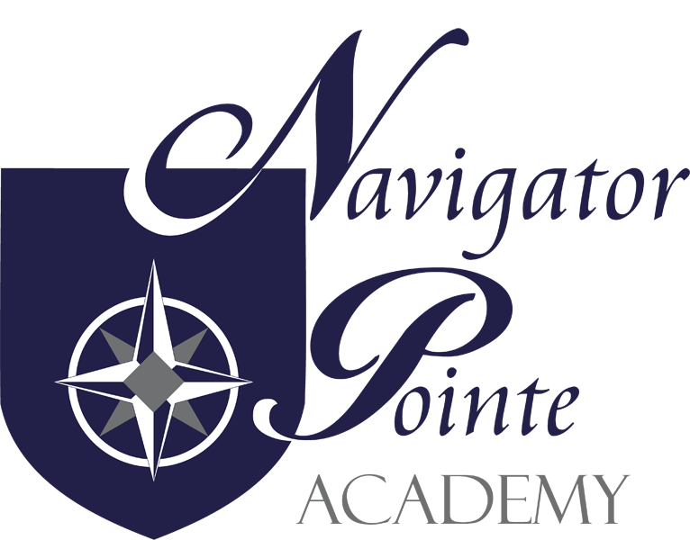
Governing Board Meeting
6844 South Navigator Drive West Jordan, Utah
THURSDAY, JANUARY 18, 2024 6:00 p.m. – 7:00 p.m.
Kristi Anderson
Jake Montague
Judy Farris
Rich Eccles
Tasha Thompson
I. Call to Order/Welcome 6:10 p.m.
II. Public Comment - None
III. NPA School Land Trust Council Meeting
- Finalizing School Trust Land Report for 2023
  - This is in process. Working on getting it finalized and sent in.
B. School Trust Lands Council
1. Training
a. Kristi will email a link
2. Calendar
a. We will have another meeting in February and July
3. 2024-2025 School Trust Land Plan
a. We will focus on the Early Literacy Plan we have been using as this is the greatest need. Jake made a motion to approve the 2024 School Trust Land Plan. Kristi seconded the motion. Roll Call: Jake – yes; Kristi – yes. Motion passed.
IV. NPA Governing Board Meeting
- Board Governance Training
  - Jake presented the board training from the book “Governing the Small School” by E. Brooke Carroll.
- Monthly Board Meeting Minutes Approval (Board action may be required)
  - Jake made the motion to approve the December 2023 Board Meeting minutes. Kristi seconded the motion. Roll Call: Jake – yes; Kristi – yes; Motion passed.
- NPA Audit Report (Board action may be required)
  - Tabled until February 2024 as Fernando Cruz wasn’t at board meeting tonight.
- Emergency School Closure Plan (Board action may be required)
  - The teachers and staff are working on putting together a packet of school work that can be used in case of a school closure. These packets will be sent home with each student. If we have an emergency school closure – the students can work on the papers in the packet and this will allow us to count the day as a school day instead of having to make up the school day later in the year.
- School Trust Lands Council Training, Calendar, 2024-25 Plan
  - Earlier in School Trust Lands Council we determined that Kristi will send out a link with the training videos. We will have a meeting again in February and another in July. Our greatest need is Literacy so we will be focusing on that again for the 2024-2025 school year.
F. “Closed Session, as necessary, to discuss allowed items” (Board action may be required)
V.. Director’s Report
A. Enrollment – 400 students currently. Targeting for 440-450 for the next school year. February 1st is the next lottery.
B. Volunteers – Had a very successful Books and Bears Service Project in December where there were a lot of volunteers. Didn’t have the numbers for board meeting. Teacher appreciation is coming up at the beginning of February and the teachers and staff are looking forward to that. FASSTeam has asked for donations and volunteers for the week long staff appreciation.
VI. Finance Report – Rich presented the December 2023 Board Finance Report.
- Jake made a motion to accept the December 2023 Board Finance Report. Kristi seconded the motion. Roll Call: Jake – yes; Kristi – yes. Motion passed.
VII. Next Meeting Schedule – next meeting will be on February 22 so that we won’t have PT Conferences and Board Meeting the same night.
VII. Adjourn at 7:17 p.m.

Notice: Virtual Meeting Only

