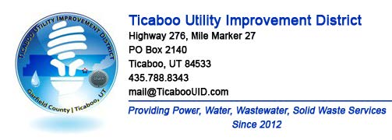
TICABOO UTILITY IMPROVEMENT DISTRICT
PUBLIC NOTICE SPECIAL MEETING Minutes
DATE: THURSDAY FEBRUARY 15TH 2024
TIME: 6:00 PM
LOCATION: Electronic Meeting
Pursuant to House Bill 5002, 'Open and Public Meetings Act Amendments,' passed during the 2020 Fifth Special Session of the Utah Legislature and codified under Utah Code Ann. § 52-4-207(4), I, Alexa Wilson, hereby make the following written determination in my capacity as Chair of the Board of Trustees of the Ticaboo Utility Improvement District warranting the TUID Board to convene and conduct electronic meetings without a proper anchor location:
AGENDA
1. Call Meeting to Order – Alexa Wilson called the meeting to order at 5:59 pm.
a. Roll Call of Board Members – Alexa Wilson called role and all board members were present.
2. Adoption of Agenda – Alexa Wilson asked for approval of the agenda, Amy Golden made the motion to approve, Mike Morlang 2nd and the agenda was approved unanimously.
3. Approval of minutes: Approval of minutes from 2/7/24 meeting- Alexa Wilson Wilson asked for approval of the 2/7 meeting minutes. Mike Morlang motioned to approve, Amy Golden 2nd and they were approved unanimously.
4. Review procedures for handling electronic participation by the public – Alexa Wilson reviewed public meeting procedures for electronic participation.
5. Public Comment -- TUID welcomes comments from the public. The Board sets aside 15 minutes at each Board meeting to hear from anyone wishing to speak. Each presenter is allowed one opportunity and has up to three (3) minutes for remarks. Any member of the public who desires to make a comment shall use the 'raise hand' feature during the Google Meet meeting. The public comment segment of the Board meeting is not the time for a question-and-answer discussion. TUID staff are available for dialogue outside of Board meetings. Jean Babilis commented/asked the question about a catastrophic equipment failure assessment plan. Alexa Wilson commented that Jean Babilis letter would be entered into public comment from the 2/7/24 meeting.
6. Vote on Fuel Surcharge implementation resolution from 2/7/24 public hearing. Alexa Wilson covered the resolution and exhibit for the proposed fuel surcharge and called for a motion to vote to adopt. Amy Golden made the motion, Alexa Wilson 2nd and a verbal call/vote was cast: Alexa Wilson, Yes. Amy Golden, Yes. Mike Morlang, Ney. The fuel surcharge resolution adoption passed via a 2-1 vote.
7. Adjournment - Alexa Wilson asked for a motion to adjourn the meeting, Mike Morlang made the motion to adjourn, Amy Golden 2nd and the meeting was adjourned at 6:13pm.

