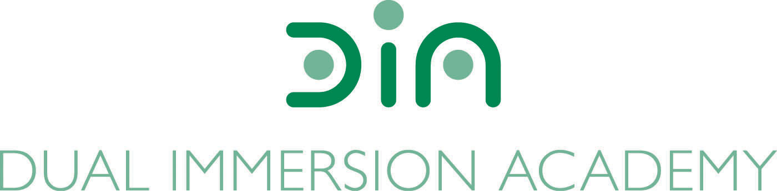

DIA Board of Directors Agenda
February 20, 2024
Dual Immersion Academy

Begin at 5:30 pm
In-person/Virtual
Roll Call

- Budget Report

- Facilities (update)

- Policy Audit

- Board Candidates/Membership by Teri Slaugh
  - Introduction of Potential Board Members

- Director’s Executive Report by Angela Fanjul

- Closed Session under UT 52-4-205 (as needed)
Re-open the meeting for board vote (as needed)

- Approval of minutes: January 16, 2024

- Motion to close the meeting

Conclude meeting by 7:00 pm

Next meeting:
Tuesday, March 19, 2024
At 5:30 pm

