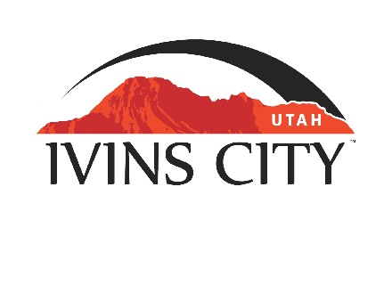
IVINS CITY

COUNCIL WORK MEETING

AGENDA

January 25, 2024

Mayor Chris Hart

City Council Members

Lance Anderson

Sharon Barton

Sharon Gillespie

Mike Scott

Kevin Smith

City Manager Dale Coulam

The Ivins City Council will hold a Joint Work Meeting with the City of Santa Clara in the Ivins City Council Chambers, 85 N. Main St., Ivins, UT, on Thursday, January 25, 2024. The meeting will begin at 5:30 P.M.

NOTICE: This meeting will be held in person and electronically. You may watch the live audio and video feed by going to www.ivins.com under “Upcoming Events”. When the meeting is live, it will reflect “In Progress” – click on the “In Progress” link to watch the meeting live. The Mayor and/or City Council Members may attend via telephone conference if they are unable to attend in person. The anchor location will be the Ivins City Council chambers located at 85 North Main Street, Ivins City, Utah 84738.

Note: The order of items discussed on this agenda is subject to change

- WELCOME AND CALL TO ORDER
- Acknowledgement of Quorum
- Disclosures

- WORK MEETING
- Discussion regarding Santa Clara Ivins Public Safety, Fire and EMS draft/proposed budgets for Fiscal Year Ending 2025

3) ADJOURNMENT

Reasonable accommodation: Ivins City will make efforts to provide reasonable accommodation to disabled members of the public in accessing City programs. Please contact the City Recorder at least 24 hours in advance if you have special needs.

I hereby certify that I have posted copies of the agenda in the following public and conspicuous places on January 19, 2024. Ivins City Hall, the Ivins Post Office, SCI Center Street Fire Station, Ivins City UNITY Park and Ivins City Animal Shelter. I have also sent a copy of this agenda to St. George News and posted it on the Utah Public Notice website.

Kari Jimenez, MMC
City Recorder

