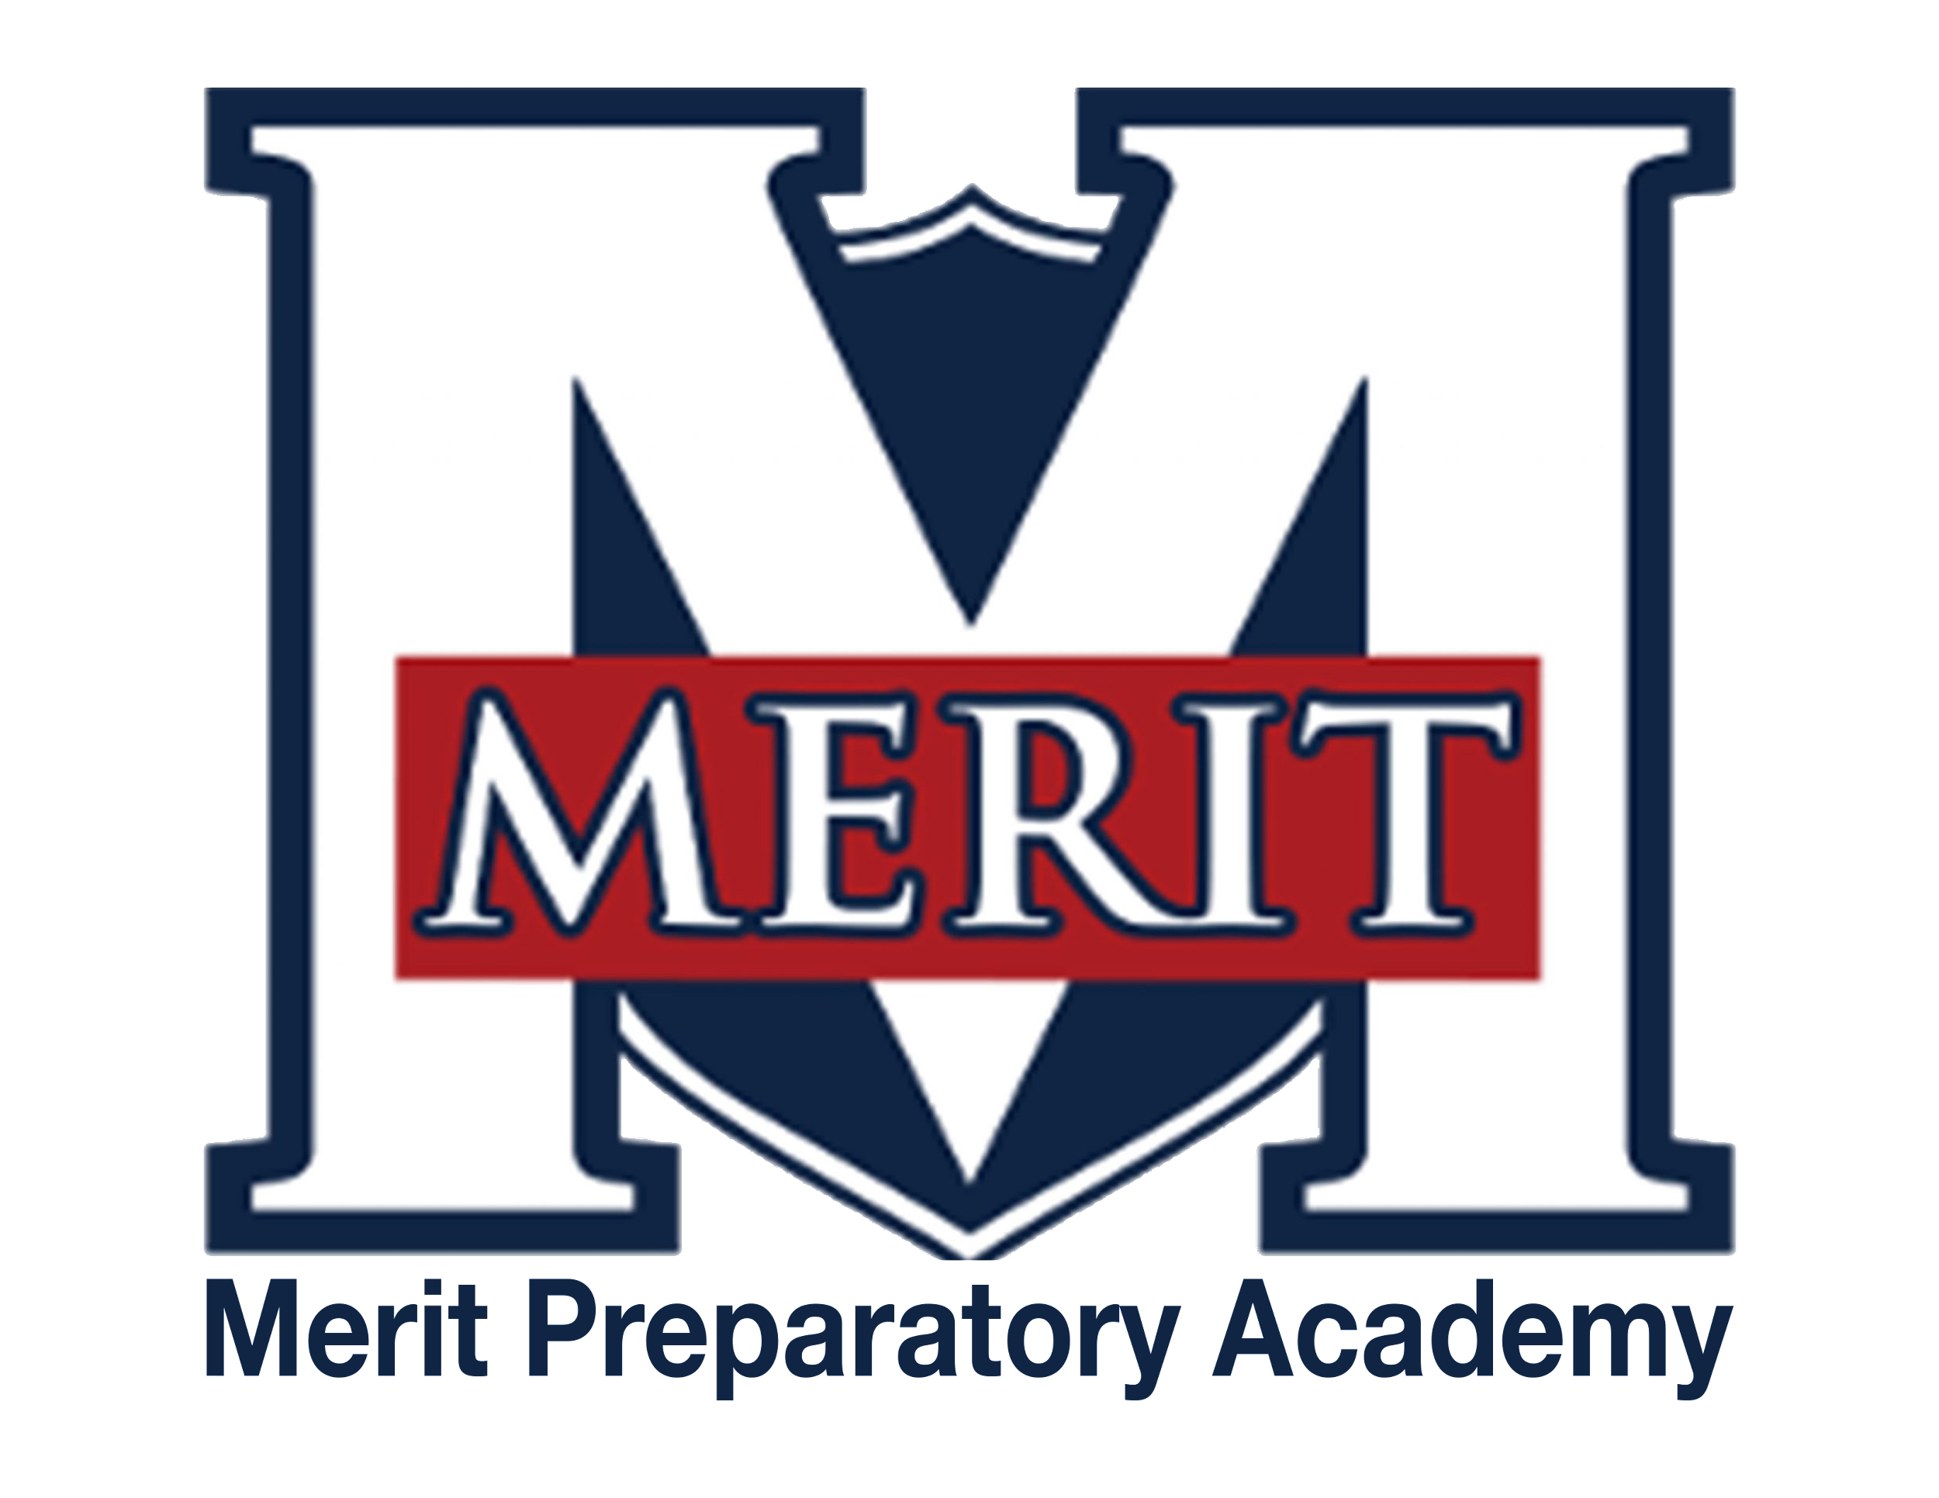
Merit Preparatory Academy
Board Meeting Minutes
January 12, 2024 at 4:30pm

Zoom link:
https://us06web.zoom.us/j/83733621736?pwd=QziEnCPng1Xa8UckFH7ToLWmdsNlkH.1

I. Welcome and Roll Call
- Meeting called to order at 4:35pm.
- Present from the board: Jeanne Condie, Angela Bunker, Rachel Jay, and Jeri Mellor

II. Action Items
- Vote to approve Special Education Policies and Procedures manual
  - Angela Bunker made a motion to approve, Jeri Mellor seconded the motion; all were in favor of approving the manual as written
- Vote to approve November 9, 2023 Board Meeting Minutes
  - Angela Bunker made a motion to approve, Jeri Mellor seconded the motion; all were in favor of approving the minutes as written
- Vote to approve December 13, 2023 Board Meeting Minutes
  - Angela Bunker made a motion to approve, Jeri Mellor seconded the motion; all were in favor of approving the minutes as written
- Vote to approve December 20, 2023 Board Meeting Minutes
  - Angela Bunker made a motion to approve, Jeri Mellor seconded the motion; all were in favor of approving the minutes as written
- Vote to approve 2024-25 academic calendar
  - Approving the calendar was tabled until the next meeting

III. Board Business
- Board member changes
  - Rozelle Hansen leaving the board
    - Rozelle was recognized at the January 11th board meeting and thanked for her work on the board
  - Policy committee changes
    - Brett Palmer has stepped down as the policy committee chair
    - Angela Bunker is proposed as the new policy committee chair
      - Jeri Mellor motions to approve, Rachel Jay seconds the motion; all are in favor

IV. Executive Session
- To discuss the character, professional competence, or physical or mental health of an individual.

V. Adjourn
- The meeting is adjourned at 4:40pm.

