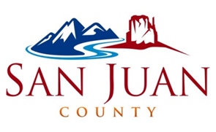

UTAH ELECTIONS
MARCH 5, 2024 PRESIDENTIAL PRIMARY ELECTION EARLY VOTING:
EARLY VOTING/ELECTION DAY LOCATIONS
Navajo Language Assistance will be available at Montezuma Creek, Monument Valley, Monticello, and Navajo Mountain. Ute Language Assistance will be available in White Mesa.

- Montezuma Creek Dine’ Building: February 5th, 12th, 19th, and the 26th, from 10:00 a.m. until 2:00 p.m.
- Monument Valley Welcome Center: February 6th, 13th, 20th, and the 27th from 10:00 a.m. until 2:00 p.m.
- Navajo Mountain Chapter House: February 7th, 14th, 21st, and the 28th, from 10:00 a.m. until 2:00 p.m.
- White Mesa Community Center: February 15th, 22nd, & the 29th from 10:00 a.m. to 2:00 p.m.
- Monticello Admin Building: February 9th, 16th, 23rd, & March 1st, from 10:00 a.m. until 2:00 p.m.

- March 5, Election Day 7:00 a.m. to 8:00 p.m.
For more information contact the San Juan County Clerk’s Office at (435) 587-3223 Ext: 4, or elections@sanjuancounty.org

