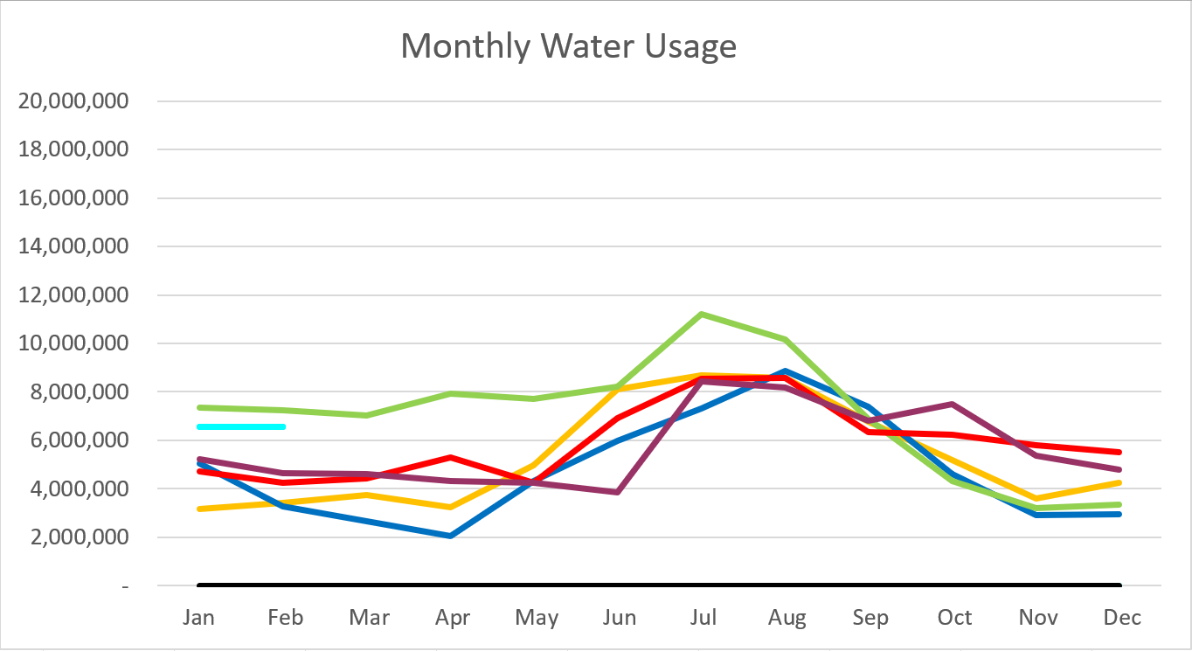

2024 – Light Blue 2023 – Purple
2022 – Red 2021 – Yellow
2020 – Blue 2019 – Green
January 2024

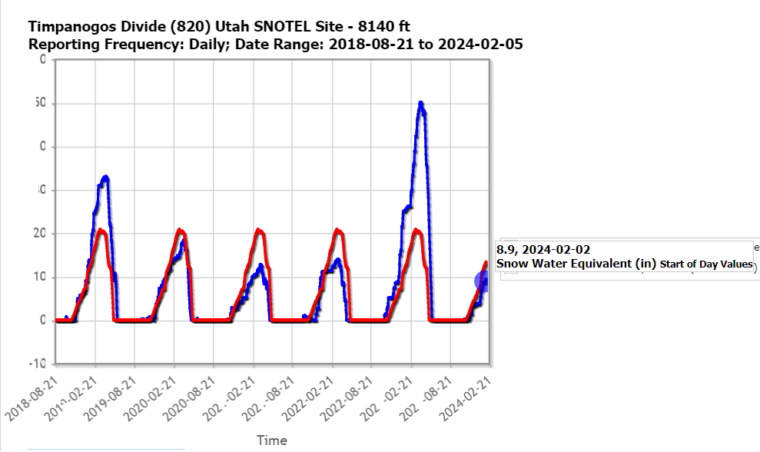

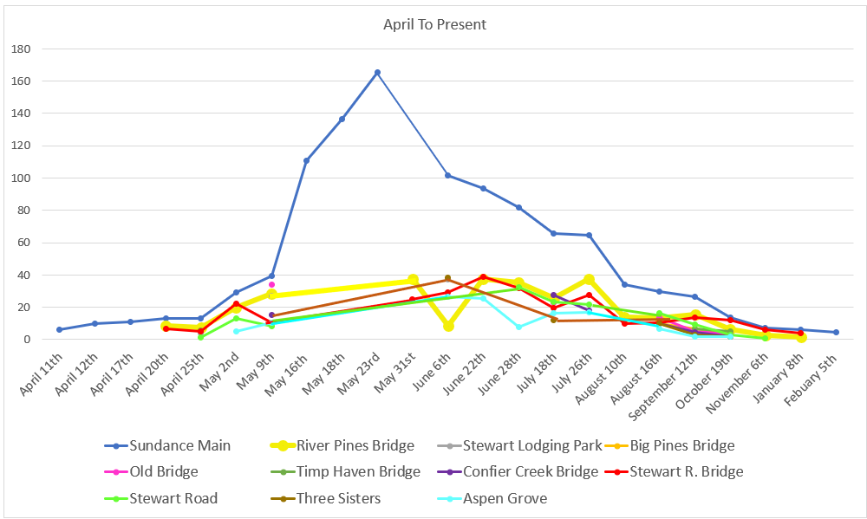
C
F
S

Water Department Information for January
- Our overall water consumption is higher compared to this time last year.
- Aspen Grove wet-well levels are averaging 5.9 feet for January 2024 which is a half a foot down from last month. This time last year for January 2023, our average was 4.6 feet. The average is higher this year compared to last.
- Stewart Spring is averaging 56.26 gpm for January 2024.This time last year it was averaging 0 gpm for January 2023.
- Stewart spring overflow is running just above 32 gpm for the month of January
- Unaccounted water
  - Upper Pressure Zone
  - Lower/Stewart Zone
- We have 100 meters on order.
- Infiltration Sampling has begun. Once a month for 6 months

Wastewater Department Information for January
- We have two labs for January. BOD and TSS were out of limits on the 9th of January. Rest were within limits.
- The Plant upgrade is moving forward.
- Working with Sundance to get the drain field radio back up and running.

Grease traps cleaned on Dec. 27th of 2023 and on Jan 28th of 2024.
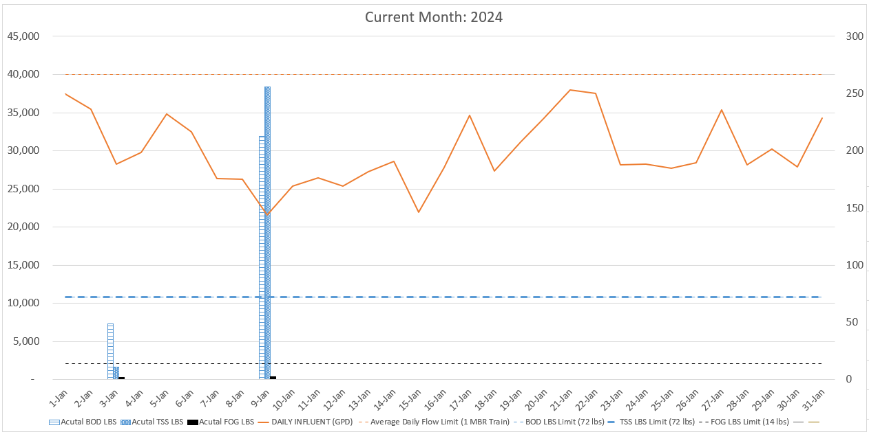

AVERAGE DAILY FLOW (GPD) | 29,888
HIGHEST DAILY FLOW (GPD) | 37,937

