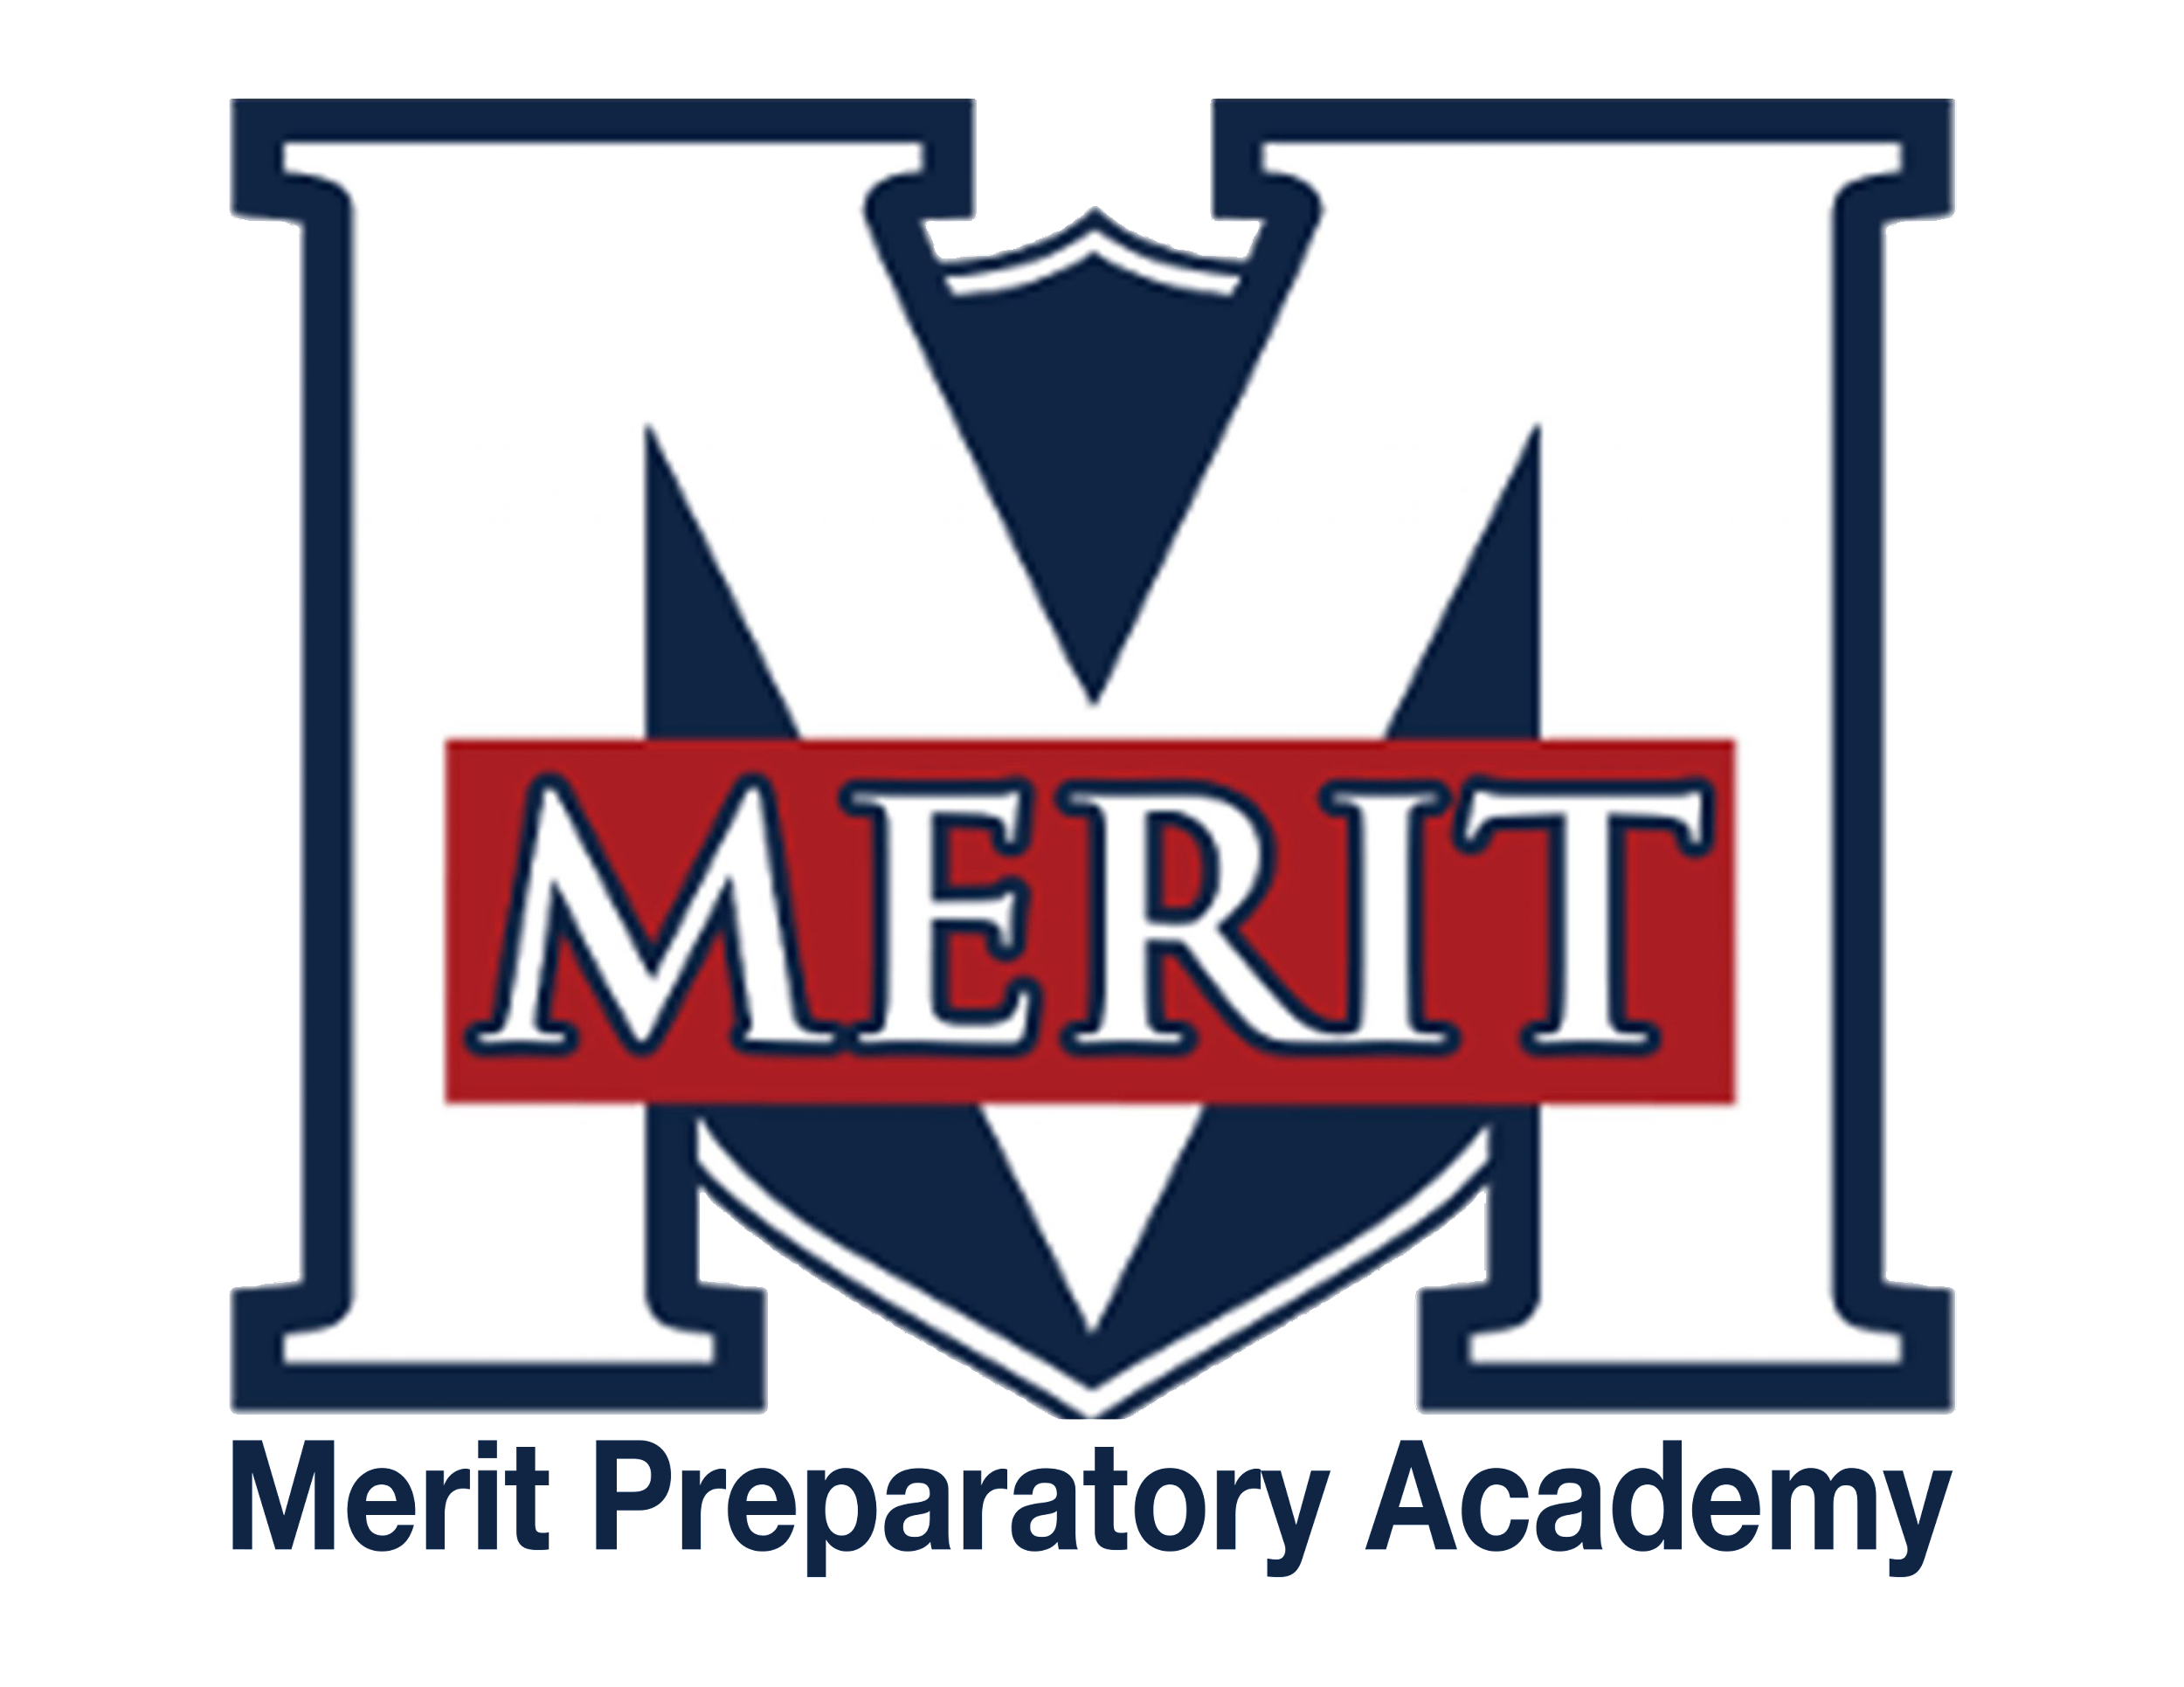
PENDING APPROVAL
Merit Preparatory Academy
Board Meeting Minutes
December 13, 2023 at 8:30pm

Zoom link: https://us06web.zoom.us/j/81898568624?pwd=BtNPLYk7Ra69S6nM5VlnjdGbG4aQjy.1

I. Welcome and Roll Call
- Called to order at 8:38pm
- Present on Zoom: Jeanne Condie, Brett Palmer, Angela Bunker, Amy Wiser, Jeri Mellor, Rozelle Hansen, Rachel Jay
- Angela motioned to go into executive session, Rozelle seconded; Brett- yes, Rachel-yes, Amy-yes, Jeri-yes, Angela-yes, Rozelle-yes, Jeanne-yes
II. Executive Session
- To discuss the character, professional competence, or physical or mental health of an individual.
- Executive session ended and the board voted to take action on items discussed in executive session
  - Rozelle-yes, Rachel-yes, Angela-yes, Amy-yes, Brett-yes, Jeanne-yes

III. Adjourn
- Adjourned at 9:48pm

