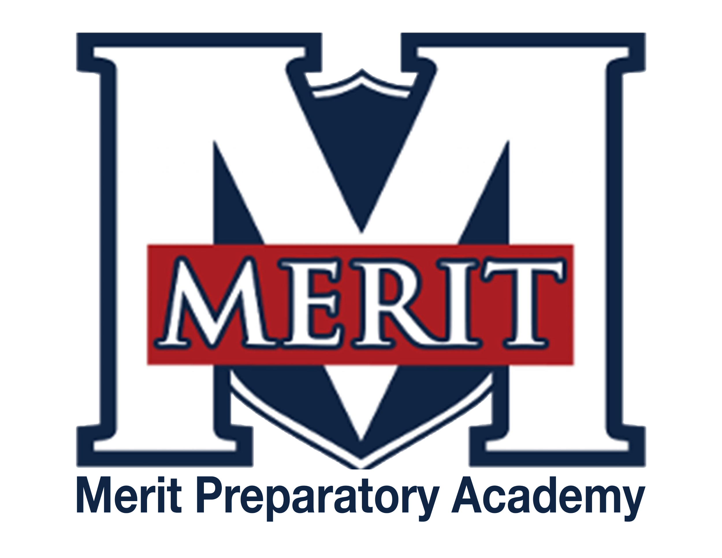
PENDING APPROVAL
Merit Preparatory Academy
Board Meeting Minutes
December 20, 2023 at 8:45pm

Zoom link:
https://us06web.zoom.us/j/86937455960?pwd=9kmzaO7udyEdbpSC00kq1aPUuUxufN.1

I. Welcome and Roll Call
- Meeting called to order at 8:52pm
- Present on Zoom from the board: Jeanne Condie, Brett Palmer, Jeri Mellor, Angela Bunker
- Excused from the meeting: Amy Wiser, Rachel Jay, and Rozelle Hansen
- Angela motioned to go into executive session; Jeri seconded
- By-name vote: Angela-yes, Jeri-yes, Brett-yes, Jeanne-yes

II. Executive Session
- To discuss the character, professional competence, or physical or mental health of an individual.

III. Adjourn
- Meeting adjourned at 9:33pm

