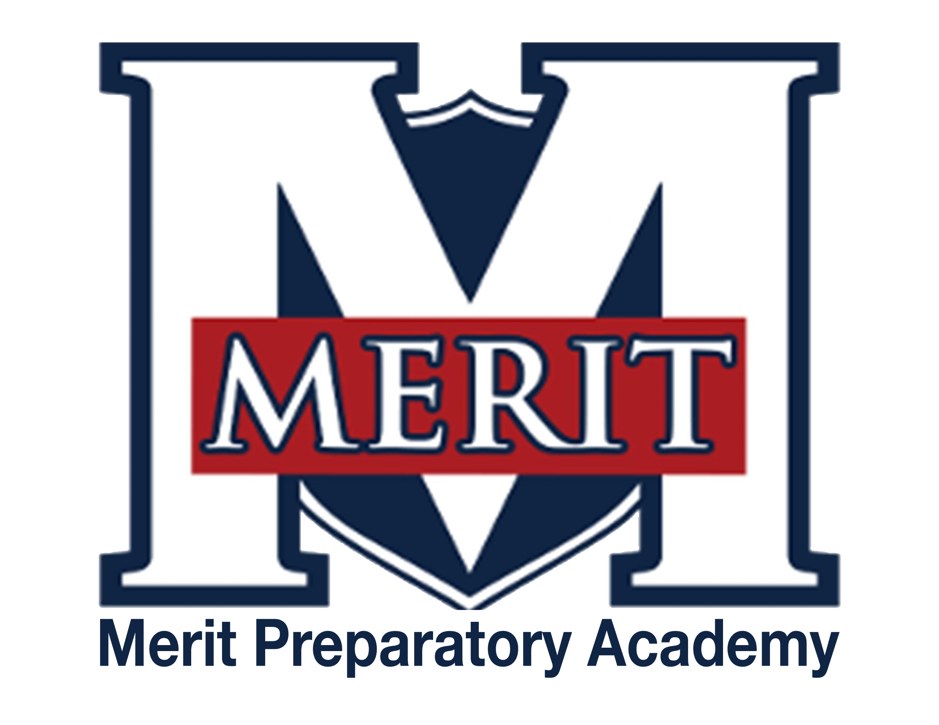
Merit Preparatory Academy
Board Meeting Agenda
February 8, 2024 at 6:30pm
Meeting at 1440 W. Center Street, Room 219

Join us on Zoom:
https://us06web.zoom.us/j/85443532051?pwd=0sbUj81v0fpR2ovEHlBJC2N8s18rMr.1

I. Welcome, Roll Call and Pledge

II. Good News from Around the School
- Meritorious Knight awards for January and February– Mike Condie
- MVP report– Sarah Jones
- Student Life report

III. Reports-
Fiscal and Enrollment Responsibilities
- Finance Report
  - Casey Holmes from Red Apple Financial
  - Finance Committee report– Rachel Jay

- Marketing and Quest Time Reports
  - Rozelle Hansen
  - Jeri Mellor

Academic Outcomes and Other Strategic Plan Areas
- Director Report
  - Mike Condie
    - Attendance enforcement
    - PLC report
    - Land Trust review
      - Vote needed?
      - Change contacts on SLT website
    - Annual board calendar items

Charter Fidelity & Adherence to Statute, Rule & Policy
- Enrollment capacity update
  - David Wiseman input
  - New re-enrollment procedure from year to year
- Discuss volunteer hours for Merit families
  - Find volunteer policy
- Policy Committee– Angela Bunker
  - Heidi Bingham and Amy Allen joining committee
  - Approve two policies
  - Cell phone policy discussion continued
- Accreditation Report– Angela Bunker

IV. Public comment- 15 minutes
As per Board procedure, public comment will be limited to 3 minutes per person. Anyone who would like to make a public comment will need to sign up prior to the start of the public comment period. Grievances, complaints, or concerns with individual employees or board members will not be allowed during this time as they must be dealt with by following the Conflict Resolution Policy process, and defamatory statements regarding any individual will not be allowed during an open public meeting.

V. Action Items
- Vote to approve LEA specific license for Kenon Dohman
- Vote to approve January 11, 2024 Board Meeting Minutes
- Vote to approve January 12, 2024 Board Meeting Minutes
- Vote to approve 2024-25 academic calendar

VI. Board Business
- Board Calendar
  - The next board meeting will be held on March 14, 2024, at 6:30pm in Merit 219.
  - Board members are responsible to attend the end of year knighting ceremony on May 22, 2024 at 8:30am, and graduation on May 23, 2024 at 4pm

VII. Executive Session
- To discuss the character, professional competence, or physical or mental health of an individual.
  - Possible Action from Executive Session

VII. Adjourn

