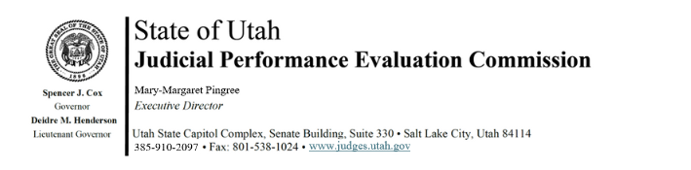

Judicial Performance Evaluation Commission
AGENDA
Tuesday, February 6, 2024
8:30 am-12 noon
Hybrid Meeting *

Members: Mallory Bateman, Christine Durham, Sherrie Hayashi, Blair Hodson, Rick Hoffman, James C. Jenkins, Curtis M. Jensen, David J. Jordan, Sonya Martinez-Ortiz, Gil A. Miller, Bridget Romano, Tom Ross, Shannon Sebahar

Staff: Madison Klein, Chris Russell, Mary-Margaret Pingree, Jason Mata, Chris Pieper (Attorney General’s Office)

8:30 a.m. Welcome Gil Miller
Approval of Minutes – January 23, 2024

8:35 Announcements Mary-Margaret Pingree

8:45 2024 Retention Evaluations Madison Klein
Closed Session Chris Russell

10:00 Break

10:15 2024 Retention Evaluations, continued Chris Russell
Closed Session

12 noon Adjourn

Next Meeting: Tuesday, February 20, 2024
8:30 a.m. – noon
CCJJ Conference Room, Senate Building Suite 330

*Anchor Location: CCJJ Conference Room, Senate Building Suite 330

