MINUTES
Weber School Foundation Board Meeting
12/14/2023 12:00 PM | Meeting held at Weber School District Office and called to order by Jeremy Dunn

Attendance
Present: Craig Adams, Dave Andersen, Jenna Andrascik, Barry Beus, Tyler Buxton, Michelle Darrington, Craig Dearden, Tony Divino, Scott Dixon, Jeremy Dunn, Jamie Ellison, Bryan Hurst, Brett Karras, Steve Kier, Ashley Loftus, Clyde Moore, Ryan Olsen, Emily Oyler, Kathy Saunders, Josh Skidmore & Angie Towns
Excused: Mark Adams, Matt Bell, Bryan Benard, Lindee Bess, Dave Broadbent, Jan Burrell, Gina Butters, Flora Cassity, Jen Dunyon, Kori Ann Edwards, Kimberli Green, Branden Hansen, Rich Hendrickson, Matt Jensen, Phill Swanson, Jennie Taylor & Kerry Wahlen
Guests: Tammy Kier, Keri Meyerhoffer, Tiffany Daniels, Julie Dixon & Jessica Peterson

Welcome
President-Elect Jeremy Dunn welcomed everyone to our Holiday Luncheon and thanked the Foundation team and everyone for their amazing work on Christmas Tree Jubilee this year!

Approval of Minutes
Craig Adams made a motion to approve the minutes from the October 19, 2023 meeting with a second from Kathy Saunders. The minutes were unanimously approved.

Committee Reports
Special Needs—Michelle Darrington reported since our last meeting we have received seven Special Needs Requests. Six requests are for Ipads with Touch Chat Apps and one request is from Early Intervention for a Tomato Chair with a Mobile Base. These requests total $5,639.95. Steve Kier made the motion to approve these projects with a second from Jeremy Dunn. The board unanimously approved.
Finance/Audit Report-Craig Adams reported that November was a great month! Our investments were up 8%.

Director’s Report
Sub for Santa-The Weber School District-District Office holds a Sub for Santa Luncheon each year where employees donate money for employees who are in need and the Foundation matches that amount raised. Assistant Superintendent’s Dave Hales and Clyde Moore talked about some families we will be able to help with this money. We are so grateful for everyone’s generosity!
Jubilee Committee Recognition’s-Emily and Michelle recognized Jubilee Committee Members: Keri Meyerhoffer, Tiffany Daniels, Julie Dixon, Jessica Peterson, Jenna Andrascik, Jeremy Dunn & Kim Skidmore for all of their hard work and dedication with Jubilee.
We had almost 300 volunteers with eight schools helping at Jubilee this year!

CTJ Recap & Feedback-
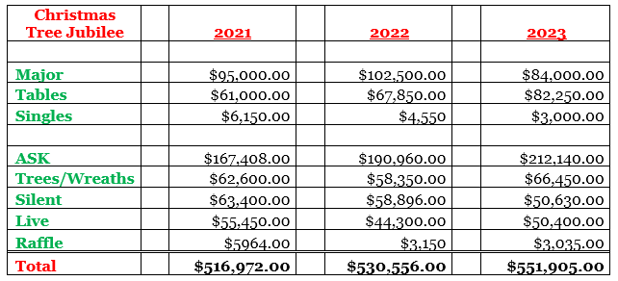
This was our BEST YEAR EVER! We also sold two additional Live Auction packages this year!
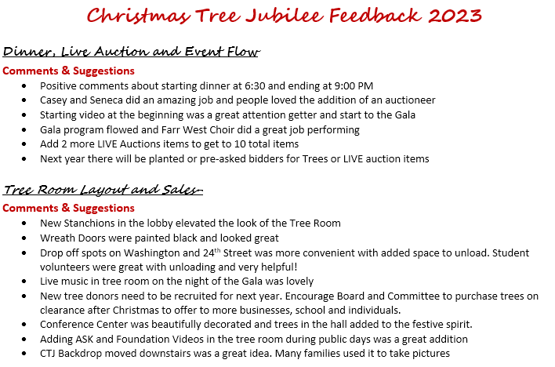
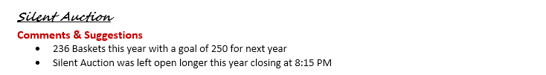
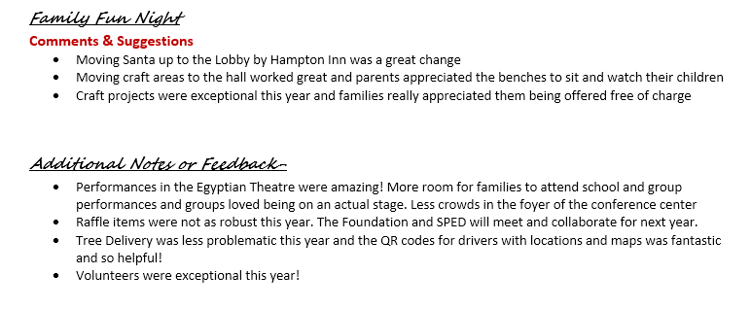
Performance by Roy High Chamber Choir-
Other Items-None

Next Meeting
January 18, 2024

