SALT LAKE VALLEY LAW ENFORCEMENT SERVICE AREA
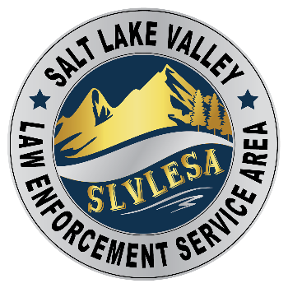
3365 SOUTH 900 WEST, SALT LAKE CITY, UT 84119 (385) 468-9662

NOTICE OF MEETING OF THE BOARD OF TRUSTEES OF THE
SALT LAKE VALLEY LAW ENFORCEMENT SERVICE AREA
(SLVLESA)

Thursday, January 18, 2024, at 10:00 a.m.
at the Salt Lake County Sheriff and Unified Police Department Building,
3365 South 900 West, Room 115, Salt Lake City, UT 84119

The SLVLESA Board of Trustees will hold a meeting on Thursday, January 18, 2024, at 10:00 a.m. at the Salt Lake County Sheriff and Unified Police Department Building, 3365 South 900 West, Room 115, Salt Lake City, Utah 84119. Members of the Board may be present in person or participate electronically.

The public may physically attend and monitor the open portions of the meeting. Members of the public may also join the open portions of the meeting by calling 1-720 707-2699 and entering Meeting ID 92301763844# and Password 259919#. The public will be allowed to listen to all open portions of the meeting. Public comment will be allowed during the Public Comment portion of the meeting which will start no sooner than 10:00 a.m. For those participating by phone, please mute your phone when you are not making public comment.

Reasonable accommodations (including auxiliary communicative aids and services) may be provided upon receipt of a request with at least three working days’ notice. For assistance, please contact Marcie Kay, SLVLESA Clerk, MKay@updsl.org or by calling (385) 468-9662. TTY users should call 711.
Board members and persons participating by phone will be able to hear all discussions.

AGENDA

1. Call to Order.

2. Public Comment.
This is a time for members of the public to comment to the Board on any issue regarding SLVLESA. For those participating electronically, the SLVLESA clerk will need to take calls in an orderly manner. The SLVLESA clerk will advise a caller when it is the caller’s turn to speak. Callers should have their call on the mute function until it is their turn to speak. Comments will be limited to 3 minutes.

3. Appoint 2024 Board Chair and Vice Chair.
Presenter: Rachel Anderson, SLVLESA Administrator and Legal Counsel.
Estimated Time for Item: 2 minutes.
Action Required: Motion, Second, and Vote for each position.

4. Approve Minutes for the November 16, 2023, and December 21, 2023 Board Meetings.
Presenter: Rachel Anderson, SLVLESA Administrator and Legal Counsel.
Estimated Time for item: 2 minutes.
Action Required: Motion, Second, and Vote.

5. Present Expenditures for the Month of December 2023, and Other Financial Information.
Presenter: Richard Moon, SLVLESA Treasurer.
Estimated Time for item: 2 minutes.
Action Required: Motion, Second, and Vote.

6. District Administrator Report.
Presenter: Rachel Anderson, SLVLESA Administrator and Legal Counsel
Estimated Time for Item: 5 minutes.
- Update on funding requests for southwest canyons. (No action required).
- Update on legislation/lobbyist contract. (Potential action).

7. Presentation From Salt Lake County Sheriff’s Office on Proposed Service Contract.
Presenter: Sheriff Rosie Rivera.
Estimated Time for item: 15 minutes.
No Action Required.

8. Update on the Unified Police Department.
Presenter: UPD Sheriff Rosie Rivera.
Estimated Time for item: 5 minutes.

9. Adjourn.

I certify that on January 16, 2024, the following notice was provided:

This notice was posted to the Utah Government Transparency Website.
This notice was posted to the Salt Lake Valley Law Enforcement Service Area Website.
A copy of this notice was mailed electronically to the Salt Lake Tribune and the Deseret News.
A copy of this notice was posted at the Salt Lake County Sheriff and Unified Police Department Building.

/s/________________________________________
Marcie Kay, SLVLESA Clerk

