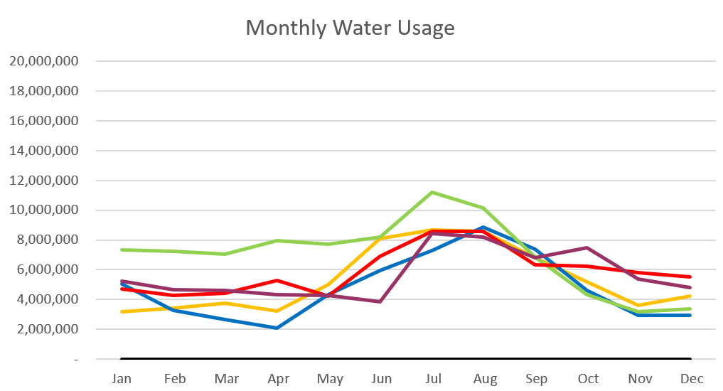

2023 – Purple
2022 – Red 2021 – Yellow
2020 – Blue 2019 – Green

December 2023

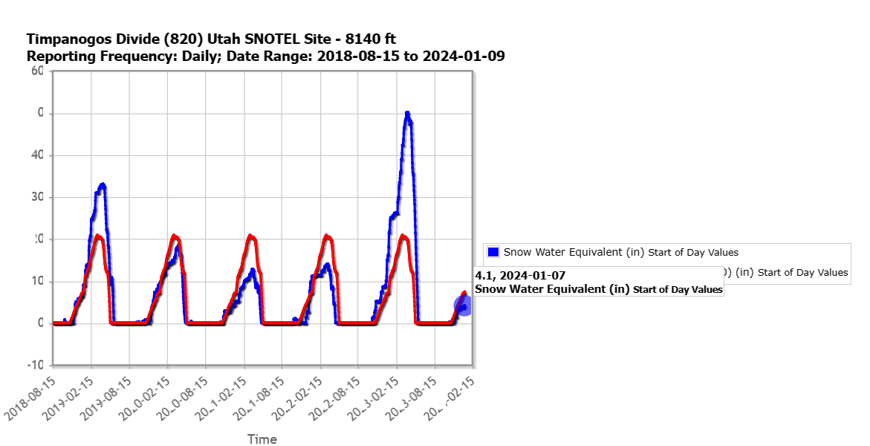

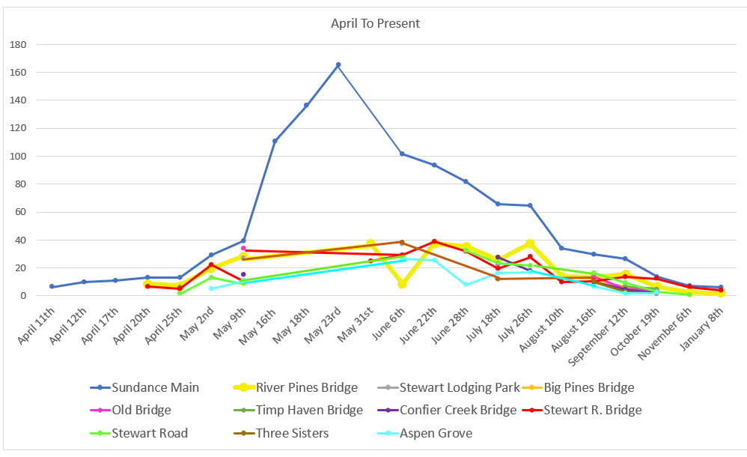
C
F
S

Water Department Information for December
- Our overall water consumption is lower than compared to this time last year.
- Aspen Grove wet-well levels are averaging 6.6 feet for December 2023 which is less than a foot down from last month. This time last year for December 2022, our average was 4.9 feet. The average is higher this year compared to last.
- Stewart Spring is averaging 76.5 gpm for December 2023.This time last year it was averaging 0 gpm for December.
- Installed an overflow meter at Stewart spring in mid Dec. Its reading as of January 8th was 1.7 million gallons.
- Unaccounted water
  - Upper Pressure Zone
  - Lower/Stewart Zone
    - Our team has been replacing meters as we get them in. Doing a fantastic job! We are starting to put in cellular endpoints as we get them.
- Infiltration Sampling 3 months in. 3 more to go.

Wastewater Department Information for December
- We have two labs for December. All was within limits.
- The Plant upgrade is moving forward 90 percent drawings will be looked at soon.
- Working with Sundance to get the drain field radio back up and running.
- A permeate pump went out. We replaced the pump, but we are still having an electrical issue the starter and thermo-breaker are outdated. We did find a thermos-breaker and are hoping that will fix the issue. If not, we will need to find a starter.

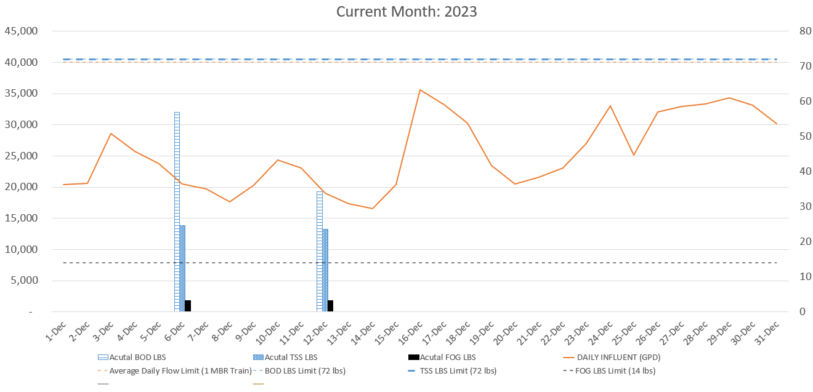

AVERAGE DAILY FLOW (GPD) | 25,385
HIGHEST DAILY FLOW (GPD) | 35,562

