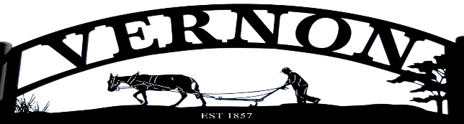

PUBLIC NOTICE
NOTICE IS HEREBY GIVEN THAT THE VERNON TOWN COUCIL will hold a Public Hearing and Public Regular Meeting on January 4, 2024 at 7:00 PM at the Vernon Fire Station 325 South Main Street Vernon UT 84080.
First Public Hearing COMMUNITY DEVELOPMENT BLOCK GRANT (CDBG)

- COMMUNITY DEVELOPMENT BLOCK GRANT (CDBG)
Mayor John Olson Read into record:
COMMUNITY DEVELOPMENT BLOCK GRANT (CDBG)
FIRST PUBLIC HEARING NOTICE
Notice is hereby given that VERNON TOWN will hold a public hearing on January 4, 2024 at 325 Main Street Vernon, Utah, 84080 at 7:00PM. VERNON TOWN is eligible to apply to the Utah Department of Workforce Services for funding under the Community Development Block Grant (CDBG) Small Cities Program, a federally funded program administered by the State of Utah, Housing and Community Development Division (HCD). VERNON TOWN is eligible to apply for CDBG funding provided VERNON TOWN meets the applicable program requirements. The purpose of the public hearing is to provide citizens with pertinent information about the Community Development Block Grant program and to allow for discussion of possible applications. This public hearing will cover eligible activities, program requirements, and expected funding allocations in the region. The CDBG Program can fund a broad range of activities, including, but not limited to: construction of public works and facilities, e.g., water and sewer lines, fire stations, acquisition of real property, and provision of public services such as food banks or homeless shelters. In the event that VERNON TOWN chooses to apply for CDBG funding, a second public hearing will be held at a later time to discuss the project. Further information can be obtained by contacting Melinda Johnson at 435-843-8222 or Mayor John Olson at 435-830-9186. In compliance with the Americans with Disabilities Act, individuals needing special accommodations (including auxiliary communicative aids and services) during this hearing should notify Nicole Hillman at 325 Main Street Vernon, Utah, 84080 at least three days prior to the hearing. Individuals with speech and/or hearing impairments may call the Relay Utah by dialing 711. Spanish Relay Utah: 1.888.346.3162.
Mayor Olson Opened public comments.
- Public Comments- Rick Shumway- Asked will these funds be Delegated for the Roads?
Mayor John Olson- At this time the funds have not been delegated to one project.
Mayor John Olson- If no further comments we will close the public comment Section.
Public comments Closed.
- Adjourn- All in favor non-opposed.

