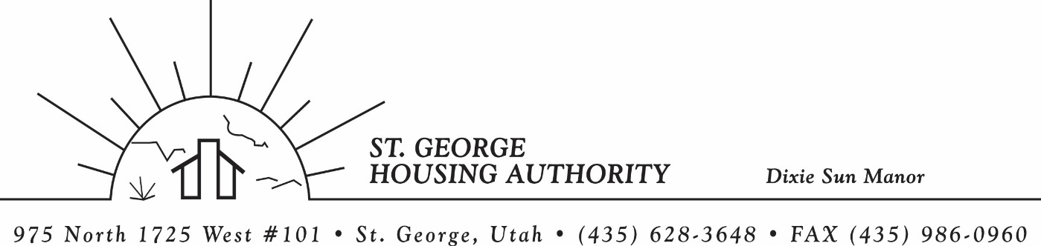
BOARD MEETING
DIXIE SUN MANOR 975 N. 1725 W. # 101
Tuesday December 12, 2023

PRESENT: Mike Barben, Greg Whitehead, Kenny Miller, Gloria Shakespeare, Tom Cover, Jane Fehrenbacher.

EXCUSED: Jimmie Hughes

MINUTES: Minutes of Board Meeting held November 14, 2023 were reviewed. Motion made by Tom Cover to approve minutes as reviewed, motion seconded by Gloria Shakespeare. Motion carried.

Review Housing Assistance Report for November 2023: Mike Barben handed out the HAP reports for December 2023. Board members were able to see the money spent for the months on rental assistance, see the average unit cost, and verify the units leased for the month. The board was also able to ask questions and have a discussion about portability, C of C, VASH, EHV, & Mainstream Vouchers. Each board member present signed off on the HAP payments and month end totals.

Review current 2023-2024 budget: Mike Barben handed the board a copy of the fiscal year 2023-2024 SGHA budget. The board was able to see how the SGHA is doing in the current fiscal year budget. Mike reported that for the most part, SGHA was right on budget, and let the board ask questions on any of the items on the report. The board has asked Mike to provide and present the most recent budget accounts at each board meeting. By providing the current budget monthly, the board can see how the SGHA is keeping up with the current budget throughout the whole year. The board thought it would be great to ask questions and be on top of what the SGHA is doing financially. Greg Whitehead asked Mike if he could break the budget down into separate programs to verify which programs are doing well and which ones are needing help.

Utah NAHRO Conference 2024: Mike Barben reported that he is no longer the President of Utah NAHRO after his 2 years of service. Mike reported that Kim Wolford is the President for the next 2 years. Mike reported that the 2024 Conference will be in St. George April 25-26. Mike asked any board members who would want to come. About half of the board members were interested and want to come.

Jane Fehrenbacker report on DSM: Jane reported that DSM is doing very well. Jane mentioned that they had a great Thanksgiving potluck dinner and are looking forward to the DSM Christmas pot luck on the 19th of December. Jane invited all board members and their wives to come. Mike said he would send out a reminder text as some of the board members are interested in coming. Jane said all the residents are very happy. Jane said DSM is a great place to live and call home.

Report from Jimmie Hughes on City of St. George: Jimmie Hughes was excused from the meeting.

SGHA employee end of year performance / Incentive: Mike Barben reported that it was time again for SGHA employee year end performance evaluations. Mike showed on the budget that monies had been set aside for incentive and performance bonuses. The board suggested to Mike that he be in charge of the performance bonuses based on the past year’s employees work ethic, being on task, and fulfilling all work responsibilities. Tom cover made the motion to approve the bonuses and Kenny Miller seconded the motion. Motion carried. Mike agreed to spread out the bonuses fairly and award employees accordingly.

Motion made by Greg Whitehead to close the meeting. Kenny Miller seconded the motion. Motion carried. Meeting adjourned at 9:15 a.m. Next board meeting will be January 9, 2024 at 8:30 am.

