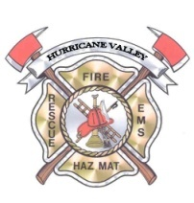
Hurricane Valley Fire
Special Services District
202 East State Street, Hurricane, Utah 84737
(435) 635-9562

NOTICE OF MEETING CANCELLATION
Notice is hereby given that the regularly scheduled
HURRICANE VALLEY FIRE SPECIAL SERVICES DISTRICT
BOARD MEETING
For TUESDAY, JANUARY 2, 2024
Has been
CANCELED

