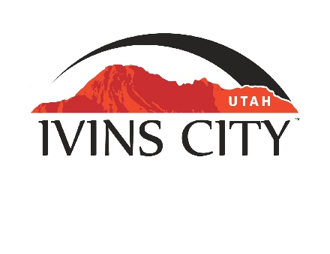
IVINS CITY

COUNCIL MEETING

*AMENDED AGENDA

December 21, 2023

Mayor Chris Hart

City Council Members

Lance Anderson

Jenny Johnson

Dennis Mehr

Adel Murphy

Mike Scott

City Manager/Attorney:

Dale Coulam

The Ivins City Council will hold a regular meeting in the City Council Chambers, 85 N. Main St., Ivins, UT, on Thursday, December 21, 2023. The meeting will begin at 5:30 P.M.

NOTICE: This meeting will be held in person and electronically. You may watch the live audio and video feed by going to www.ivins.com under “Upcoming Events”. When the meeting is live, it will reflect “In Progress” – click on the “In Progress” link to watch the meeting live. The Mayor and/or City Council Members may attend via telephone conference if they are unable to attend in person. The anchor location will be the Ivins City Council chambers located at 85 North Main Street, Ivins City, Utah 84738.

The link for Public Hearing electronic participation is: https://us02web.zoom.us/j/88517601996

Note: The order of items discussed on this amended agenda is subject to change
The order of agenda items has been re-arranged.

- WELCOME AND CALL TO ORDER
- Acknowledgement of Quorum
- Flag Salute
- Invocation
- Disclosures

- REPORTS, PRESENTATIONS AND APPOINTMENTS
- Washington County Solid Waste District Report – Cheyne McDonald
- Department Reports: Building Department; Public Works/Engineering; Finance
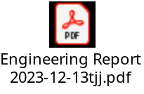
- Planning Commission Report

- CITIZEN REQUEST FOR FUTURE AGENDA ITEMS REGARDING ORDINANCES, POLICIES OR OTHER LEGISLATIVE ITEMS
Any person wishing to bring a legislative item not otherwise on the Agenda to the attention of the Mayor and City Council may address the City Council at this point by stepping to the microphone and giving their name and address for the record. Citizen Request for Future Agenda Item forms should be filled out in advance and given to the City Recorder. Remarks should be limited to no more than two minutes, unless the Governing Body allocates additional time. The Mayor and City Council will take no action this evening.

- PUBLIC HEARING AND ACTION ITEMS
- Public Hearing on the Planning Commission’s recommendation to deny a Land Use Amendment from MDR (Medium-Density Residential) to HDR (High-Density Residential) and a Zone Amendment from RE-12.5 (Residential Estates, minimum lot size 12,500 sq ft) to R-M (Residential Multi-Family) and instead recommends approval of a Zone Amendment to R-1-7.5 (Residential Single Family, minimum lot size 7,500 sq ft) on approximately 1.97 acres, located approximately on the corner of Main Street and 200 South

- Discuss and consider approval of Ordinance No. 2023-31, an Ordinance of Ivins City, Utah, denying a proposed concurrent Land Use Amendment from MDR (Medium-Density Residential) to HDR (High-Density Residential) and a proposed Zone Amendment from RE-12.5 (Residential Estates, minimum lot size 12,500 sq ft) to R-M (Residential Multi-Family) and instead approving a Zone Amendment from RE-12.5 to R-1-7.5 (Residential Single Family, minimum lot size 7,500 sq ft) on approximately 1.97 acres located at approximately Main Street and 200 South
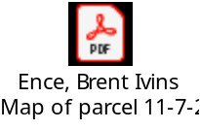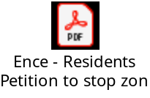
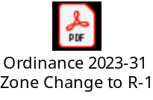

- DISCUSSION AND POTENTIAL ACTION ITEMS
- Discussion regarding the Planning Commission’s recommendations on updating the General Plan

- Discuss and consider approval of Resolution No. 2023-16R, a Resolution of Ivins City, Utah, approving a Second Amendment to the Governing Document of Black Desert Public Infrastructure District and a Second Amendment to the Interlocal Agreement related thereto; and Related Matters
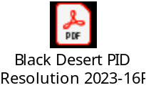
- Discuss and consider approval of the Planning Commission’s recommendation on the Retreat at Snow Canyon Preliminary Plan, (west of West), located at approximately Puerto Drive and 400 South. SITLA-Owner. Jerry Miyahara-Applicant

- Discuss and consider approval of Ordinance No. 2023-30, an Ordinance of Ivins City, Utah, amending Section 11.03.112(1) of the Ivins City Code regarding Burial Vaults

- Discuss and consider approval of expenditure for crack seal maintenance
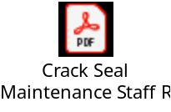
- Discussion regarding the Proposed Santa Clara Annexation Policy Plan
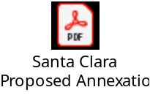

6) CONSENT AGENDA
- Approval of City Council Meeting Minutes for December 7, 2023
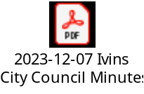

7) CONSENT AGENDA ITEMS FOR DISCUSSION

8) REPORTS
- Council
- Mayor
- City Manager/Attorney Dale Coulam
- Items to be placed on future agendas

9) CLOSED MEETING

10) ADJOURNMENT

Reasonable accommodation: Ivins City will make efforts to provide reasonable accommodation to disabled members of the public in accessing City programs. Please contact the City Recorder at least 24 hours in advance if you have special needs.
I hereby certify that I have posted copies of the amended agenda in the following public and conspicuous places on December 20, 2023. Ivins City Hall, the Ivins Post Office, SCI Center Street Fire Station, Ivins City UNITY Park and Ivins City Animal Shelter. I have also sent a copy of this agenda to The Spectrum, St. George News and posted it on the Utah Public Notice website.

Kari D. Jimenez, MMC
City Recorder

