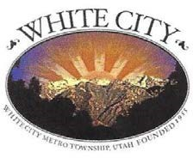
WHITE CITY METRO TOWNSHIP 2023 MUNICIPAL GENERAL ELECTION
CANVASS REPORT

I, Rori L. Andreason, the duly chosen, qualified and acting City Administrator for White City Metro Township, Salt Lake County, State of Utah, certify the following is a true, correct summary of the Canvass Report for the November 21, 2023, Municipal General Election as approved by the Board of Canvassers for White City Metro Township, Utah, on December 6, 2023:

COUNCIL MEMBERS AT-LARGE (4-Year Terms)
Candidate Votes Received
Paulina F. Flint 579
Greg Shelton 558
Tyler Huish 448
Howard F. Van Horn II 375
Nick West 252

Dated this 22nd day of December 2023.
Rori L. Andreason, White City Administrator

