Utah County Community Reinvestment
Agency Notice 2023 - 1236

NOTICE OF PUBLIC HEARING

In accordance with the Limited Purpose Local Government Entities—Community Reinvestment Act, Utah Code, Title 17C (“Community Reinvestment Act”), the Utah County Community Reinvestment Agency will hold a public hearing on Wednesday, January 17, 2024, at 2:00 PM at the Utah County Administration Building, 100 East Center Street, Room 1400, Provo, Utah, to consider the adoption of the official project area budget for the Community Reinvestment Project Area.

The Utah County Community Reinvestment Agency has requested approximately $61,452,000 in property tax revenues that will be generated by development within the Community Reinvestment Project Area to fund a portion of project costs within the Community Reinvestment Project Area. These property tax revenues will be used for the following:

Prior to distribution of any project area funds to the Agency pursuant to this Budget, Utah County may retain up to $50,000 per year to cover the County’s costs administrative costs relating to this budget and project area.

Of the amount remaining after the $50,000 is retained (projected at $61,402,000), sixty percent (60%) (projected at $36,841,200) shall be used for project area development as follows:
- promoting, creating, or retaining public or private jobs within the state or a community;
- providing office, manufacturing, warehousing, distribution, parking, or other facilities or improvements;
- planning, designing, demolishing, clearing, constructing, rehabilitating, or remediating environmental issues;
- providing residential, commercial, industrial, public, or other structures or spaces, including recreational and other facilities incidental or appurtenant to the structures or spaces;
- altering, improving, modernizing, demolishing, reconstructing, or rehabilitating existing structures;
- providing open space, including streets or other public grounds or space around buildings;
- providing public or private buildings, infrastructure, structures, or improvements;
- relocating a business;
- improving public or private recreation areas or other public grounds;
- eliminating a development impediment or the cause of a development impediment;
- redevelopment as defined under the law in effect before May 1, 2006; or
- any activity described in Subsections (47)(a) through (k) outside of a project area that the board determines to be a benefit to the project area. (Utah Code § 17C-1-102(48)).

Of the amount remaining after the $50,000 is retained (projected at $61,402,000), forty percent (40%) (projected at $24,560,800) shall be used as follows:
For housing as required by Utah Code section 17C-1-412 – 20.85%. To Alpine School District – 70.96%
To Utah County- 8.19%
These property taxes will be taxes levied by the following governmental entities, and, assuming current tax rates, the taxes paid to the agency for this project area from each taxing entity will be as follows:

Utah County: $6,362,000 (projected)

Alpine School District: $55,090,000 (projected)

All of the property taxes to be paid to the agency for the development in the project area are taxes that will be generated only if the project area is developed.

All concerned citizens are invited to attend the project area budget hearing scheduled for Wednesday, January 17, 2024, at 2:00 PM at the Utah County Administration Building, 100 East Center Street, Room 1400, Provo, Utah. A copy of the Community Reinvestment Project Area budget is available at the offices of the Utah County Administration Building, 100 East Center Street, Room 1400, Provo, Utah.

DATED this 13th day of December 2023.

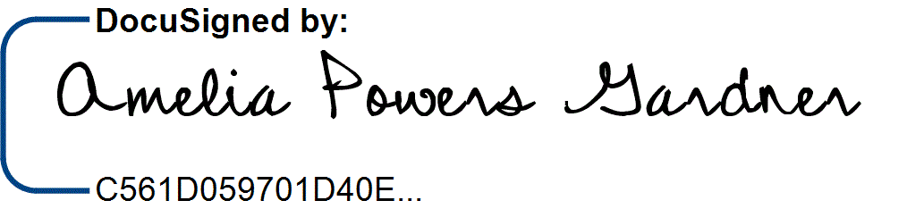BOARD OF COUNTY COMMISSIONERS UTAH COUNTY, UTAH

AMELIA POWERS GARDNER, Chair

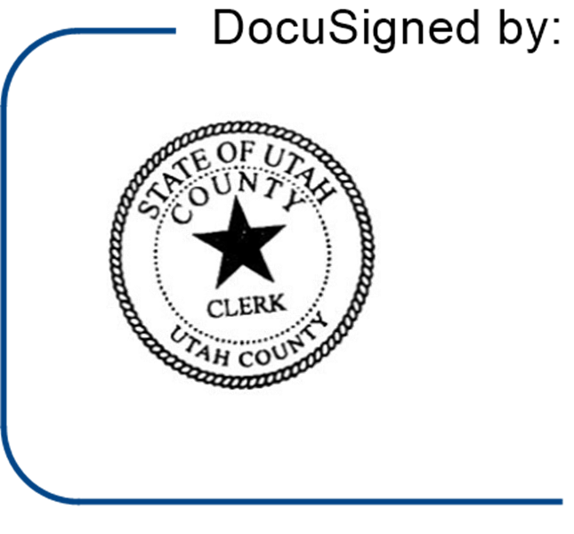
ATTEST:
AARON R. DAVIDSON
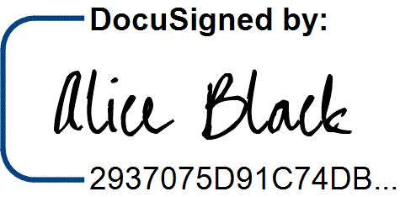
Utah County Clerk

By: Deputy
APPROVED AS TO FORM AND LEGALITY: JEFFREY S. GRAY
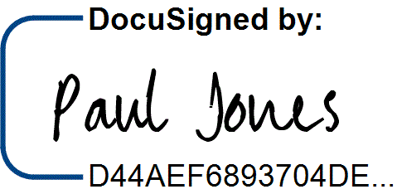
Utah County Attorney

By: Deputy Utah County Attorney

To be published as a Class A Notice, as follows:
- Publish the public notice on the Utah Public Notice Website.
- Publish the public notice on the public body’s official website.
- Post the notice in a public location within the county that is reasonably likely to be seen by residents of the county.

UTAH COUNTY COMMUNITY REINVESTMENT PROJECT AREA BUDGET

Section 1: Introduction

Per Utah Code § 17C-5-302(2), the Utah County Community Reinvestment Agency (the “Agency”) is required to prepare a project area budget (“Budget”) for the Utah County Reinvestment Project Area (the “Project Area”). This Budget is based on projected development within the Project Area, which includes a proposed new renewable energy facility. As development takes time to occur, the Budget takes into account the anticipated timing of the development. The purpose of this Budget is to set forth the Agency’s good-faith projections about the impact of development within the Project Area on the Agency and the benefits to the individual taxing entities. This budget will be presented for approval from the Utah County Redevelopment Agency.

This budget meets the requirements of the Utah Limited Purpose Local Government Entities – Community Reinvestment Agency Act (the “Act”). This Budget is prepared in good faith as a current reasonable estimate of the economic impact of projected development within the Project Area. Fundamental economic changes and other circumstances may influence the actual impact. With these assumptions, the information contained within this Budget represents the reasonable expectations of the Agency. The Agency makes no guarantee that the projections contained in this Budget for the Project Area accurately reflect the future development within the Project Area. Further, the Agency specifically reserves all powers granted to it under the Act, as amended; this Budget shall not be interpreted to limit or restrict the powers of the agency as granted by the Act. The actual amount of tax increment received by the Agency shall be governed by this Budget.

Section 2: Project Area

The Project Area is being created contemporaneously with the adoption and approval of this Budget. It encompasses approximately 5,000 acres and is shown on the map in Exhibit A.

Section 3: Base Taxable Value

The base value for the Original Area is the total assessed value of property within the Project Area for the 2023 tax year, which is estimated to be $15,110,900.

Section 4: Each Project Area Funds Collection Period

The project area funds collection period under this Budget begins on January 1, 2024 and ends on December 31, 2038 (the “Project Area Funds Collection Period”). In other words, the Agency shall receive project area funds generated by development within the Project Area for all periods up to and including 2038. No action by the Agency shall be required to begin (or “trigger”) collecting tax increment from this Project Area pursuant to this Budget.

Section 5: Project Area Funds to be Paid to the Agency

The Agency shall receive one hundred percent (100%) of the tax increment generated by the Project Area during the Project Area Funds Collection Period, subject to the terms set forth below:

  - The base value for purposes of calculating tax increment generated by the Original Area shall be the 2023 assessed value, as described in Section 3, above.

  - Of the project area funds received by the Agency pursuant to this Budget, sixty percent (60%) shall be used for project area development (as defined in the Act) and the remaining forty percent (40%) shall be used as described in Section 6, below.

  - The Agency shall not make allocations to Agency administrative costs from the project area funds received by the Agency pursuant to this Budget.

- Prior to distribution of any project area funds to the Agency pursuant to this Budget, Utah County may retain up to $50,000 per year to cover the County’s costs administrative costs relating to this Budget and the Project Area.

- This Budget does not set a maximum amount that the Agency is allowed to receive.

Section 6: The Projected Amount of Tax Increment to be Paid to Other Taxing Entities

Of the forty percent that the Agency retains (as described in Section 5, #3, above), the Agency shall distribute said project area funds on an annual basis as follows:

For housing as required by Utah Code section 17C-1-412 – 20.85%. To Alpine School District – 70.96%
To Utah County- 8.19%

To illustrate, if the Agency receives $5,000,000 in project area funds for a given year,
$3,000,000 (or 60%) shall be used for project area development and $2,000,000 shall be retained by the Agency. Of that $2,000,000, the Agency shall use $417,008 for housing purposes as outlined in Utah Code section 17C-1-412 , shall pay $1,419,115 Alpine School District (70.96%), and pay $163,878 to Utah County.

Section 7: Projected Amount of Tax Increment to be Generated Within the Project Area

It is currently estimated that over a 15-year period, the tax increment to be generated by new and existing development within the Project Area will be approximately $30,590,000. These projections are based on estimated taxable value of real and personal property in the Project Area of $790,411,000.00. The Agency’s detailed financial projections are shown on the spreadsheet attached hereto as Exhibit B. Note that these financial projections are the Agency’s estimates

based on currently-available information and do not constitute guarantees of tax revenue generation or limits on the Agency’s authorization to receive tax increment under this Budget.

Section 8: If the Area From Which Tax Increment is Collected is Less Than the Entire Community Reinvestment Project Area

The Agency is hereby authorized to collect tax increment from the entirety of the Project Area.

Section 9: The Percentage and Maximum Cumulative Dollar Amount of Tax Increment the Agency is Authorized to Receive From the Community Reinvestment Project Area

As noted above, the Agency is authorized to receive 100 percent of the tax increment generated within the Project Area for the entirety of the Project Area Funds Collection Period. The total amount to be collected by the Agency is not subject to dollar limits.

Section 10: Sales and Use Tax Revenue

The Agency does not anticipate that development within the Project Area will generate a significant amount of sales or use tax revenues. This Budget does not allow the Agency to receive any portion of sales and use taxes generated within the Project Area.

Section 11: The Amount of Project Area Funds the Agency will use to Implement the Reinvestment Project Area Plan

The Agency anticipates using all tax increment received by the Agency to implement the Project Area Plan and to encourage development within the Project Area. The Agency currently anticipates using that full amount for infrastructure needed to allow for development within the Project Area and business incentive. The anticipated infrastructure costs are shown below.

Improvements Needed to Implement the CRA Plan
Road, water, sewer, curb, gutter and sidewalk | $0
Acquisition of property | $0
Incentive | $0
Total Fund Uses | $0

Section 12: Other

The Agency does not own and does not anticipate purchasing property within the Project Area. The distribution of Project Area Funds for this Project Area is governed by this Budget.
However, nothing in this Budget shall be interpreted to limit the Agency’s ability to enter into other agreements with any or all of the taxing entities as may be appropriate.

Exhibit A – Project Area Map
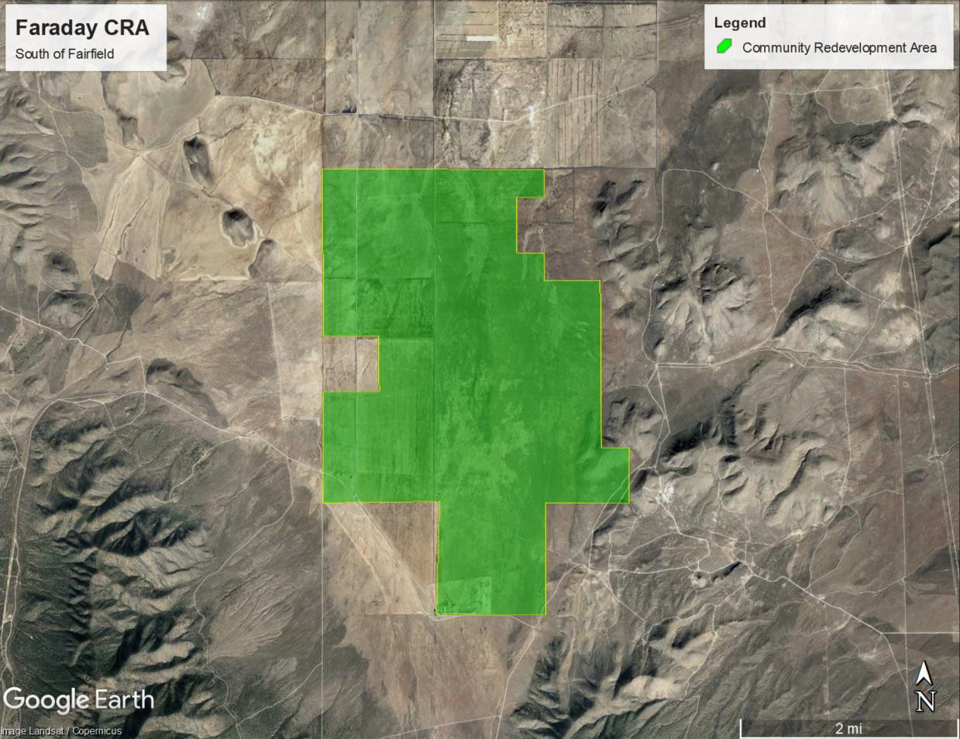

Exhibit B – Detailed Financial Projections

Utah County Project Area

Parcel | Owner | Acres | Value
60:044:0001 | Faraday Solar B LLC | 160 | $ 510,200
60:044:0002 | Faraday Solar B LLC | 320 | $ 1,020,400
60:044:0003 | Faraday Solar B LLC | 160 | $ 510,200
60:045:0001 | Millerberg Holdings | 560 | $ 1,785,800
60:053:0003 | Millerberg Holdings | 320 | $ 1,020,400
60:052:0001 | Millerberg Holdings | 560 | $ 1,785,800
60:051:0001 | Millerberg Holdings | 320 | $ 1,020,400
60:053:0002 | Millerberg Holdings | 160 | $ 510,200
60:052:0002 | Millerberg Holdings | 80 | $ 255,100
60:056:0001 | Millerberg Holdings | 320 | $ 1,020,400
60:057:0001 | Millerberg Holdings | 640 | $ 2,040,900
60:058:0001 | Millerberg Holdings | 400 | $ 1,084,200
60:056:0002 | Millerberg Holdings | 320 | $ 1,020,400
60:035:0001 | Millerberg Holdings | 640 | $ 1,526,500
Total |  | 4,960 | $ 15,110,900

