Present: Zachary Posner (Information Technology), Chris Stavros (Assessor), Megan Hillyard (Administrative Services), Reid Demman (Surveyor), Chris Harding (Auditor), Jami Johanson-online (attendance for Public Works), Lisa Ashman-online (District Attorney), Katherine Fife-online (Human Services), Hoa Nguyen-online (Council), Joey McNamee-online (Community Services), Katy Fleury-online (Mayor Administration), Shanda Gonzalez (attendance for Sheriff)-online
Representation Absent: Clerk, Recorder, Treasurer
Staff Present: Tony Jolley-online, Mark Evans, Rina Shipley-online, Cindy Beck, Kimball Ball-online Andrew Dudley, Lee Wilstead-online, Mark Miller-online, Mike Bailey-online, Sam Sedivec-online, Kira Moody-online, Valina Eckley-online, Jon Thelen-online, Trevor Hebditch, Cherie Root, Cindy Beck

TOPIC | POINTS OF INTEREST
Welcome & Remote Meeting Instructions | Reid Demman opened the meeting.  Trevor Hebditch shared the following slide:  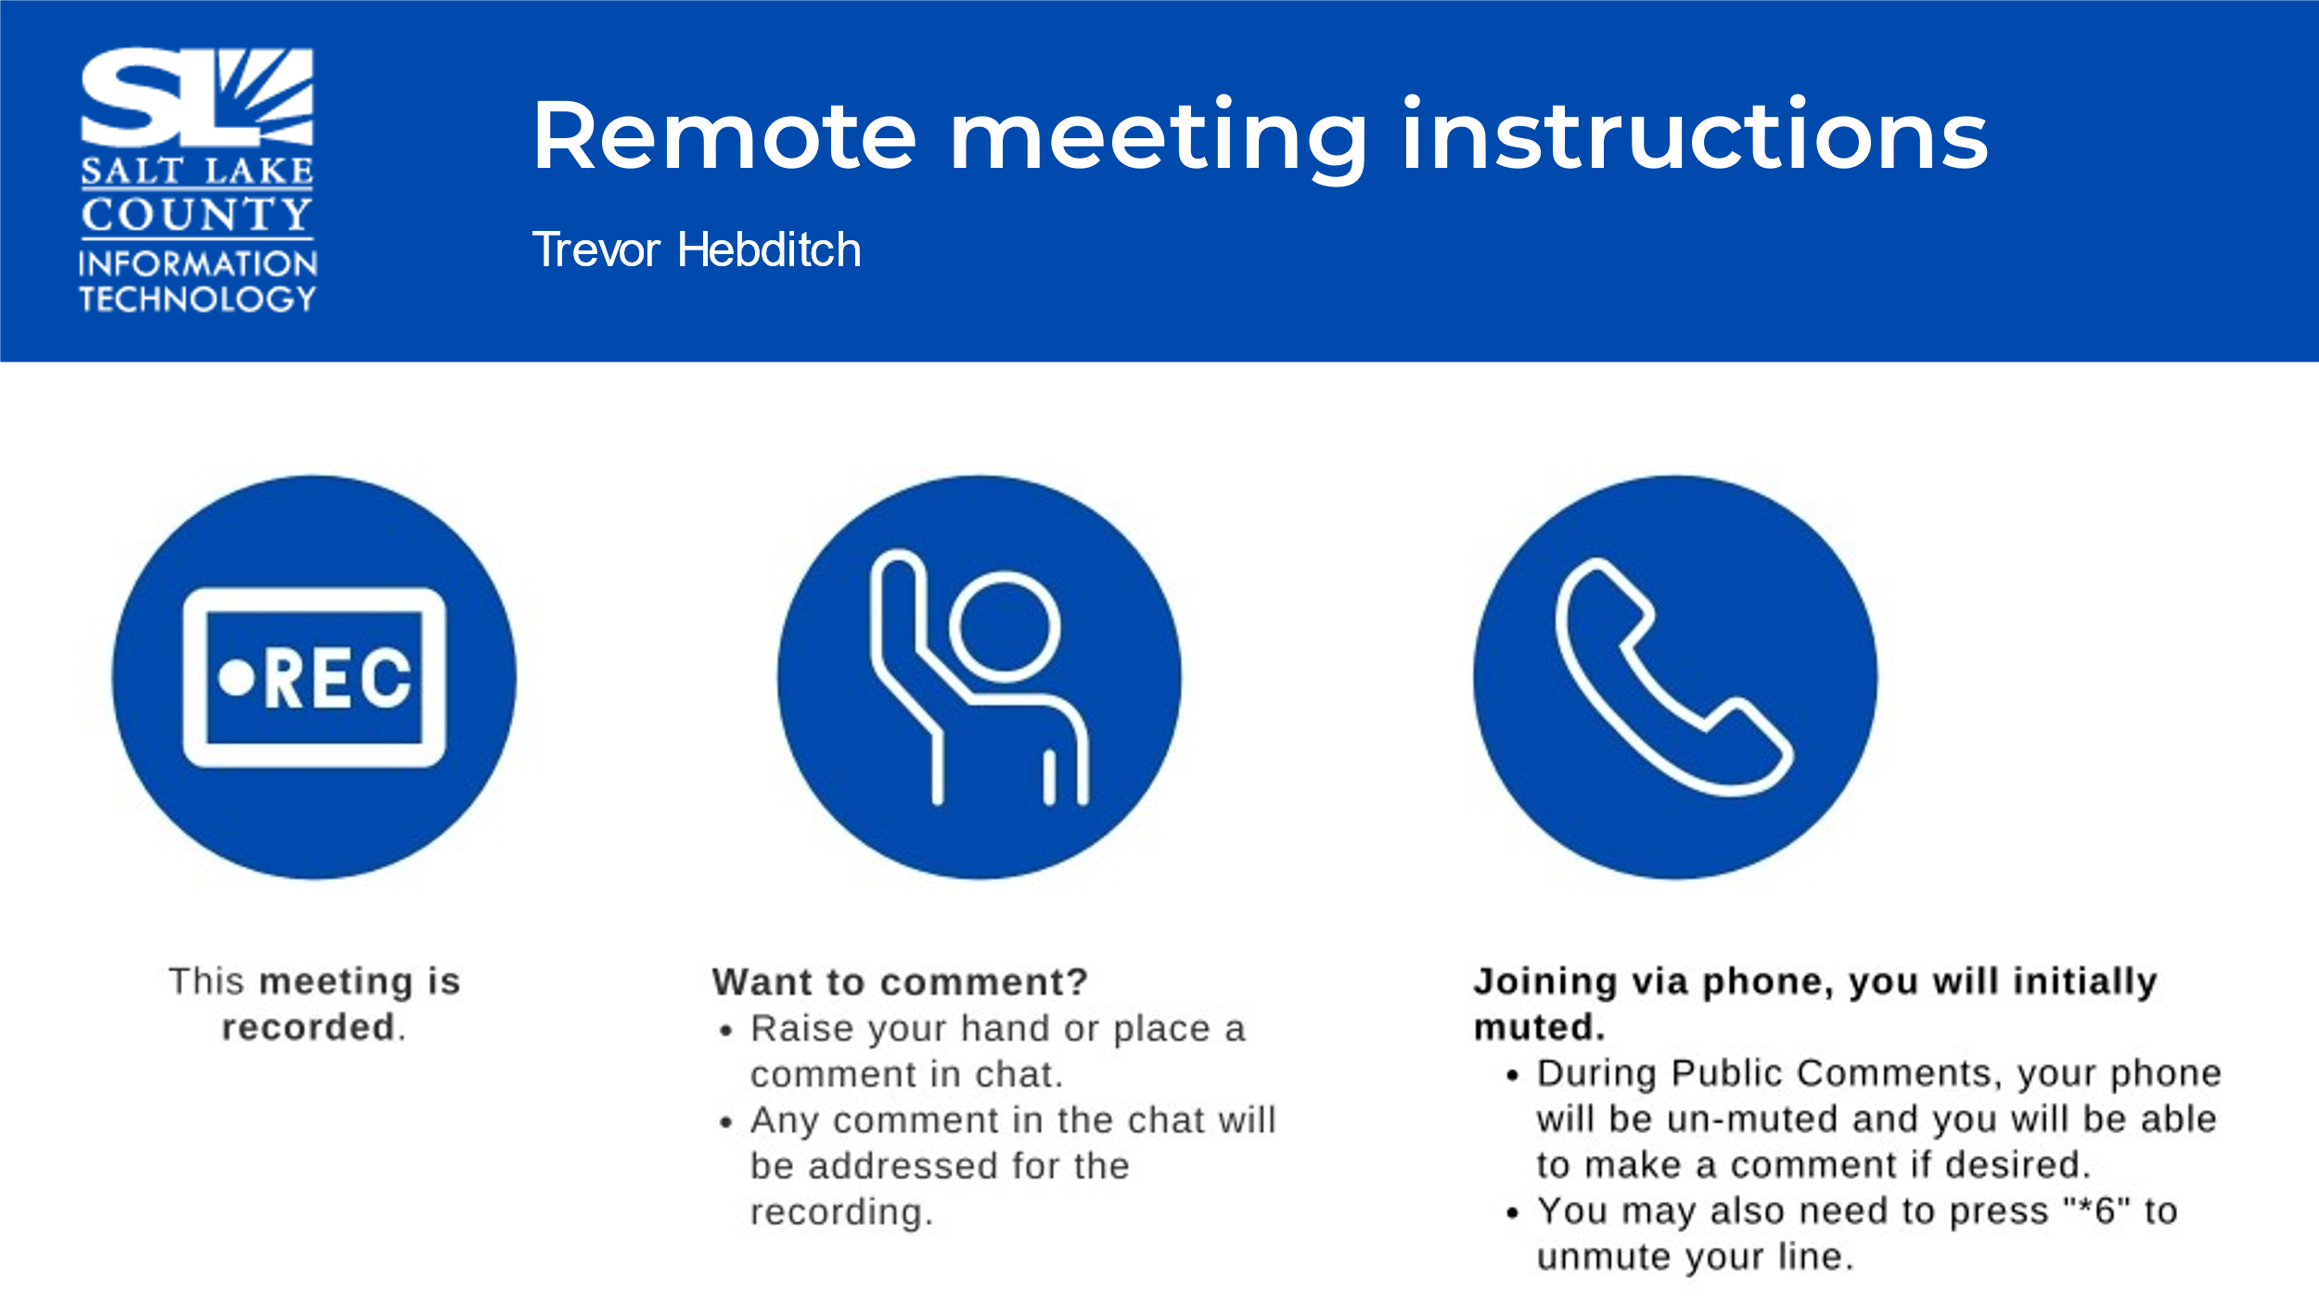
Public Comments  (Reid Demman) | It was noted the Leslie Webster from the Library wanted to introduce their new Sr. IT Manager, Elliot Fenech. No other comments.
Approval of minutes from August 10 and 16, 2023 meetings | Motion to accept the minutes by Chris Stavros, Chris Harding, seconds the motion. No discussion.  Motion passed unanimously.
Open & Public Meetings Act Training  (Dianne Orcutt)  All TAB Members to Complete the Annual Training by end of 2023. | 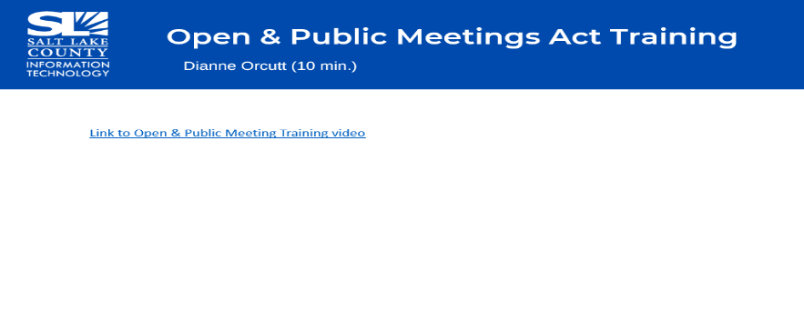  - The video is 7:57 minutes in length and all TAB members are required to view it by the end of year. Here is the link: Open and Public Meetings Act 2023 - YouTube
Follow-up Items (Cherie Root) | 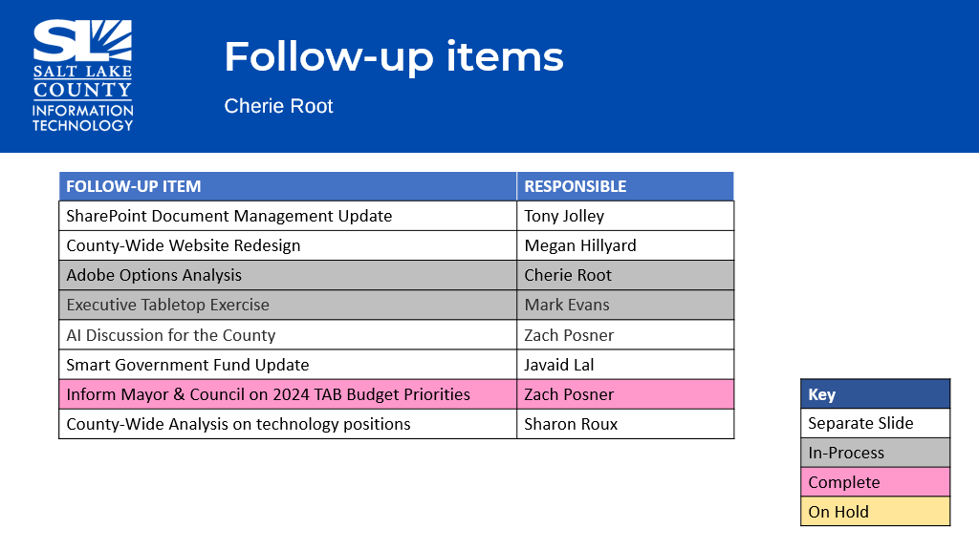
SharePoint Update (Informational) (Tony Jolley) | 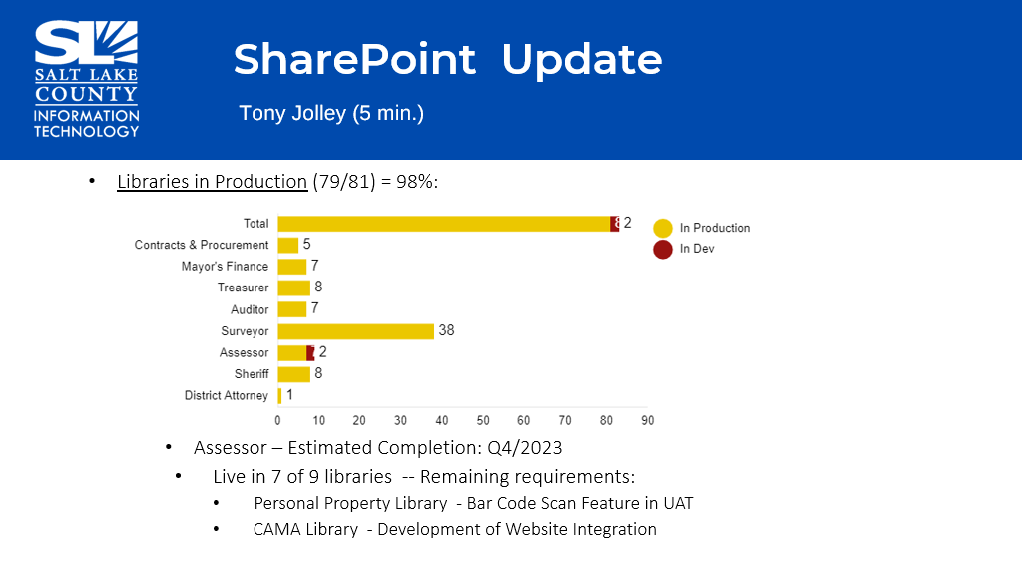
Website Redesign Update (Informational) (Megan Hillyard)  This slide was left blank intentionally. | - Four years into this project and are actively engaged on the remaining sites.  - Thank you to all the agencies for their cooperation and efforts with the redesign due to time constraints.  - Getting onto the new platform will help our Web team with the .gov transition and the CMS update (works on the back end of the website).  - A reminder to all agencies to work as fast as you can to get on the new platform as our goal is to complete this by the end of year.  - Thank you to the committee who has been working on this initiative: Katy Fleury, NIFTIC, Thomas Yeung, Halo Willgues, Valina Eckley, Zach Poser.
Technology Positions County-Wide (Sharon Roux) | 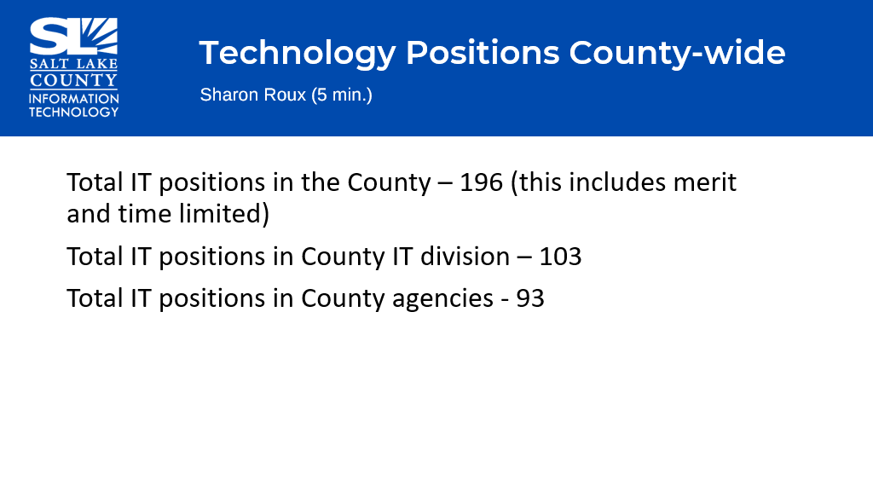
Working Group Milestones (Tony Jolley)  This chart reflects milestones that will complete in 2023. | 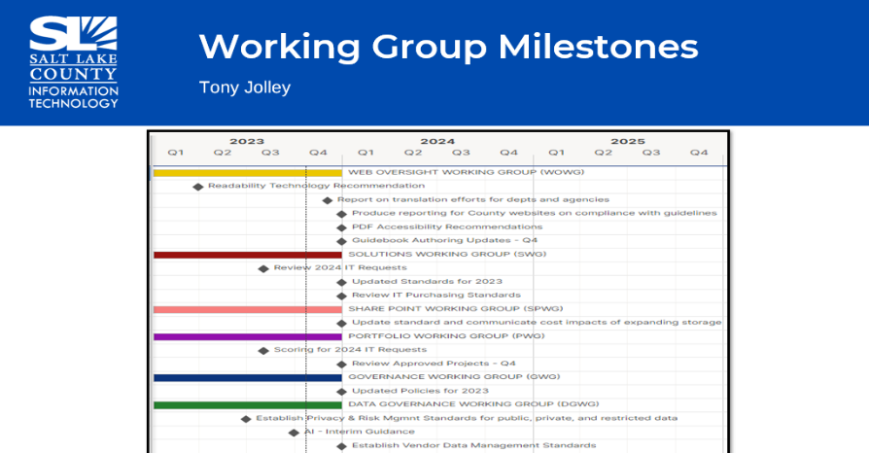  - Please note this chart reflects milestones that will complete in Q4 2023  - Web Oversight Working Group (WOWG) made recommendations for readability.  - Solutions Working Group (SWG) and Portfolio Working Group (PWG) have made recommendations for ALL the 2024 IT requests.  - Governance Working Group (GWG) working to update policy for recent changes in standards.  - Thank you to all members of the various working groups for the work they do for Salt Lake County.
Portfolio Working Group Update (Tony Jolley)  Advises on what projects are being worked on and which projects that should be worked on.  Portfolio Working Group (Tony Jolley) Cont.  Reminder: Fixed or Capital Assets use the stickers provided by Mayor’s Finance. | - Reviewed the projects that were scored by TAB last year and funds allocated by council.  - 7900 Phone Replacement not approved for 2024.  - Issue: Project will not meet the 2024 deadline  - Issue: Inhibits updates to phone system while we have the “old” phones on the system  - Funding for GIS ELA was not recommened in the Mayor’s budget.  - Reviewed status of this year’s projects
New Projects Recently Reviewed (Tony Jolley) | - Five projects (listed above) with separate or existing funding have been reviewed by the Solutions Working Group (SWG) and the Portfolio Working Group (PWG).  - Library increased the number of Microsoft Office 2021 licenses from 900 to 1000 and funding from $126,000 to $140,000.
Solutions Working Group Update (Trevor Hebditch/Rina Shipley/Mark Evans) | 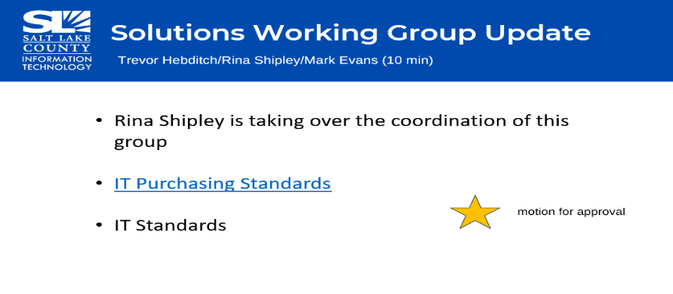  - Announced Rina Shipley will be taking over this working group effective immediately.  - Reviewed the minor annual changes to the IT Purchasing Standards document.  - Viewed the recommended updates to the IT Standards: Secure Windows Device Configuration, Server Windows Server Configuration, Secure MAC Device Configuration, and Cyber Security Incident Reporting & Response
Approval of modifications to IT Standards | Motion to approve all these modifications to the IT Standards by Chris Stavros, Megan Hillyard, seconds the motion.  It has been noted Chris Harding, Auditor abstains from the vote. Acknowledged does not see a problem with the updates but views this item as a management function.  Aye: Administrative Services, Assessor, Community Services, District Attorney, Human Services, Mayor Administration, Public Works, Sheriff, Surveyor  Nay: None  Abstain: Auditor  Absent: Clerk, Recorder, Treasurer  Motion passed. Motion carries.
Governance Working Group (Cherie Root) | 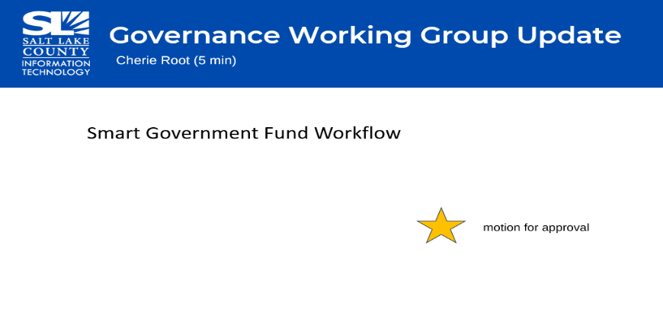  - Updated workflow to reflect when partner submits the full application a question has been added if additional IT resources are needed  - Updated title from Business Technology Partner (BTP) to Business Relationship Manager (BRM)  - Changed verbiage in document from “customer” to “partner”
Approval of updated Governance Workflow | Motion to approve the updated Governance Workflow by Megan Hillyard, Chris Stavros, seconds the motion.  It has been noted Chris Harding, Auditor abstains from the vote.  Aye: Administrative Services, Assessor, District Attorney, Human Services, Mayor Administration, Public Works, Sheriff, Surveyor  Nay: None  Abstain: Auditor  Absent: Community Services, Clerk, Recorder, Treasurer  Motion passed. Motion carries.
AI Best Practices + Guidance (Javaid Lal) | 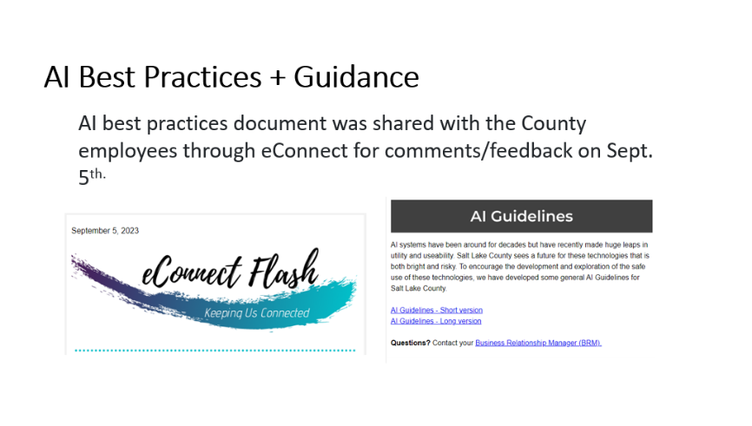
Artificial Intelligence Guidelines (Zach Posner)  AI Best Practices + Guidance (Javaid Lal) | 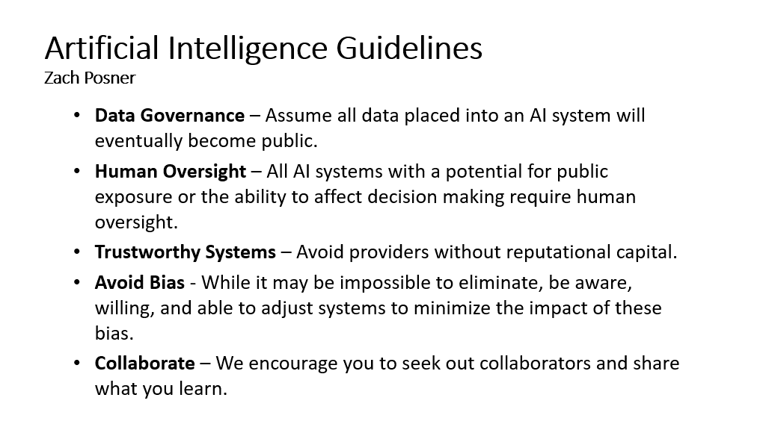  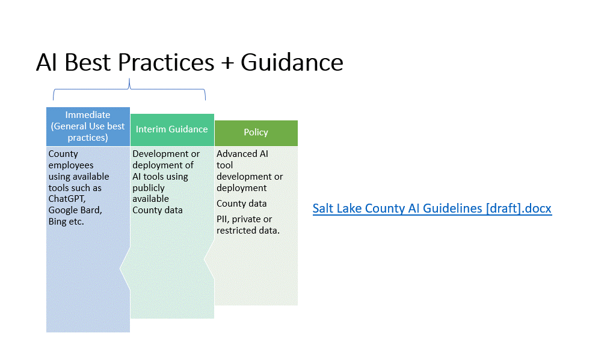
Smart Government Fund Ideas Submission (Javaid Lal)  Smart Government Fund Ideas Submission (Javaid Lal)  Cont. | 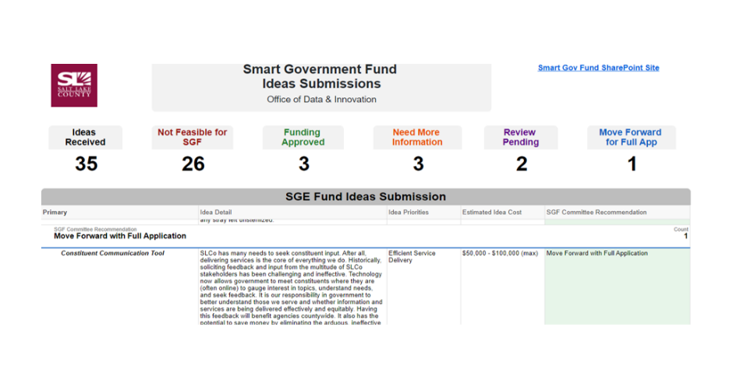  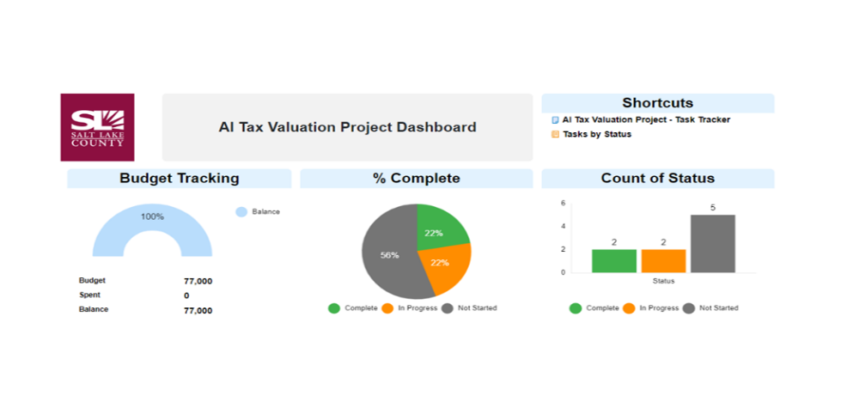  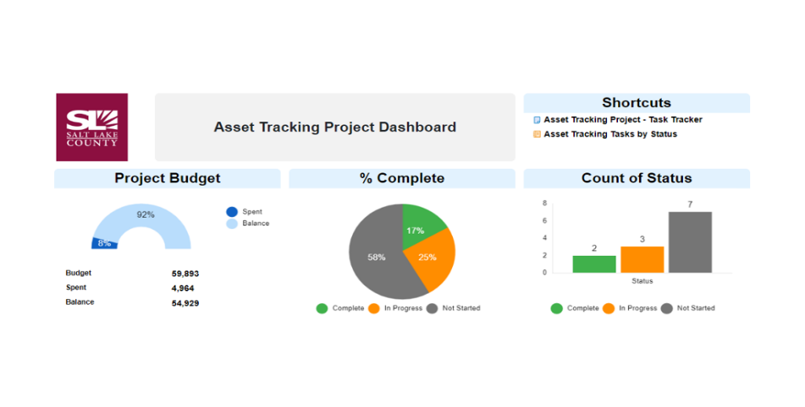
Security Update (Mark Evans) | Motion to enter a closed session to discuss deployment of security personnel, devices, or systems by Chris Stavros and Megan Hillyard, second.  Aye: Administrative Services, Assessor, Auditor, District Attorney, Human Services, Mayor Administration, Public Works, Sheriff, Surveyor  Nay: None  Roll Call: Absent Clerk, Community Services, Recorder, and Treasurer  Motion passed unanimously.  Motion to exit the closed session by Chris Harding and Lisa Ashman, seconds.  Motion passed unanimously.
2024 Budget Update (Zach Posner) | - Three critical categories impacted by budget reduction:  - Hardware & Software maintenance increases, 2% “overall” ops reduction, & GIS ELA license ageements.  - Possible methods to aide in budget constraints: delay the start of projects, TIP funding, and each team “tighten” their own budget.  - Potential emergency TAB meeting to discuss impact of budget.  - With a hiring freeze and a 3% reduction on the personnel budget, this may impact our ability to execute projects over the next year.
Other Business (TAB Members) | None
Communications Items (Chair & CIO) | None
Upcoming Meeting Schedule (Cindy Beck) | - Possible emergency TAB meeting. We will coordinate with Reid if the additional meeting is needed.
Review Action Items (Cindy Beck) | - All TAB members to complete the Open & Public Meeting Act training video. The link will be sent to the TAB members who were absent from today’s meeting.  - The IT Department will follow up with Mayor’s Finance on getting the “fixed” asset stickers for the conference room equipment.  - Changes to IT Standards will be communicated in the IT Newsletter and eConnect.
End of Session | - Motion to adjourn the meeting by Chris Harding. Meeting adjourned. So moved.
Next Meeting | December 7th, 9:00 – 10:30 AM (Possible additional emergency meeting)
Submitted by Cindy Beck

