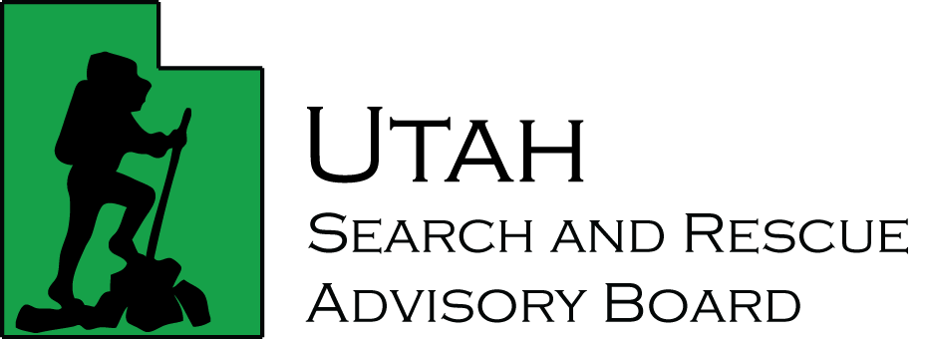

Search and Rescue Advisory Board Meeting

Friday, December 15, 2023
Utah Division of Emergency Management, Taylorsville Utah

AGENDA

Welcome Sheriff Nathan Curtis
Board Chair

Review of Target River USARA Marketing Wade Mathews

Utah Open Meetings Training David Mooers-Putzer

Review and Approval of Minutes

Review New Applications for Reimbursement

Working Lunch

Unfinished Business

Meeting Adjourned Sheriff Nathan Curtis
Board Chair

