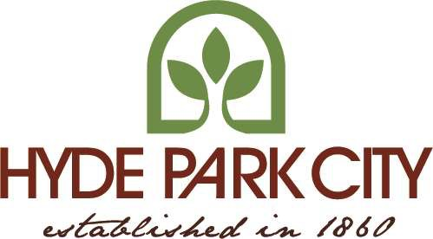
12.40 Development Review Committee

12.40.010 Membership

The Development Review Committee (DRC) shall consist of varied members that include:

- Planning Commission Chairperson or designee
- City Building Inspector or designee
- City Public Works Director or designee
- City Engineer or designee
- Fire Chief or designee

- Zoning Administrator or other city staff member as designated b the zoning administrator

The term of office of each member will be in connection with the designation of city employee classifications and by appointment by City Council as appointed and qualified.

HISTORY
Adopted by Ord. 2015-03 on 5/13/2015 Amended by Ord. 2019-05 on 4/24/2019

12.40.020 (Reserved)

HISTORY
Adopted by Ord. 2015-03 on 5/13/2015 Amended by Ord. 2019-05 on 4/24/2019

12.40.030 Members Compensation
Members of the DRC shall serve with no compensation in addition to their regular city salaries. They may be reimbursed for reasonable expenses incurred, with the approval of the City Council.

HISTORY
Adopted by Ord. 2015-03 on 5/13/2015 Amended by Ord. 2019-05 on 4/24/2019

12.40.040 Contracts And Employment

The DRC may request that the city contract employees, staff, city planners and other consultants, as it may deem necessary for its work. The expenditures of the DRC shall be within the amounts appropriated for that purpose by the City Council.

HISTORY
Adopted by Ord. 2015-03 on 5/13/2015 Amended by Ord. 2019-05 on 4/24/2019

12.40.050 Powers And Duties

The DRC of Hyde Park shall have such powers and functions and shall perform such duties as are prescribed by Utah Code, as amended annually by the Utah State Legislature. Such powers and duties shall include, but shall not be limited to, the submission to the City Planning Commission recommendations concerning all proposed changes in ordinances pertaining to zoning as provided in General Provisions (Section 1-4) of the Zoning Ordinances of Hyde Park, Utah. The DRC shall have such other powers and duties as prescribed by law.

HISTORY
Adopted by Ord. 2015-03 on 5/13/2015 Amended by Ord. 2019-05 on 4/24/2019

12.40.060 Record Of Proceedings
The DRC shall keep a public record of its proceedings that shall be filed with the City Recorder.

HISTORY
Adopted by Ord. 2015-03 on 5/13/2015 Amended by Ord. 2019-05 on 4/24/2019

12.40.070 Rules And Regulations

The DRC shall interpret rules and regulations subject to the provisions of the laws of the State of Utah and the Zoning Ordinances of Hyde Park, Utah, and may suggest amendment to such rules and regulations from time to time to the Planning and Zoning Commission.

HISTORY
Adopted by Ord. 2015-03 on 5/13/2015 Amended by Ord. 2019-05 on 4/24/2019

12.40.080 Land Use Authority Designations
Land Use Authority Table - Applies to all zones

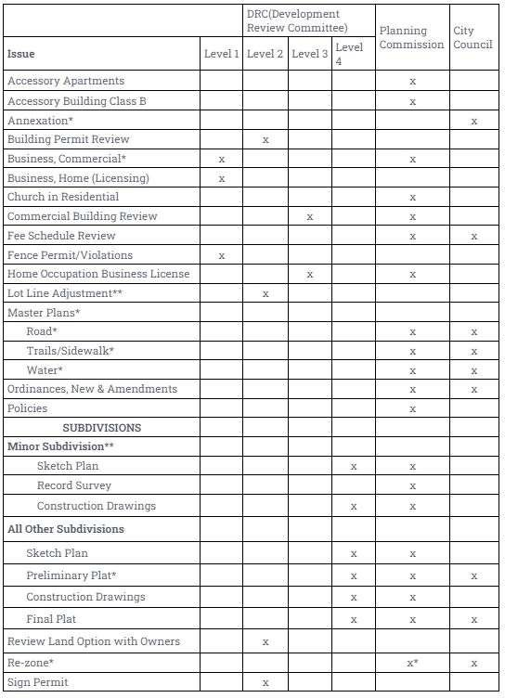

*Requires a Public Hearing with Public Notice
** Requires Public Notice
Level 1 Building Official and (1 of these 3) Public Works Director or Planning Commission Chair or Staff Secretary
Level 2 Building Official, Public Works Director, Planning Commission Chair and Staff Secretary
Level 3 All Level 2 members and Fire Department Representative

Level 4 All Level 3 members and City Engineer

HISTORY
Adopted by Ord. 2015-03 on 5/13/2015 Amended by Ord. 2019-05 on 4/24/2019 Amended by Ord. 2022-15 on 6/23/2022

