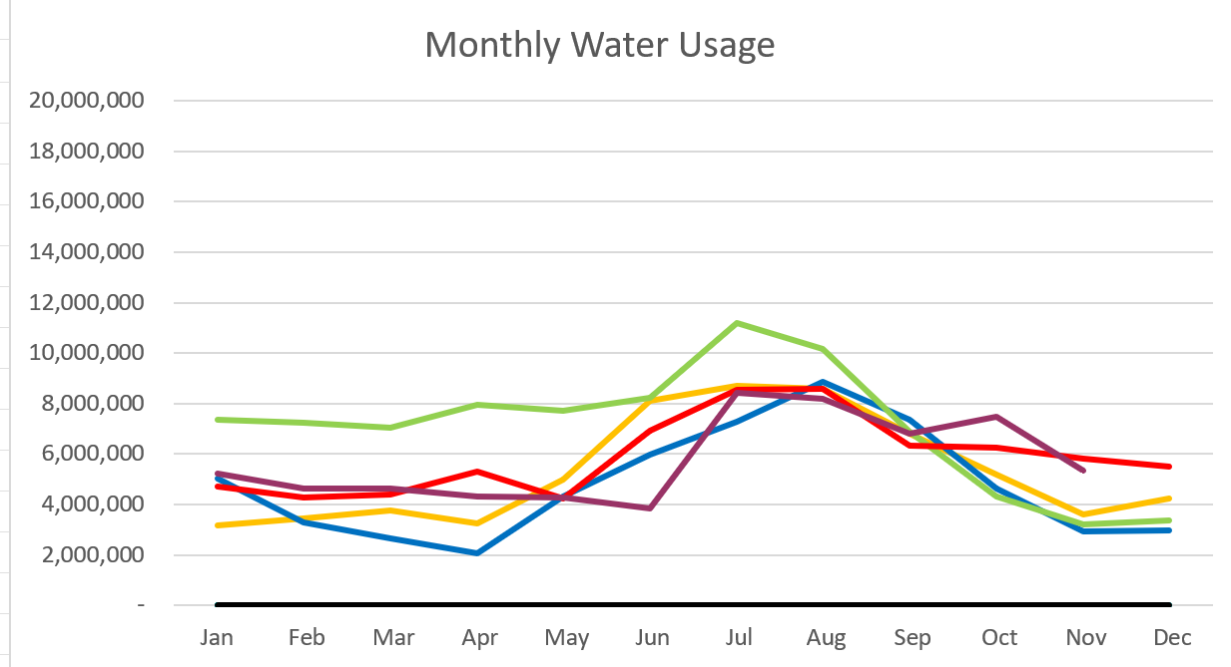

2023 – Purple
2022 – Red 2021 – Yellow
2020 – Blue 2019 – Green

November 2023

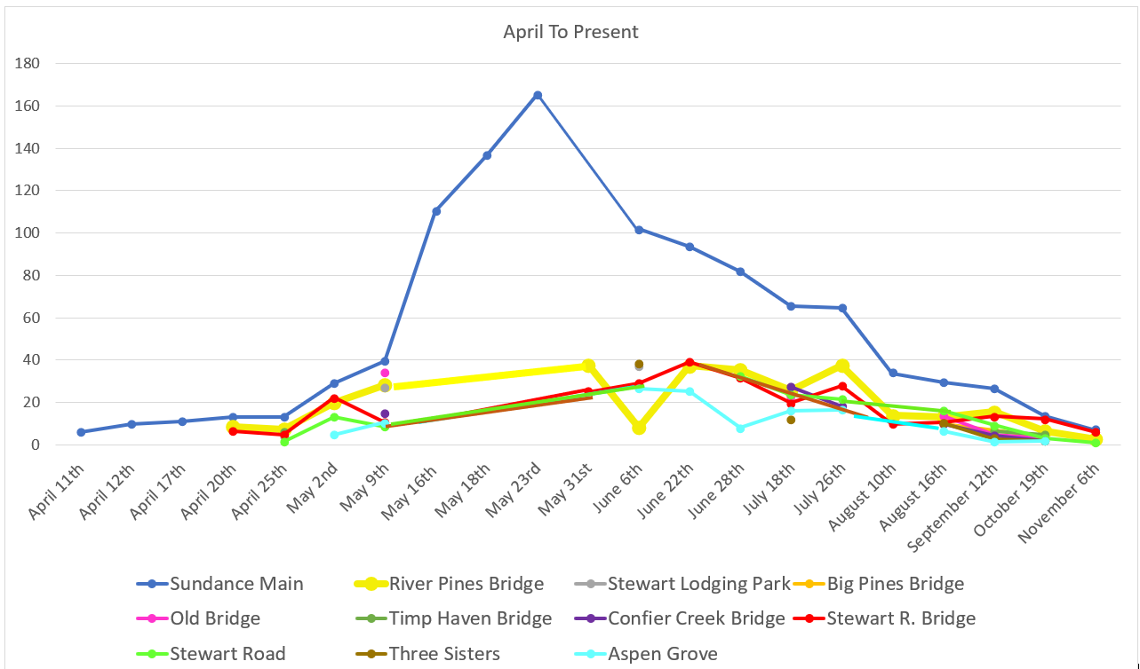
C
F
S

Water Department Information for November
- Our overall water consumption is lower than compared to last year.
- Aspen Grove wet-well levels are averaging 7.12 feet for November 2023 which is less than a foot down from last month. This time last year for November 2022, our average was 5.2 feet. The average is about 2 feet higher this year compared to last.
- Stewart Spring is averaging 77.9 gpm for November after it was brought back on line. Looking great! This time last year it was averaging 0 gpm for November and December.
- Unaccounted water
  - Upper Pressure Zone
  - Lower/Stewart Zone
    - Our team has been replacing meters as we get them in. Doing a fantastic job! We are starting to put in cellular endpoints as we get them.
- Stewart Spring rehab is 100 percent complete.
- Infiltration Sampling has begun. Once a month for 6 months
- Sundance master meters are installed.
- We ordered a 3 in meter for the Stewart Overflow
- We Fixed the Roof at Aspen Grove.

Wastewater Department Information for November
- We have four labs for November. BOD and TSS was over limits on Nov. 1st. Rest were within limits.
- The Plant upgrade is moving forward.
- Working with Sundance to get the drain field radio back up and running.
- We did have a sewer issue with groundwater getting into the system. Which caused havoc at the treatment plant it lowered are overall operating temp and doubled the flow coming into the plant. We had to place the other MBR online. We are currently running both sides.

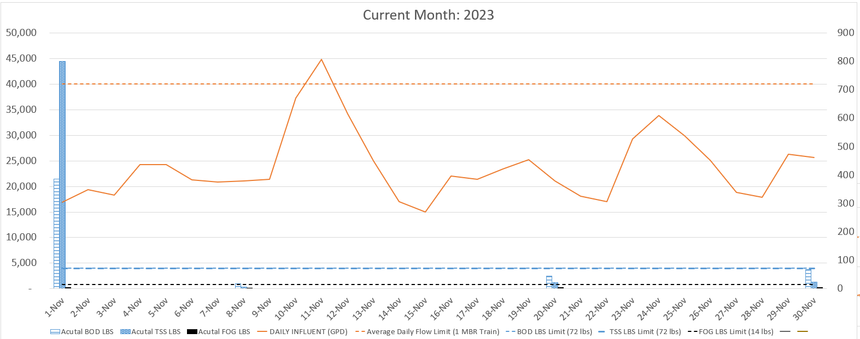

AVERAGE DAILY FLOW (GPD) | 23,872
HIGHEST DAILY FLOW (GPD) | 44,790

